The contribution of reproductive technologies for dairy cattle genetic improvement in Amhara region: success and challenges on research and development efforts
Assemu Tesfa,^{a,b*} Birhan Kassa,^{a,b} Mengistie Taye,^{a,c} Ahemed Alkader^{d}, Demelash Aychilie^{d} Zemenu Birhan,ª Tarekegn Demekeª and Mesfin Lakew^{e}
ªCollege of Agriculture and Environmental Science, Bahir Dar University, Bahir Dar Ethiopia; ^{b}Andassa Livestock Research Center, Bahir Dar Ethiopia; ^{c}Biotechnology Research Institute, Bahir Dar University, Bahir Dar Ethiopia; ^{d}ANRS Livestock and Fishery Resources Development Office, Bahir Dar, Ethiopia; ^{e}Amhara Agricultural Research Institute (ARARI), Bahir Dar, Ethiopia
*Correspondence: assemu546@gmail.com; +251913998581

ABSTRACT

In the Amhara region, cattle genetic improvement had conducted by the Amhara agricultural research institute (ARARI), and Amhara Livestock and Fishery Resources Development Office (LFRDO). The aim of the article was to evaluate the contribution of reproductive technologies for dairy cattle genetic improvement in the research and development sectors of the Amhara region. A total of 13 year data from the LFRDO was used to analyze the successes of reproductive technologies in the livestock extension sector. Under the research system, delivery rate (%) through Oestrus Synchronization and Mass Artificial Insemination (OSMAI) had reported from 4.93% at Andassa Livestock Research Center (ALRC) to 60.1% at Debre Birhan Agricultural Research Center (DBARC). The data from LFRDO indicate a calving rate (%) of 44.46, and 44.84 through insemination done with conventional semen, and bull service, respectively. In the region, sexed semen to female was used to increase the number of crossbred females and the work done for one year revealed an overall conception rate (%) of 42.09%, ranging from 19.1% to 79% and the overall sex efficiency to be female calve was 94.8%. The time of insemination after the onset of heat, body condition, breed, parity, technical efficiency of the artificial insemination technicians were reported factors for the success of OSMAI. The OSMAI that targets to increase milk yield had better be integrated with different actors in the dairy value chain and accountable collaboration between different actors participating in the technology should be realized.

Keywords: Amhara region, conception rate, reproductive biotechnology, sexed semen, sex efficiency

INTRODUCTION

The world population is projected to grow from 7.8 billion in 2020 to 9.7 billion by 2050, with growing incomes and urbanization, and the demand for animal-source foods is projected to continue increasing (Kadarmideen, 2014; Smith et al., 2020; Burrow et al., 2021). According to the Food and Agriculture Organization (FAO, 2013), beyond the population increment, global food production is experiencing challenges due to climate change, which requests a doubling of food production to meet the increasing demand (Eggen, 2012; Yadav et al., 2018; Strandén et al., 2022). Animal production is likely to grow in both developed and developing countries (Dube-Takaza et al., 2021). Animal breeding supported by reproductive biotechnologies and genomic tools plays a critical role in ensuring future food security through rapid genetic improvement (Kadarmideen, 2014).
Indigenous animal genetic resources are believed to preserve much of the current global genetic diversity, with millions of people directly dependent on them (Mekuriaw & Kebede, 2015; FAO, 2021). The reasons behind these breeds are the source of vast environmental adaptations for diverse diseases and parasite resistance, tropical climate conditions (including dry, hot, and humid), and excessive heat tolerance, are suitable for extensive management systems, and are the only options for ecosystem restoration (Kim et al., 2017; Taye et al., 2018; FAO 2021). Indigenous animal genetic resources are the only option available to millions of farmers in African agro-pastoral systems, where exotic breeds underperform in traditional management systems (Kim et al., 2020).
Cattles are central to the African economy (Kim et al., 2020; Saravanan et al., 2021), playing a pivotal role through the provision of food, fiber, and labor, acting as walking larders, traction power, and manure. They are of societal importance and considered a primary source of wealth (Zerabruk et al., 2007; IBC, 2012; Xu et al., 2019; Kim et al., 2020). Ethiopia has the highest concentration of domesticated and diversified cattle in the continent (Rege, 1999). This is mainly because the country is a gateway for cattle entry into Africa (Hanotte et al., 2002) and has diverse agro-ecology, allowing it to produce feed (Takele et al., 2011). Even though the contribution of the livestock sector to the national economy in Ethiopia is significantly higher, reaching about 25% of total agricultural GDP (Behnke & Metaferia, 2011), the production per animal is 1.45 liters per cow per day (CSA, 2022). The average lactation milk production of the indigenous cows ranges from 494–850 kg under optimum management (Haile et al., 2011), and the lactation length and average milk yield/day/cow were seven months and 1.48 litter, respectively (CSA, 2021). Different efforts have been made through selection and crossbreeding to improve the milk production of indigenous cattle. The best contributors to this genetic improvement are the presence of a range of agro-climates and production systems, feed and water availability, and small-to-large-scale farms (Hiemstra, 2018). However, the implementation did not function due to separate implementation interests between research and development officials, the absence of a clear and implementable strategy that targets the improvement scenario of indigenous breeds, the absence of sustained support from different stakeholders, and others (Shapiro, 2015).
In Ethiopia, various reproductive biotechnological tools have been used to accelerate the genetic improvement of dairy cattle production. Artificial insemination using exotic semen and estrus synchronization began in the 1960s (Chencha & Kefyalew, 2012), and 1980 (Tegegne et al., 2016), respectively. Embryo transfer was demonstrated at the International Livestock Research Institute and Holetta Agricultural Research Center in 1990 (Ahmed & Mohammed, 2017; Daba et al., 2022). Recently, the use of sexed semen in female calves has increased. Except for embryo transfer, which is limited to research, artificial insemination and estrus synchronization have been widely implemented in research and development institutions all over the country, including the Amhara region. Recently, mass synchronization with fixed-time artificial insemination campaigns has been implemented in different parts of the county to further improve the production of crossbred animals.
Despite long-lasting efforts to crossbreed dairy cattle in the country using artificial insemination, the contribution of crossbred animals to the total cattle population is very small, only 2.29% (CSA, 2021). Moreover, the national government plans to increase milk yield by 200% and the proportion of improved breeds by 600% by 2030 (Raad et al., 2021). Moreover, the efficiency of these efforts so far is below expectations owing to numerous factors. Several scholars have attempted to evaluate the efficiency of these technologies with different setups and animals of different breeds (blood levels), ages, and body condition scores. This study aimed to evaluate the attempts made to genetically improve dairy cattle through reproductive technologies and to identify the major challenges and future directions used to improve the success and wider dissemination of estrus synchronization with mass artificial insemination in the Amhara region.

MATERIAL AND METHODS
Description of the Amhara Region

The Amhara Region is located in the northwestern part of Ethiopia, with a land area of 170,752 square kilometers. It is situated 8°45’ to 13°50’N and 36°20’ to 40°30’E (Figure 1). The region’s capital city, Bahir Dar, is 566 km from Addis Ababa. The total cattle population of the region is 17.3 million contributing 24.6% of the nation’s cattle population (CSA, 2021). The Amhara region holds the largest milk shed in the country, which is characterized by the presence of a large market, high potential for roughage production, a significant number of milk cooperatives, and cooperative unions involved in milk processing (Brandsma et al., 2012). Menale et al. (2022) reported that the biophysical environment of the region is approximately 14.2%, 56.1%, 28.1%, and 1.7% highly suitable, moderately suitable, marginally suitable, and unsuitable for dairy cattle production, respectively. According to Moges et al. (2019), in the main towns of the region, 885 dairy farms were reported holding 1-2 cows, 3-10 cows, and >10 cows/farm with respective percentages of 45.1%, 46.2%, and 8.7%. In regions such as the Amhara Livestock and Fishery Development Offices, Bahir Dar Artificial Insemination Center, Bahir Dar Animal Health and Disease Surveillance Office, Amhara Agricultural Research Institute, and Amhara Cooperative Agency, work on genetic improvement, semen production, disease prevention, and development of cooperatives across the dairy cattle value chain.
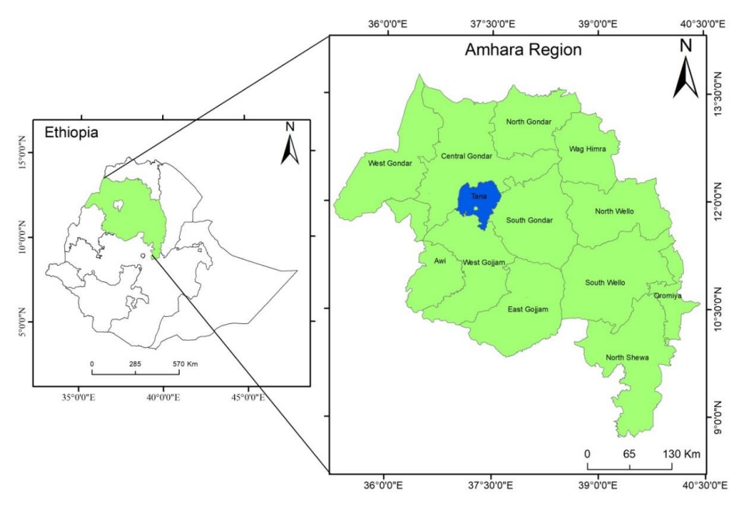
Figure 1: Map of the Amhara region

Data Source and Analysis

To compile the study results, research findings on assisted reproductive technologies from research centers in the Amhara region were gathered. Thirteen-year retrospective data collected from the region's livestock extension system were used to evaluate the trends in the success of reproductive technologies in the region. The major working procedures and challenges related to the OSMAI in the Amhara region was collected from key informant interviews conducted with animal breeding experts in the office. In addition, a field visit was conducted to evaluate the performance of the Bahir Dar artificial insemination center on semen collection, processing, and dissemination, their performance in liquid nitrogen production, and their involvement in the cattle genetic improvement program. The collected raw data were analyzed using Microsoft Excel software (MS-Excel, 2010).

Oestrus Synchronization and Artificial Insemination Protocols

Currently, prostaglandins and progesterone are widely used to synchronize estrus in dairy cattle operations (Murugavel et al., 2010). Prostaglandin is the first method of estrus synchronization that depends on the presence of a functional corpus luteum particularly in the diestrus stage of the estrous cycle (7th to 17th day of the cycle) (Cordova-Izquierdo et al., 2009). The use of prostaglandin or its analog (PGF2α) in a synchronization protocol shortens the estrous cycle, with oestrus occurring two–seven days after hormone injection (Demis et al., 2022). Two protocols were evaluated in the research centers: 1) single-shot, delivering AI after seven days of hormonal injection; and 2) double-shot, repeated hormonal injection after seven days and insemination within 18 days were evaluated (Yeshimebet et al., 2017). The Prostaglandin-based synchronization technique to support artificial insemination has previously been evaluated in four regions of Ethiopia for four consecutive: Oromia (283,231 cattle), Amhara (69,207 cattle), Tigray (129,220 cattle), and the SNNP (129,545 cattle) (Tegegne et al., 2016; Demis et al., 2022). The implementation of OSMAI is to support the national policy of producing more crossbred heifers, to which the cost of producing crossbred heifers is increasing (Azage et al., 2012; Tegegne et al., 2016; Demis et al., 2022).

Semen Collection, Processing and Dissemination in the Amhara Region

The artificial insemination center of the Amhara region, which operates under the region’s livestock and fishery resources development office, has been mandated to collect, process, and distribute semen, train and certify AI technicians, and purchase and distribute AI equipment and consumables under the region. The region had five liquid nitrogen production plants in Bahir Dar, Gondar, Debre Markos, Dessie, and Debre Birhan, which maintained semen before distribution to the neighboring district. The production potential of the liquid nitrogen processing plant varies from 9 L/h in Debre Markos to 3 L/h in the remains, and the low potential was due to the lack of timely maintenance and aging of the plants (e.g., the plant installed at Bahir Dar was dated to the 1980s).
Semen collection in the region was performed using a dummy cow and an artificial vagina. The semen collected before distribution was subjected to different processing, quality tests, and packing procedures (Figure 2), and the processing operations were performed in an enclosed area, which is restricted to technicians who operate the activity.
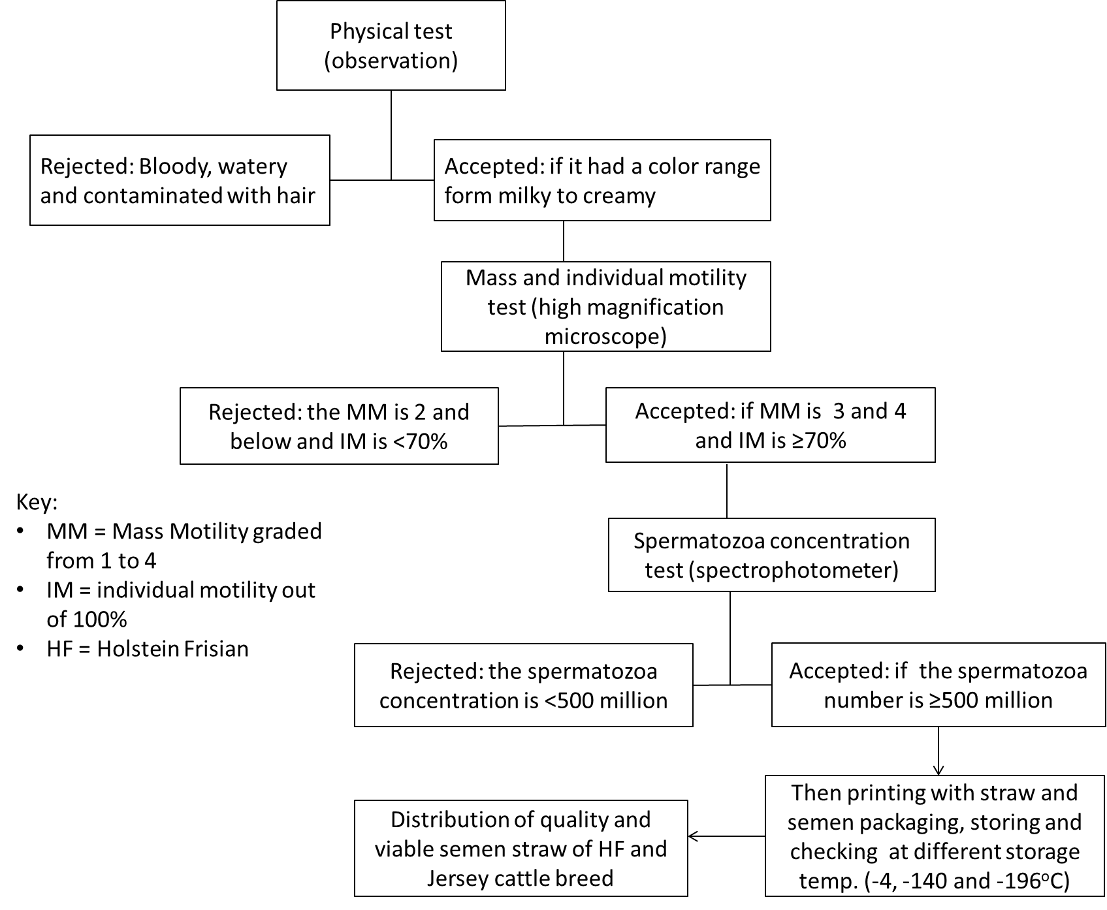
Figure 2: Schematic diagram in semen collection, quality checking, and distribution used at Bahir Dar AI center

RESULT AND DISCUSSIONS
Reproductive Technologies for Cattle Genetic Improvement in Ethiopia

Reproductive biotechnology is used to accelerate genetic improvement in cattle. In Ethiopia, various projects have been implemented for the genetic improvement of cattle (Chencha & Kefyalew, 2012). Currently, under the International Livestock Research Institute (ILRI), a project called African Dairy Genetic Gain (ADGG) supports genetic improvement in cattle across the country (Gebreyohanes et al., 2021). Accordingly, the government has established five cattle genetic improvements and multiplication ranches throughout the country, which are used for the production of crossbred pregnant heifers and bulls to be distributed to smallholder farmers (Assemu et al., 2017) and to act as test sites for different reproductive technologies. The first attempt at genetic improvement of cattle through crossbreeding was initiated by the Ethiopian Institute of Agricultural Research (EIAR) using Friesian, Jersey, and Simmental sires that were crossed with local Fogera, Horro, Boran, and Barka dams (EARO, 2001; IBC, 2012; Chencha & Kefyalew, 2012). To date, three main reproductive technologies have been implemented in the country: artificial insemination, estrus synchronization, and embryo transfer (Gizaw et al., 2016; Ahmed and Mohammed, 2017). These have been implemented for cattle genetic improvement, from which artificial insemination has made the greatest contribution to genetic improvement programs (Ahmed and Mohammed, 2017). Artificial insemination began in the early 1970s (Chencha & Kefyalew, 2012) around the Addis Ababa milkshed and was slowly disseminated throughout the country.
Embryo transfer (ET), which is still limited to the research center, began in 1991 (Daba et al., 2022). In Ethiopia, the first calf from embryo transfer was born in 1991 at the ILCA-Debre Zeit Research Station from the production of eight pairs of identical twins using embryo splitting technology (Daba et al., 2022). Another subsequent ET effort was restarted in 2009 at the Adami Tullu Research Center. Imported frozen embryos were transferred to Boran heifers as recipients, and six calves were born in 2010, after which the EIAR researchers produced three ET calves at DZARC and two ET calves were born at HARC in 2010. At DZARC, an additional seven ET calves in the research center and two ET calves on dairy farms were born (Daba et al., 2022). Currently, the government has mobilized researchers to start embryo transfer technologies for different selected local cattle breeds using the LFSD project and private organizations.
Hormone-assisted estrus synchronization in cattle started in the late 1980s by researchers of the ILCA, now the ILRI. The research program was initiated with the long-term objective of integrating emerging reproductive technologies, such as embryo transfer, to improve genetics and breeding of indigenous cattle for desirable traits, and also to explore opportunities for using these technologies for genetic conservation of indigenous cattle in Africa (Tegegne et al., 2016). Synchronization of estrus (heat) involves manipulating the estrous cycle of females such that they can be bred at approximately the same time, thereby saving both time and logistics (Rick and Gene, 2013). The technology also improves farm economics through short calving intervals, shorter breeding seasons, and reductions in time for estrous detection; it allows matching calving with feed availability and market demand for dairy products and improves the effectiveness and efficiency of AI services (Azage et al., 2012; Tegegne et al., 2016).

Status of Reproductive Biotechnologies in Research Centers in Amhara Region

Overall, 77.0% estrus response under regular service and 89.3% under the research condition was achieved (Gizaw et al., 2016). According to a report by Gatew et al. (2018), the heat response in estrus synchronization was 74.48% in North Showa, 89.3% in Bahir Dar Millshed (Adebabay et al., 2012), 100% in the Adigrat-Mekele milkshed (Azage et al., 2012), 97.7% in Awassa-Dale milkshed, and 98.92% in the Fogera district (Tewodros et al., 2015). These authors reported pregnancy rates of 20.18, 13.17, 61.7, 57.7, and 26.88%, respectively. However, lower and different pregnancy rates (from 4% to 60%) have been recorded across research centers and extension works operating in the Amhara region. The heat response report indicated that the hormone brings the animals to heat, but the lowered pregnancy rate can be related to different factors, such as breed difference, body condition, artificial inseminator technician skill, and animal management before and after insemination.
In the Amhara region, beyond the work done by the Livestock and Fishery Resources Development Office, the Amhara Agricultural Research Institute (ARARI) has conducted OSMAI through its research centers for the last three years (Belayneh et al., 2022). The institute cascaded the result obtained from the Debre Birhan Agricultural Research Center, where a pregnancy rate, at three months of pregnancy diagnosis (PD) test, of 60.1% was attained (Yeshimebet et al., 2017). Under the works done in the researchers follow-up, various results from 4.93% delivery rate at Andassa Livestock Research center (Belayneh et al., 2022) to 60.1% at Debre Birhan Agricultural Research Center (Yeshimebet et al., 2017) were reported (Table 1). In a comparative study conducted by Shiferaw (2015) in three districts, Bahir Dar, Mecha, and Yilmana Densa, with a total of 225 animals, reported a 66.15% estrus rate and 36.27% pregnancy rate in 2013, and the repeated study conducted in the same districts with 126 animals in 2014 had an estrus rate of 88.9% and a pregnancy rate of 60.32%.
As presented in Table 1, the varying results between and among research centers, besides many other factors, might be due to the number of animals used. The higher number of animals reported, for example in ALRC, makes addressing all animals for PD tests difficult, and unwillingness of cattle owner farmers to assess pregnancy contributed to lower conception rate reports.

Table 1: Efficiency of Oestrus Synchronization and Mass Artificial Insemination (OSMAI) activities in the research system of Amhara region.
Centers | Year | No. injected | No. in heat, N (%) § | No. inseminated, N (%) | No. conceived, N (%) | Birth, N (%) | References
DBARC | 2018/19 | 63 | 43 (68.3) | 34 (79.1) | 16 (47.1) | 15 (93.8) | Demis et al., 2022
DBARC | 2019/20 | 395 | 243 (61.5) | 181 (74.5) | 66 (36.5) | 64 (97) | Demis et al., 2022
DBARC | 2015 | 94 | 89 (94.7) | 89 (100) | 53 (59.55) | 50 (94.34) | Yeshimebet et al., 2017
ALRC | 2019 | 395 | 241 (61.0) | 224 (93.0) | NA | 11 (4.93)** | Belayneh et al., 2022
** the birth (%) was calculated from the inseminated animals because pregnancy diagnosis was not done due to lack of permission from the farmers, and this contributes to the extremely lower delivery rate. DBARC = Debre Birhan Agricultural Research Center; ALRC = Andassa Livestock Research Center; § percentages (%) were calculated by dividing the active cell number by the previous column number (e.g., % heat = 43/63 × 100 = 68.3%).

Factors Contributing to the Success of OSMAI under the Research Condition

Researchers conducting OSMAI in the Amhara region have reported various factors contributing to success (Table 2). Yeshimebet et al. (2017) reported that success was affected by the heat response duration (h) after hormonal injection. The author indicated that cows inseminated within 72 to 120 h of hormonal injection showed better heat response and pregnancy rate compared with animals inseminated at 24, 48, and 144 h; and body condition score, on which animals with a score of 3.5, had a better pregnancy rate than those with lower and above body condition scores. Belayneh et al. (2020) reported that the low success rate of OSMAI was due to poor management for inseminated cows, inability to present efficient cows, inability to identify heat signs, poor capacity and absence of AI technician on the time heat, and distance of hormone-injected cows from the collection centers in their order of importance. Different factors were considered in the evaluation of OSMAI (Figure 3) (Shiferaw, 2015). According to the author, age, body weight, and year also had an effect on the success of OSMAI, in which cows aged four to seven years and cows with an average weight of 300 to 330 kg were found to be the best achievers. Shiferaw (2015) additionally reported that the variation in conception of success due to technicians was higher and ranged from 16.03 to 40% when evaluating six technicians working in the Amhara region. Demis et al. (2022) indicated that heifers had better conception rates than cows, and animals with 3 (out of 5) body condition scores (BCS) had comparably better body condition scores. In addition, Marques et al. (2018) indicated that the pregnancy rate increased with increased body condition score from two to four. The major reasons contributing to the rates of insemination, conception, and delivery are summarized in Table 2.
Table 2: Major reasons contributing to the rate of insemination, conception and delivery.
Processes | Reasons for failures
Hormone administration (lower number of animals for OSMAI) | Animals that are pregnant, with a closed cervix, having low body condition scores, lower and too old aged animals were not provided with the hormone
AI delivery (lower rate of hormonal response) | Animals failed to come for AI because of bull mating in the village, poor/unable to detect heat by farmers, distance of farmers house from AI center, and the need of farmers for the hormone (as they believe it brings non-cyclic animals to heat) were the major once.
Delivery rate (lower rate of conception and pregnancy) | The major probable reasons for the lower delivery rate were management effect (feeding, and herding) after AI delivery, breed difference, inability to address all animals for pregnancy test, and absence of animal’s history after insemination.

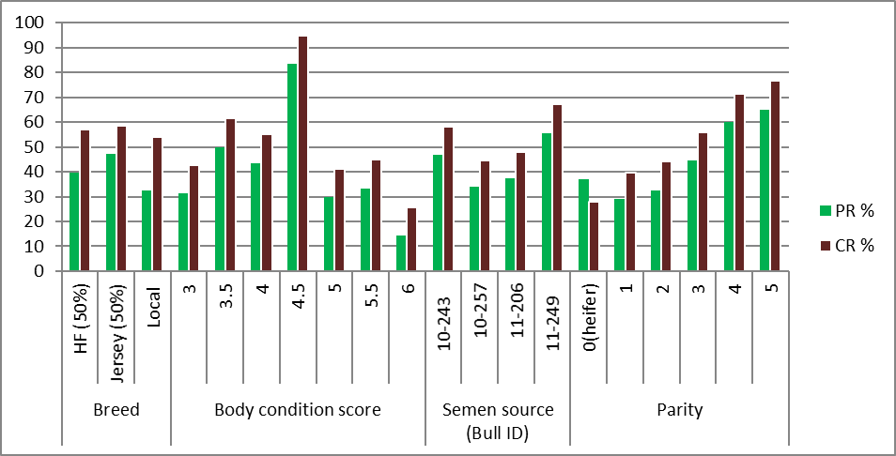
Figure 3: Factors contributing to the success of pregnancy rate (PR%) and conception rate (CR%) through OSMAI under researchers management; CR% = number of cows pregnant / number of cows inseminated * 100; PR% = heat detection rate / conception rate * 100; heat detection rate = number of cows inseminated over 21 days / number of cows eligible to be bred over 21 days * 100.

Status of Reproductive Technology under LFRDO of the Amhara Region
Assisted reproductive dairy technologies in the region
Status and achievement of artificial insemination

In the Amhara region, based on focus group discussions with regional experts, mating of animals was conducted with artificial insemination and bull services with high-grade Holstein Frisian bulls. Bull mating was conducted in milk-shed areas where AI services are not timely accessible and in peri-urban dairy cattle production belts. Based on the regional livestock and fishery resource development office report, the number of cows served by artificial insemination and bull services and their respective calving rates across years are presented in Figure 4. To increase the number of animals coming to heat, the region has continuously distributed hormones for estrus synchronization since 2012, and mating has been performed by either AI or bull mating.
The number of cows inseminated by artificial insemination and bull services has increased over the years, which indicates the increased need for crossbreeding animals and better achievements in the regional livestock sector to increase milk production. However, the calving rate (%) with artificial insemination and bull service was inconsistent, with overall percentages of 44.46% and 44.84%, respectively (Figure 4). The calving rate (%) trend (Figure 4) indicates an inconsistency up to 2016, and then it becomes a consistent and increasing trend, which might be due to the involvement and engagement of livestock experts in the genetic improvement program. Discussions among livestock office experts point out that the lower result of artificial insemination is associated with the poor efficiency of artificial insemination technicians, poor semen handling and administration, poor cow management before and after insemination, and silent heat in zebu cattle. Similarly, Gebremedhin (2005) stated that the success of AI depends on various factors such as the efficiency, capacity, and commitment of AI centers in procedurally and ethically producing, processing, handling, and distributing semen; the commitments and efficiencies of Artificial Insemination Technicians (AITs); presence of appropriate breeding policy along with proper control of indiscriminate crossbreeding; and proper heat detection by farmers.
Based on the data, the number of animals served with mating crossbred bulls increased from 2012 to the present, while there was an inconsistent trend in estrus synchronization and mass artificial insemination throughout the year (Figure 4). It was observed that the average conception rate through bull services was higher than that through artificial insemination services. Although AI has a 41% advantage over natural mating through heat detection and timed AI (Karisch, 2020), the conception rate in bull service was higher, which might be due to the correct heat detection by bulls and a heavier dose of spermatozoa per ejaculation.
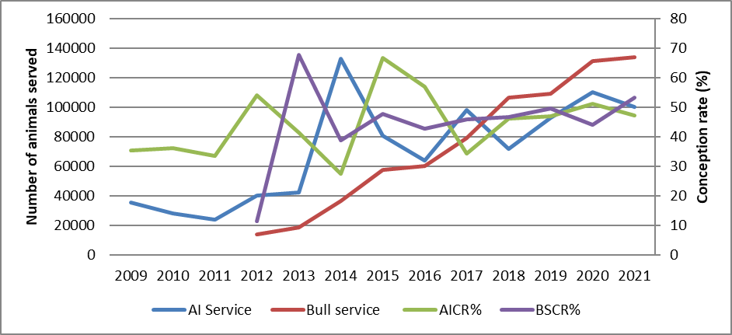
Figure 4: Number of animals served through AI, bull and conception rate through AI (AICR%) and bull (BSCR%); AICR% = number of cows pregnant / number of cows inseminated with AI * 100; BSCR% = number of cows pregnant / number of cows served with bull * 100
Status of oestrus synchronization and mass artificial inseminations (OSMAI)
Oestrus synchronization (OS) in the Amhara region was started in 2012 as a pilot study in four districts with full involvement of researchers in a project-based study. In 2013, pre-scaling up was conducted in six districts, and in 2014, scaling out was conducted in 51 milk-shed areas of the region. At the time, 67852 animals were addressed with OS. However, as the work was conducted in a campaign with the absence of attention as a basic contributing factor for the success of the OSMAI, the result was as low as expected. After gaining experience in these years, LFRDO lowered the number of districts and focused on milk sheds that are well established and suitable for monitoring to implement the technology.
The overall hormonal delivery of OS in the region showed a declining trend (Figure 5), which can be attributed to different reasons. From this, the recurrent war starting from 2018/19 resulted in a low participation of projects that supplied hormones and other material, low level of participation of the agriculture extension experts, lack of budget on which the government’s recurrent budget had shifted to military support, and all directions were towards safeguarding the country rather than working on genetic improvement. In addition, the work has started to be led by experts other than politicians, involvement of research centers and universities, and supporting projects (such as LFSDP, SNV, PAID), probably improving the achievement of OSMAI to increase the number of heifers and productivity per animal.
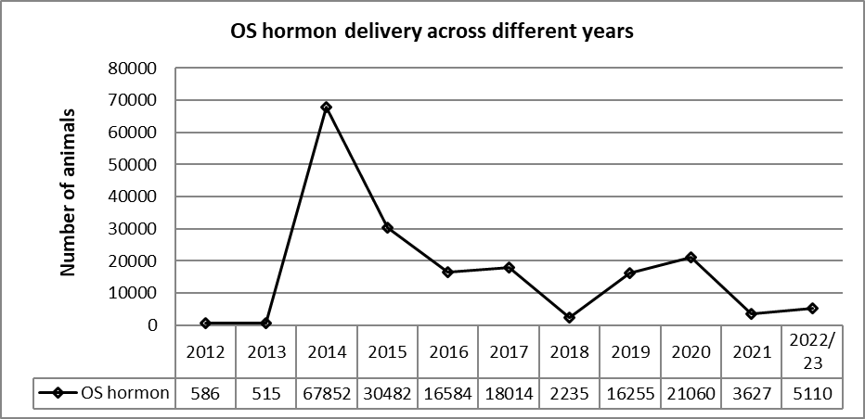
Figure 5: Achievements of OS hormone delivery in the Amhara region across different years
The one-year plan, 2022/23 for OS hormone service across zones of the Amhara region, indicated an improvement in achievements to attain the plan (Figure 6). From the graph, it was observed that West Gojjam and South Gondar are the best achievers of their plan in the half year of 2022/23. In addition, this might be due to these zones being well known for their suitability of dairy cattle (Minale et al., 2023) and have well developed milk cooperatives with a big number of members.
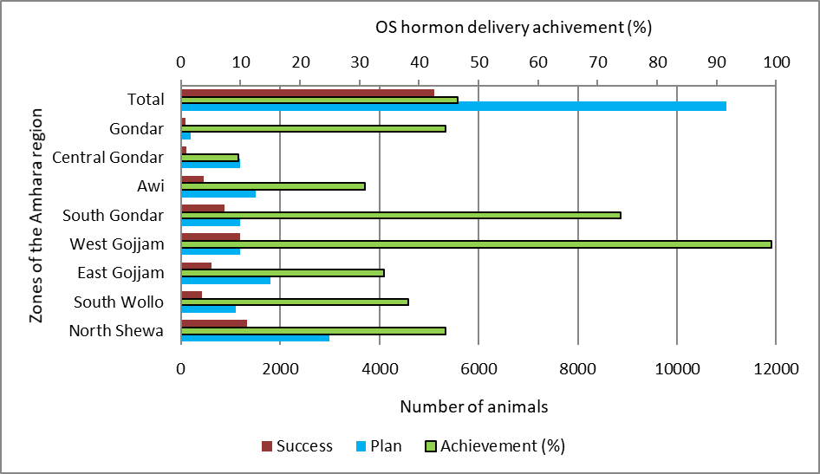
Figure 6: The number of cow/heifer plan to administered OS hormone and success across zones of the Amhara region in 2022/23 under LFSDO; Achievement (%) = success/plan*100
Status and achievement of sexed semen
Sex-sorting of bovine spermatozoa was established through the development of flow cytometric sorting in the late 1980s, with the first live calf born in 1993 (Reese et al., 2021). Sexed semen in the Amhara region was started at the research level in 2014 by researchers from ILRI and Andassa Livestock Research Center, and the success rate was low because the evaluation was conducted in local Fogera cattle and improper handling of inseminated cows on which they were mated with local bulls. Subsequently, AI with sexed semen was started in 2020 under government ranches to produce and distribute in-calf crossbreed heifers to local producers. The strategy was also conducted throughout the country as a YeLemat Turufat project launched by the Prime Minister on November 3, 2022, for four consecutive years (ENA, 2022). The main application of sexed semen is to increase the percentage of heifer calves to expand herds or to sell replacements. In the Amhara region, it was conducted at a subsidized cost (1000 Ethiopian birr (ETB)/straw) with LFSDP and PAID projects in a selected and well-established milkshed area.
In the work done in the 2022 physical year, the overall conception rate (%) of AI with sexed semen was 42.09%, ranging from 19.1% at Chagni ranch and 22.2% in Dangela town to 64% in Kombolcha town and 79% at Bahir Dar town intensive dairy farms. The overall sex efficiency for females of the semen was 94.8%, with lower efficiency in Gondar (71.4%), Debre Tabor (75%), and Kombolch (75%), and 100% female calves were delivered at Chagni ranch, South Achefer district, Debre Markos town, Mekit district, Bahir Dar town, and Dessie town (Table 3). Compared to the potential sex efficiency of sexed semen (90%) (Kumar et al., 2017; Reese et al., 2021; Boneya, 2021) the current findings are comparable to and above the potential average of the technology. The reason for low sex efficiency in the aforementioned districts might be the repeated breeding nature of the cow, in that the producers use conventional unsexed semen for the second time of insemination due to the cost and access of the sexed semen. The conception rate observed in the current study (35.5%) was lower than the reported average of technology, 50-60% (Marques et al., 2018). This might be due to sexed semen being affected during the sorting process, the low number of spermatozoa per straw (5 million VS 20 million in conventional semen), conformation of active heat, inseminator skill, timing of AI, and other factors. Although the producers need and are eager to use the semen, its cost is 5000 Ethiopian Birr (ETB)/straw and is lowered to subsidize through projects to 1000 ETB/straw, and its lowered conception rate and repeated mating limits its wider application.
A meta-analysis done (Reese et al., 2021) of sexed semen indicated that the use of sexed semen reduces pregnancy rates by 23% (25% cows, 21% heifers) and calving rates by 24%. Boneya (2021) also reported that the biggest disadvantage of sex-sorted semen is its decreased conception rate. Similarly, Babura et al. (2021) indicated that the use of sexed semen for embryo development contributed to a higher number of defective embryos compared to conventional unsexed semen on the comparable work done on Boran and HF cross breeds in Bishoftu, Ethiopia. Babura et al. (2021) pointed out that the major problem in low conception rate related to sexed semen was related to proper handling technique and exact site of semen deposition.

Table 3: Performance of female sexed semen, conception rate (%) and sex efficiency (%) in major milkshed towns of the Amhara region in one year (2022).
Location | No of cows inseminated | No of cows conceived | Conception rate (%) | Birth |  |  | Sex efficiency (%)
 |  |  |  | Female | Male | Total | Sex efficiency (%)
Chagni ranch | 241 | 46 | 19.1 | 30 | 0 | 30 | 100
Dangila | 99 | 22 | 22.2 | 16 | 1 | 17 | 94.1
S/Achefer | 96 | 25 | 26.1 | 22 | 0 | 22 | 100
N/Achefer | 90 | 36 | 40 | 36 | 1 | 37 | 97.2
Farta | 217 | 51 | 23.5 | 12 | 2 | 14 | 85.7
Debre Tabor | 29 | 11 | 37.9 | 3 | 1 | 4 | 75
Gonder | 50 | 19 | 38 | 5 | 2 | 7 | 71.4
Anigolela | 25 | 8 | 32 | 8 | 1 | 9 | 88.9
D/Birhan | 25 | 12 | 48 | 7 | 1 | 8 | 87.5
Kombolcha | 50 | 32 | 64 | 9 | 3 | 12 | 75
Debre Markos | 29 | 17 | 58.6
Mekit | 51 | 27 | 52.9 | 5 | 0 | 5 | 100
Bahir Dar | 100 | 79 | 79 | 57 | 0 | 57 | 100
Dessie | 50 | 24 | 48 | 11 | 0 | 11 | 100
Average | 1152 | 409 | 35.5 | 221 | 12 | 233 | 94.8
Note: Conception rate (%) = number of cows conceived / number of cows inseminated × 100; sex efficiency (%) = number of female calves born / total number of calves born × 100

Challenges in OSMAI under livestock extension (LFRDO)

The success of the OSMAI relies on four main pillars (Figure 7), and they have contributed equally to the success, and if there is a deviation in either of the components, the success will vary. According to the discussion with the livestock office genetic improvement experts, these factors at different levels of effect contributed to the success of OSMAI in the region. According to a report from the office, more than 400 certified AITs participate in dairy genetic improvement programs through crossbreeding in the region. Most of them were trained and permanently recruited by the office; some of them were private, while others were operating under milk cooperatives.
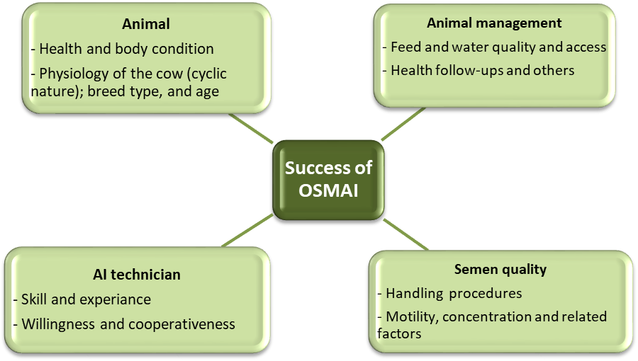
Figure 7: The main pillars contributed for the success of OSMAI

With the presence of these potentials in the region, the effectiveness and wide range of applications of OSMAI have been challenged by various factors. Less structural and functional linkage and communication systems among AI centers and district-level livestock and fishery development offices are the major challenges in establishing proper and structured data collection and reporting systems. The absence of incentives, rewards, and refreshment training for AI technicians coupled with the lengthy working steps of OSMAI (animal selection, identification of active CL, delivering hormone, following the heat, insemination, pregnancy diagnosis test) lowers the willingness of the technicians and also contributes to the disruption of AI delivery during weekends and holidays throughout the region. In addition, the following challenges are discussed:
- Lack and presence of variation between AI technicians in identifying the active corpus luteum before insemination to check the cyclic nature of the animals and detect active heat during insemination.
- Absence of collaboration between required actors, such as research centers, universities, and projects
- Lack of integration with feed, animal health, better environmental conditions/season, and other required inputs
- Pre- and post-cow management after OS hormone delivery and insemination: flushing of cows with the best feed and separating the cow from the bull after hormonal injection and AI for 2 to 3 days is mandatory to avoid losing a crossbreed calf.
- The hormone brings silent heat in indigenous cattle breeds, which requires strong follow-up after hormonal delivery. Some technical and organizational problems associated with the success of OSMAI have been reported (Tegegne et al., 2016).

CONCLUSIONS AND RECOMMENDATIONS

The overall success rate of OSMAI in the region through research and development practitioners’ management is good, but still to improve the success using the available human resources, capacities installed, funding projects, and government direction is mandatory. The performance of liquid nitrogen plants in this region is very low, which is a major threat to future genetic improvement programs. The most important challenges of the OSMAI in the region are the low motivation of technicians, lack of inputs, inadequate liquid nitrogen, low engagement of stakeholders, lack of appropriate collaborations, and absence of a herd recording system. The following recommendations were amended to improve the current level of OSMAI success in this region:
- New semen and liquid nitrogen production and distribution centers should be established to satisfy the demand for livestock keepers.
- Wider awareness creation, proper training, careful animal selection, good animal handling facilities, and a well-trained, willing, and cooperative technician are mandatory.
- The OSMAI, which aims to increase milk yield, should be integrated with different actors in the dairy value chain, such as feed and medication supplies, and around producers with strong dairy cooperatives.
- Strong and accountable collaboration between different actors participating in the OSMAI should be realized.
ACKNOWLEDGMENTS
The authors duly acknowledge the regional livestock and fishery resources office cattle genetic improvement experts and process owners for a detailed discussion and the required data supplementation for this article. The authors extend their gratitude to the Amhara region artificial insemination center and its experts operating at every step from semen processing to dissemination.
AUTHORS’ CONTRIBUTIONS
Assemu Tesfa, Birhan Kassa, and Mengistie Taye were responsible for study design, data collection, analysis, interpretation, and manuscript writing. Ahemed Alkader, Demelash Aychilie, Zemenu Birhan, Tarekegn Demeke, and Mesfin Lakew participated in the raw data collection and preliminary data analysis. All the authors have read and agreed to the published version of the manuscript.
CONFLICTS OF INTEREST
No potential conflict of interest was reported by the author(s).
FUNDING STATMENT
No funding was received.

REFERENCES
Adebabay, K., Getinet, Z., Yeshwas, F., Temesegen, A. & Azage, T. (2013). Prostaglandin (PGF2α) based oestrous synchronization in postpartum local cows and heifers in Bahir Dar milk shed. Int. J. Pharm. Med. Biol. Sci. 2(4):37-43.
Ahmed, S. & Mohammed, A. (2017). Status of Assisted Reproductive Technologies for Genetic Improvement of Dairy Cattle in Ethiopia: Review. International Journal of Livestock Research; Vol 7(7), 1-13. DOI- http://dx.doi.org/10.5455/ijlr.20170521042914
Assemu, T., Dilip, K., Solomon, A. & Getinet, M. (2017). Conservation and Improvement Strategy for Fogera Cattle: A Lesson for Ethiopia Ingenious Cattle Breed Resource. Advances in Agriculture Volume 2017. Article ID 2149452 | https://doi.org/10.1155/2017/2149452.
Azage T., Awete E., Asrat T. & Dirk H., 2012. Technological options and Approaches to improve smallholder access to desirable animal genetic martial for Dairy development: for dairy development: IPMS experience with synchronization and mass insemination. Tropentag, September, 19-21, 2012, Göttingen. WWW.ipms-ethiopia.org
Behnke, R. & Metaferia, F. (2011). The Contribution of Livestock to the Ethiopian Economy – Part II. IGAD LPI Working Paper No. 02 – 11. https://core.ac.uk/download/pdf/132642443.pdf
Belayneh, L., Assemu, T., Eyasu, L., Zelalem, A., Molla, H. & Yeshewas, F. (2022). Evaluation of single-shoot estrus synchronization protocol in selected kebeles of Bahir dar milk-shed, Amhara Region. Progress report at Andassa Livestock Research Center.
Brandsma, W., Mengistu, D., Kassa, B., Yohannes, M. & Jan van der Lee. (2012). The Major Ethiopian Milksheds; Wageningen, Wageningen UR (University & Research Centre) Livestock Research, Livestock Research Report 735, 245 blz. https://edepot.wur.nl/341410
Burrow, H.M., Mrode, R., Mwai, A.O., Coffey, M.P. & Hayes, B.J. (2021). Challenges and Opportunities in Applying Genomic Selection to Ruminants Owned by Smallholder Farmers. Agriculture 2021, 11, 1172. https://doi.org/10.3390/agriculture11111172
CSA (Central Statistical Agency). (2021). Agricultural sample survey. Vol. II. Report on livestock and livestock characteristics. Statistical Bulletin.AddisAbaba, Ethiopia.
CSA (Central Statistical Agency). (2022). Agricultural Sample Survey 2021/22 [2014 E.C.] Volume II, Report on Livestock and Livestock Characteristics. Statistical Bulletin 594; March 2022; Addis Ababa, Ethiopia.
Chencha, C. & Kefyalew, A. (2012). Trends of cattle genetic improvement programs in Ethiopia: Challenges and opportunities. Livestock Research for Rural Development 24 (7) 2012.
Demis, C., Zewudie, T., Aydefruhim, D. & Terefe, W. (2022). On-farm trial of pgf2α based estrus synchronization protocols in selected milk-shed areas of Amhara region. IN: Getnet Zelleke, & Mesfin Lakew (Eds.), 2022. Proceedings of the 14th Annual Regional Conference on Completed Livestock Research Activities May 2021, Volume II, Amhara Agricultural Research Institute, Bahir Dar, Ethiopia.
de Raad, S., Getaw, H., Tadesse, S. & Yohannes, A. (2021). Investment Opportunities in the Ethiopian Dairy Sector. TRAIDE Ethiopia, Embassy of the Kingdom of the Netherlands, TRAIDE Foundation.
Dube-Takaza, T., Shoko, R., Mudziwapasi, R. & Jomane, F. (2021). Animal Breeding Genomic Selection for Improved Animal health: A review of challenges and opportunities in Zimbabwe. Frontiers in Genetics, https://doi.org/10.22541/au.160978760.07531836/v1.
Edea, Z., Bhuiyan, M., Dessie, T., Rothschild, M. F., Dadi, H. & Kim, K. S. (2014). Genome wide genetic diversity, population structure and admixture analysis in African and Asian cattle breeds. Animal (2015), 9:2, pp 218–226. doi:10.1017/S1751731114002560
Eggen, A. (2012). The development and application of genomic selection as a new breeding paradigm. Animal Frontiers, January 2012, Vol. 2, No. 1. doi:10.2527/af.2011-0027
ENA (Ethiopian News Agency). (2022). PM Launches "Yelemat Tirufat" Dev't Campaign that Focuses on Nutritional Opulence. https://www.ena.et/web/eng/w/en_39824.
EARO (Ethiopian Agricultural Research Organization). (2001). Back ground paper on developing animal breeding policy working paper. January, 2001, 21pp.
FAO. (2011). Guideline for the In Vivo Conservation of Animal Genetic Resources. Rome (Draft).
FAO. (2021). Draft Practical Guide on Genomic Characterization of Animal Genetic Resources. Eighteenth Regular Session: 27 September – 1 October 2021. CGRFA-18/21/10.2/Inf.2
FAO. (2013). Tackling climate change through livestock. A global assessment of emissions and mitigation opportunities. Food and Agricultural Organization of the United Nations. Rome, Italy. Retrieved on 14 Oct 2021 from https:// www.fao.org/3/i3437e/i3437e.pdf
Gatew, H., Zewde, T., Kassa, G., Chanyalew, Y. & Gazu, L. (2018). Factors influencing the success of on-farm estrus synchronization of dairy cattle in North Shewa Zone, Amahara Region, Ethiopia. Int. J. Livest. Prod. Vol. 9(1), pp. 9-16, January 2018. DOI: 10.5897/IJLP2017.0408.
Gebremedhin, D. (2005). All in one: A Practical Guide To Dairy Farming. Agri-Service Ethiopia Printing Unit, Addis Ababa. Pp. 15-21.
Gebreyohanes, G., Meseret, S., Raphael, M., Ojango, J., Ekine, C., Tessema, E., Jufare, B., Negussie, E., Lidauer, M., Tera, A., Kahumbu, S. & Mwai, O. A. (2021). Application of ICT tools and genomics technology for the transformation of dairy cattle genetic improvement in Ethiopia: ADGG approaches, experiences, and prospects. Proceedings of the 29th Annual Conference of the ESAP Held at the Sky Light Hotel, Addis Ababa, August 29-31, 2021.
Gizaw, S., Tesfaye, Y., Mekuriaw, Z., Tadesse, M., Hoekstra, D., Gebremedhin, B. & Tegegne, A. (2016). Oestrus synchronization for accelerated delivery of improved dairy genetics in Ethiopia: Results from action research and development interventions. LIVES Working Paper 12. Nairobi, Kenya: International Livestock Research Institute (ILRI).
Haile, A., Ayalew, W., Kebede, N., Dessie, T. & Tegegne, A. (2011). Breeding strategy to improve Ethiopian Boran cattle for meat and milk production. IPMS (Improving Productivity and Market Success) of Ethiopian Farmers Project Working Paper 26, ILRI, Nairobi, Kenya, 2011.
IBC (Institute of Biodiversity Conservation). (2012). Ethiopian National Strategy and Plan of Action for Conservation, Sustainable Use and Development of Animal Genetic Resources: Draft document.
Kadarmideen, H.N. (2014). Genomics to systems biology in animal and veterinary sciences: Progress, lessons and opportunities. Livestock Science 166 (2014) 232–248. http://dx.doi.org/10.1016/j.livsci.2014.04.028
Karisch, B. (2020). Economic Comparisons of Artificial Insemination vs. Natural Mating for Beef Cattle Herds. Mississippi State University. https://extension.msstate.edu/sites/default/files/publications/publications/P2486_web.pdf
Kim, J., Hanotte, O., Mwai, O. A., Dessie, T., Bashir, S., Diallo, B., Kim, K., Kwak, W., Sung, S., Seo, M., Jeong, H., Kwon, T., Taye, M., Song, K. D., Lim, D., Cho, S., Lee, H.J., Oh, S.J., Kemp, S., Lee, H.K. & Kim, H. (2017). The genome landscape of indigenous African cattle. Genome Biology (2017) 18:34; DOI 10.1186/s13059-017-1153-y.
Kim, K., Kwon, T., Dessie, T., Yoo, D., Mwai, O. A., Jang, J., Sung, S., Lee, S., Salim, B., Jung, J., Jeong, H., Tarekegn, G. M., Tijjani, A., Lim, D., Cho, S., Oh, S. J., Lee, H. K., Kim, J., Jeong, C., Kemp, S., Hanotte, O. & Kim, H. (2020). The mosaic genome of indigenous African cattle as a unique genetic resource for African pastoralism. NATURE GENETICS, VOL 52, October 2020, 1099–1110. https://doi.org/10.1038/s41588-020-0694-2.
Marques, M. de O., Morotti, F., Lorenzetti, E., Bizarro-Silva, C. & Seneda, M. M. (2018). Intensified use of TAI and sexed semen on commercial farms. Proceedings of the 32nd Annual Meeting of the Brazilian Embryo Technology Society (SBTE); Florianopólis, SC, Brazil, August 16th to 18th, 2018. DOI: 10.21451/1984-3143-AR2018-0070
Mekonnen, S., Bestha, S. & Banerjee, S. (2021). Assessment of Breeding Practice and Statues of Estrus Synchronization and Mass Insemination Conception Rate of Dairy Cattle in North Shewa Zone, Ethiopia. A paper on Research Square. DOI: https://doi.org/10.21203/rs.3.rs-1091412/v1.
Mekuriaw, G. & Kebede, A. (2015). A review on indigenous cattle genetic resources in Ethiopia: adaptation, status and survival. Online J. Anim. Feed Res., 5(5): 125-137.
Menale, W., Assemu, T., Tewodros, B., Mekonen, T., Demelash, K., Adebabay, K., Addisu, B., Likawent, Y., Beyene, B. & Yeshwas, F. (2022). Suitability mapping of biophysical environment for dairy cattle production in Amhara Region, Ethiopia. IN: Getnet Zelleke, & Mesfin Lakew (Eds.), 2022. Proceedings of the 14th Annual Regional Conference on Completed Livestock Research Activities May 2021, Volume II, Amhara Agricultural Research Institute, Bahir Dar, Ethiopia.
Moges, N., Getu, A., Guadu, T., Bogale, B., Mengistu, A. & Tesfaye, S. (2019). Challenges of dairy production and marketing in urban and peri-urban areas of Amhara region, Ethiopia. Online J. Anim. Feed Res., 9(3): 116-124. www.ojafr.ir
Nuraddis, I., Reta, H. & Abidu, M. (2014). Assessment of Problems Associated with Artificial Insemination Service in Selected Districts of Jimma Zone. Journal of Reproduction and Infertility 5 (2): 37-44
Rege, J.E.O. (1999). The State of African Cattle Genetic Resources I. Classification Framework and Identification of Threatened and Extinct Breeds. International Livestock Research Institute (ILRI), Addis Ababa, Ethiopia, 1999.
Saravanan, K.A., Panigrahi, M., Kumar, H., Parida, S., Bhushan, B., Gaur, G.K., Dutt, T., Mishra, B.P. & Singh, R.K. (2021). Genomic scans for selection signatures revealed candidate genes for adaptation and production traits in a variety of cattle breeds. Genomics 113 (2021) 955–963.
Shapiro, B.I., Gebru, G., Desta, S., Negassa, A., Nigussie, K., Aboset, G. & Mechal, H. (2015). Ethiopia livestock master plan. ILRI Project Report. Nairobi, Kenya: International Livestock Research Institute (ILRI).
Shiferaw, S. (2015). Assessment of breeding practices and evaluation of estrus synchronization and mass artificial insemination techniques in dairy cattle in west West Gojjam zone. MSc thesis, Bahir Dar University College of agriculture and environmental sciences, graduate program, Ethiopia
Smith, J., Wright, I., Grace, D. & Perry, B. (2020). Conclusion: The Future of Research at ILRI. ‘The Impact of the International Livestock Research Institute’. 2020. Edited by John McIntire and Delia Grace. Nairobi, Kenya: ILRI, and Wallingford, UK: CABI.
Strandén, I., Kantanen, J., Lidauer, M.H., Mehtiö, T. & Negussie, E. (2022). Animal board invited review: Genomic-based improvement of cattle in response to climate change. Animal 16 (2022) 100673. https://doi.org/10.1016/j.animal.2022.100673
Taye, M., Lee, W., Caetano-Anolles, K., Dessie, T., Cho, S., Oh, S. J., Lee, H.K. & Kim, H. (2018). Exploring the genomes of East African Indicine cattle breeds reveals signature of selection for tropical environmental adaptation traits. Cogent Food & Agriculture, 4:1, 1552552, DOI: 10.1080/23311932.2018.1552552.
Tegegne, A., Hoekstra, D., Gebremedhin, B. & Gizaw, S. (2016). History and experiences of hormonal oestrus synchronization and mass insemination of cattle for improved genetics in Ethiopia: From science to developmental impact. LIVES Working Paper 16. Nairobi, Kenya: International Livestock Research Institute (ILRI).
Tewodros, A., Wondifraw, M., Guadie, M. & Zewdu, A. (2015). Study on the Conception Rate of Dairy Cows Artificially Inseminated During Natural Heat and by Synchronization in FogeraWoreda, North-West of Ethiopia. African Journal of Basic and Applied Science, 7(5), 291-297.
Xu, L., Yang, L., Zhu, B., Zhang, W., Wang, Z., Chen, Y., Zhang, L., Huijiang, Gao, Liu, G. E. & Li, J. (2019). Genome-wide scan reveals genetic divergence and diverse adaptive selection in Chinese local cattle. BMC Genomics (2019) 20:494. https://doi.org/10.1186/s12864-019-5822-y.
Yadav, V., Singh, N.P., Sharma, S., Lakhani, N., Bhimte, A., Khare, A. & Yousuf, S. (2018). Genomic selection and its application in livestock improvement. Journal of Entomology and Zoology Studies 2018; 6(3): 1838-1844.
Yeshimebet, C., Tesfaye, Z., Hulunim, G., Lina, G., Getachew, K., Chekol, D., Amare, B., Ayele, A. & Yishak, T. (2017). Evaluation of Two Estrus Synchronization Protocols in Dairy Cattle at North Shoa Zone, Ethiopia. Animal Production, 19(2): 93-100.
Yirsaw, D.M. (2021). Genome-Wide Signature of Positive Selection, Breed-specific SNPs and Linkage Disequilibrium in Ethiopian Indigenous and European Beef Cattle Breeds. MSc Thesis; Addis Ababa University, Addis Ababa, Ethiopia. Pp 111.
Zerabruk, M., Bennewitz, J., Kantanen, J., Olsaker, I. & Vangen, O. (2007). Analysis of genetic diversity and conservation priorities for six north Ethiopian cattle breeds. J. Anim. Breed. Genet. 124 (2007) 236–241.

