**Assessment of the current status of area enclosures and their livelihood contribution in Wag-Lasta areas**

Yekoye Alene1*, Abebe Shumie1, Birhan Worie1, Haymanot Lamesgin, Minale Wondie3, Beyene Belay4, Silesh Asmare1, Girma Nigusie1, Adino Ababu1, Mubarek Eshetie2

1Sekota Dryland Agricultural Research Center, Sekota, Ethiopia;

2 Gondar Agricultural Research Center, Gondar, Ethiopia

3 Amhara Agricultural Research Institute, Bahir Dar, Ethiopia

4 Bahir Dar University, Collage of agriculture, P.O.Box 79, Bahir Dar, Ethiopia  
* Correspondending author’s email: yakoyea@gmail.com

***Abstract***

*Several studies have shown that keeping watersheds free from animal contact can not only restore degraded areas but also provide benefits to local communities. This survey aims to identify the changes that the barren areas have shown after they are protected, the benefits they are giving to the farmers, and the current constraints of the area enclosure in Wag-Lasta area. Simple random sampling method was conducted to select respondents. A total of 180 farmers were participated who benefited from area enclosure. The data were analyzed by descriptive statistics using SPSS tool version 26. According to the result, the majority of the respondents (76%) said area enclosure were effective, and among them, 51% replied that area enclosure were beneficial for soil erosion control, the development of water sources, the conservation of natural resources (soil, water, trees, and shrubs), and the rehabilitation of degraded lands (trees and shrub regeneration). The results also showed farmers gained benefits from area enclosure such as a source of animal fodder (45%), a source of fuelwood (23.3%), beneficial for bee pollen sources (17.2%), and reducing soil erosion (14.4%). Farmers also gained on average 40102.3ETB and 1018.18ETB from selling grass and fuelwood respectively after closing areas.* *Even if the above benefits were gained from area enclosure, free grazing (58%); flooding (22%); and illegal cuttings (20%) were the main constraints for the success of area enclosure. In order to avoid such burdens on area enclosure, it is important to provide new technologies related to sources of fuelwood and animal fodder as well as maintaining SWCs and strength SWCs by biological methods through tree planting.*

***Key word****: area enclosure, agro-ecology, constraints, participation, socio-economic importance*

Introduction

Land degradation is defined as a negative trendin land condition caused by direct or indirect human-induced processes, including anthropogenic climate change, expressed as a long-term reduction or loss of at least one of the following: biologicalproductivity, ecological integrity, or value to humans (Berry, 2003)*.* It is widespread and a serious threat, affecting the livelihoods of 1.5 billion people worldwide, of whom one-sixth resides in dry lands (Yirdaw et al., 2017). Globally, it is estimated that 10–20% of dry lands are already degraded, and about 12 million ha are degraded each year (Yirdaw et al., 2017). It also comprises the loss of biological and water-related goods and services, as well as land-related social and economic goods and services (FAO, 2015).

In Ethiopia, land degradation affects all provinces of the social, economic, and political lives of the people (Aune et al., 2001). It is also a driver of climate change through the emission of greenhouse gases and reduced rates of carbon uptake. Due to the fact that more than 85% of the Ethiopian economy is dependent on agriculture, land degradation is seriously affecting the productivity of the economy (food insecurity, poverty, and low agricultural productivity) (Gupta, 2019; Atef, 2014). People in degraded areas who directly depend onnatural resources for subsistence, food security, and income, including women and youth with limited adaptation options, are especially vulnerable to land degradation and climate change (Lamb and Gilmour, 2003). The main reason for land degradation is deforestation, which is a severe problem and has a long history in Ethiopia, especially in the central and northern highlands, where subsistence farming and settlements have been changing landscapes for millennia (Lemenih and Kassa, 2014). It has also had an effect on biodiversity, ecosystem services, soil erosion, and climate change in Ethiopia (Gedefaw and Soromessa, 2015). According to Bishaw (2001), forest land degradation in Ethiopia is caused by the expansion of agriculture, repeated cultivation, removal of residuals and dung, single cropping rather than intercropping, extraction of wood, expansion of infrastructure, rainfall variability, increasing rate of population growth, deforestation activities, soil and water erosion, loss of biodiversity, low technology, inadequate extension services, political unrest and civil wars, and a lack of awareness and consciousness. Berry (2003) also pointed out that poor infrastructure, poor markets, low levels of technology, low levels of investment in agriculture, sensible growth in population, and dissipating woodland for agricultural activities are the factors that contribute to land and forest land degradation in Ethiopia. This means deforestation that leads to soil erosion is a major problem in the region, with the land estimated to be eroding at very rapid rates of 16–50 t/ha per year (Lakew et al., 2000). About 20 thousand hectares of forest are harvested annually in the Amhara Region for fuel wood, logging, and construction purposes. Since harvested trees are not replaced and, thus, expose the soil, about 1.9–3.5 billion tons of fertile topsoil is washed away annually into rivers and lakes due to deforestation alone (Lakew et al., 2000). Accordingly, allowing farmers from the scratch up to the final of rehabilitation works enables them to enhance a sense of ownership for common property and hence the success of enclosures (Mengistu et al., 2005). In many parts of eastern Amhara, most of the hillside and previous forest areas are degraded and characterized by severe forest degradation and soil erosion. Some studies were carried out on tree and shrub species selection for rehabilitation of degraded land in north-eastern Ethiopia (Kasaye et al., 2020). Combating land degradation, controlling soil erosion, and restoring degraded land is an urgent priority to protect the biodiversity and ecosystem services vital to all life on Earth and to ensure human well-being (Peterson et al., 2018). Recently, Ethiopia has begun taking measures to rehabilitate degraded forests and forest lands using area enclosures (Lemenih and Kassa, 2014). According to Bazezew and Belay (2020), reducing land degradation to maximize vegetation cover, replace nutrients removed, and construct structures like terraces, bunds, vegetation strips, afforestation, reforestation, terracing, and traditional soil conservation are among the coping strategies for land degradation and the practice of area enclosures.

Area enclosure is highly practiced in Ethiopia, which contributes to the rehabilitation of degraded areas within a short period of time through the application of aided and natural regeneration methods (Wondie et al., 2016). Area enclosures lead to restoration of natural resources such as soil fertility, vegetation biomass and composition, fauna, and water storage; however, this is not supported by studies (Mekuria et al. 2007). This author also reported that area enclosures are not only effective in restoring vegetation, but also in improving soil nutrient status and reducing erosion. Beyond rehabilitating degraded lands and regulating ecosystem service, area enclosures also have socio-economic benefits to the livelihoods of the community by providing animal feed, bee fodder, fuelwood, and other non-timber forest products (Mulugeta and Achenef, 2015; Mekuria et al., 2011). In addition, Kasim et al. (2015) indicated that area enclosure contribute direct and indirect benefits, i.e., to the rehabilitation of degraded areas in a relatively short period of time, while contributing to the improved livelihoods of the local community by providing animal fodder, bee forage, and fuelwood sources. Successful strategies for rehabilitating degraded areas must be based on the needs and priorities of stakeholders and the associated costs and benefits (Knowles, 2001). More rarely, forest rehabilitation projects involve planting a diversity of forest species with the objective of re-creating to a greater or lesser extent the forest ecosystem believed to have formerly occupied the landscape (FAO, 2015). Area enclosures have a positive impact on the livelihood of the farmers, which provides fodder, construction materials, and income from cattle rearing and the sale of wood (Lemenih and Kassa, 2014). The assessment of the rehabilitation status of closed areas through formal and informal surveys is important to identify the gaps and determine the success of the rehabilitation of degraded areas. Therefore, this study was conducted to assess: **(a)** the existing condition of area enclosures for rehabilitation of degraded areas; **(b)** the existing benefits of area enclosures for farmers; and **(c)** the constraints that influence the effectiveness of area enclosures.

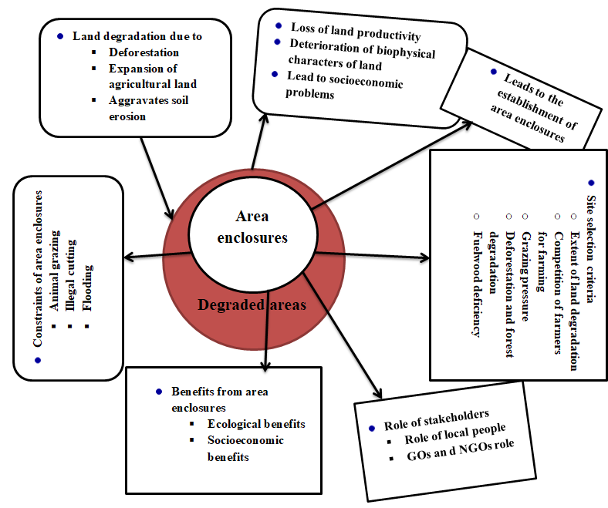

Figure 1: Conceptual framework of the study (own work)

Materials and Methods  
**Description of the study area**

The study was conducted in Waghimra and North Wollo Zones in three agro-ecologies (lowland, mid-altitude, and highland) of Amhara Region (Figure 2). It is located between 12°15′ North latitude and 39°17′34'' East longitude. Waghimra is an administrative zone in eastern Amhara, having seven districts, namely Sekota, Dehana, Gazgibla, Ziquala, Abergelle, Sehala, and Tsagibiji, and is north of Addis Ababa and 540 km northeast of the regional state capital, Bahir Dar. Lasta District is one of the administrative districts in North Wollo Zone, which is geographically located between 1235′31″ N latitude and 3904′30″ E longitude (Figure 2 and Table 1). Sekota Town, the capital of the zone, is 720 km away.

|  |
| --- |
| C:\Users\hp\Downloads\Water shade map.jpg |

Figure 2: Map of the study area

**Sampling Procedure and Data Collection**

A reconnaissance survey was conducted to get an overview of the area and specify the study sites. Then, three districts were selected purposively based on agro-ecological difference. The districts were Lasta (highland), Sekota (mid-altitude), and Ziquala (lowland). The criteria for selection were the presence of area enclosure interventions and their accessibility in three agro-ecologies. In every selected district, three representative area enclosures were selected; Abaregay, Awobay, and Genete-Mariam in the highland agro-ecology; Tiya, Hamusit, and Agew Mariam in the mid-altitude; and Tsabsina, Libamswr, and Bilaku in the lowland agro-ecology. The existing status of area enclosures, community role in management and utilization of area enclosure, benefits gained from area enclosures, experience to date, and constraints of area enclosure were assessed using a questionnaire survey and focus group discussions. A semi-structured questionnaire was employed. Respondents were selected randomly from the list of community members directly involved in the management of area enclosure and users of area enclosures. Twenty (20) respondents were selected and interviewed in every watershed; in total, sixty (60) respondents in every agro-ecology. All respondents were engaged in farming. A total of 180 respondents were interviewed in all agro-ecologies. Focus group discussions included individuals from the local administrations, community representatives, and older community members. In the focus group discussions, elders were given a chance to express their views, as they are in a position to compare changes resulting from the use of enclosures with previous open access.

**Data analysis**

The data were categorized into different strata to facilitate analysis. First, variables were identified which are the best indicators for the sustainability of area enclosure. An analysis of selected socioeconomic characteristics related to area enclosure practices provided a basis for evaluation of the system. The attitudes and feelings of community members towards area enclosure, site selection and future expansion, farmers involvement in management of area enclosure and its effectiveness, observed changes and benefits gained from area enclosure, the role of farmers, GOs, and NGOs in management of area enclosure, community feeling on the futurity of area enclosure, and the effectiveness of community bylaws (reflected in the interviews and/or focus group discussions) were used as important indicators of the sustainability of area enclosure. The data were analyzed by descriptive statistics. The questions and questionnaires were coded to fit the statistical package. Finally, the data were analyzed by SPSS tool version 26.

Table 1: Characteristics of the study area

|  |  |  |  |
| --- | --- | --- | --- |
| Attributes | Highland | Mid-altitude | Lowland area |
| Altitude (m.a.sl.) | 2129 to 3600 | 1340 to 2200 | 500 to 1300 |
| Rainfall (mm) | 500 to 1000 | 350 to 700 | 250 to 750 |
| Temperature (0C) | 24.5 | 16 to 27 | 23 to 43 |
| Soil type | Eutric Cambisols (51%) | Umbric Leptosols (52%) | Eutric Leptosols (29%) |
| Agro-ecology | Dega (52.7%) | Woyna-dega (65%) | Dry kolla |
| Topography |  | Chain of mountains, hills and cliffs | Chain of mountains, hills and cliffs |
| Vegetation |  | Bushy woodlands and forest only around churches |  |

Source: Kassaye et al., 2018

**Result and discussion**

**Demographic characteristics of the respondents**

A total of 180 respondents were interviewed in all agro-ecologies. From the total number of respondents, 72.8% were males, and the remaining 27.2% were females (Table 2). Of these respondents, 74.4% (n = 134) were married, while 8.9% (n = 16) were single. The highest number of respondents (55%, n = 99) were in the 36–50 age category. When looking at the educational status of the respondents, only 58% (n = 105) were well-educated. As presented in Table 3, half of the respondents have a farmland size of 0.25–1 ha, followed by 47.8% of the respondents with a farmland size of 1.1–2.5 ha. Only 2% of the respondents have farmland sizes greater than 2.5ha.

Table 2: Demographic characteristics of the respondents

|  |  |  |  |  |  |
| --- | --- | --- | --- | --- | --- |
| Sex of respondent | Frequency | % | Maternal status | Frequency | % |
| Male | 131 | 72.8 | Single | 16 | 8.9 |
| Female | 49 | 27.2 | Married | 134 | 74.4 |
| Divorced | 30 | 16.7 |
| Respondent age |  |  | Educational status |  |  |
| 20-35 | 60 | 33.3 | Read and write | 70 | 38.9 |
| 36-50 | 99 | 55.0 | Literate | 35 | 19.4 |
| >50 | 21 | 11.7 | Illiterate | 75 | 41.7 |

Table 3: Average land holding of the respondents across agro-ecologies

|  |  |  |  |  |  |
| --- | --- | --- | --- | --- | --- |
| Categories | Farmland size | | | | Frequency |
| 0.25-1 ha | 1.1-1.75 ha | 1.76-2.5 ha | > 2.5 ha |
| Lowland | 28 | 25 | 7 | 0 | 60 |
| Mid-altitude | 27 | 27 | 4 | 2 | 60 |
| Highland | 35 | 11 | 12 | 2 | 60 |
| Total | 90 | 63 | 23 | 4 | 180 |

Table 4: Livestock distribution across agro-ecologies

|  |  |  |  |  |  |  |  |  |
| --- | --- | --- | --- | --- | --- | --- | --- | --- |
| Agro-ecology | | Goat | Sheep | Cow | Ox | Calf | Equine | Total |
| Highland | Max | 23 | 14 | 4 | 4 | 3 | 3 |  |
|  | Min | 0 | 0 | 1 | 0 | 0 | 0 |  |
|  | Total | 248 | 572 | 147 | 137 | 99 | 89 | **1292** |
|  | Ave | 4 | 9 | 2 | 2 | 2 | 1 |  |
| Mid-altitude | Max | 48 | 14 | 4 | 3 | 2 | 2 |  |
|  | Min | 0 | 0 | 0 | 0 | 0 | 0 |  |
|  | Total | 1118 | 277 | 101 | 117 | 49 | 49 | **1711** |
|  | Ave | 18 | 4 | 2 | 2 | 1 | 1 |  |
| Lowland | Max | 63 | 8 | 4 | 3 | 3 | 2 |  |
|  | Min | 5 | 0 | 0 | 0 | 0 | 0 |  |
|  | Total | 1801 | 94 | 125 | 105 | 64 | 64 | **2253** |
|  | Ave | 28 | 1 | 2 | 2 | 1 | 1 |  |

Source: sampled survey

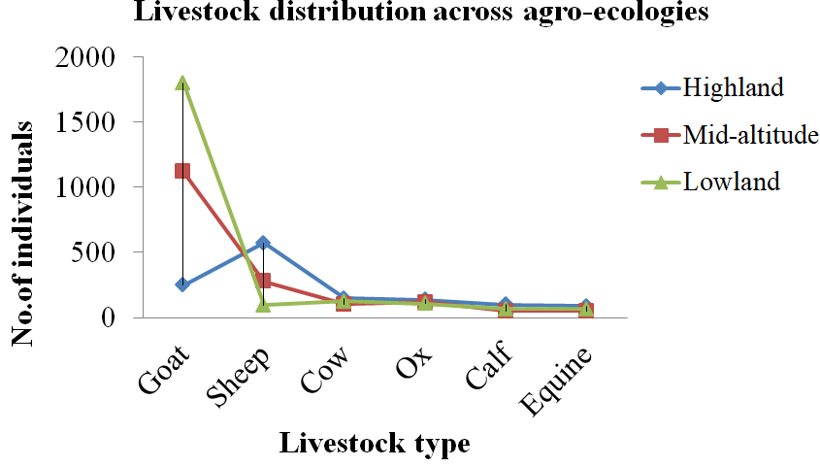

Figure 3: Distribution of livestock across agro-ecologies

**Household members in site selection and maintenance of SWCs**

The vast majority of community members in this study (92%) participated in the on-site selection of enclosures (Figure 4 (a)), and 82% agreed on the selection criteria (Figure 4 (b)). As Kassa (2018) indicated, deforestation and forest degradation risk; grazing pressure; land degradation and soil erosion risk; wood fuel deficiency; water scarcity; food insecurity; and biodiversity hotspots were the prioritization criteria to identify areas for conservation and restoration. The most important (indicated by 68.3% of the respondents) criterion for site selection was the extent of land degradation as evaluated by villagers and development agents, implying that the more an area is degraded, the more likely it is to be enclosed for regeneration. Some of the indicators for assessing the extent of degradation were the past history of the area and sensitivity to soil erosion. Another criterion, following the extent of land degradation, was avoiding competition with other agricultural practices (Table 5). This means farmers adjacent to an area that becomes an area closure expand their farmland as it is communal land.

Table 5: Site selection criteria for area enclosure

|  |  |  |  |  |  |
| --- | --- | --- | --- | --- | --- |
| Participants | What are the selection criteria? | | | | |
| extent of land degradation and soil erosion risk | competition among farmers for farming | grazing pressure | deforestation and forest degradation risk | fuelwood deficiency |
| 180 | 123(68.3%) | 40(22.2%) | 5(2.7%) | 9(5%) | 3(1.6%) |

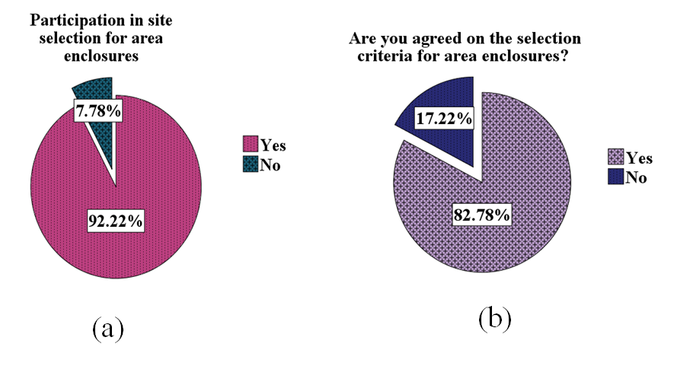

Figure 4: Participation in site selection for area enclosure (a), agreement on selection criteria for area enclosure (b)

From the total respondents, the majority (115, or 63.89%) were (husbands) from household members, followed by wives (22.2%), husbands and wives (9.4%), and husbands and wives with their children (4.4%) those participate in the construction and maintenance of SWCs as presented in Table 6 and Figure 5. When looking at the participation of household members in the construction and maintenance of SWCs across agro-ecologies, the household head (husband) had higher participation in all agro-ecologies. Even if the participation was very low, household heads (husband and wife) constructed and maintained SWCs with their children in mid-altitude and highland agro-ecology, which is the best experience. In all agro-ecologies, only wives had a participation in the maintenance and construction of SWCs, but they participated when their husbands left for other jobs. To ensure the success of area enclosure and the active participation of farmers in all agro-ecologies, awareness creation is needed to involve all household members in every activity in the management of area enclosure, and experience of all household members for their participation in the construction and maintenance of area enclosure in mid-altitude and highland agro-ecologies should be taken at large.

Table 6: Household members in constructing and maintenance of soil and water conservation structures

|  |  |  |  |  |  |  |
| --- | --- | --- | --- | --- | --- | --- |
| Characteristic | Categories | Participation | | | | Frequency |
| Husband | Wife | Husband and wife | Husband, wife and child |
| household members in constructing and maintenance of soil and water conservation structures | Lowland | 42 | 18 | 0 | 0 | 60 |
| Mid-altitude | 34 | 16 | 8 | 2 | 60 |
| Highland | 39 | 6 | 9 | 6 | 60 |
| Total | 115 | 40 | 17 | 8 | 180 |

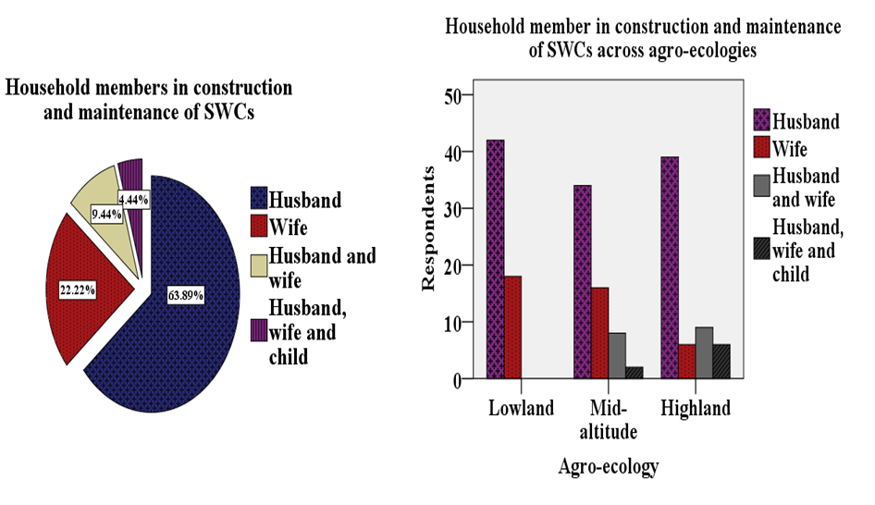

Figure 5: Household members in constructing and maintenance of soil and water conservation structures

**For how long farmers participate in management of area enclosure**

When looking at the participation of the participants in the area enclosure, especially by doing soil and water conservation structures and participating in management of area enclosures, the majority of the respondents, 105 farmers, or 58% of them, have participated for a short period of time, up to 5 years, and only 12% have more than 15 years of participation experience, as presented in Table 7 and Figure 6. When looking at this across agro-ecology, those who have up to 5 years of participation experience have the highest number in all agro-ecologies, while those who are lowest number are those who have 11–15 years of participation experience. Therefore, it is necessary to do a lot of work on them about the benefits they get from area enclosure by making them understand the original identity of the place from the elders, especially about the benefits they used to give and what they lost after it was stripped, in economic, social, and environmental benefits; Noting the current situation of the area after protecting the degraded areas, it is necessary to raise a good understanding of what kind of change was brought about at their age and what the young people are teaching to the next generation. It is also necessary to explain to them about the benefits they are getting and how they can increase this in the future.

Table 7: Years of farmers’ participation in management of area enclosure

|  |  |  |  |  |  |
| --- | --- | --- | --- | --- | --- |
| Categories | years of farmers participation in management of area enclosure | | | | Frequency |
| 1-5 years | 6-10 years | 11-15 years | > 15 years |
| Lowland | 28 | 21 | 4 | 7 | 60 |
| Mid-altitude | 38 | 7 | 4 | 11 | 60 |
| Highland | 39 | 13 | 3 | 5 | 60 |
| Total | 105 | 41 | 11 | 23 | 180 |

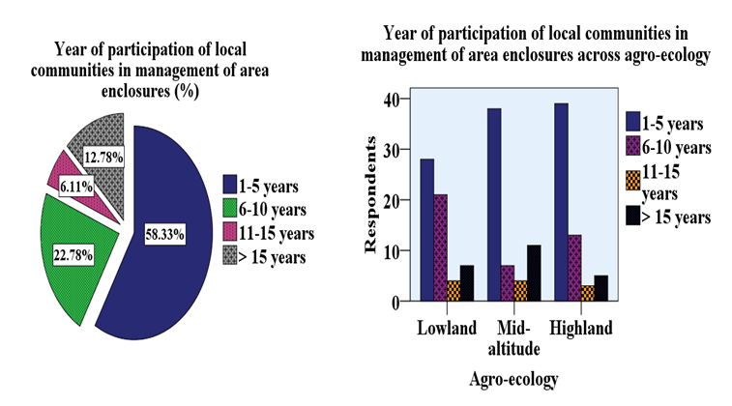

Figure 6: Experience of local people participation in area enclosure management

**Involvement of local people in area enclosure**

In terms of properly managing area enclosure, 84% (n = 151) of them confirmed they actively participate in area enclosure, and among them, 74% (n = 134) mainly participate in amending and approving bylaws, and the remaining 25.6% (n = 46) were involved in amendment of bylaws and auditing as presented in Table 8. When looking at the participation of farmers across agro-ecologies, in highland (68%, n = 41), mid-altitude (80%, n = 48), and lowland (75%, n = 45), they participate in amending and approving the bylaws (Table 8 and Figure 7). To ensure the long-term effectiveness of the area enclosures, farmers, governmental and non-governmental organizations participated in the construction and maintenance of soil and water conservation structures and strengthened the physical structures through biological measures.

Table 8: Involvement of respondents in management of area enclosure across agro-ecologies

|  |  |  |  |  |  |  |
| --- | --- | --- | --- | --- | --- | --- |
| Characteristic | Categories | Participation | | | Frequency | |
| Yes | | No |
| Active involvement of respondents in management of area enclosure | Lowland | 50 | | 10 | 60 | |
| Mid-altitude | 54 | | 6 | 60 | |
| Highland | 47 | | 13 | 60 | |
| Total | 151 | | 29 | 180 | |
| In what you actively involved? |  | Categories | | | | |
| Variables | Highland (n=60) | Mid-altitude (n=60) | | | Lowland (n=60) |
| Amendment of bylaws | 41 | 48 | | | 45 |
| Amendment of bylaws, auditing | 19 | 12 | | | 15 |

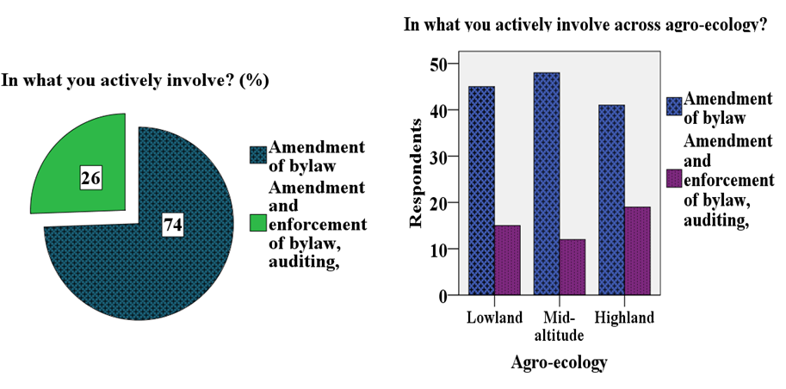

Figure 7: Involvement of farmers in area enclosure

**Role of stakeholders in management of area enclosure**

**Role of local people**

Local communities have a vital role in the effectiveness and management of area enclosure. They were involved in maintaining and constructing soil and water conservation structures and planting seedlings to enrich degraded areas after closing. Among the participating farmers, 40% (n = 72) performed their roles by constructing soil and water conservation structures and strengthening the physical work through biological methods (Table 9 and Figure 8). The remaining’s were involved in the construction and maintenance of soil and water conservation structures (35%, n = 63) and enrichment planting (25%, n = 45). Of the participating farmers, the majority (92%) were involved in site selection for area enclosure (Figure 8 (a)). Similarly, Mengistu et al. (2004) reported that a vast majority of community members participated in enclosures. When looking across agro-ecologies, the majority of the respondents (56.6%, n = 34) were involved only in soil and water conservation works in lowland agro-ecology. It seems that the benefits of grasses have been a significant factor in influencing farmers’ attitudes and active involvement in area enclosure. This was supported by Mengistu et al. (2004), who found that the availability of grasses for thatching after enclosure was attractive to local people in financial terms. In order to ensure the effectiveness of area enclosure, it is better to enrich an area through seedling planting, mainly in lowland areas where most area enclosure users’ lack seedling planting. Planting seedlings in area enclosure has a great role in enriching the area, in addition to the plant species that grow in the area. When looking at the experience of planting seedlings in area enclosure, they have better experience of planting seedlings in mid-altitude and highland agro-ecology, while they have no experience planting in the lowlands. Although they do not have the experience of planting seedlings in area enclosure in the lowlands, from the point of view of righteousness, it is very low in those who have the experience of planting in the mid-altitude and highlands as observed in the field. To solve this problem, since the areas are mostly dryland areas, bring in plant species and new technologies that can withstand this harsh environment and create awareness for users to have the experience of planting seedlings in area enclosure, especially for the communities living in the lowland agro-ecology that have no planting experience in area enclosure, and seedling planting should be practiced.

**GOs and NGOs in management of area enclosure**

In addition, GOs and NGOs have a role in supporting the users of area enclosure by providing training and follow-up, providing materials for the maintenance and construction of SWCs, and financing them in kind. Among the participating farmers, 43% of them confirmed that government organizations especially the Bureau of Agriculture provided training. They stated that government organizations are involved in providing materials for maintenance and construction of soil and water conservation measures, monitoring, and supporting them with help (work for food). From the participating farmers (42.5%, n = 77) confirmed that GO's were involved in support by training and follow-up, providing materials for soil and water conservation works, and financing in kind. When looking across agro-ecologies, (41.6%, n = 25) farmers replied that GOs provide materials for constructing and maintaining SWCs and financing them in kind in lowland agro-ecology (Table 9 and Figure 8). From the participating farmers (35%, n = 21) and (58.3%, n = 35) in mid-altitude and highland agro-ecologies respectively reported that GOs support farmers by training on how to construct SWCs, providing materials for SWCs, and providing financing in kind. When looking at the role of NGOs, among the participating farmers, 42.2% (n = 76) of them replied that NGOs support them by providing materials for constructing SWCs and financing them in kind. The majority of farmers who participated in all agro-ecologies lowland (36.6%, n = 22), mid-altitude (50%, n = 30), and highland (40%, n = 24) replied that NGOs support them by providing materials for constructing SWCs and financing in kind.

Table 9: Role of local people and GOs and NGOs in management of area enclosure

|  |  |  |  |  |
| --- | --- | --- | --- | --- |
| Stakeholders  Role of local people | Response | Highland  (n=60) | Mid-altitude  (n=60) | Lowland  (n=60) |
| Constructing & maintenance of SWCs | 9 | 20 | 34 |
| Seedling planting | 24 | 6 | 15 |
| Both | 27 | 34 | 11 |
| Government role | Support by training & follow up | 20 | 6 | 9 |
| Providing materials and financing in kind | 17 | 13 | 25 |
| Both (support by training and follow up, and provide materials and financing) | 21 | 35 | 21 |
| Don't know about GO's role | 2 | 6 | 5 |
| Role of NGOs | Support by training and follow up | 16 | 17 | 27 |
| Providing materials and financing in kind | 24 | 30 | 22 |
| Both (support by training and follow up, and provide materials and financing) | 15 | 13 | 11 |
| Don't know about NGO's role | 5 | 0 | 0 |

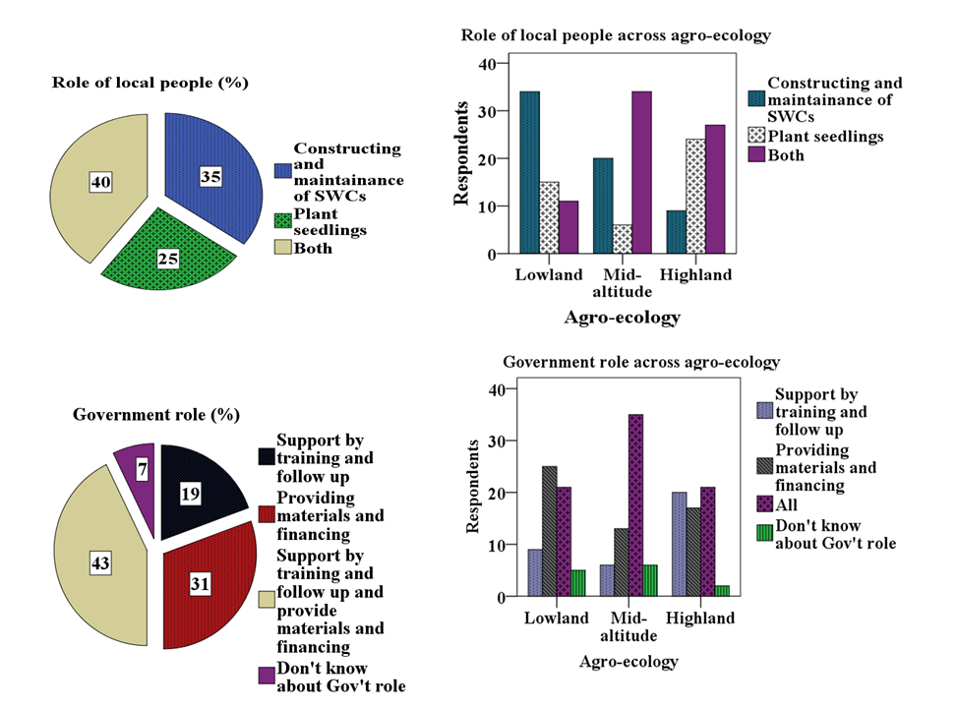

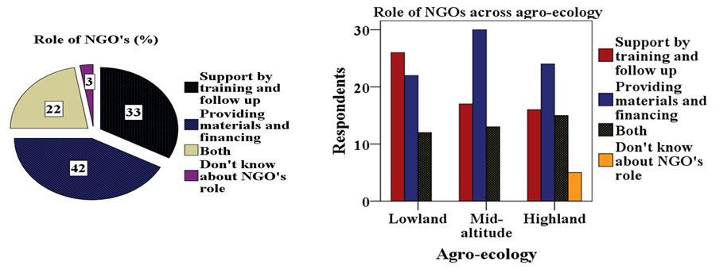

Figure 8: Role of local people, GOs and NGOs in area enclosure

**Observed changes in area enclosure and their effectiveness in rehabilitation of degraded lands**

Area enclosures are among the rehabilitation mechanisms mostly practiced in their locality to return degraded lands and improve agricultural productivity as well (Asmamaw and Argaw, 2015). From the participating farmers, most respondents (51%, n = 91) reported that they have observed rehabilitation of degraded lands, mainly sprouting of plants that did not exist, conservation of natural resources (soil, water, trees, and shrubs), soil erosion control, and water source development from area enclosure in all agro-ecologies (Table 10 and Figure 9). The majorities of respondents are optimistic about the performance of enclosures and reported that enclosures are effective in rehabilitating degraded lands; hence, they support vegetation growth on degraded lands. This was in line with the findings of Mengistu et al., (2004) and (2005) who reported above-ground woody species composition increased by half in area enclosures compared to adjacent free-access lands, and woody species were substantially richer in enclosures than in open areas, indicating the importance of enclosures for the conservation of biological diversity. Establishing area enclosures is one of the cheapest and most convenient methods employed to restore, manage, and conserve woody species in degraded areas (Birhane et al., 2006, 2007), and in Ethiopia, the number of woody species found in enclosures is higher than the adjacent open grazing lands (Yayneshet, 2011; Kasim et al., 2015; Manaye, 2017). Elders who know the protected areas well and who were in the survey said that the area was previously a wild fruit feeding place for shepherds, which was a habitat for various wild animals covered with various tree species. Then, when the population was increasing, they were able to destroy the forest, which was especially greedy for agriculture and various household materials, for the fence, and for fuelwood sources. At present, after the place has been free from animal contact, it has recovered to some extent, although it cannot return to its original state. The remaining tree species are protected; extinct tree species have regrown, reducing soil erosion. Similarly, Mulugeta and Achenef (2015) reported that the majority of the respondent farmers agreed that the changes in the vegetation coverage of area enclosure had increased after the practice of area enclosure, mainly shrubs and trees. Regeneration of trees and grasses, woodland conservation, and a reduction of soil erosion were considered the major positive changes observed after the establishment of area enclosure (Kasim et al., 2015), and similar findings were reported by Birhane et al. (2006).

Table 10: Biophysical changes in area enclosure at different agro-ecologies

|  |  |  |  |  |
| --- | --- | --- | --- | --- |
| Characteristic | Variables | Categories | | |
|  |  | Highland  (n=60) | Mid-altitude  (n=60) | Lowland  (n=60) |
| What kind of changes you observe from the area enclosure? | Rehabilitation of degraded land (trees and shrub regeneration) | 19 | 1 | 2 |
| Conservation of soil, water, trees and shrubs | 11 | 3 | 10 |
| Water source development | 5 | 4 | 22 |
| Soil erosion control | 2 | 8 | 1 |
| All | 23 | 44 | 25 |

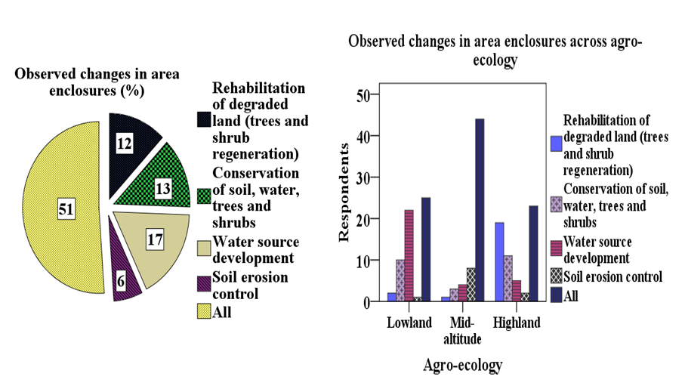

Figure 9: Observed changes in area enclosure

**Effectiveness of area enclosures in restoring degraded areas**

As presented in Table 11 and Figure 10 , most of the farmers who participated in this study (82.7%, n = 149) confirmed that area enclosure have a typical role in restoring abandoned areas, and this was similar to the findings of Mengistu et al. (2004) who stated that above-ground woody species composition increased by half. In addition, Mengistu et al. (2004) in central and northern Ethiopia confirmed that the diversity of all plant species was greater in the area enclosure compared to adjacent bare land. There also observed that land cover improved appreciably and gullies disappeared, as a biophysical comparison of area enclosure and adjacent free-access lands showed. When looking at the participation of farmers across agro-ecologies, most of them confirmed that area enclosure are the best solutions to restore degraded areas, closed from animal contact so that most of the deprived areas can be restored.

Table 11: Effectiveness of area enclosure in rehabilitation of degraded lands across agro-ecologies

|  |  |  |  |  |
| --- | --- | --- | --- | --- |
| Characteristics | Categories | Participants | | Frequency |
| Yes | No |
| Area closure effectiveness | Lowland | 44 | 16 | 60 |
| Mid-altitude | 50 | 10 | 60 |
| Highland | 55 | 5 | 60 |
| Total |  | 149 | 31 | 180 |

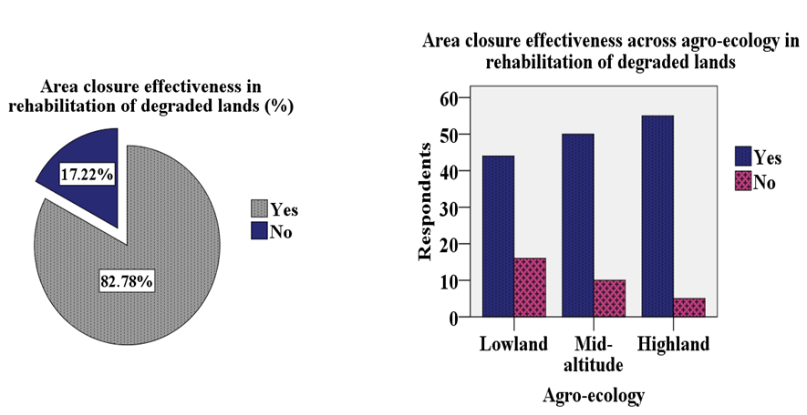

Figure 10: Effectiveness of area enclosure in rehabilitation of degraded lands

**Benefits gained from area enclosure for farmers**

Among the benefits that farmers get from area enclosures are as a source of fodder for animals (45%, n = 81) and as a source of fuelwood from dried wood (23.3%, n = 42). They reported that they have great benefits beekeepers (17.2%, n = 31) and by reducing soil erosion, especially by protecting farmers' land at the bottom of the area enclosure from flooding (14.4%, n = 26). Similarly, Mengistu et al. (2004) reported that the rehabilitation of deforested lands provides economic benefits by supplying raw materials to meet the local demand for wood, reducing the pressure on the remaining forests, and supplying various non-timber products. Beyond rehabilitating degraded lands and regulating ecosystem service, enclosure also has socio-economic benefits to the livelihoods of the community by providing animal feed, bee fodder, fuelwood, and other non-timber forest products (Mulugeta and Achenef, 2015; Mekuria et al., 2011). In addition, Kasim et al. (2015) indicated that area enclosure contribute direct and indirect benefits, i.e., to the rehabilitation of degraded areas in a relatively short period of time, while contributing to the improved livelihoods of the local community by providing animal fodder, bee forage, and fuelwood sources. When looking at the benefits of area enclosure in terms of agro-ecology (Table 12 and Figure 11), most of them (55%, n = 33) are used as a source of animal fodder, followed by soil erosion control (21.6%, n = 13), and a source of fuelwood (20%, n = 12) in mid-altitude; a source of animal fodder (55%, n = 33), followed by a source of bee forage (20%, n = 12) in the highland; while in lowland agro-ecology (36.6%, n = 22), farmers used area enclosure as a fuelwood source, followed by a source of bee pollen (28.3%, n = 17), and a source of animal fodder (25%, n = 15).

Table 12: Benefits of area enclosure across agro-ecologies

|  |  |  |  |  |  |  |
| --- | --- | --- | --- | --- | --- | --- |
| Categories | | What benefits you gain from area enclosure? | | | | Frequency |
| Source of animal fodder | Source of bee forage | Soil erosion control | Source of fuelwood |
| Agro-ecology | Lowland | 15 | 17 | 6 | 22 | 60 |
| Mid-altitude | 33 | 2 | 13 | 12 | 60 |
| Highland | 33 | 12 | 7 | 8 | 60 |
| Total | | 81 | 31 | 26 | 42 | 180 |

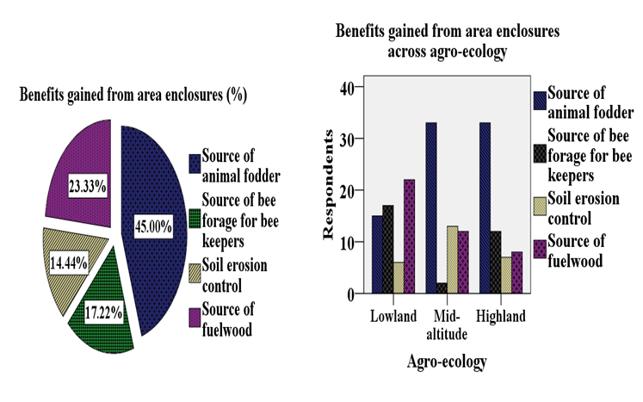

Figure 11: Benefits gained from area enclosure

The result from focus group discussion and key informant interview showed that the availability of grasses for their livestock and source of fuelwood after enclosure attractive in financial terms, as local people previously had to purchase grass from other areas at considerable expense and shortage of fuelwood. On average, a household share of grass sells for 4102.3 ETB (Std. = 460.7ETB) and 1018.18ETB (Std. = 203.86 ETB from fuelwood sell as Std. being the standard deviation from average annual income (Table 13). This has helped increase annual household income for those who are entitled the right to use. It seems that the benefits of grasses have been a significant factor in influencing farmers’ opinions.

Table 13: Contribution of area enclosures on local people livelihood

|  |  |  |  |  |  |  |  |
| --- | --- | --- | --- | --- | --- | --- | --- |
| Amount of grass obtained from area enclosures(tone) | | | | | | | |
| Respondents | Total | | Mean | Std. | Min | Max | Range |
| 7.2 | | .33 | .04 | .3 | .4 | .1 |
|  | | Income from grass sell (ETB) | | | | | |
| 90250 | | 4102.3 | 460.7 | 3500 | 5000 | 1500 |
| 22 | | Fuelwood amount obtained from area enclosure (tone) | | | | | |
| 16.8 | | .76 | .15 | .6 | .9 | .3 |
|  | | Income from fuelwood sell (ETB) | | | | | |
|  | 22400 | | 1018.18 | 203.86 | 800 | 1200 | 400 |

**Attitude of farmers towards area enclosure**

Among the participating farmers, 93% felt positively about the area enclosure (Table 14 and Figure 12). A similar report was made by Asmamaw and Argaw (2015), who reported that local farmers perceived enclosures positively in their effectiveness for land management options that promote surface cover and mitigate soil degradation. Mengistu et al. (2004) also reported a positive attitude from the majority of the people about enclosures and feel that they have benefited from area enclosure as most of the farmers depend on animal husbandry due to the decrease in land productivity. In addition, there was strong support from the majority of the respondents for the establishment of area enclosure (Demissie et al., 2019), and good participation and trust from local communities for area enclosure mainly in highland and mid-altitude areas in northern Ethiopia (Kassaye et al., 2022). Besides, Manaye (2017) and Mulugeta & Achenef (2015) reported local communities have a positive attitude towards the establishment of area enclosures in the degraded lands in the northern and central rift valley of Ethiopia. A similar result was reported by Kasim et al. (2015) the majority of the respondents had positive attitudes and perceptions towards the conservation of woodland through area enclosure in their locality, which could indicate that there was a strong local people's commitment to combating land degradation. When looking at across agro-ecologies, except in the highland, all respondents perceived area enclosures positively in lowland and mid-altitude agro-ecologies. The majority of the participating farmers (60%, n = 108) worried about the futurity of area enclosure. Across agro-ecologies, the majority of farmers worried about area enclosure future in lowland and mid-altitude agro-ecologies, but in highland agro-ecologies, they were not worried. This is due to a decrease in land productivity that led farmers to depend on animal husbandry, which in turn increased the burden of area enclosure and made them highly dependent on area enclosure for fuelwood sources, mainly in lowland and mid-altitude agro-ecologies, while in highland agro-ecologies, farmers have planted tree species around their homesteads for live-fence and fuelwood consumption. This indicates a participatory resource management strategy is important to ensure the sustainability of the enclosures, especially from the start of the practice.

Table 14: Attitude of farmers about area enclosure futurity

|  |  |  |  |  |
| --- | --- | --- | --- | --- |
| Variables | Response | Categories | | |
| Highland (n=60) | Mid-altitude (n=60) | Lowland (n=60) |
| Farmers attitude about area enclosure | Positive | 48 | 60 | 60 |
|  | Negative | 12 | 0 | 0 |
| Are you worried about the future of area enclosure? | Response | Highland  (n=60) | Mid-altitude  (n=60) | Lowland  (n=60) |
| Yes | 21 | 36 | 51 |
| No | 39 | 24 | 9 |
| Total | | 108 | 72 | 180 |

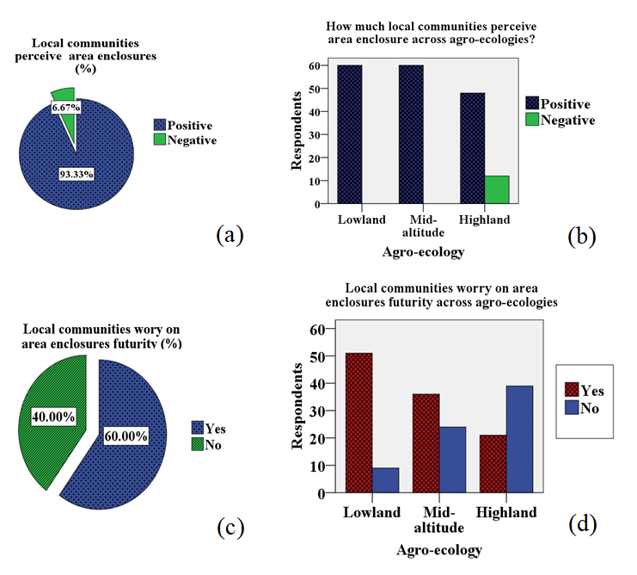

Figure 12: Local communities’ attitude and their worry on area enclosure

When looking the attitude of respondents in relation to their sex regarding the practice of area enclosure, women accept area enclosure more easily than men, as it appears that women aspire to relief from the burden of collecting wood for daily household consumption (Figure 13). This was in line with the findings of Mengistu et al. (2005). Conversely, the relationship between age and attitudes about future expansion of area enclosure revealed that the young (20–35 years old) in the community were least interested in expansion which is similar report with Mengistu et al. (2005); rather, they do not have land, and so instead of expanding area enclosure, they want the remaining areas to be distributed to each of them, while almost all elders want the expansion of watersheds, especially because they want places to return to their former state.

Table 15: Local people acceptance on future expansion of area enclosure

|  |  |  |  |  |
| --- | --- | --- | --- | --- |
| Categories | | Would you accept the future expansion of area enclosure? | | Frequency |
| Yes | No |
| Respondent age | 20-35 | 0 | 60 | 60 |
| 36-50 | 72 | 27 | 99 |
| > 50 | 20 | 1 | 21 |
| Total | | 92 | 88 | 180 |

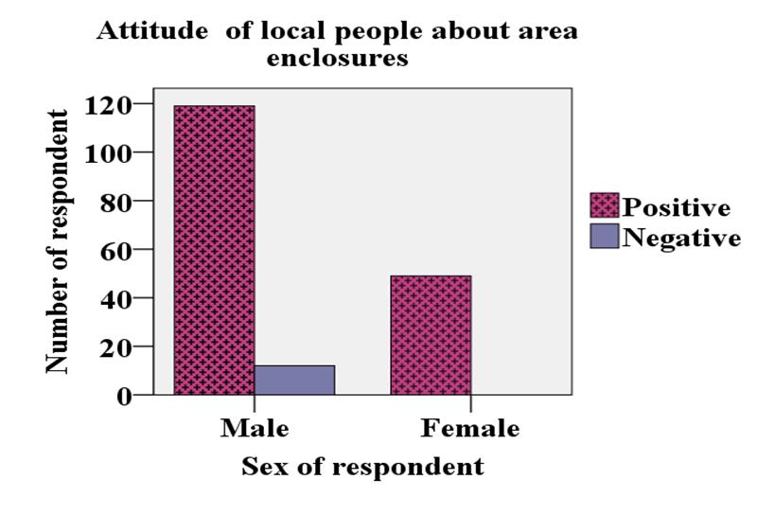

Figure 13: Attitude of farmers about area enclosure between genders

**Constraints of area enclosure**

Disturbance has both positive and negative impacts on forest ecology in general and area enclosure ecosystems in particular, depending on the level of disturbance (Tasisa, 2018). Gezimu et al. (2022) also indicated that illegal cutting, livestock grazing and trampling, and fire were the problems faced by area enclosure. As presented below in Table 16 and Figure 14, majority of the participated farmers (58%, n=104) confirmed free grazing is the main problem of area enclosure followed by flooding (22%, n=40) and illegal cutting (20%, n=36). Free grazing and flooding are the leading problems of area enclosure for highland and mid-altitude agro-ecologies where as illegal cutting was a serious problem next to free grazing in the lowland agro-ecology. Similarly, Mulugeta and Achenef (2015) confirmed that among 45% of the respondents those indicated the existence of challenges in the area enclosure, majority of them (47%) were replied free grazing was a serious problem for area enclosure. In the highland agro-ecology, farmers used an alternative energy sources to overcome the shortage of fuel wood by planting different tree species around homestead in addition to managing the regenerated trees on their farmlands while in lowland and mid-altitude agro-ecologies, planting trees around their homestead is less and they only managing the regenerated trees on their farmlands to fill their fuelwood gap. Therefore, it is necessary to support those farmers by training to encourage tree planting experiences and managing regenerated trees by concerned bodies.

Table 16: Constraints of area enclosure across agro-ecology

|  |  |  |  |  |
| --- | --- | --- | --- | --- |
| Variables | Response | Highland  (n=60) | Mid-altitude  (n=60) | Lowland  (n=60) |
| Constraints of area enclosure |  |  |  |  |
| Free grazing | 36 | 25 | 43 |
| Illegal cutting | 10 | 15 | 11 |
| Flooding | 14 | 20 | 6 |

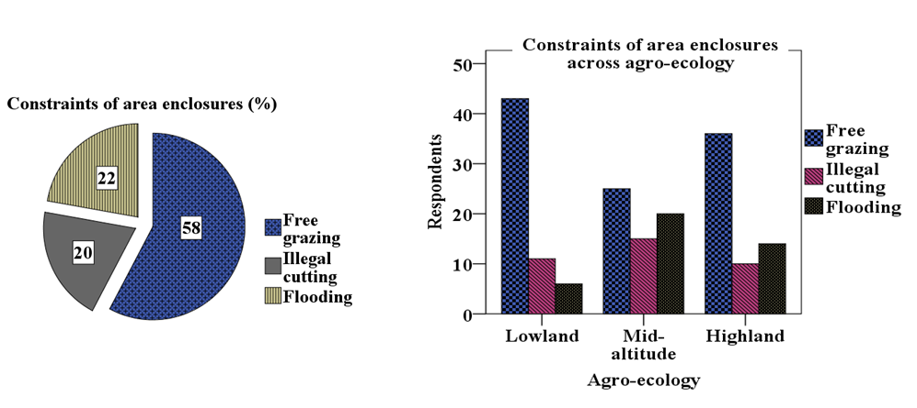

Figure 14: Constraints of area enclosure

**Conclusion and recommendation**

Area enclosures became the best way to restore degraded lands by controlling soil erosion and providing benefits for local communities as a source of animal fodder, bee forage, and fuelwood. To achieve this, full participation of the communities at large from the very beginning of site selection to its establishment and proper management were indispensible. Socio-economic and environmental benefits obtained from area enclosure develop a positive attitude among the farmers towards area enclosure. Although benefits were gained from area enclosures, free grazing and illegal cutting are the main constraints to ensuring their success. Based on the findings, the following important points are recommended for successful area closure practices:

* Area enclosure practices have a potential role in improving the recovery of woody vegetation on degraded lands. Moreover, it can also offer the local community different types of benefits and services. These can be achieved through proper protection and management. Thus, for addressing ecological problems as well as socio-economic benefits by establishing area enclosure, concerned bodies could not achieve their tasks rather work with local communities, NGOs and GOs mainly the office of agriculture, local extension workers, administrative bodies, and the active participation of the local people jointly is quite indispensable.
* Attempts should be made by the local community, government, and NGOs in order to address the various challenges of area enclosure practices and to be able to step on further development activities. Local by-laws should be implemented and exercised after awareness is created in the local communities.
* Efforts should be made by GO and NGOs to change the perceptions, attitudes, and behaviors of local people towards their environments, diversify the livelihoods of households, and actually rehabilitation degraded areas.
* Special attention should be given to solving the shortage of grazing land due to area enclosure so as to encourage the community's interest in expanding and managing area closure practices in their locality by providing new technologies related to sources of fuelwood and animal fodder. In addition, awareness creation should be given, especially to those who are having problems bringing animals from protected areas that live around area enclosure and have better livestock numbers, so instead of punishment; they should have experience sharing from other areas and create awareness.

**Acknowledgment**

We would like to thank the farmers, local administrators and watershed management experts of the study area for their cooperation during the field work. We are also grateful to Sekota Dryland Agriculture Research Centre (SDARC) for providing financial support for the data collection.

# References

Arega Bazezew Berlie and Mehretie Belay Ferede. (2020). Practices and challenges of integrated watershed management in the Amhara region of Ethiopia: case study of Gonji Kolela District. *Journal of Environmental Planning and Management*.

Atef, H. a. (2014). LAND DEGRADATION, AGRICULTURE PRODUCTIVITY AND FOOD SECURITY .

Aune, JB., Bussa, MT, Asfaw, FG., Ayele, AA. . (2001). The ox ploughing system in Ethiopia: can it be sustained?

Berry, L. (2003). Land Degradation in Ethiopia: Its Extent and Impact. Land Degradation Assessment in Dry.

Birhane, E., Teketay, D., & Barklund, P. (2006). Actual and Potential Contribution of Exclosures to Enhance Biodiversity of Woody Species in the Drylands of Eastern Tigray. *Journal of Drylands*.

Bishaw, B. (2001). Deforestation and Land Degradation on the Ethiopian Highlands:A Strategy for Physical Recovery. *International Conference on African Development Archives*.

David Lamb and Don Gilmour. (2003). Rehabilitation and restoration of degraded forests.

Desta, L., Kassie, M., Benin, S., and Pender, J. (2000). Land degradation and strategies for sustainable development in the Ethiopian highlands.

Emiru Birhane, Demel Teketay, Pia Barklund. (2007). Enclosures to Enhance Woody Species Diversity in The Dry Lands of Eastern Tigray, Ethiopia. *East African Journal of science*.

Eshetu Yirdaw, Mulualem Tigabu and Adrian Monge. (2017). Rehabilitation of degraded dryland ecosystems – review.

FAO. (2015). Dynamics of global forest area: Results from the FAO Global Forest Resources Assessment.

Fikirte Demissie, Kumelachew Yeshitela, Mark Rouleau, David Flaspohler, Mengistie Kindu. (2019). Socio-economic importance of forest resources and their conservation measures in Ethiopia: the case of area closure in South Gonder of Ethiopia. *Environ Monit Assess*.

Getachew, Mulugeta and Malke, Achenef. (2015). Socio-economic challenges of area exclosure practices: a case of gonder zuria woreda Amhara region, Ethiopia,. *Journal of Natural Sciences Research*.

Girma Gezimu Gebre, Asmiro Abeje Fikadu, Assefa Ataro Ambushe & Dil Bahadur Rahut. (2022). Factors Influencing the Adoption of Area Closure Practices in Loma Bosa District of Dawuro Zone, Southwestern Ethiopia. *JOURNAL OF SUSTAINABLE FORESTRY*.

Gupta, G. S. (2019). Land Degradation and Challenges of Food Security. *Canadian Center of Science and Education*.

Kassa, H. (2018). Reshaping the Terrain Landscape Restoration in Ethiopia.

Knowles, J. A. (2001). Restoring tropical forests on lands mined for bauxite: Examples from the Brazilian Amazon. *Ecological Engineering*.

Manaye, A. (2017). Contribution of Exclosures for Restoration of Woody Species Diversity and Regulating Ecosystem Services in Ethiopia. *Journal of Natural Sciences Research*.

Mekuria, W., Veldkamp, E., Tilahun, M., Roland. (2011). Economic valuation of land restoration: The case of exclosures established on communal grazing lands in Tigray, Ethiopia. *Land degradation and development*.

Melkamu Kasaye, Getu Abebe, Abrham Abiyu, Menale Wondie, Beyene Belay. (2020). Selection of Different Trees/Shrubs Species for Rehabilitation of Degraded Lands in Wag-Lasta Area, Northeastern Ethiopia. *Journal of forest research*.

Melkamu Kassaye Mekonen , Abrham Abiyu Hailu, and Asmamaw Alemu Abitew. (2022). Social and Institutional Status of Area Exclosure in North Wollo and Waghemira Zones, Northeastern Ethiopia. *International Journal of Forestry Research*.

Melkamu, Kassaye, Abrham Abiyu, and Asmamaw Alemu. (2018). Effect of forest restoration on vegetation composition and soil characteristics in north Wollo and Waghemira zones, northeastern Ethiopia.

Mengistu Asmamaw Mengesha and Mekuria Argaw Denoboba. (2015). Assessing Farmers’ Perception of Enclosures, Kewot District, Northeastern Ethiopia. *nternational Journal of Environmental Protection and Policy*.

Mohammed Gedefaw and Teshome Soromessa. (2015). Land degradation and its impact in the highlands of Ethiopia: Case study in Kutaber wereda, South wollo, Ethiopia. *Global Science Research Journal*.

Mohammed Kasim, Zebene Assfaw, Abayneh Derero, Mateos Melkato and Yosef Mamo. (2015). The role of area closure on the recovery of woody species composition on Degraded lands and its socio-economic importance in central rift Valley area, Ethiopia. *International Journal of Development Research 5*.

Mulugeta Lemenih and Habtemariam Kassa. (2014). Re-greening Ethiopia: history, challenges and lessons.

Peterson, G. D., Harmáčková, Z. V., Meacham, M., Queiroz, C., Jiménez-Aceituno, A., Kuiper, J. J., Malmborg, K., Sitas, N., & Bennett, E. M. (2018). Welcoming different perspectives in IPBES: “Nature’s contributions to people” and “Ecosystem services”. *Ecology and society*.

T. Mengistu, D. Teketay , H. Hultenc, Y. Yemshaw. (2004). The role of enclosures in the recovery of woody vegetation in degraded dryland hillsides of central and northern Ethiopia. *Journal of Arid Environments*.

Tasisa, B. Y. (2018). Local and landscape level impacts of enclosure and patterns used by pastoralist in shaping plant diversity of rangelands, eastern Ethiopia.

Tefera Mengistu, Demele Teketay, Hulten H. and Yonas Yemishaw. (2005). The role of communities in area closure management in Ethiopia. *Mountain Research and Development*.

Tefera, Mengistu, Demel, Teketay, Hultén, Håkan, and Yemshaw, Yonas. (2004). The Role of Communities in Closed Area Management in Ethiopia. *Mountain Research and Development*.

Wolde Mekuria, E. Veldkamp, Mitiku Haile, J. Nyssena, B. Muysd, Kindeya Gebrehiwot. (2007). Effectiveness of exclosures to restore degraded soils as a result of overgrazing in Tigray, Ethiopia. *Journal of Arid Environments*.

Wondie, Menale., Werner, Schneider., Klaus, Katzensteiner., Reinfried, Mansberger., Demel, Teketay. (2016). Modelling the dynamics of landscape transformations and population growth in the highlands of Ethiopia using remote-sensing data. *International journal of remote sensing*.

Yayneshet, T. (2011). Restoration of Degraded Semi-Arid Communal Grazing LandVegetation Using the Exclosure Model. *International Journal of Water Resources and Arid Environments* .