**Resource Assessment and Local Farmer’s Knowledge of *Terminalia brownii* Utilization and Managements in Eastern Amhara**

Andualem Ayalew*1, Hodaddis Kassahun2, Mulken Wudu3, Gebeheyu Alamarie3, Gezahagn Getachew3, Derbie Wudu3 and Tigabu Redae3

1*Debre birhan Agricultural Research Center, P.o.box 112, Debre birhan,Ethiopia

2Adet Agricultural Research Center P.O. Box 08, Bahir Dar, Ethiopia

3Sirinka Agricultural Research Center, P.O. Box 74, Woldia, Ethiopia

Corresponding author’s email: andualemayalew2010@gmail.com

**ABSTRACT**

*Terminalia brownii* is a multi-purpose tree used to treat bacterial, fungal, and allergic infections and malarial diseases. *T. brownii* is overutilized for fumigation purposes and for an income source illegally cut from the wild and in all its growing areas. However, the *T.brownii* overutilization with sustainable use interplay within the resource potential of species in the Amhara region seems intricate and not well understood. The study aimed to assess *T.brownii* distribution, utilization, and management in the Bati and Dawa Cheffa districts of the Amhara region. The data were collected through semi-structured interviews from 111(male=56 and female=25) home garden and 30 farmland owners (All Males). In addition, a total of 81 sample plots from home gardens and 30 sample plots from farmlands were taken for observation in the growing niches. Home gardens and farmlands emerge as predominant niches for cultivation, primarily utilized for fumigation purposes (55.9%). Respondents highlight stems and twigs as the most commonly used plant parts (92.2% and 50.7%, respectively), with pruning identified as the most effective management practice. Population structure reveals a bell-shaped curve, implying an immediate need for conservation measures. This characteristic implies a potential challenge to the species' regeneration and recruitment capacity. Overall, the study provides valuable insights into the ecological and socio-economic significance of *T. brownii*, emphasizing the importance of balancing utilization with conservation efforts.

***Key words:*** *Semi-structured interview; Niche; dominant; Fumigation;*conservation efforts

1. **INTRODUCTION**

The deciduous tree *Terminalia brownii* is distinguished by its small stature, with a rounded or flattened crown, and can grow to a height of less than 20 meters (Schmidt ,2010). Terminalia, ranking as the second-largest genus in the Combretaceae family, derives its Latin name ("Terminalis" meaning end) from the leaf arrangement. *T.brownii*, a genus of mostly medium or large trees in the family Combretaceae with about 250 species in the world, is distributed mainly in southern Asia, the Himalayas, Madagascar, Australia, and the tropical and subtropical regions of Africa. Among 250 species of T.brownii in the world, around 50 indigenous species have been found in Africa, spanning the sub-Saharan region ( Enass et al., 2017; Lebrun and Stork, 1991). *T. browni*i is native to Kenya, Uganda, Tanzania, Eritrea, Ethiopia, Somalia, and Malawi (Schmidt 2010).

Renowned for its versatile medicinal properties, this plant is widely employed by herbalists in different countries of Africa such as Ethiopia and Kenya to address various ailments, including eye infections, allergies, and malaria (Kareru et al. 2007; Kamtchouing et al.2006; Masoko et al.2005)*. The Terminalia genus, to which T. brownii* belongs, is frequently integrated into mixed crop systems, contributing to the establishment of "Taungya agri-sylvicultural systems”. In this context, these trees serve the dual purpose of providing shade and enhancing soil fertility(FAO 2016; Norgrove and Hauser 2002)*.*

*T. brownii* is also used for firewood, charcoal production, timber, poles, medicinal extracts from leaves and bark, fodder for both human and livestock consumption (leafy branches), mulching, soil enhancement, shading, dye production, and ornamental landscaping in urban areas and parks (Bekele 2007; Habtamnesh and Agena 2023; Orwa et al.2009). The wood of *T.brownii* is recognized for its toughness, strength, and moderate hardness, and also termite resistant, facilitating ease of processing with both machine and hand tools (Oriowo and Aina, 2015). The species boasts a wood density of 0.445 g/cm3 and a calorific value of 7.3 KJ per gram (Tarun et al. 2023).

*T.brownii* is overutilized for fumigation purposes and for an income source illegally cut from the wild and in all its growing areas (observation during socioeconomics and field survey). Unfortunately, this valuable resource faces the threat of extinction due to unregulated harvesting for construction purposes, beautification, fumigation, fuel wood, charcoal production, and medicinal applications, worsened by a lack of awareness regarding sustainable management practices (Gebrekidan et al., 2018). Keeping Terminalia brownii trees in agricultural fields is vital for farmers to enhance the soil's physicochemical characteristics in the South Ari District of the South Omo Zone, Southern Ethiopia, as noted by (Mitiku et al.,2025).

Recognizing the critical importance of *T.brownii*, there is a compelling need to comprehend its geographical distribution, optimal utilization methods, and effective management strategies. This study is conducted to assess the *T. brownii* distribution, utilization, and management to conserve the species in a sustainable way.

1. **MATERIALS AND METHODS**

**2.1. Description of the Study Area**

The research was carried out in the Dawa Cheffa and Bati districts, in the Oromiya zone of the Amhara region, Ethiopia. Study site 1 (Goda and Belecha kebels) in Dawa Cheffa district are found within a latitude range of 10°42'N and 10°46'N and longitude range of 39°52'E and 39°58’E respectively. Figure 1 is presented in Study site 2 (Hato and Furra kebels ) in Bati district are found within a latitude range of 11°5'N and 11°13'N and longitude range of 40°2'E and 40°12'E respectively . Furra and Hato in Bati District are two specific kebeles within the districts that are located at 1418 and 1358 meters above sea level, respectively and also reported by (Asmare et al.2014). The Dawa Cheffa district’s Goda and Belecha are located at elevations of 1669 and 1841 meters above sea level, respectively.

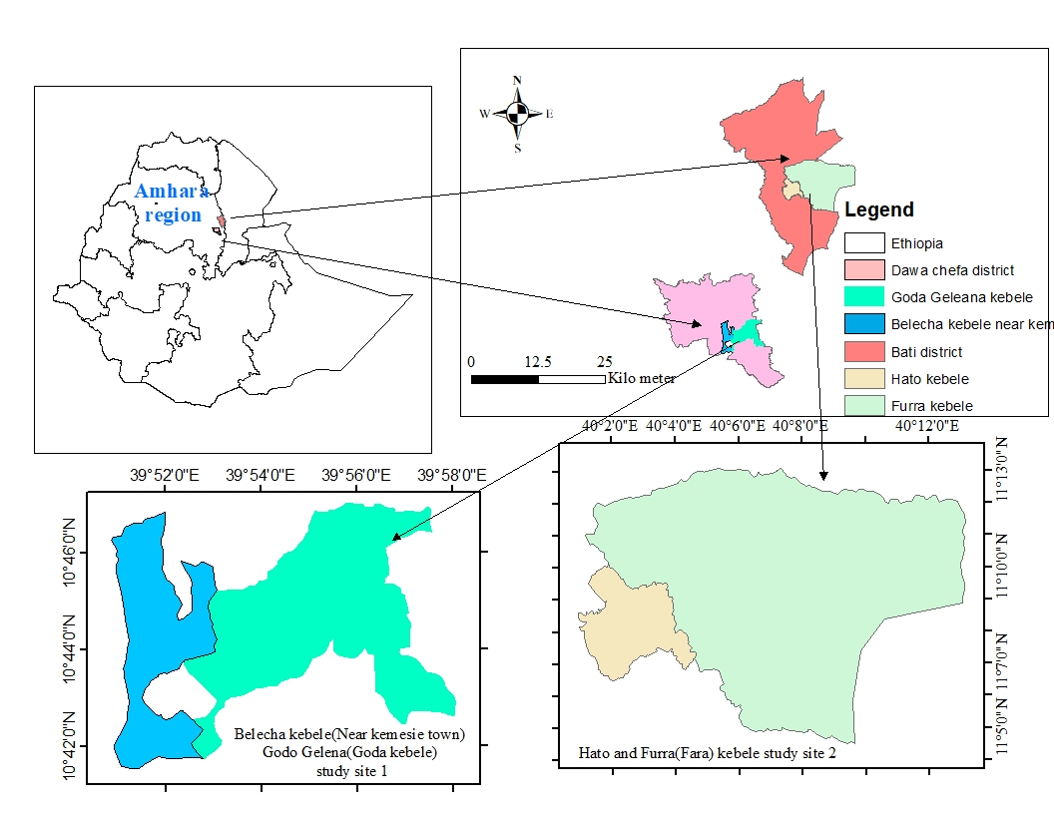

Figure 1. Map of the study areas

* 1. **Data collection**

The study consisted of two parts: a socioeconomic study and a vegetation survey conducted in Bati and Dawa Cheffa Districts for T. brownii, respectively (Figure 2).

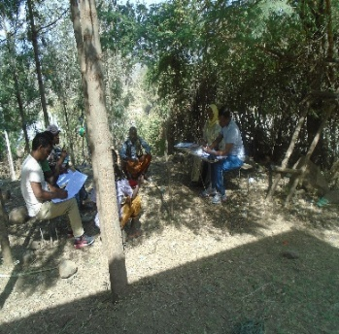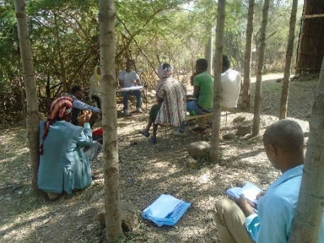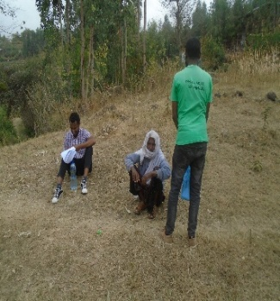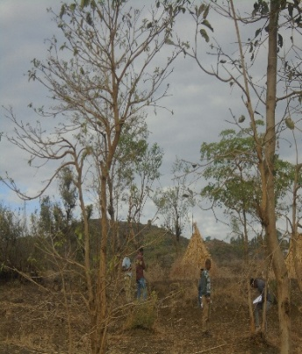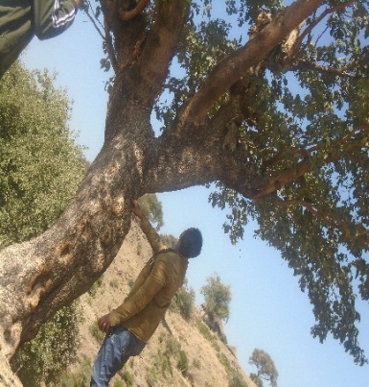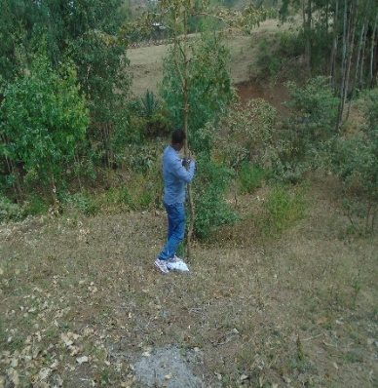

B

B

B

A

A

A

Figure 2: Field data collection in the study area: a socioeconomic study (A) and Vegetation survey (B).

* + 1. **Sample size determination and household survey**

Before commencing the main survey, a preliminary reconnaissance survey was undertaken. Primary data were collected using a semi-structured questionnaire, supplemented by secondary data obtained from Agricultural experts and Development agents at the zonal level.

The selection of households for interviews followed a multistage sampling procedure, facilitated by collaboration with zonal and district experts as well as local informants. In 2021, two districts, Bati and Dawa Cheffa, characterized by a significant *T.brownii* cover, were identified. Subsequently in 2022, two kebeles, namely Goda and Belecha from Dawa Cheffa district, and Furra and Hato from Bati district were chosen in consideration of their proximity to main roads and the presence of *T. brownii* resources. The administrative office provided lists of households for each kebele, and with input from key informants such as elders, women's and youth associations, kebele leaders, religious leaders, and development agents, these households were categorized as poor, medium, or rich. Wealth classification was based on local criteria including landholding size, housing status, and livestock holdings. The determination of the number of respondents for the household survey was carried out using methods outlined by ( Yaman, 1977).

$n=\frac{N}{1+n*{(e)}^{2}}$**……………………………………….. (1)**

The minimum sample size of households (n) was determined using the formula where N represents the target population of households in the Bati and Dawa Cheffa districts, and e represents the accepted minimum level of precision for statistical inference, set at 10%. As a result, a total of 111 households from both Bati and Dawa Cheffa districts (as presented in Table 1) were sampled. This sample size corresponds to 21% of the total number of households in the area, as indicated by ( Vianny et al.2019).

Table 1. Sample size determination for the household survey of *T.brownii*

|  |  |  |  |  |  |
| --- | --- | --- | --- | --- | --- |
| Site | Male headed (HH) | Female-headed HH | Total HH | Sampled HH | Sample size per kebele |
| Goda & Belecha | 430 | 288 | 718 | 60 | 30 each |
| Furra and Hato | 416 | 89 | 505 | 51 | 30(Furra) /21(Hato) |
| Total sample size for the survey | | | | 111 | 111 |

* + 1. **Vegetation survey**

The assessment of *T.brownii* resources at selected sites utilized the transect walk method. Enumeration of *T.brownii* in home gardens within the study area was conducted through a comprehensive species enumeration approach( Motuma et al.2008) . For collecting vegetation data from farmlands, 50 m * 50 m plot areas were established at 300 m intervals between transect lines and 150 m intervals between plots ( Nikiema, 2005) . The initial transect line and plot were randomly chosen, with a systematic layout of 30 plots in the farmlands.

To evaluate regeneration, *T.brownii* specimens were categorized based on height and diameter at breast height (DBH). Trees were defined as those with a height greater than 2m and DBH greater than 2 cm, saplings included those with a height between 1-2m and DBH greater than 2 cm, and seedlings were characterized by a height of 1m, regardless of DBH ( Tegenu and Simon, 2018) .

* 1. **Data analysis**

Data were analyzed using simple descriptive statistics such as means and, percentage using SPSS software version 20 to characterize farmers' perceptions and tree management activities within the study area. The results were visually presented through tables and graphs. The social data (farmer’s preference) were analyzed by pair wise ranking matrix. The biological data were analyzed by using one way ANOVA.

Before ANOVA, normal distributions of the data sets were checked using the Shapiro-Wilk test of normality, and it was considered significant at *P* > 0.05. One-way Analysis of Variance (ANOVA) was performed to analyze variations in wealthy categories and the number of *T.brownii* retained across studies sites home gardens Significant means were compared using Tukey’s Honestly Significant Difference (Tukey’s HSD) post hoc test at *P* ≤ 0.05. For the examination of the regeneration status of *T.brownii* species, a comparative analysis was conducted by assessing the ratio of seedlings to saplings and saplings to mature trees (Tegenu and Simon, 2018). This method provided insights into the progression of tree growth stages within the studied sites**.** Using a prioritization matrix, which ranks and weighs several factors for priority-setting with numerical values to identify the top issues for growing *T. brownii*, the priority issues were analyzed.

1. **RESULT AND DISCUSSION**

**3.1. Household Characteristics**

The fundamental characteristics of households in the study area are notable, T. brownii appears as a significant player in Agroforestry practices across all the examined study areas, as highlighted in (Table 2).

Table 2.Socioeconomic profile of the study areas

|  |  |  |  |  |  |
| --- | --- | --- | --- | --- | --- |
| Socio-demographic profile of the respondents | | Bati district  (Furra&Hato kebele)N=51 | Dawa Cheffa district(Goda&  Belecha) N=60 | Total frequency | Percent |
| Educational status | Illiterate | 23 | 31 | 54 | 48.6 |
| Read and write | 28 | 29 | 57 | 51.4 |
| Age | 15-64 | 51 | 59 | 110 | 99.1 |
| >64 | 1 | 0 | 1 | 0.9 |
| Sex | Male | 40 | 46 | 86 | 77.47 |
| Female | 11 | 14 | 25 | 22.5 |
| Marital status | Married | 49 | 54 | 103 | 92.8 |
| Single | 1 | 2 | 3 | 2.7 |
| Divorced | 1 | 2 | 3 | 2.7 |
| Widowed | 0 | 2 | 2 | 1.8 |
| Family size | 1-4 | 4 | 15 | 19 | 17.1 |
| 5-8 | 30 | 27 | 57 | 51.4 |
| >8 | 17 | 18 | 35 | 31.5 |
| Landholding | <0.5ha | 8 | 41 | 49 | 44.14 |
| 0.5-1ha | 29 | 12 | 41 | 36.94 |
| >1ha | 14 | 7 | 21 | 18.92 |
| Social and religious views on *T.brownii* expansion | Good | 30 | 41 | 71 | 64 |
| No concern | 21 | 19 | 40 | 36 |
| Household source | Tree +crop | 7 | 21 | 28 | 25.23 |
| Income based on production |  |  |  |  |  |
| Livestock rearing | 1 | 2 | 3 | 2.7 |
| Agroforestry system (crop+animal+tree) | 43 | 37 | 80 | 72.07 |

The kebele with the highest contribution from women is Hato, followed closely by women farmers in Goda kebele. In the current study, both farm size and educational status were found to influence the domestication of T. brownii, as indicated in Table 2, Table 3, and Figure 3.

Farmers' perceptions regarding social and religious aspects significantly impact the expansion, utilization, and management of *T. brownii*, aligning with the interplay of human affairs and nature, as suggested by (Abiyou,2015). The landholding sizes in the present studied sites are comparatively smaller than those reported in the study on rural land access in Eastern Ethiopia, ranging from 0.1 to 7.25 hectares ( Geremew, 2018) .

A predominant majority of the survey respondents of the present study fall within the age range of 15-64, considered the working force, constituting 99.1%, which is consistent with findings in rural land demographics in Eastern Ethiopia (Tilahun, 2015). The limited contribution of women, attributed to issues of land rights and tenure security, aligns with observations by (Agnes et al.2013). Another study in Eastern Kenya identified education, farm size, and the level of infrastructure as significant factors affecting the domestication of *T. brownii* among smallholder farmers (Alber et al.2019) .

|  |
| --- |
| P < 0.05 |

Figure 3.Mean number of *T.brownii* per household across wealthy status

Notably, the average landholding size of poor and medium-class farmers is consistently smaller than that of wealthier counterparts across all studied sites, as outlined in Table 3.

Comparatively, the average landholding size of poor and medium-class farmers in this investigation is lower than reported in Kenyan and Tembaro District, Southern Ethiopia, where landholding sizes range from 0.47 to 0.9 hectares (FAO 2015; Belayneh and Abayneh, 2018) .

The higher prevalence of *T. brownii* among poor and medium-class farmers for income generation aligns with (Arild et al.2003), but contradicts (Gebremedhin, 2020) . This disparity may be attributed to variations in tree planting practices among farmers and the market-related opportunities available.

Table 3.The average land holding size (ha) of farmers (n=111) across the study areas

|  |  |  |  |  |
| --- | --- | --- | --- | --- |
| Kebele | Village | Wealth categories and their land size(ha) | | |
| Poor(M+std) | Medium(M+std) | Rich(M+std) |
| *Goda (n=30)* | Abudalis,Deraleyu,Goda & Jeranio | 0.43+ 0.3 | 0.8+ 0.29 | 1.7 + 0.26 |
| *Belecha(n=30)* | Goro,Goha,Passgorie  and Korekarit | 0.28+ 0.2 | 0.6+ 0.4 | 1.4 + 0.15 |
| *Furra (n=30)* | Adie, Engedaw, Genedahaberu, Hameru and Genedmotie | 0.7+ 0.1 | 1.1 + 0.3 | 1.6 + 0.7 |
| *Hato (n=21)* | Salahua | 0.04 | 0.93+0.35 | 2+1.6 |

Where n=number of households taken, M=mean and std=standard deviation

The survey reveals that *T. brownii* is more prevalent among poor and middle-class farmers in the study sites compared to wealthier counterparts. This trend is significant in supporting farmers to generate income and sustain their livelihoods, as illustrated in Figure 3.

The assessment results indicate diverse uses of *T. brownii* by the local community. The leaves, twigs, and bark are employed for fumigation; stems serve various purposes such as timber, fuelwood, and farm tools, while the tree itself acts as a source of additional income and shade for animals. In this study, 92.2% of respondent’s utilized *T. brownii* stems differently, and 50.7% used twigs. The tree contributes to milk preservation, shading, and fodder, accounting for 6.7% in Belecha, 6.7% in Furra, and 4.8% in Hato kebele, respectively. Stems emerge as the most commonly utilized parts of *T. brownii*, followed by twigs and roots, as outlined in (Table 4 and Table 5).

Table 4. Number of respondents and the percent (%) of their responses stating the main parts of T.brownii used in the study site

|  |  |  |  |  |  |
| --- | --- | --- | --- | --- | --- |
| Study kebele | The main parts of *T.brownii used* | | | | |
| Stem | Twigs | Leaf | Bark | Root |
| Goda(n=30) | 96.5 | 49.8 | 23.2 | 16.6 | 19.9 |
| Belecha(n=30) | 86.7 | 50 | 10 | 10 | 6.7 |
| Furra(n=30) | 100 | 56.7 | 0 | 0 | 0 |
| Hato(n=21) | 85.8 | 46.3 | 9.6 | 4.8 | 19.1 |
| Mean | 92.2 | 50.7 | 10.7 | 7.85 | 11.42 |

Table 5. Number of respondents (%) stating the importance of *T.brownii* used across the study areas

|  |  |  |  |  |  |  |  |  |  |  |
| --- | --- | --- | --- | --- | --- | --- | --- | --- | --- | --- |
| Study kebele | Importance of *T.brownii* | | | | | | | | | |
| Fum | FW | HC | FT | Fen | Med | InS | MiP | Fod | Sh |
| Goda(n=30) | 60 | 16.7 | 35.7 | 3.3 | 3.3 | 0 | 60 | 0 | 0 | 0 |
| Belecha(n=30) | 46.7 | 23.3 | 47 | 43.3 | 0 | 6.7 | 36.7 | 6.7 | 0 | 0 |
| Furra(n=30) | 47 | 3.3 | 0 | 0 | 0 | 3.3 | 10 | 0 | 0 | 6.7 |
| Hato(n=21) | 70 | 14.3 | 26.7 | 19 | 3.3 | 14.3 | 19 | 0 | 4.8 | 0 |
| Mean | 55.9 | 14.4 | 27.3 | 16.4 | 1.65 | 6.07 | 31.4 | 1.6 | 1.2 | 1.67 |

Note: Fum=Fumigation, FW=Fuel wood, HC=House construction, FT=Farm tools, Fen=Fencing, Med=medicinal use, Ins =Income source, MiP=milk preservation, Fod=fodder and Sh=shading

Fumigation, income sources, house construction, for making farm tools, fuel wood, medicinal value and milk preservation, shade, fencing, fodder, and shade to some extent are the main importance of *T. brownii* in the study areas (Table 5).

The main importance of *T.brownii,* ,such as used for fumigation, income sources, house construction, and others listed in the present study, is in line with (Habtamnesh and Agena, 2023), from Arba Minch Town, Southern Ethiopia.

Research findings reported from raya Azebo by (Guesh et al.2016) also showed similar results that the stems and branches of *T.brownii* fumigants compared to *Olea european* are used to treat rheumatic and back pains, the stems smoked help to preserve milk, the roots and stems smoked for house fumigation and for insect repellent.

The use of *T.brownii* to smoke milk utensils for milk preservation and the good taste of milk due to its good aroma is also reported by Tewodros and Muluken (2018), Seraphine et al.(2022), from the Tigray region and South Wollo, Ethiopia. The importance of *T.brownii* as a shade tree in one of the study areas is in line with (Masoko et al.2005, Biruk et al.2020). The other important issue of *T.brownii* is the presence of hydro-methanolic and aqueous extracts of bark that have anti-malarial activity ( Madalcho and Tefera, 2016), The benefits attributed to the retention and planting of *T. brownii* in homesteads in different parts of the Ethiopia align with findings from (Gebrekida, 2018; Tesfaye et al.2006), emphasizing the multifaceted advantages of tree species and widespread distribution of *T.brownii* in the study areas underscores its significance for local communities across various districts within the Amhara region.

Additionally, *T. brownii* stems play a role in traditional smoking practices locally known as "Wollo Chese" in Ethiopia, contributing to insect protection. The stems, sold at markets, are also used for childbirth relief and are believed to promote strength and health (personal observation). Research from Wollo Mirutse (2018) supports these findings, highlighting *T. brownii's* use for fumigation, preservation of milk utensils, and insect repellents.

Silvicultural management practices in the study areas primarily involve pruning (28.75%) and coppicing (19.5%), with lopping observed in both Furra and Hato farmlands (Table 6). These practices contribute to the sustainable cultivation and utilization of *T. brownii* in the region. Pruning, pollarding, and lopping are also common practices by farmers in the south Omo for *T.brownii* reported by (Mitiku et al.2025). Similarly, Madalcho and Tefera(2016), stated that proper pruning maintains trees’ health for trees found on the farmlands. The management practice exercised for *T.brownii* in the study kebeles, such as pruning and coppicing, explained in a similar report by Mesele(2007), which finds that coppicing ability is good for several Terminalia spp. Similarly, not specific months are stated to apply pruning and coppicing except the rotation period may vary for different sizes of stems ( Yemiru et al.2015).

*Table 6.* Number of respondents (%) mentioning types of *T. brownii* tree management practices employed in the study sites

|  |  |  |  |  |  |
| --- | --- | --- | --- | --- | --- |
|  | Tree management practices | | | |  |
| Study kebele | Pruning | Pollarding | Coppicing | Lopping | Overall mean |
| Goda (n=30) | 33 | 13 | 43 | 0 | 22.25 |
| Belecha (n=30) | 23 | 10 | 3 | 0 | 9 |
| Furra (n=30) | 30 | 23 | 13 | 17 | 20.75 |
| Hato (n=21) | 29 | 5 | 19 | 10 | 15.75 |
| Mean | 28.75 | 12.75 | 19.5 | 6.75 |  |

n=number of respondents in each Kebeles

The Table 7 proved that the largest percentage of silvicultural management time (49.8%) for *T.brownii* across study kebeles, except leap year and Paugumie. This might be related to Paugumie time to plant and hoeing than cutting, as tree planted and hoeing at the time is believed by the local community completely survive in the field and also better to coppice during the time.

Table 7.Number of respondents (%) mentioning the silviculture management time of T. brownii employed in the study sites

|  |  |  |  |  |  |  |  |  |  |  |  |  |
| --- | --- | --- | --- | --- | --- | --- | --- | --- | --- | --- | --- | --- |
| Study kebele | Silviculture management time of *T.brownii* | | | | | | | | | | | |
| Any time except Pagumie | | | Oc | Jan | Feb | Mar | Apr-Jun | Jan-June | Apr-may | May-Jun | Jun-July |
| Goda (n=30) | 73.3 | | 3.3 | | 3.3 | 0 | 0 | 3.3 | 0 | 0 | 0 | 0 |
| Belecha (n=30) | 76.7 | | 0 | | 0 | 10 | 0 | 6.7 | 0 | 0 | 0 | 0 |
| Furra (n=30) | 40 | | 10 | | 56.7 | 0 | 0 | 26.7 | 10 | 0 | 0 | 0 |
| Hato (n=21) | 9.5 | | 0 | | 0 | 14.2 | 4.7 | 14.7 | 0 | 4.7 | 9.5 | 4.7 |
| Mean | | 49.8 | 3.3 | | 15 | 6.1 | 1.17 | 12.8 | 2.5 | 1.17 | 2.3 | 1.1 |

n- Number of respondents in each Kebele

Similarly, not specific months are stated to apply pruning and coppicing, except the rotation period may vary for different sizes of stems and species (Gezahegn et al. 2015).

Table 8. The retained tree species in the main niches across kebele and respondent percent

|  |  |  |  |  |  |  |
| --- | --- | --- | --- | --- | --- | --- |
| S.no | Species | Family name | Bati district | | Dawa Cheffa District | |
| Hato kebele | Furra kebele | Goda Kebele | Belecha Kebele |
|  | *Acacia asak* | Fabaceae | 14.3 | 3 | - | - |
|  | *Acacia nilotica* | Fabaceae | 4.8 | 76 | - | 13 |
|  | *Acacia polycanatha* | Fabaceae | - | - | 3 | 10 |
|  | *Albizia gummifera* | Fabaceae | - | 13 | 3 | - |
|  | *Balanites aegyptiaca* | Zygophyllaceae | - | 3 | - | - |
|  | *Calpurnia aurea* | Fabaceae | - | - | - | 10 |
|  | *Carissa edulis* | Apocynaceae | 4.8 | - | 3 | 6 |
|  | *Casuarina equisetifolia* | Casuarinaceae | - | - | 3 | 3 |
|  | *Celtis Africana* | Cannabaceae | - | - | - | 23 |
|  | *Cordia africana* | Boraginaceae | 14.3 | 16 | - | 66 |
|  | *Croton macrostachyus* | Euphorbiaceae | 14.3 | - | 0.2 | 16 |
|  | *Delonix regia* | Fabaceae | 9.5 | - | - | 6 |
|  | *Dovyalis abyssinica* | Flacourtiaceae | 4.8 | - | - | - |
|  | *Ehretia cymosa* | Boraginaceae | 4.8 | - | - | 6 |
|  | *Eucalyptus camaldulensis* | Myrtaceae | 66.7 | 76 | 76 | 63 |
|  | *Euclea racemosa subsp. schimperi* | Ebenaceae | 33.3 | 7 | 10 | - |
|  | *Euphorbia candelabrum* | Euphorbiaceae | - | 7 | - | 13 |
|  | *Grevillea robusta* | Proteaceae | - | 46 | 43 | 37 |
|  | *Grewia ferruginea* | Malvaceae | - | - | - | 3 |
|  | *Jacaranda mimosifolia* | Bignoniaceae | 9.5 | - | - | - |
|  | *Jatropha curcas* | Euphorbiaceae | 23.8 | 27 | 10 | 16 |
|  | *Maytenus arbutifolia* | Celastraceae | 4.8 | - | - | - |
|  | *Melia azedarach* | Meliaceae | 4.8 | 3 | - | - |
|  | *Moringa stenopetala* | Moringaceae | 19 | 20 | 3 | 3 |
|  | *Olea europaea* | Oleaceae | 9.5 | 23 | - | - |
|  | *Rhus natalensis* | Anacardiaceae | 9.5 | - | - | 3 |
|  | *Ricinus communis* | Euphorbiaceae | - | 3 | - | - |
|  | *Schinus molle* | Anacardiaceae | 4.8 | - | - | - |
|  | *Sesbania sesban* | Fabaceae | 9.5 | - | - | - |
|  | *Terminalia brownii* | Combretaceae | 100 | 90 | 97 | 100 |
|  | *Ximenia americana* | Oleaceae | - | 7 | - | - |
|  | *Ziziphus mauritiana* | Rhamnaceae | 9.5 | 86 | 23 | 30 |

The vegetation assessment result shown on Table 8 proved that *T.brownii* is the most dominant tree species across the study sites followed by *Eucalyptus camaldulensis*. The species dominance is due to the farmers’ willingness to plant in their home garden, the boundary of farm lands, the hillsides, the burial, the schools and the religious sites. The present study sites constitute 32 indigenous and exotics species.

Similar results were also reported as T.brownii is the most dominant in Humbo Farmer Managed Natural Regeneration forest (Wondimagegn et al. 2024).

The distribution of *T. brownii* spans all 28 kebeles, including two in the town of Bati and 26 in the Dawa Cheffa districts. Key areas with substantial *T. brownii* coverage in the Bati district include Furra, Kurkura, Cheqoreti, Hato, Selati, and Garero. Additionally, *T. brownii* can be found in woodlots in the Bati district, such as Damot and Ameleka, covering areas ranging from 0.25 to 0.5 hectares. Beyond Bati, *T.brownii* exhibits widespread distribution in Aregoba, Aretuma Furese, and Dewi districts, spanning 10 kebeles, including Harewa, Ajeo Woecka, and Karepela, among others. These areas are renowned for the extensive distribution of T.brownii in South Wollo and the Oromiya zone within the Amhara region. Dodo, Dendie, Harogomensa, and Erkie Gelana are recognized in the Dawa Cheffa district as key locations for the distribution of T.brownii. In North Wollo, small patches of T.brownii can be found in the farmlands around Gobeye Kebele, known locally as "Korasema."

Table 9.The main constraints of *T. brownii* production in the study areas

|  |  |  |  |  |  |  |  |
| --- | --- | --- | --- | --- | --- | --- | --- |
| Study kebele | Low Market price | Unavailability of the market | | The decline of *T.brownii* production | Difficult to Propagate by cutting | Poor transport | Lack of market information |
| Goda(n=30) | 40 | 43.3 | | 40 | 47 | 40 | 20 |
| Belecha(n=30) | 53 | 43.3 | | 37 | 50 | 27 | 30 |
| Furra(n=30) | 40 | 43.3 | | 47 | 60 | 23 | 30 |
| Hato(n=21) | 20 | 57.1 | | 29 | 38 | 10 | 14.28 |
| Mean | 38.25 | 46.75 | 38.25 | | 48.75 | 25 | 23.57 |

As Table 10 illustrates, the primary issues with *T.brownii* in the Bati and Dawa Cheffa districts are overuse, germination issues, drought, and inadequate management. When taken as a whole, these elements present serious challenges to the conservation and sustainable farming of *T.brownii* in the studied areas. Interestingly, compared to the problems described above, the frequency of *T. brownii* hosting insect pests is deemed less important. For the resources of T. brownii in the area to be effectively managed and conserved, several priorities must be addressed. Priority problems in *T,brownii* growing areas of the present study that align with previous studies reported by (Michael et al.2019), between *T. brownii* and gall formation brought on by gall wasp assaults, highlights a common problem. The fact that *T.brownii* fruits are home to a variety of insect pests, including Lasioglossum species, Lipotriches species, Hemipepsis isoptera, Scolia morio, Ammophila bonae species, and Gastrosericus species, is in line with the pest-related problems noted in this investigation. Challenges in *T.brownii* production are evident, with difficulty in propagation through cutting being the primary constraint (48.75%). The unavailability of a consistent market is also a significant hurdle, accounting for 46.75%. These challenges indicate that *T.brownii* primarily grows naturally in the surveyed areas, and factors such as lack of awareness, poor management, and inadequate supply of quality seedlings from government nurseries contribute to the reliance on naturally grown *T.brownii* within farm boundaries (Table 9). In one of the study areas, *T.brownii* serves as a shade tree, a feature consistent with other studies (FAO,2016; Masoko et al. 2005). The plant's hydromethanolic and aqueous bark extracts exhibiting anti-malarial activity further underline its medicinal importance (Biruk et al. 2020). Terminalia species, including *T. brownii*, are widely recognized for their use in herbal medicine, treating various diseases due to their antibacterial, antifungal, anti-inflammatory, antiviral, antiretroviral, and antioxidant properties importance (Tewodros and Muluken, 2018).

Table 10.The priority problems in T. brownii growing areas of Oromiya zone, Amhara region (n=111) using prioritization matrix.

|  |  |  |  |  |  |  |  |  |  |  |  |
| --- | --- | --- | --- | --- | --- | --- | --- | --- | --- | --- | --- |
| Pairwise ranking | dt | Gp | Hip | Ou | Ia | La | Og | Sg | Pm | Total score | Rank |
| Drought(dt) | 1 | dt | *dt* | *Ou* | Ia | dt | dt | dt | Lm | 5 | 3 |
| Germination problem(Gp) |  | 1 | Gp | Gp | Gp | Gp | Gp | Sg | GP | 6 | 2 |
| Harbor insect pest (Hip) |  |  | 1 | Ou | HiP | Hip | Og | Sg | Lm | 2 | 5 |
| Overutilization(Ou) |  |  |  | 1 | Ou | Ou | Ou | Ou | Ou | 7 | 1 |
| Inaccessibility(Ia) |  |  |  |  | 1 | Ia | Og | Sg | Lm | 2 | 5 |
| lack of awareness (La) |  |  |  |  |  | 1 | La | La | Lm | 3 | 4 |
| Overgrazing(Og) |  |  |  |  |  |  | 1 | Og | Lm | 3 | 4 |
| Slow growing(Sg) |  |  |  |  |  |  |  | 1 | Sg | 4 | 4 |
| Poor management (Lm) |  |  |  |  |  |  |  |  | 1 | 5 | 3 |

**\**

Overutilization of T. brownii for medicinal and other uses is also the main problem that leads to the species being endangered similarly reported by (Gebrekidan et al., 2018). Similarly, the germination problem of T. brownii is related to either seeds having a barrier to water uptake or to radicle emergence due to its hard seed coat (Carl and Christian, 2015).

* 1. **Vegetation study**

Table 11 illustrates the distribution of T. brownii growth, which is mostly found in home gardens and sporadic trees on farmlands. Variations exist in T. brownii densities throughout the research regions; the densest, 34 trees ha -1, was found in Furra, while Hato had the lowest density (7 trees ha-1). The dynamic cultivation practices and spread of T. brownii within the investigated locations are highlighted by this diversity in density. According to the distribution of height classes, Goda Kebele in the Dawa Cheffa district had the greatest number of trees and seedlings. This finding is consistent with earlier research that highlights home gardens' importance as the primary niche for the growth of tree species (Abeje et al. 2011). According to other studies, farmers in Ethiopia typically keep trees on their homesteads and farmlands, mostly for the benefit of fuelwood and timber products ( Habtam and Ali, 2015; Tesfaye et al.2006).

The present study exhibits varying densities of *T. brownii*, with some exceeding the findings reported by *(*Abeje *et al.2011)* , who observed 6.6 trees per hectare. Comparably, the fact that there are fewer sapling individuals than there are trees suggests that most seedlings will not survive to reach the sapling stage, either as a result of grazing, animal browsing, human intervention, or the nature of the seeds ( Habtam and Ali, 2015) .

Table 11.The density of T. brownii across the study areas

|  |  |  |
| --- | --- | --- |
| ***Study kebele*** | **Number of *T.brownii* ha-1** | **Niche** |
| Goda (n=30) | 11 | Homegarden |
| Belecha (n=30) | 13 | Homegarden |
| Furra (n=30) | 34 | Farmland |
| Hato (n=21) | 7 | Homegarden |

Figure 4.DBH class distribution among T.brownii in the study areas

Figure 5.Height class distribution among T.brownii grown naturally in the study area

*The population structure displayed in Figure 4 and Figure 5 is bell-shaped, implying immediate conservation measures. This dominance suggests the deliberate retention and management of* T.brownii *by farmers in the Bati and Dawa Cheffa Districts. A survey listing tree species present in the study areas revealed the retention of thirty-two tree and shrub species across twenty-one families. The distribution of* T.brownii *seedlings reveals that Hato kebele has the largest number, followed by Goda kebele (Figure 3). But if we look at the distribution of diameter at breast height (DBH) in saplings and trees, most of them are found in Guda kebele, which is on farmlands, and Belacha kebele, which is in household gardens. The observation that the highest number of* T. brownii *falls within the middle DBH class, with a decrease towards both lower and larger diameter classes, suggests a potential issue with the species' reproduction and recruitment capacity (Figure 4). The overuse of greater-diameter trees and the disregard for organically produced seedlings in farmlands could be the cause of this phenomenon. Furthermore, only a tiny percentage of seedlings may be kept by farmers on their farms. The sustainability of* T. brownii *populations in the examined locations is a concern raised by this information, which also shows the necessity of conservation efforts to guarantee the species' continuous existence and robust regeneration*A bell-shaped curve is revealed by the population structure analysis based on diameter at breast height (DBH) and height class, suggesting a possible problem with the species' ability to regenerate and recruit. This bell-shaped structure highlights the need for efficient conservation methods by highlighting the difficulties in controlling and protecting *T. brownii* populations(Melese and Wendawek, 2016) .

Comparing this study to one conducted in Kunama, Northern Ethiopia, Meaza et al.(2015) brought attention to the traditional applications of *T. brownii*, including fumigation against mosquitoes and usage as a material for stem baths. It was determined that one reason that might put the species' population in jeopardy soon is overexploitation. All of these results highlight how crucial it is to pursue conservation and sustainable management strategies to guarantee *T. brownii's* survival in the regions under study.

1. **CONCLUSION AND RECOMMENDATION**

The multi-purpose *Terminalia brownii* (*T. brownii*) tree emerges as the most dominant species compared to other retained species in both home gardens and farmlands across Bati and Dawa Cheffa districts. The utilization of various parts of *T. brownii* for a multitude of purposes is evident in the surveyed areas, although the specific modes of management and utilization vary among kebeles. Notably, stems and twigs of *T. brownii* stand out as the primary and widely used parts across all assessment sites. The study sheds light on the diverse importance of *T. brownii* to local communities, serving purposes such as fumigation, house construction, shade provision, medicinal applications, fuelwood, and milk preservation. The prevalent management practices involve pruning as the most frequently employed technique, followed by coppicing in the assessed sites. Population structure analysis reveals a bell-shaped distribution for *T. brownii* in the surveyed areas. This characteristic implies a potential challenge to the species' regeneration and recruitment capacity. The observed structure underscores the need for urgent management and conservation measures to ensure the sustained presence of *T. brownii* in the studied sites. Overall, the study provides valuable insights into the ecological and socio-economic significance of T. brownii, emphasizing the importance of balancing utilization with conservation efforts.

**ACKNOWLEDGEMENT**

The authors wish to acknowledge Amhara Region Agricultural Research Institute (ARARI) for funding the project.

**REFERENCES**

Abeje, E., Sterck F., &Bongers F. 2011. Diversity and Production of Ethiopian Dry Woodlands Explained by Climate- and Soil-Stress Gradients. *Forest Ecology and Management* 261(9):1499–1509. doi: 10.1016/j.foreco.2011.01.021.

Abiyou, T. 2015. Structure and Regeneration Status of Menagesha Amba Mariam Forest in Central Highlands of Shewa, Ethiopia. *Agriculture, Forestry and Fisheries* 4(4):184. doi: 10.11648/j.aff.20150404.16.

Agnes, M., Peter, G.&Benard, M. 2013. Land Ownership and Its Impact on Adoption of Agroforestry Practices among Rural Households in Kenya: A Case of Busia County. *International Journal of Innovation and Applied Studies* 4(3):552–59.

Albert, M., Christopher, N., Sylvia, M., Pauline, B., Michael, M. 2019. The Determinants of Livelihood Diversification Strategies In. *Journal of Economics and Sustainable Development* 10(9):6–14. doi: 10.7176/JESD.

Arild, A., &Sven, W. 2003. *Hernia in Childhood*. Vol. 27.

Bekele,A. 2007. *Profi Table Agroforestry Innovations for Eastern Africa: Experience from 10 Agroclimatic Zones of Ethiopia, India, Kenya, Tanzania and Uganda. World Agroforestry Centre (ICRAF), Eastern Africa Region.92 9059 2133 ISBN*.

Belayneh, L., & Abayneh, L. 2018. Management and Socioeconomic Determinants of Woody Species Diversity in Parkland Agroforestry in Tembaro District, Southern Ethiopia. *Biodiversity International Journal* 2(5):456–62. doi: 10.15406/bij.2018.02.00100.

CARL, C.,&Chrstian, S. 2015. Kenya Forestry Research Institute. 00:933.

FAO. 2015. The Economic Lives of Smallholder Farmers. 39. doi: 10.5296/rae.v6i4.6320.

Gebrekidan, A., Sibhatleab, H., Gebrekiros, G. 2018. Indigenous Knowledge Based Identification of Medicinal Plants in Central Zone of Tigray, North Ethiopia.” *International Journal of Biodiversity and Conservation* 10(6):265–75. doi: 10.5897/ijbc2017.1159.

Gebremedhin, C. 2020. Management and the Influence of Socioeconomic Factors on Tree Species Diversity in Traditional Agroforestry Practices in Demba Goffa District ,.12(March):13–19. doi: 10.5897/JHF2019.0579.

Geremew, W. 2018. Agroforestry and Farm Income Diversification: Synergy or Trade-off? The Case of Ethiopia.” *Environmental Systems Research* 6(1). doi: 10.1186/s40068-017-0085-6.

Gezahegn, K.,, Tesfaye, A., Zeleke, E. 2015. “7104-Article Text-16797-1-10-20240105.Pdf.” *Ethiop. J. Sci.* 38(1):01–16.

Guesh, G., T. Yayneshet, H,. Kidane, & B. &Mulubrhan. 2016. “Indigenous Dairy Production and Utilization in Different Agro- Ecological Zones in Northern Tigray , Ethiopia Indigenous Dairy Production and Utilization in Different Agro-Ecology.” (December 2017).

Habtam, G.,& S. Ali. 2015. Short Communication. *Human Reproduction* 6(7):931–33. doi: 10.1093/oxfordjournals.humrep.a137463.

Hana, B., Biruk, A., Yonatan, T., Wondmagegn, E., &Abebe, S. 2020. In Vivo Antimalarial Activity of 80% Methanol and Aqueous Bark Extracts of Terminalia Brownii Fresen. (Combretaceae) against Plasmodium Berghei in Mice. *Biochemistry Research International* 2020. doi: 10.1155/ 2020/9749410.

Kareru, P. G., Kenji, G. M., Gachanja, A. N., Keriko, J. M., & Mungai, G. 2007. Kareru et Al. (Traditional Medicines among Embu, Solanum). 4(1), 75–86.

L., Norgrove.,S, Hauser., & S. Hauser. 2002. Yield of Plantain Grown under Different Tree Densities and ‘slash and Mulch’ versus ‘Slash and Burn’ Management in an Agrisilvicultural System in Southern Cameroon.*Field Crops Research* 78(2–3):185–95. doi: 10.1016/S0378-4290(02)00134-X.

L, Norgrove., & Hauser. S. 2002. Measured Growth and Tree Biomass Estimates of Terminalia Ivorensis in the 3 Years after Thinning to Different Stand Densities in an Agrisilvicultural System in Southern Cameroon. *Forest Ecology and Management* 166(1–3):261–70. doi: 10.1016/S0378-1127(01)00614-4.

Madalcho, AB., & Tefera, MT. 2016. Management of Traditional Agroforestry Practices in Gununo Watershed in Wolaita Zone, Ethiopia. *Forest Research: Open Access* 05(01):1–6. doi: 10.4172/2168-9776.1000163.

Meaza,G.,Tadesse,B.,Maria,A.,Piero,B., &Y. Gidey. 2015. Traditional Medicinal Plants Used by Kunama Ethnic Group in Northern Ethiopia. *Journal of Medicinal Plants Research* 9(15):494–509. doi: 10.5897/jmpr2014.5681.

Melese,B.,&Wendawek, A. 2016. Floristic Composition and Vegetation Structure of Woody Species in Lammo Natural Forest in Tembaro Woreda, Kambata-Tambaro Zone, Southern Ethiopia. *American Journal of Agriculture and Forestry* 4(2):49. doi: 10.11648/j.ajaf.20160402.16.

Mesele, N. 2007. Trees Management and Livelihoods in Gedeo’s Agroforests, Ethiopia. *Forests Trees and Livelihoods* 17(2):157–68. doi: 10.1080/14728028.2007.9752591.

Michael, M., Gilbert, O.,Dickson, L., Jane, W., Miriam, W. 2019. Insects Associated with Terminalia Brownii Growing in Kitui , Baringo and Homa Bay Counties , Kenya : Implications on Tree Species Domestication.5–15.

Mirutse, G. 2018. Traditional Knowledge of People on Plants Used as Insect Repellents and Insecticides in Raya-Azebo District, Tigray Region of Ethiopia. *Indian Journal of Traditional Knowledge* 17(2):336–43.

Mitiku, A., Bruk, L.,Zebene, A.,Tobias, B.,. Beyene, T., Mellisse.B. 2025. Farmers ’ Perceptions of Terminalia Brownii Management in Agroforestry Parklands and Its Impact on Soil Physicochemical Properties in the South Ari District ,.*Agroforestry Systems* 99(2):1–16. doi: 10.1007/s10457-025-01138-3.

Motuma,T.,Zebene,A., Mulugeta, L.,Erik, K. 2008. Woody Species Diversity in a Changing Landscape in the South-Central Highlands of Ethiopia.*Agriculture, Ecosystems and Environment* 128(1–2):52–58. doi: 10.1016/j.agee.2008.05.001.

Nikiema, A. 2005. *Agroforestry Parkland Species Diversity: Uses and Management in Semi-Arid West Africa (Burkina Faso)*.

Oriowo, B. F., N. A. Amusa, &K. S, Aina. 2015. Evaluation of Mechanical Properties of the Terminalia Catappa Trees and Stems from South Western Nigeria. 2(3):132–38.

Schmidt, L. 2010. *Terminalia Brownii Fresen. Schmidt, Lars Holger*.

Seraphine, E.M., Bindeh, C. G., Enow E. A.,& Njombe, E, B. 2022. Silvicultural Assessment of Enrichment Planting with Commercial Tree Species after Selective Logging.*Journal of Ecology and The Natural Environment* 14(1):28–43. doi: 10.5897/jene2021.0919.

Tegenu,M.,and Simon, S. 2018. Structure and Regeneration Status of Nagasa Sacred. *Journal of Cell and Molecular Biology* 7(1):1–13.

Tesfaye, A.K.F, W. F, B.F, S. 2006. *Diversity and Dynamics in Homegardens of Southern Ethiopia*.

Tilahun, A. 2015. The Contribution of Ethiopian Orthodox Tewahido Church in Forest Management and Its Best Practices to Be Scaled up in North Shewa Zone of Amhara Region, Ethiopia. *Agriculture, Forestry and Fisheries* 4(3):123. doi: 10.11648/j.aff.20150403.18.

Vianny, A., Eckhard, A., Jürgen, G. Susan, , B.,&Uta, B. 2019. Drivers of Household Decision-Making on Land-Use Transformation: An Example of Woodlot Establishment in Masindi District, Uganda. *Forests* 10(8):1–19. doi: 10.3390/f10080619.

Wondimagegn, A., Tadesse. C., Molla, M., Tesfaye, M., Mekonnen, Z., &Yimer,F. 2024. Carbon Stocks of Humbo Farmer Managed Natural. *Journal of Ecology and Environment* 48(35):1–13.

Yaman, T. 1977. *Statistics: An Introductory Analysis, 2nd Edition, New York: Harper and Row.*