**ABSTRACT**

*The research was done at three woredas of North Shewa Zone for two years with the objectives of creating wider demand, enhancing improved bread wheat seed multiplication, and creating linkage among possible actors****.*** *The improved bread wheat varieties (Lemu, Ogolcho, and Sanate) were promoted in different locations in clustered bases through seed distribution, training, a field day, and extensive media coverage****.*** *The introduced bread wheat varieties gave up to 47% yield advantage over the local checks especially in high vertisol areas. Farmers' perceptions and reflections on the introduced varieties were assessed using the Likert scale method and analyzed using appropriate statistical techniques. The major bread wheat production problems in the three woredas are the cost and shortage of chemical fertilizer, high cost of agrochemicals, lack of disease-tolerant wheat varieties and high seed costs. The technological and extension gap of the introduced varieties were also assessed and reached up to 17 Quintal and 15 Quintal per hectarerespectively. Field-level seed inspections were done and the produced seed was collected by local cooperatives with the support of an organization for the rehabilitation and development of Amhara region. The recommendation of this study was scaling out of these varieties with improved agronomic management like controlling rust and other diseases, strengthening seed systems through seed production and marketing cooperatives, unions, and seed enterprise, and solving the identified bread wheat production problems through a multidisciplinary team approach.*

***Keywords:*** Bread wheat, Farmers, field day, Training, Seed

**INTRODUCTION**

Agriculture is an essential driver of economic growth in the Ethiopian economy. It contributed to 32.4% of the national GDP following the service sector (40%) while the rest (28.6%) was from the manufacturing sector (NBE, 2022). Wheat is the most important staple food crop for 2.5 billion people across the globe (Bentley et al., 2022). It is the most widely grown crop in the world, with a cultivated land area of 219.2 million hectares and an annual production of 808.4 million tons in 2022. China, India, and Russia are the world's largest wheat producers with an annual output of 137.7, 107.7, and 104.2 million tons, respectively. Ethiopia is the largest wheat producer in Sub-Saharan African countries, In Ethiopia; wheat production is about 7.5 million metric tons accounting for 75% of domestic wheat consumption. However, this production still failed to meet domestic demands. To boost wheat production, various efforts have been made by the Ethiopian government like supplying improved seed, chemical fertilizer, and agrochemicals at the lowest price and borrowing. The government of Ethiopia is increasing investments to expand irrigated wheat production to meet domestic demands and generate exports.  The U.S. is a leading wheat exporter to Ethiopia, with a market share of 67% in 2022 (International Trade Administration, 2024).

Ethiopia is the second largest wheat producer in Africa next to Egypt (FAOSTAT, 2024). Wheat is the most commercialized crop globally, with the traded amount reaching 25 % of the total production (Erenstein et al., 2022). It is the second most significant crop in Ethiopia (Bezabeh et al., 2015), and is primarily cultivated by smallholder farmers. In terms of area coverage, wheat ranks fourth after tef, maize, and sorghum which stand from first to third. Wheat covers 1,867,047.71 ha of land in Ethiopia with a national productivity of 3.1 tons per hectare (CSA 2022). Amhara region has a share of 36.94% wheat coverage and its productivity is 2.8 tons per hectare, which is less than the North Shewa Zone (3 tons per hectare). In Ethiopia, more than hundreds of high-yielding and disease-resistant wheat varieties have been released and are available with their recommended packages which are suitable for different agroecologies (MoARD, 2016). Most of the released varieties were introduced in the farming communities with their recommended production package by different governmental and non-governmental organizations. However, there are high-yield gab and low adoption of improved wheat technologies (Zewdie H., 2022). This is due to Diseases, pests, and climate variation (Tadesse, Bishawand, et al., 2018), limited access to information, technical knowledge, and agricultural technologies (Anteneh & Asrat, 2020), Weak coordination among actors (Biggeri et al., 2018), Failed in input coordination, such as information asymmetry and opportunistic behavior (Shikur et al., 2020), poor wheat policy and input market coordination (Hei et al., 2017; Shikur et al., 2020), absence of systematic linkages among wheat producers, wheat-producing factories, and cooperatives (Biggeri et al., 2018) and Low rates of technical knowledge usage (World Bank, 2008).

In the North Shewa Zone of the Amhara Region, there is also high wheat production potential and market demand. To fill the high market demand and improve the production and productivity of wheat, the Debre Birhan Agricultural Research Center conducted various researches to adapt and generate improved wheat varieties for its mandate area. However, the released and adapted bread wheat varieties were not widely disseminated and positively impacted the farmers. As a result, these activities were implemented with the objectives of create wider demand for improved bread wheat technologies with its improved management practices to the farming communities; enhance multiplication and dissemination of bread wheat technologies in the study areas and To create and strengthen linkage among various actors involved in market linkage and the seed system of bread wheat.

**MATERIALS AND METHODS**

**Description of the study areas**

The study was done in the North Shewa Zone of the Amhara Region Ethiopia. The North Shewa Zone is one of the administrative zones in the Amhara Region bordered on the north by South Wello, on the south and southwest by the Oromia Region, on the west by East Gojam, and the east by Afar Region. The North Shewa Zone is located between 8° 38’ to 10°42' Northing and 38°40' to 40°03' Easting. The total area of the Zone is 15,936.13 km2 (unpublished document of the Department of Agriculture). Based on the 2019 Ethiopian [CSA](https://www.sciencedirect.com/topics/agricultural-and-biological-sciences/community-supported-agriculture) population projection, the total population of North Shewa Zone was 1,962,558 with an average density of 123/km2. The present study was carried out in three selected woredas (Moretina Jiru, Mojana wodera, and Menz lalo mdir ) of the North Shewa Amhara Region of Ethiopia ([Fig. 1](https://www.sciencedirect.com/science/article/pii/S2949697724000213" \l "fig0005)). The study woredas were selected purposively based on bread wheat production potential in North Shewa Zone. The woredas are located 195km, 275km, and 202km northeast of Addis Ababa, respectively. All woredas are agro-ecologically similar, mostly midlands and having low and high lands with bimodal rainfall patterns. The majority of the soil types for all woredas are vertisols with some clay soils in the lowlands. The woredas are characterized by mixed farming systems (crop & livestock production). The crops widely grown in the study areas are wheat, tef, faba bean, and lentil respectively (District Agriculture Office, 2023).

The mean annual minimum and maximum temperature of the Zone ranges from 2.30 C and 220 C, respectively, whereas its mean annual rainfall is 906 mm.

**Map of the study areas**

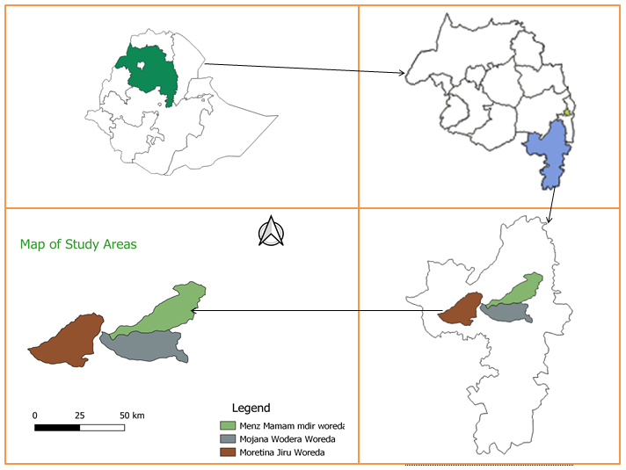

Figure 1: map of the study areas

**Approach followed and materials used**

As the starting point of the activities, the entry zonal workshop was organized by inviting different stakeholders from zone agricultural office professionals, seed union, cooperative experts, researchers, government administrative bodies (Leaders/managers), woreda and kebele agricultural experts participated and responsibility sharing to conduct the activity easily way. Farmers' selection and farmland clustering were done by woreda and kebele agricultural experts and researchers based on farmers’ willingness. The varieties used for this activity were Senate, Ogolcho, and Lemu at different woredas and clusters independently. The seed and fertilizer rates for all varieties were 150 kg/ha 225 NPS and 275 UREA kg/ha respectively. Both practical and theoretical training was organized about the importance & characteristics of improved bread wheat varieties, agronomic practice, and disease & pest control mechanisms for kebele agricultural experts and participant farmers. The required amount of seed was given to host farmers with a seed repayment system based on the cluster approach. The recommended agronomic practice was applied with the help of kebele agricultural experts and researchers. Continuous field monitoring and evaluation were done with the collaboration of researchers, Woreda & kebele agricultural experts, and cluster coordinator farmers from planting to harvesting time. The field day was organized by inviting different stakeholders to evaluate the performance of bread wheat varieties in the study area. The field day program, participant stakeholder’s reflection, performance of the introduced bread wheat as well as way forwarding was popularized by national and local TV and Radio programs.

***Capacity building and* awareness creation through training and experience sharing**

Capacity building helps small-scale farmers to improve agricultural practices, access new markets, adopt sustainable methods, and increase crop yields. Empowering smallholders is key to unlocking their potential to effectively contribute to the development agenda ([Feyissa et al., 2023](https://www.sciencedirect.com/science/article/pii/S0301479724025222" \l "bib31) [Kumar, 2023](https://www.sciencedirect.com/science/article/pii/S0301479724025222" \l "bib47)). Training engages the transfer of new knowledge, skills, technology, behavior, and attitude to build up and continue the farmers' competencies to carry out their allocated tasks more efficiently and resources fully. Likewise, farmers necessitate training to magnify yield per unit area because agricultural knowledge and technology are constantly changing and farmers need to keep abreast of new technologies (Ahmad, et al., 2005). To improve the awareness level of both host farmers and experts, training was given about the improved bread wheat agronomic management and other related issues. In total, more than 221(18% female)farmers and experts participated in the training program. The theoretical training given to participant farmers and experts about the agronomic management of bread wheat capacitated their skill and awareness level which helped them to adopt and apply the technology easily. Most of the training participant farmers applied the recommended bread wheat agronomic package exactly and their fields were net and better performed.

**Seed dissemination, area coverage, and beneficiary farmers**

Seed is among the most key inputs for improving crop production and productivity. The use of improved, high-yielding crop varieties is an important way to reduce hunger and food insecurity in developing countries (Teressa T., 2019). Transfers of improved technologies are critical prerequisites for agricultural development particularly for an agrarian-based economy such as Ethiopia (Abebe G., et al, 2017). During the two study years, three improved bread wheat varieties (Senate, Ogolcho, and Lemu) were distributed at different clusters of the three woredas based on a seed repayment system. As a result, more than 53.36 quintals of improved bread wheat seed were distributed and covered 35.44 hectares of farmland by participating 98 (8.2 % female) farmers.

**Monitoring and Evaluation**

The role of monitoring is seen as one of regular and continuous tracking of inputs, outputs, outcomes, and impacts of development activities against targets. It determines whether adequate implementation progress has been made to achieve outcomes, and provides management with information to enhance implementation (FAO, 2010). Monitoring and evaluation can be carried out at various levels within a research system and at different stages in the life cycle of the activities under scrutiny (ISNAR, 1990). For these intervention activities, continuous monitoring and evaluation were done by concerned experts more than three times. During monitoring and evaluation, e woreda & kebele agricultural experts, farmers, and researchers participated. Challenges and possible solutions raised by a team of evaluators during field supervision and evaluation time. Shortage of urea fertilizer (Solution, use organic fertilizer and eco-green fertilizers), remove excess water from the farmland, remove weeds by hand weeding & using chemicals, and also when rust occurs: (Use tilt and other fungicide chemicals) (Figure 2).

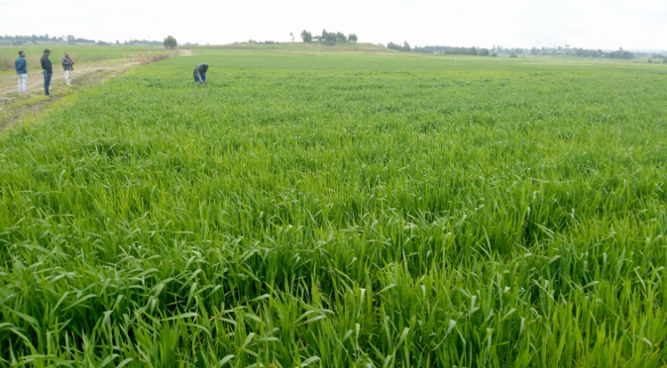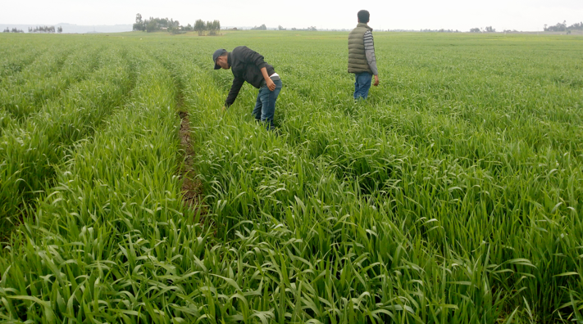

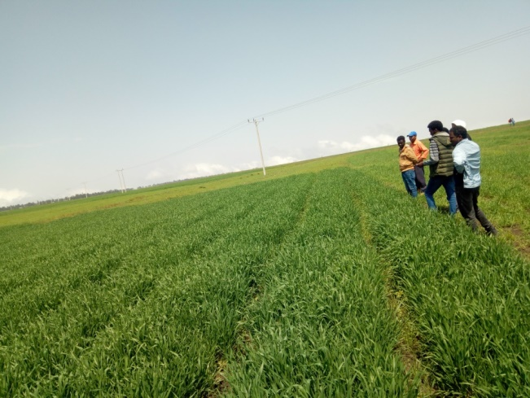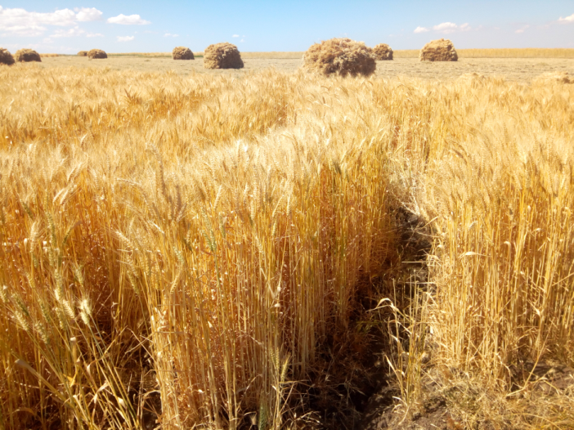

Figure 2: picture taken during field monitoring

**Field day and Technology popularization**

Field day is an extension teaching method used by extension workers to explain improved agricultural technologies to farmers (Ajayi, 2001). Field days are important because they provide a forum for interaction between farmers and extension staff and among farmers themselves for sharing new information and experiences (Osward, 2005). The field day creates an opportunity for farmers to share information, observe performance, and deliberate on technological attributes (Emerick, K., & Dar, M. H., 2021). Field days are both cost-effective and more impactful for poorer farmers to be easily aware and adopt new technologies. More than three field days were organized by inviting different stakeholders and the information was popularized by Amhara TV news, FM Radio programs, and Documentary film Extension Case team Field day Video\Improved Wheat .mp4. During the field day program, more than 278(8.3% female)host farmers, experts, and administrative bodies participated and reflected their views and way-forwarding mechanisms. During the field day, more than 84 sheets of leaflets were disseminated to farmers and other stakeholders (Figure 3).

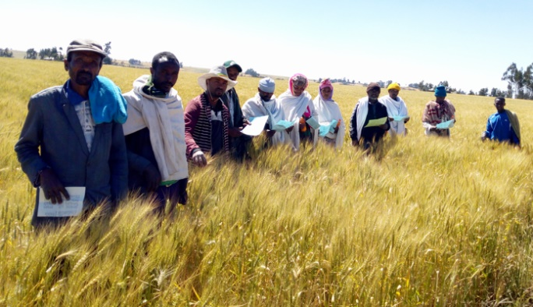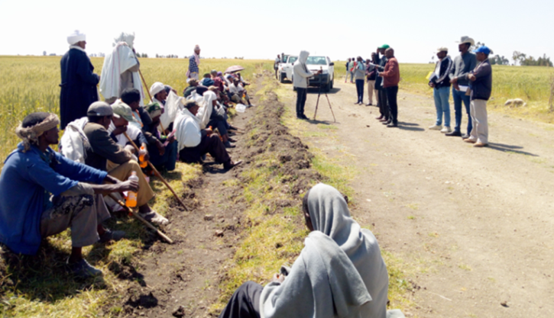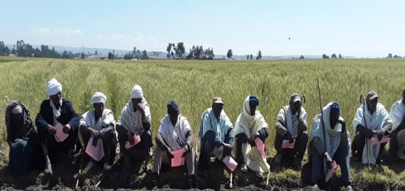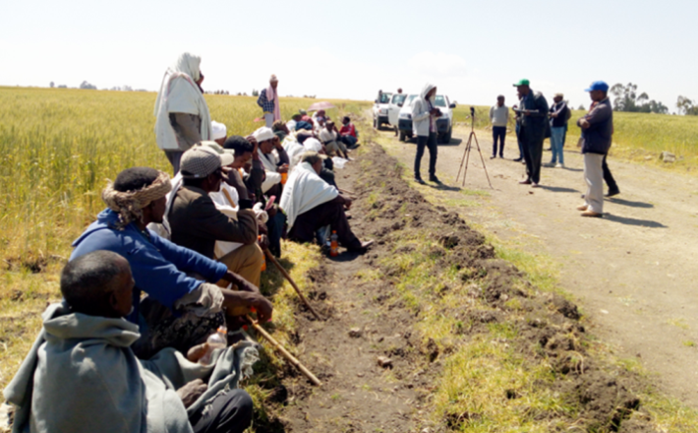

Figure 3: picture taken during field day programs

**Farmers’ and experts' reflection during field day**

Farmers were comparing the improved bread wheat variety with the local/standard check variety. The improved bread wheat varieties of Lemu, Ogolcho, and Senate contain more of a tiller, several seeds per plant, and longer spike length, the straw is palatable for animals, relatively disease tolerant, early matured variety, and gives better straw & grain yield. The sustainability of the seed supply system can be through; multi-disciplinary team stakeholders approach participation, establishing and strengthening seed-producing and marketing cooperatives (Formal seed exchange systems). Strengthening farmers to farmers' seed exchange systems in the community (Informal seed exchange systems). During the field day, responsibility and experience were shared among each other for sustainable bread wheat production and productivity improvement and also reducing poverty. Therefore these scaling-up activities would scale down for the stakeholders to expand their intervention strategies in the wheat potential areas of North Shewa Zone.

**Data Collection and Analysis**

Farmers' & agricultural experts' perceptions of the introduced varieties were collected through a semi-structured questionnaire**.** Field day participant stakeholders' reflections on the implemented activities and way forwarding were collected. Yield and Yield-related data were collected by X-fashion using quadrant sampling methods from each cluster and adjacent bread wheat farms. The major bread wheat production challenges of the study location were collected. Farmer’s perception and major production challenges were analyzed using Likert scale methods and chi-square test using SPSS software. A Likert rating scale was used to analyze the respondents’ attitudes and perceptions toward a product, service, activity, and more (Likert R.A, 1932). In this research, the sample host farmers were asked to indicate their level of agreement and specify the characteristics of the introduced bread wheat varieties. The set of alternatives provided to the farmers were “strongly disagree” (1), “disagree” (2), "neutral” (3), “agree” (4), and “strongly agree” (5). The highest value (5) indicates how highly farmers were perceived in the statement, and the statement presented for assessment is being embodied. The lowest value (1) indicates the weakest agreement of farmers, and the statement being presented is not being embodied. The same as that of bread wheat production constraints in the study areas, farmers' perceptions were recorded as very serious, serious, medium, and no problem.

$$Yield advantage of the improved technology$$

$=\frac{Yi-Yj}{Yj} x 100$……………………… 1

**Where**: Yi: average yield of the improved technology and

Yj: average yield of the local variety

Technological gap, extension gaps, and the technological index between the farmer practice and the improved technologies were calculated using the following formulas suggested by (Samui et al., 2000).



$TG=Y_{i}-Y_{j} …….…………………………2$

$VG={PY}_{i}-Y_{i} ……………………………… 3$

$TI=\frac{TG}{{PY}_{i}}x 100 ..………………………………4$

Where: TG: technological gap, VG: variety gap, PYi: potential yield of the improved technology, TI: technological index.

**RESULT AND DISCUSSION**

**Yield advantage of the introduced bread wheat varieties.**

At Majana wodera woreda, the highest grain yield (68.4 quintals per hectare) was obtained from the Lemu variety with a yield advantage of 33.89 % compared to the Dendea variety. At Menz lalo midir woreda, the highest grain yield (61.8 quintals per hectare) was recorded from the senate variety with a yield advantage of 46.88 % compared to the Hidase variety. The Lemu variety also gives the highest grain yield (67.4 quintals per hectare) with a yield advantage of 10.45 % compared to the Dendea variety at Moretina Jiru Woreda (Table 1).

Table 1: Average grain yield and yield advantage of introduced varieties

|  |  |  |  |
| --- | --- | --- | --- |
| Woreda | Variety | Average grain yield kg ha-1 | Yield advantage (%) |
| Mojana Wedera | Lemu | 6843.38 | 33.89 |
| Ogolcho | 5347.89 | 4.63 |
| Dendea | 5111.16 | **-** |
| Menz Lallo | Ogolcho | 5189.65 | 23.31 |
| Sanate | 6181.32 | 46.88 |
| Hidase | 4208.38 | **-** |
| Moretina Jiru | Lemu | 6744.14 | 10.45 |
| Sanate | 6421.11 | 5.16 |
| Dendea | 6106.24 | **-** |

**Farmer perception in scaling improved bread wheat varieties**

The perception of the farmers’ was measured using the character of the varieties and the challenges of the farmers in producing the varieties. The character of the varieties was assessed with their adaptability, tillering capacity, spike length, grain size, rust-tolerant, maturity date, plant height, yield, and straw biomass. The challenge of the farmers was measured in terms of the damage of disease, access to diverse varieties, seed availability, disease tolerance, cost of seed, and weed damage. Furthermore, the study considered the shortage of inputs, including fertilizer and chemicals, as an important challenge for the farmers in the production of improved bread wheat varieties in the study area. The character and challenges of the varieties are discussed below.

**Attributes of the varieties**

The adaptability of the varieties refers to how the introduced varieties adapt to the weather conditions and soil type so that to perform well in the production season at the study areas. The other variety traits like tillering capacity, spike length, grain size, and plant height are the determinant factors for grain and biomass yield which is directly related to farmers' interest. Due to rust being the major bread wheat production constraint, tolerance to rust is the better merits of farmers' preferred varieties. In addition, a maturity date of the variety directly related to frost or dry wind escaping mechanize of the variety which had major yield loss in the study areas.

**Challenges of the farmers**

The major bread wheat production challenges of farmers were damage from disease, lack of access to diverse varieties, low improved seed availability, lack of disease tolerant varieties, high cost of seed and chemical fertilizer, low availability of chemical fertilizer, and weed damage. The most economically important disease for bread wheat production is yellow rust which significantly damages the yield. Farmers tried to prevent yellow rust by applying chemicals. However, due to a lack of effective chemicals and wrong application methods at the locality, the diseases significantly affect the yield every year. The availability of improved seeds is also a major challenge in most of the study areas. While improved bread wheat seed is available, its cost is very high compared to the grain farmers delivered to the market. As a result, most farmers preferred to use their seed instead of using the improved/ quality declared/ bread wheat seed. The availability, accessibility, and affordability of agrochemical and chemical fertilizers are serious issues in the study areas. Most of the agrochemical traders are nonprofessional with informal market chains and they deliver ineffective and expired chemicals at high costs which farmers can't afford to buy. It is well-known that the chemical fertilizer is delivered by the government and recently the availability and affordability of it have been in serious condition. Most of the study areas are characterized by heavy black vertisol which needs more chemical fertilizer to be able to produce better wheat yield, however, farmers could not easily access this chemical fertilizer at the required time.

The applicability of agricultural technologies in developing countries was influenced by farmer’s attitudes to the characteristics of the introduced technologies (Meijer et al., 2015). Therefore identifying and analyzing the aptitudes and perceptions of host farmers' helps to further scale out the introduced improved bread wheat varieties as well as to understand their priority traits for future research on the crop. The perception and reflection of host farmers were assessed during the field day and after the crops were harvested using semi-structured mini questionnaires. The collected Likert scale data of farmers' perception of the introduced varieties was analyzed using the Kruskal-Wallis Test to compare the varieties using the major bread wheat selection traits. Due to varietal differences across the three study woredas, the farmer's perception data were analyzed independently for each woreda. At more tina jiru woreda, the Kruskal-Wallis test result of comparing the two bread wheat varieties by farmers' perception data had statistically significant variation by tillering capacity, spike length, and expected straw yield. 100% of the sample households strongly agree on the tillering capacity of the lemon variety. More than 85% of the respondent households strongly agree on the spike length of the lemur

Variety. More than 80% of the households strongly agree on better straw yield of lemur variety (Table 2).

Table 2. Farmers' Perception of Improved Bread wheat Varieties at Moretina Jiru woreda (N=20)

|  |  |  |  |  |  |  |  |  |  |
| --- | --- | --- | --- | --- | --- | --- | --- | --- | --- |
| Perception parameters | Variety | Likert scale (%) | | | | | Kruskal-Wallis Test | | |
| SDA | DA | NU | A | SA | Mean Rank | Chi-Square | Sig |
| The variety was adapted to the area | Lemu | 0 | 0 | 0 | 25 | 75 | 23 | 2.6 | .107ns |
| Dendea | 0 | 0 | 0 | 50 | 50 | 18 |
| The variety was good tillering capacity | Lemu | 0 | 0 | 0 | 0 | 100 | 27.5 | 20.741 | .000*** |
| Dendea | 0 | 5 | 0 | 65 | 30 | 13.5 |
| The variety was long spike length | Lemu | 0 | 0 | 5 | 10 | 85 | 27.55 | 18.934 | .000*** |
| Dendea | 0 | 0 | 0 | 90 | 10 | 13.45 |
| The variety was good grain size | Lemu | 0 | 0 | 0 | 50 | 50 | 22 | .84 | .36ns |
| Dendea | 0 | 5 | 5 | 50 | 40 | 19 |
| The variety was rust-tolerant | Lemu | 0 | 20 | 0 | 20 | 60 | 22.4 | 1.253 | .263ns |
| Dendea | 0 | 5 | 5 | 60 | 30 | 18.6 |
| The variety was early maturing | Lemu | 0 | 0 | 5 | 75 | 20 | 18.63 | 1.473 | .225ns |
| Dendea | 0 | 5 | 0 | 55 | 40 | 22.38 |
| The variety has a longer plant height. | Lemu | 0 | 0 | 0 | 50 | 50 | 19.25 | .613 | .434ns |
| Dendea | 0 | 0 | 5 | 30 | 65 | 21.75 |
| The variety expected to give a better grain yield | Lemu | 0 | 0 | 0 | 55 | 45 | 21.55 | .414 | .52ns |
| Dendea | 0 | 0 | 10 | 50 | 40 | 19.45 |
| The variety expected to give a better straw yield | Lemu | 0 | 0 | 0 | 20 | 80 | 25.2 | 8.535 | .003*** |
| Dendea | 0 | 0 | 10 | 55 | 35 | 15.8 |

Note: ***, ** and * significant at p<0.01, p<0.05 and p<0.1, respectively. Where, NS= Non-significant, SDA=strongly disagree,

DA=Disagree, Nu=Neutral, A=Agree, SA=strongly agree.

The results of the Kruskal-Wallis test at Menz Lalo Midir Wereda revealed host farmers' perception data had statistically significant differences between the two bread wheat varieties in terms of tillering capability, spike length, grain size, and plant height. 65% of the households who responded strongly concur that the Lemu variety outperformed the Hidase type in terms of tillering capacity. Most respondent households (85%) strongly agree that the Ogolcho variety had longer spike lengths than the Hidase variety. But also, 80% of households strongly agree that the Ogolcho variety outperformed the Hidase type in terms of grain size. In Menz lalo midir woreda, 75% of the households strongly believe that the Ogolcho variety had longer plant heights than the Hidase variety (Table 3).

Table 3. Farmers' Perception of Improved Bread wheat Varieties at Menz Lallo woreda (N=20)

|  |  |  |  |  |  |  |  |  |  |
| --- | --- | --- | --- | --- | --- | --- | --- | --- | --- |
| Perception parameters | Variety | Likert scale (%) | | | | | Kruskal-Wallis Test | | |
| SDA | DA | NU | A | SA | Mean Rank | Chi-Square | Sig |
| The variety was adapted to the area | Ogolcho | 0 | 0 | 20 | 10 | 70 | 22.55 | 1.540 | .215ns |
| Hidase | 0 | 5 | 0 | 55 | 40 | 18.45 |
| The variety was good tillering capacity | Ogolcho | 0 | 0 | 20 | 15 | 65 | 23.43 | 2.949 | .086* |
| Hidase | 0 | 15 | 0 | 55 | 30 | 17.58 |
| The variety was long spike length | Ogolcho | 0 | 0 | 5 | 10 | 85 | 25.55 | 9.781 | .002*** |
| Hidase | 0 | 15 | 5 | 45 | 35 | 15.45 |
| The variety was good grain size | Ogolcho | 0 | 0 | 10 | 10 | 80 | 25.75 | 9.840 | .002*** |
| Hidase | 0 | 25 | 10 | 35 | 30 | 15.25 |
| The variety was rust-tolerant | Ogolcho | 5 | 30 | 30 | 20 | 15 | 17.90 | 2.134 | .144ns |
| Hidase | 5 | 15 | 0 | 55 | 25 | 23.10 |
| The variety was early maturing. | Ogolcho | 0 | 0 | 0 | 40 | 60 | 19.20 | .743 | .389ns |
| Hidase | 0 | 5 | 0 | 20 | 75 | 21.80 |
| The variety has longer plant height | Ogolcho | 0 | 0 | 0 | 25 | 75 | 25.63 | 10.006 | .002*** |
| Hidase | 0 | 5 | 0 | 70 | 25 | 15.38 |
| The variety expected to give a better grain yield | Ogolcho | 0 | 0 | 15 | 15 | 70 | 22.50 | 1.518 | .218ns |
| Hidase | 0 | 10 | 10 | 30 | 50 | 18.50 |
| The variety expected to give a better straw yield | Ogolcho | 0 | 15 | 15 | 10 | 60 | 22.20 | .985 | .321ns |
| Hidase | 0 | 25 | 5 | 30 | 40 | 18.80 |

Note: ***, ** and * significant at p<0.01, p<0.05 and p<0.1, respectively. Where, NS= Non-significant, SDA=strongly disagree,

DA=Disagree, Nu=Neutral, A=Agree, SA=strongly agree.

The results of the Kruskal-Wallis test at Mojana wider woreda revealed that host farmers' perception data showed statistically significant differences between the three varieties by all traits except rust tolerance. Most of the respondents (83.3%) and (100%) strongly agree on the tillering capacity and long spike length of the Ogolcho variety respectively (Table 4).

Table 4. Farmers' Perception of Improved Bread wheat Varieties at Mojana Wedera woreda (N=24)

|  |  |  |  |  |  |  |  |  |  |
| --- | --- | --- | --- | --- | --- | --- | --- | --- | --- |
| Perception parameters | Variety | Likert scale (%) | | | | | Kruskal-Wallis Test | | |
| SDA | DA | NU | A | SA | Mean Rank | Chi-Square | Sig |
| The variety was adapted to the area | Ogolcho | 16.7 | 8.3 | 0 | 8.3 | 66.7 | 21.71 | 6.092 | .048* |
| Lemu | 0 | 8.3 | 8.3 | 16.7 | 66.7 | 20.83 |
| Dendea | 8.3 | 8.3 | 0 | 66.7 | 16.7 | 12.96 |
| The variety was good tillering capacity | Ogolcho | 0 | 0 | 0 | 16.7 | 83.3 | 22.58 | 6.797 | .033* |
| Lemu | 0 | 0 | 0 | 33.3 | 66.7 | 19.67 |
| Dendea | 0 | 8.3 | 0 | 58.3 | 33.3 | 13.25 |
| The variety was long spike length | Ogolcho | 0 | 0 | 0 | 0 | 100 | 26.00 | 21.593 | .000*** |
| Lemu | 0 | 0 | 0 | 33.3 | 66.7 | 20.67 |
| Dendea | 0 | 25 | 8.3 | 58.3 | 8.3 | 8.83 |
| The variety was good grain size | Ogolcho | 0 | 0 | 8.3 | 8.3 | 83.4 | 23.71 | 16.144 | .000*** |
| Lemu | 0 | 8.3 | 0 | 16.7 | 75 | 22.21 |
| Dendea | 0 | 8.3 | 8.3 | 83.3 | 0 | 9.58 |
| The variety was rust-tolerant | Ogolcho | 8.3 | 16.7 | 16.7 | 33.3 | 25 | 16.04 | 3.415 | .181ns |
| Lemu | 16.7 | 8.3 | 0 | 8.3 | 66.7 | 22.92 |
| Dendea | 25 | 8.3 | 8.3 | 33.3 | 25 | 16.54 |
| The variety was early maturing | Ogolcho | 0 | 8.3 | 0 | 16.7 | 75 | 26.33 | 12.228 | .002*** |
| Lemu | 0 | 16.7 | 0 | 66.7 | 16.7 | 13.92 |
| Dendea | 0 | 16.7 | 0 | 58.3 | 25 | 15.25 |
| The variety has longer plant height | Ogolcho | 0 | 0 | 0 | 0 | 100 | 27.50 | 18.880 | .000*** |
| Lemu | 0 | 8.3 | 0 | 50 | 41.7 | 16.83 |
| Dendea | 0 | 8.3 | 0 | 83.3 | 8.3 | 11.17 |
| The variety expected to give a better grain yield | Ogolcho | 0 | 0 | 0 | 16.7 | 83.3 | 23.17 | 5.972 | .050* |
| Lemu | 0 | 0 | 8.3 | 33.3 | 58.3 | 18.29 |
| Dendea | 0 | 0 | 8.3 | 58.3 | 33.3 | 14.04 |
| The variety expected to give a better straw yield | Ogolcho | 0 | 0 | 0 | 25 | 75 | 25.13 | 14.476 | .001*** |
| Lemu | 0 | 0 | 0 | 58.3 | 41.7 | 19.29 |
| Dendea | 0 | 8.3 | 0 | 91.7 | 0 | 11.08 |

Note: ***, ** and * significant at p<0.01, p<0.05 and p<0.1, respectively. Where, NS= Non-significant, SDA=strongly disagree, DA=Disagree, Nu=Neutral, A=Agree, SA=strongly agree.

As mentioned in the introduction, several factors contribute to Ethiopia's lower productivity and production of bread wheat among smallholder farmers. The major issues with bread wheat production were evaluated in this study using a semi-structured questionnaire and analyzed using Likert scale methods in each intervention woreda. This was done because it is crucial to assess site-specific production constraints to suggest location-specific recommendations and ways of forwarding. According to the participating households' responses, the main (very serious) issues with bread wheat production in Mojana wider woreda were the cost of chemical fertilizer (100%), the absence of wheat varieties resistant to diseases (91.7%), the scarcity of fertilizer (79.2%), the high cost of seeds (70.8%), the high cost of chemicals (62.5%), and the lack of improved bread wheat varieties (58.3%) (Table 5).

Table: 5 Major production challenges of bread wheat in the study areas (N= 60)

|  |  |  |  |  |  |  |
| --- | --- | --- | --- | --- | --- | --- |
| **Constraints of bread wheat production** | **Likert scale (%)** | | | | **Chi-Square** | **Sig** |
| Very serious | Medium | Low | Not a problem |
| Breadwheat disease damage | 37.5 | 32.2 | 23.9 | 6.4 | 10.8 | 0.31ns |
| Lack of improved bread wheat varieties | 39.4 | 26.1 | 3.7 | 24.7 | 18.2 | 0.02** |
| Lack (shortage) of improved seed | 53.1 | 19.4 | 11.1 | 16.4 | 338.1 | 0.04**\*\*** |
| Lack of disease-tolerant bread wheat varieties | 62.2 | 29.4 | 6.7 | 0 | 16.4 | 0.02**\*\*** |
| High cost of seed | 56.9 | 26.4 | 3.3 | 13.3 | 5.4 | 0.04** |
| Weed damage | 44.4 | 22.5 | 23.1 | 10 | 0.36 | 0.67ns |
| Shortage of fertilizer | 93.1 | 4.2 | 1.4 | 1.4 | 37.8 | 0.00*** |
| High cost of fertilizer | 96.7 | 3.3 | 0 | 0 | 5.6 | 0.04** |
| Unavailability of chemicals | 40.3 | 22.2 | 16.1 | 21.4 | 3.2 | 0.45ns |
| High cost of chemicals (herbicide & insecticide) | 69.2 | 27.8 | 1.7 | 1.4 | 11.4 | 0.05** |
| Marketing problem | 33.9 | 14.7 | 21.7 | 29.7 | 14.3 | 0.03** |
| Soil fertility problem | 13.9 | 25.8 | 19.2 | 41.1 | 5.3 | 0.42ns |
| Frost problem | 19.7 | 30.3 | 38.6 | 11.4 | 9.5 | 0.04* |
| Moisture stress (Deficiency) | 5 | 16.4 | 4.4 | 74.2 | 33.1 | 0.00** |
| Crop rotation problem | 1.4 | 6.1 | 21.7 | 70.8 | 334.6 | 0.00** |

The survey results from the three woredas found that most of the sample households identified shortage of fertilizer (93.1%) and fertilizer costs(96.7%) as their top challenges in producing bread wheat. These were followed by the high cost of agro chemicals (69.2%), lack of disease-tolerant wheat varieties (62.2%), high seed costs (56.9%), and shortage of improved seed (53.1%) (Table 5).

The T-test result in Table 6at Menz Lalo Midir woreda shows that there was a statistically significant difference in all agronomic parameters between the Ogolcho and Hidase varieties. In terms of production, the Ogolcho variety (5527.19 kg/ha) outperformed a higher yield than the Hidase variety (4208.38 kg/ha). Therefore scaling out the Ogolcho variety in the study areas helps farmers to improve their bread wheat production as well as their household income. To achieve this, the concerned stakeholders like the Woreda Office of Agriculture, cooperatives, and other non-governmental organizations working on farmers' livelihood improvement and agriculture need to introduce the Ogolcho variety in the formal seed system in the locality to create better seed access for them.

Table: 6 Mean values of yield and yield-related attributes at Menz Lallo Woreda

|  |  |  |  |  |  |
| --- | --- | --- | --- | --- | --- |
| Varieties | Menz Lallo | | | | T-Test |
| Ogolcho | | Hidase | |
| Mean | Std. deviation | Mean | Std. deviation |
| Plant height | 108.4 | 11.64 | 82.63 | 13.38 | 7.96*** |
| Number of tillers | 5.4 | 3.2 | 2.27 | 1.14 | 5.05*** |
| Spike length | 7.97 | 0.99 | 6.9 | 0.92 | 4.3*** |
| Number of seeds per spike | 48.4 | 8.32 | 31.77 | 6.81 | 8.5*** |
| Biomass (kg ha-1 ) | 15587.25 | 3127.48 | 11060.71 | 7184.51 | 3.532* |
| Grain Yield (kg ha-1) | 5527.19 | 1150.04 | 4208.38 | 2740.55 | 3.942* |

All agronomic traits in Mojana Wedera woreda showed a statistically significant difference between the Ogolcho and Dendea cultivars, except grain and biomass yield. Conversely, only spike length and grain yield showed a statistically significant difference between the Lemu and Dendea varieties in the intervention areas (Table 7).

Table: 7 Mean values of yield and yield-related attributes at Mojana Wedera Woreda

|  |  |  |  |  |  |
| --- | --- | --- | --- | --- | --- |
| Varieties | Mojana Wedera | | | | T-Test |
| Ogolcho | | Dendea | |
| Mean | Std. deviation | Mean | Std. deviation |
| Plant height | 106.68 | 8.1 | 102.3 | 5.42 | 2.466** |
| Number of tillers | 6.62 | 3.41 | 2.37 | 1.9 | 5.977*** |
| Spike length | 8.76 | 1.4 | 7.4 | 1.05 | 4.177*** |
| Number of seeds per spike | 50.77 | 9.67 | 46.67 | 8.33 | 1.76* |
| Biomass Yield (kg ha-1 ) | 15048.46 | 2243.88 | 12824.74 | 970.1 | 1.58ns |
| Grain Yield (kg ha-1) | 5347.89 | 422.16 | 5111.16 | 372.81 | 0.769ns |
| Varieties | Mojana Wedera | | | | T-Test |
| Lemu | | Dendea | |
| Mean | Std. deviation | Mean | Std. deviation |
| Plant height | 99.97 | 7.02 | 102.3 | 5.42 | 1.44ns |
| Number of tillers | 1.90 | 1.54 | 2.37 | 1.9 | 1.051ns |
| Spike length | 9.27 | 0.89 | 7.4 | 1.05 | 7.31*** |
| Number of seeds per spike | 47.63 | 6.70 | 46.67 | 8.33 | 0.495ns |
| Biomass Yield (kg ha-1 ) | 21595.38 | 3991.17 | 12824.74 | 970.1 | 2.956ns |
| Grain Yield (kg ha-1) | 6843.38 | 1398.19 | 5111.16 | 372.81 | 3.65*** |

The highest yield advantage (33.89 %) was obtained from the Lemu variety at Mojana Wedera woreda followed by the Ogolcho variety (31.34%) at Menz Lalo Midir woreda and Lemu variety (17.37%) at Moretina Jiru woreda (Table 8). The technological gab (TG), variety gab (VG), and technological index (TI) were analyzed using the appropriate formula.

Table: 8 Technological Impact on YA (%), TG, VG & TI

|  |  |  |  |  |  |  |
| --- | --- | --- | --- | --- | --- | --- |
| Woreda | Variety | Average grain yield kg ha-1 | Yield advantage (%) | Technological gap (kg ha-1) | Variety gap (kg ha-1) | Technological index (%) |
| Mojana Wedera | Lemu | 6843.38 | 33.89 | 1732.22 | -343.38 | 26.65 |
| Ogolcho | 5347.89 | 4.63 | 236.73 | -1347.89 | 5.92 |
| Dendea | 5111.16 | - | - | - | - |
| Menz Lallo | Ogolcho | 5527.19 | 31.34 | 1318.81 | -1527.19 | 32.97 |
| Hidase | 4208.38 | - | - | - | - |
| Moretina Jiru | Lemu | 7166.94 | 17.37 | 1060.7 | -666.94 | 16.32 |
| Dendea | 6106.24 | - | - | - | - |

**CONCLUSION AND RECOMMENDATION**

Wheat is the most important food security crop in the world as well as in Ethiopia. Despite its immense importance productivity is low under smallholder farmers due to biotic and abiotic factors. The research was done at three woredas of North Shewa Zone for two years with the objectives of creating wider demand, enhancing improved bread wheat seed multiplication, and creating linkage among possible actors**.** The improved bread wheat varieties were promoted through seed distribution, training, a field day, and extensive media coverage**.** The introduced bread wheat varieties gave up to 47% yield advantage over the local checks especially in high vertisol areas. Based on the farmer's perception and reflection, the Lemu variety is mostly preferred by farmers at Moretina jiru woreda while the Ogolcho variety is preferred by farmers at Menz lalo and Mojana wedera woreda. The major bread wheat production problems in the three woredas are the cost and shortage of chemical fertilizer, high cost of agrochemicals, lack of disease-tolerant wheat varieties, high seed costs, and shortage of improved bread wheat seed.

The technological and variety gap of the introduced varieties were also assessed and reached up to 17 and 15 Quintals per harespectively. As a result, concerned experts and Development agents should support farmers to use the recommended improved agricultural technologies by delivering continuous practical and theoretical training, field field-level technical support during land preparation, planting, harvesting, trashing, and postharvest handling to reduce the technological gap. But also, creating access to improved agricultural technologies and agricultural markets by establishing local farmers' cooperatives to increase their bargaining power As a recommendation, scaling out of these varieties with improved agronomic management like controlling rust and other diseases, strengthening seed systems through seed production and marketing cooperatives, unions, and seed enterprise, and solving the identified bread wheat production problems through a multidisciplinary team approach.

**ACKNOWLEDGMENT**

The authors would like to express their gratitude to DBARC/ARARI and AGP-II for providing the logistic and financial support needed to carry out this study; to the host farmers who generously donated their farmland and their valuable time; and to the development agents, woreda and zonal level agricultural experts for their professional assistance during the study's execution.

**CONFLICT OF INTERESTS**

The authors declare that there is no conflict of interest regarding the publication of this article.

**FUNDING STATEMENTS**

The field and other related work of this research was supported by Amhara Regional Agricultural Research Institute

**REFERENCES**

Abebe, G., & Alemu, A. (2017). Role of improved seeds towards improving livelihood and food security in Ethiopia. *International Journal of Research-Granthaalayah*, *5*(2), 338-356.

Ahmad, M., Ali, T., Khan, A. S., & Yaseen, M. (2005). An appraisal of extension work by the private sector with special reference to plant protection: a case study. *Pakistan Entomologist*, *27*, 73-76.

Ajayi, M. T. (2001). Evaluation of the effectiveness of field days carried out by agricultural trainees as a technology transfer strategy. Journal of International Agricultural and Extension Education, 8(3), 57-64.

Anteneh, A., & Asrat, D. (2020). Wheat production and marketing in Ethiopia: Review study. *Cogent*

*Food & Agriculture*, *6*(1), 1778893.

Bezabeh, E. (2015). National Government vs. CIMMYT Investment Trends in Maize Research, Case of EIAR. *Research Journal of Agriculture and Environmental Management. Vol*, *4*(4), 192-196.

Bentley, A. R., Donovan, J., Sonder, K., Baudron, F., Lewis, J. M., Voss, R., ... & Govaerts, B. (2022). Near-to long-term measures to stabilize global wheat supplies and food security. *Nature Food*, *3*(7), 483-486.

Biggeri, M., Burchi, F., Ciani, F., & Herrmann, R. (2018). Linking small-scale farmers to the durum wheat value chain in Ethiopia: Assessing the effects on production and wellbeing. *Food Policy*, *79*, 77-91.

CSA (Central Statistical Agency). Agricultural sample survey: Report on area and production of major crops (Private peasant holdings, Meher Season 2021/2022). 2022; Volume III Statistical Bulletins 591, Addis Ababa, Ethiopia.

Emerick, K., & Dar, M. H. (2021). Farmer field days and demonstrator selection for increasing technology adoption. *Review of Economics and Statistics*, *103*(4), 680-693.

Erenstein, O., Jaleta, M., Mottaleb, K. A., Sonder, K., Donovan, J., & Braun, H. J. (2022). Global trends in wheat production, consumption, and trade. In *Wheat improvement: food security in a changing climate* (pp. 47-66). Cham: Springer International Publishing 2025

FAO (Food and Agricultural Organization of the United Nations). The use of monitoring and evaluation

in agriculture and rural development projects.2010 Rome Italy.

FAOSTAT(Food and Agricultural Organization of the United Nations Statistical Data). Crops and livestock products Data. Food and Agricultural Organization of the United Nations. 2024; <https://www.fao.org/faostat/en/#data/QCL>

Feyissa, F. Senbeta, A. Tolera, D.D. Guta(2023).Unlocking the Potential of Smallholder Dairy

Farms: Evidence from the central highland of Ethiopia. Journal of Agriculture and Food

Research, 11 (2023), Article 100467

Gebreegziabher, W., Dilnesaw, Z., Hailu, T., Tadesse, M., & Berhe, M. (2018). Adaptation and Promotion of Irrigated Wheat Genotypes at Tendahoo Sugar Factory, Afar Regional State of Ethiopia. *Int. J. Adv. Res. Biol. Sci*, *5*(10), 70-83.

ISNAR (International Service for National Agricultural Research). Highlight of a consultation on Monitoring and Evaluation of Agricultural Research. The Hague, November 12-14, 1990.

S. Kumar 92023).Unlocking the potential of smallholder farming systems for sustainable development.

Farming System, 1 (2023), pp. 1-2

Likert R. A., Technique of measurement of attitude, *Journal of Archives of Psychology*. (1932) **140**, no.

44.

Meijer, S. S., Catacutan, D., Ajayi, O. C., Sileshi, G. W., & Nieuwenhuis, M. (2015). The role of knowledge, attitudes, and perceptions in the uptake of agricultural and agroforestry innovations among smallholder farmers in sub-Saharan Africa. *International journal of agricultural sustainability*, *13*(1), 40-54.

MoARD (Ministry of Agriculture and Rural Development). "Crop Variety Registers," Ministry of Agriculture and Rural Development (MoARD), Addis Ababa, Ethiopia, 1953-2016.

NBE (2022). National Bank of Ethiopia Annual Bulletin.

Osward, A. (2005). Striga Control-Tchnologies and their dissemination. Crop protection, 24(4), 333-342.

Shikur, Z. H. (2020). Agricultural policies, agricultural production and rural households’ welfare in Ethiopia. *Journal of Economic Structures*, *9*(1), 50.

Teressa, Temesgen. Demand and supply status of improved seed and factors governing it in Ethiopia. *Journal of Biology, Agriculture and Healthcare* 9, no. 3 (2019): 33-39).

World Bank. World Development Report. Washington, DC: The World Bank. 2008.