**Impact of boset teff variety adoption on household farm income in Minjar Shenokora district, Amhara Region, Ethiopia**

**Alebachew Molla**,Ethiopian Institute of Agricultural Research, Debre ziet Agricultural Research Centre, PO.Box Bishoftu, Ethiopia,Email [alebachewslove@gmail.com](mailto:alebachewslove@gmail.com)

**Marelign Adugna** (PhD), Department of agricultural economics, University of Gondar,Gondar,Ethiopia, marlynk3@gmail.com

**Assefa Tilahun** (PhD), Department of agricultural economics, University of Gondar,Gondar,Ethiopia, [aseefa37@gmail.com](mailto:aseefa37@gmail.com)

**Corresponding Author Alebachew Molla,** [alebachewslove@gmail.com](mailto:alebachewslove@gmail.com)

**Abstract:** the government of Ethiopia renew their interest on improved variety adoption to improve farmer’s income, motivated this study which aims to analyse boset variety were play a great role in improving households farm income. We applied endogenous switching regression method to drive the impact of boset teff variety on household farm income using household level structural survey data. Estimates of ESR model indicated that using boset teff variety affects positively and significantly the household farm income. More over improved boset teff variety adoption had a positive and significant impact on household’s farm income such as the observed difference of average treatment effect in household farm income between adopter and non-adopter group were Ethiopian birr 18694.22. In the counterfactual condition, adopter groups were gained benefit than non-adopter groups. So to improve households’ farm income boset teff variety and information related with boset teff variety should be disseminated to other areas.

**Key words Minjar Shenkora, impact, Boset, ESR, Farm income**

# Introduction

Over the next few decades, global agriculture will encounter a number of difficulties. A more varied diet will be required to feed the world's expanding and increasingly affluent population, thus it must produce more food (Cleland, 2013). According to the World Bank (2016), millions of people live in extreme poverty in Sub-Saharan Africa (SSA), one of the regions in the world that is predominantly defined by farm households whose livelihoods depend mostly on agriculture.

According to research by Gebretsadik et al. (2009), teff grains are ground into flour, combined with water to create a slurry, fermented for two or three days, and baked into a soft, flat bread that resembles pancakes, or "Injera" as they are known locally.

Either expanding the area covered or raising agricultural productivity could improve agricultural output (Cleave and Donovan, 1995). However, operating on the vast margin is extremely challenging in Ethiopia due to the lack of available land. Therefore, investing in agricultural technologies to increase productivity is the practical means of achieving this goal (Mohammed, 2014).

When a development intervention interacts with the various components influencing development change, it can result in negative or positive changes that are direct or indirect, planned or unforeseen in the context of its environment. An intervention can have short-, medium, and long-term effects. Impact happens at different levels and during different time periods. Depending on the type of intervention and the setting, different effects will manifest at different times (Rogers et al., 2012).

A systematic and empirical study of the effects that an intervention produces, impact evaluation aims to determine whether an intervention has improved people's lives. An empirical investigation known as "impact evaluation" measures how interventions affect the desired outcomes. A comparison between the outcomes of an intervention and an empirically calculated counterfactual scenario of what would have occurred in the absence of the intervention forms the basis of impact evaluations. The measure of impact is the difference between the counterfactual and observed outcomes (White et al., 2017).

An impact evaluation assesses the primary, secondary, and beneficial long-term effects. The outcome of a development intervention evaluates the direct and indirect contributions of research on development interventions to the effects on end users, particularly the impoverished. It also describes how policy interventions influence an impact, whether they are intended or not. Other forms of evaluation often do not seek to prove the intervention's causal impact to development outcomes, albeit they can include assessing the intervention's results and unintended effects (Rogers et al., 2012).

Wordofa et al. (2021) investigated that in eastern Ethiopia, it was examined how the application of better agricultural crop technologies affected farm household income. The findings showed that households that used these technologies had greater yearly farm incomes than those that did not.

According to research by Habtewold (2021), the impact of implementing climate-smart agricultural crop technology on the multidimensional poverty status of rural households in Ethiopia is considerably greater in households with severe deprivation. It is also noted that the technology reduces multidimensional poverty by increasing income and consumption through improvements in production gain.

Mekonnen (2017) employed panel data to investigate how enhanced agricultural technology affects rural households' welfare using the probit model and productivity using the PSM technique. His research indicates that the decision to use chemical fertilizer and improved verities is positively and significantly correlated with farm size, labor, credit availability, land quality, and livestock assets. Additionally, the results of his study show that those who adopted agricultural technology earned more than those who did not.

Debelo (2015) employed PSM model to study the impact of improved Quncho teff variety on the farmer’s income in Wayu Tuqa District. Debelo takes 388 households as a sample and his research result indicated that adopters of Quncho teff variety were got 11,790.59 birr higher than non-adopters. According to studies conducted by Gebretsadiket al*.,* (2009) indicated that teff grains are milled into flour and mixed with water in order to form slurry and fermented for two or three days and bake in to a flat soft bread –just like pancake, which is locally known as “Injera”.

Debelo (2015) investigated how the improved Quncho teff variety affected farmers' incomes in Wayu Tuqa District using the PSM model. According to Debelo's research, adopters of the Quncho teff variety received 11,790.59 birr more than non-adopters, based on a sample of 388 families.

Debre ziet agricultural research centre released improved boset teff verities from 2012 up to now to the woreda by the support of government but researches are limited about the impact. Therefore evaluated this research helps in order to identify the impact of improved boset teff variety adoption on household farm income.

# Research Methodology

## Description of the Study Area

The study was carried out in Ethiopia's Amhara Region's Minjar Shenkora District in the North Shewa Zone. Arerti, the wereda's capital, is located 136 kilometers away from Ethiopia's capital. Situated further southward in the North Shewa zone, Minjar Shenkora District (MSD) is bordered to the north by Berehet woreda and Hgere Mariam. In the west, south, and east, the remaining boundary is shared with a portion of the Oromia Region. The study region is situated 260 kilometers to the south of Debre Berhan, the North Shewa zone's administrative center.

## Sampling Technique and Sampling Design

the data used in this study comes from farm household survey in Minjar Shenkora disistrict, North Shewa zone, Amhara region. Teff grower households were used as the universe of the study and sample households were sampling unit of the study. To select sample respondents from the population, multi stage sampling technique were used. There are 29 kebeles in the woreda.

Among this kebeles Boloselasie and Kombolcha supported by government and non-government organizations to adopt improved boset teff variety which were used as a sample kebele. In the first stage kebeles was identified randomly by simple random sampling technique. In the second stage sample households was stratified on adopter and non-adopter groups. In third stage sampled households were selected by simple random sampling technique with in the community at each selected kebeles by proportionate sample to size.

Therefore 246 households were be selected 80% adopter and 20% non- adopters from both kebeles for adopter and non-adopter groups as well as Sample was determined by cochran Formula because of populations that are large and heterogeneous.

Cochran (1963:75) equation yields a representative sample for proportions.

$n=\frac{Z^{2}pq}{ e^{2}}=\frac{{1.96}^{2}\left(0.8*0.2\right)}{{0.05}^{2}}=246$ Where

* n is the sample size
* Z is the abscissa of the normal curve that cuts off an area α at the tails and value for Z is found in statistical tables, which contain the area under the normal curve.
* e is the desired level of precision or error term
* p is the estimated proportion of the adopters in the population and q is 1-p

## Types, Sources and Methods of Data Collection

Qualitative and quantitative data were collected from primary and secondary sources. Secondary data were obtained from different sources statistical authority, ministry of agriculture, wereda agriculture offices and other concerned offices are considered which are relevant for this study. To collect the primary data structural interviews were applied. In addition to the primary and secondary data focus group discussion were conducted to clarified and support the research finding with qualitative information about impact of improved boset teff variety adoption and used to combine the information generated from the structured interview method. The study was based on the data of the last three years and the production year of 2012/2013E.C.

* 1. **Method of Data Analysis** 
     1. **Outcome variables**

The outcome variable employed in this study was farm income. The monetary difference between the amount of boset teff produced and the amount of local teff produced was used in this study to compute farm revenue. ESR was therefore used to quantify the impact.

## How to Apply Endogenous Switching Regression (ESR)

endogenous switching regression (ESR) of econometrics analysis were used to explore the determinants of improved teff variety adoption. According to the well-known studies conducted by (Gujarati (1995) investigated that Ignoring the minor differences between binary logit and binary probit models, the binary probit and binary logit models are quite similar, so they usually generate predicted probabilities that are almost identical and The choice between logit and probit models is largely a matter of convenience But the logit model is computationally easier to use and leads itself to a meaningful interpretation than the other types.

Binary probit regression is typically used when the dependant variables were dichotomous and the regressers may be continuous and dummy. The treatment is defined as a binary outcome of the use of improved teff variety by the households with value of “1” assigned to households that was adopters and “0” for non-adopters (Maddala, 1985). Non-adopter and adopters groups were identified based on the number of years of growing of improved teff variety.

In this study one year data (in the cropping year of 2013E.C) on area allocated to improved teff variety was used to classify two groups. Adopters was those that allocated land to improved boset teff variety for three or more consecutive years and non-adopters was those who did not allocate land to for at least one improved teff variety for three or more years.

Most of these studies tend to evaluate the impact of single technology adoption on productivity by using PSM and OLS method. Besides, OLS method couldn’t show the real impact of technology adoption on productivity since technology adoption decision has self –selection an endogeneity problem which make the OLS estimation biased. The result of PSM also could not show the pure impact of technology adoption on productivity, since adoption decision is highly influenced by unobserved factors like skill, knowledge and other unobserved factors, which could not handle by PSM.

In the study area, the placements of the intervention (boset teff adoption) were not randomly distributed. Hence, the decision to adopt boset variety is due to voluntariness. Therefore, it should be emphasized that farmers may self-select themselves as improved boset teff variety adopters, results selection bias. This selection bias may result from both observed (observed to the researcher) and unobserved (observed to the respondent but not the researcher) characteristics. Failure to account this bias could limit the true impact of the intervention.

Endogenous switching regression (ESR) was utilized in order to examine the impact of improved teff Variety (ITV) adoption on household farm income. PSM is a technique often used in observational causal studies and it uses observable characteristics to observation units in the sample to generate a control group that is comparable to the treated group (Rosenbaum and Rubin, 1983).

It constructs a statistical comparison group based on a model of probability of improved teff adopting, using observed characteristics. Based on this analysis was identified and compare the sample farmers annual farm income of adopters and non-adopters and also estimate the impact of the improved teff variety adoption on household farm income.

$Y=β_{°}+β_{1}X_{1}+…+β_{10}X_{10}+е$................................................................................. (1)

Where Y-is dependant variable, $β_{°}$- is constant, $β_{1},β_{2…….}β_{n}$- is parameters, $X_{1}X_{2}{……X}_{n}$- is independent variables, e- error term,

Adoption of improved variety may not be random, instead farmers may endogenously self-select in to using or not using decisions and such decisions are influenced by unobservable characteristics that may be correlated with the outcome variables. The outcome of adopters and non-adopters may not only due to observable but also unobservable characteristics of households; therefore we use endogenous switching regression (ESR). Following Di Falco et al., (2011) ESR measuring the impact of the adoption when treatment has not been randomly assigned and the treatment variable as endogenous is by using the instrumental variable method as well as the idea is to find unobservable exogenous variable that influence the participation variable but do not influence the outcome of the program.

By estimating a simultaneous equation model using the full information maximum likelihood method (FIML), ESR designs take into account both endogeneity and sample selection bias. This allowed us to control for selection and unobserved heterogeneity issues that might arise later when performing the basic estimation procedure (Lokshin & Sajaia, 2004). Furthermore, it adjusts for structural differences between the enhanced boset teff adopters and non-adopters with respect to the outcome functions, thereby accounting for selection bias resulting from unobserved factors that may influence both the decision to use improved teff and the outcomes (Alene & Manyong, 2007).

Additionally, according to Lokshin & Sajaia's (2004) study, there are two steps: first, the choice to adopt improved boset teff is modeled using standard limited dependent variable models; second, once the selection equation is obtained, the outcome variables are estimated independently for each group. The following is the selection formula to take part in the enhanced adoption of teff varieties

$D=Z_{i}β+ε_{i}$..................................................................................................................... (2)

Where, $Z_{i}$ represents the explanatory variables of the observed characteristics, $β$ is the parameters of the unknown to be estimated, $ε_{i}$ is random error and D represents farmers decide to participate in improved teff variety adoption ( $D_{1}^{*}$ decide to adopt and $D_{0}^{*}$ decide not to adopt) if D =1 if $D_{1}^{*}>D_{0}^{*}$ and D = 0 if $D_{1}^{*}<D_{0}^{*}$. Based on the selection Equation (2), Consider the following model which describes the behavior of two regression equations

$y_{1}=X_{1}ω_{1}+ϵ_{1} if D=1$.................................................................................................. (3)

$y_{0}=X_{0}ω_{0}+ϵ_{0} if D=0$....................................................................................................... (4)

Where $y_{i}$ is a vector of dependent variables representing outcomes for adopters ($y_{1}$) and non-adopters ($y_{0}$), $X_{i}$ is explanatory variables, $ω_{i}$ is a vector of parameters to be estimated, and $ϵ_{1}$,and $ϵ_{0}$ are error terms. The error terms from the three equations $ε$, $ϵ_{1}$, and $ϵ_{0}$ are assumed to have a trivariate normal distribution with mean vector zero and the following covariance matrix.

$cov\left(ε,ϵ_{1,}ϵ_{0}\right)=\left[\begin{matrix}σ_{ϵ0}^{2} & σ_{ϵ1ϵ0} & σ_{ϵ0ε} \\ σ_{ϵ1ϵ0} & σ_{ϵ1}^{2} & σ_{ϵ1ε} \\ σ_{ϵ0ε} & σ_{ϵ1ε} & σ_{ε}^{2}\end{matrix}\right]$.................................. ............................................. (5)

Where $σ_{ε}^{2}$ is the variance of the selection equation (equation 2), $σ_{ϵ0}^{2}$ and $σ_{ϵ1}^{2}$ are the variances of the outcome equations for non-adopters and adopters while $σ_{ϵ0ε}$ and $σ_{ϵ1ε}$ represent the covariance between, $ϵ_{1}$, and $ϵ_{0}.$ Following Di Falco et al., (2011), The full information maximum likely hood (FIML) estimator can be used to fit an endogenous switching regression that simultaneously estimates the selection and outcome equations to yield consistent estimates.

The key issue was controlling endogeneity and selection bias. endogeneity a bias A failure to consider and correct for endogeneity in research practice can lead to biased and inaccurate results but be controlled by finding instrumental variables that could be strongly correlated with the selection equation (boset adption) but not the outcome equations (farm income) (Wooldridge, 2010). Hence, having on the data set, this study used education of the household head as instrumental variables to properly identify the model. Following Falco et al. (2011), the validity of the selected instrumental variable was tested. Finally, the average treatment effect on the treated (ATT) and untreated (ATU) were computed by comparing the expected values of boset adopters and non-adopter households in actual and counterfactual outcome scenarios.

The average treatment effect on the treated (ATT) which represents the effect of improved boset teff varieties on household’s farm income that actually adopted the technology and calculated as the difference between equation (6) and (9) and untreated (ATU) were computed by comparing the expected values of the outcomes of the treatment and controlled groups in actual and counterfactual scenarios. The ESR can be used to compare the actual expected outcomes of adopters (6) and non-adopters (7), and to investigate the counterfactual hypothetical cases that the non-adopters did adopt (8) and the adopters did not adopt (9) as follows.

$E\left(y_{1} | D =1\right)=X_{1}ω_{1}+σ_{ϵ1ε}λ_{1}$...............................(6) Adopters with adoption (actual)

$E\left(y_{0} | D =0\right)=X_{0}ω_{0}+σ_{ϵ0ε}λ_{0}$............................. (7) non-adopters without adoption (actual)

$E\left(y_{0} | D =1\right)=X_{1}ω_{0}+σ_{ϵ0ε}λ_{1}$....................... (8) Adopters had they decided not to adopt (counterfactual)

$E\left(y_{1} | D =0\right)=X_{0}ω_{1}+σ_{ϵ1ε}λ_{0}$........................ (9) non-adopters had they decided to adopt (counterfactual)

The treatment effect is differentiated from heterogeneity effect. The treatment group may have more outcome than the counterfactual control group due to unobservable characteristics. Therefore the effect of base heterogeneity (BH1) is defined for the treatment group (Carter and Milon, 2005). The equation specified as the difference between equation (6) and (9) as well as for control group (BH2) specified as the difference between (8) and (7).

the effect called “transitional heterogeneity” (TH), estimates whether the effect of using boset is larger or smaller for households that use boset or for the households that did not use in the counterfactual case that they did use. The transitional heterogeneity is the difference between average treatment effect on treated and average treatment effect of on the untreated.

Table 1: Conditional expectations of heterogeneity effects

|  |  |  |  |
| --- | --- | --- | --- |
| Samples | Decision stage | | Treatment effects |
|  | To adopt | Not to adopt |  |
| Boset teff Adopter | (a) | (c) | ATT |
| do not adopt Boset teff | (d) | (b) | ATU |
| Heterogeneity effects | BH1 | BH2 | TH |

Source: Lokshin and Sajaia, (2004)

Note: (a) and (b) represents observed expected farm income of boset adopters and non-adopters ;(c) and (d) represents counterfactual of boset teff adoption.

# Result and Discussion

## Farm Income Generating from Different Farm income Sources

The rural household in the study district had different income sources such as crop production, livestock production activities are the main farm income sources. Among the farm income source farm income, generating from crop and livestock production and its products had a significance difference between adopter and non-adopter groups at a one percent level of significance (Table 2).

Table 2: Household farm income mean comparison results

|  |  |  |  |  |  |  |
| --- | --- | --- | --- | --- | --- | --- |
| Income gained from | Adopter | | Non-adopter | | Difference | t-test |
|  | Mean | SE | Mean | SE | Mean |  |
| crop and its products | 52323.78 | 386.602 | 38580.28 | 262.4735 | -13743.49 | 17.2 a |
| Livestock,itsproducts | 42810.36 | 316.3107 | 31565.69 | 214.7511 | -11244.68 | 18 a |
| Total | 95134.14 | 702.9128 | 70145.97 | 477.2246 | -24988.17 | -17.8 a |

Source (own survey, 2022)a represent significant at 1% level of significance

Accordingly based on the above table (Table 2) the survey result indicate that the mean annual crop and its product income of adopters (ETB 52323.78) are greater than that of its non-adopters (ETB 38580.28) and it was statistically significant at 1% level of significance. This showed that the adopter groups more crop income gained than that of non-adopter groups. These results indicated that adoption of improved boset teff variety had a direct positive reward to crop income generate over non-adopter groups.

Likewise, the justification indicated that the mean livestock and its product income of adopters (ETB 42810.36) were greater than that of non-adopter groups (ETB 31565.69). The mean difference of the two groups was statistically significance at 1% level. To sum up, the total farm income of adopters had higher than compared to non-adopter groups by ETB 24988.17 and statistically significance at one percent level of significance (Table 2). Hence the descriptive statistics analysis suggests that adopter households have more farm income than on average with compared to that of non-adopter groups.

## Comparison of Production of Improved Boset Teff varieties with Other Local Teff Varieties

The major factors that determine crop production is land size, seed, fertilizer and labor utilized and the result indicated that there is a difference in terms of the variables mentioned on below table (Table 3).

Table 3: Comparison of production of improved boset teff varieties with other local teff varieties

|  |  |  |  |  |  |
| --- | --- | --- | --- | --- | --- |
| Variables | Adopter | | Non-adopter | | t-test |
| Mean | Standard deviation | Mean | Standard deviation |
| Land size (ha) | 1.20 | 0.57 | 0.56 | 0.21 | 7.8 a |
| Input seed(tone) | 1.55 | 0.67 | 1.11 | 0.39 | 4.52 a |
| Fertilizer used(tone) | 0.77 | 0.41 | 0.83 | 0.38 | 0.68 |
| Family size (labour) | 3.95 | 1.73 | 4.17 | 1.88 | 0.83 |
| Yield obtained(tone) | 12.5 | 0.38 | 8.9 | 3.17 | 4.5 a |

Source (own survey, 2022)a represent significant at 1% at level of significance

**Land size**: The result in the above table (Table 3) revealed that the average farm size of adopter and non-adopter groups for the production of teff was 1.2 and 0.56 hectare respectively. This indicated that adopter groups used large plots of land for teff production than their counterparts of non-adopter groups. The t-test result confirmed that there was statistically significance difference between adopter and non-adopter groups land used for teff production at 1% level of significant.

**Teff seed input**: Based on the table above (Table 3) revealed that the mean seed input of adopters and non-adopters for teff production were 1.55 tone and 1.11 tone respectively. The average teff input seed used for production of teff 1.55tone/ha and 1.11tone/ha for adopters and non-adopters respectively. Teff seed input is statistically significance at 1% level of significance.

**Teff yield**: The t-test result indicated that there was statistically significance of teff yield obtained from teff at 1% level of significance. There is statistically significance difference between adopters and non-adopters in terms of teff yields and this indicated that improved boset teff variety can enhance the production of teff because of the mean teff yield of adopters were higher than that of non-adopter.

* 1. **Econometric Results**

## Full Information Maximum Likelihood Estimates of ESR Model

The main concern of this study was to evaluate the impact of improved boset teff variety adoption on household farm income. Results from endogenous switching regression models are presented below (table 4). The ESR models were estimated using the full information maximum likely hood estimation (FIML) method, which derives both the selection equation (Boset adoption) and outcome equations (farm income) jointly. The first stages of the estimation of ESR regressions are presented in columns (2) and (3) that was the estimation of separate farm income outcome equations for adopters and non-adopters. (Table 4).

The basic impact analysis model adopted was endogenous switching regression (ESR) capable of controlling for all possible biases that could confound our results. The results of the estimations are presented in table 4. The model wald chi2 (12) was satisfactory and reject the null hypothesis, indicated that the overall fitness of the model at 5% significance level for outcome variables of household farm income. $σ_{1}$ and $σ_{2}$ are the standard deviations and variances of the outcome equations respectively. In other words the standard deviations were the square-roots of the variances of the residuals of the regression part of the model and they are positively and significantly at 1% level of significance.

The key issues in endogenous switching regression were controlling the problem of selection bias. It is necessary of finding instrumental variables that could be strongly correlated with the selection equation (boset teff adoption) but not the outcome equations (farm income). From the variables in the data set, this study uses the education of the household head used as instrumental variables used in the model (Table 4). Following (Di Falco et al., 2011), the validity of the selection instruments was tested.

According to his argument, a variable is a valid selection instrumental variable, if it significantly affects the selection variable (boset teff adoption) but not affect the total farm income of households that did not use boset teff variety. The estimated coefficient of correlation (𝞺) between boset teff adoption and household farm income are statistically significance with positive sign and different from zero for adopter groups. This indicated that addressing selection bias for unobservable factors. The likely hood ratio test of independence of adoption decision also significant at 1% level of significance.

Table 4: Full Information Maximum Likelihood Estimates of endogenous switching regression model

|  |  |  |  |
| --- | --- | --- | --- |
|  | Household farm income |  |  |
| Variable | lnincome_1 | lnincome_0 |  |
| Sex | 0.0528 (0.030) | 0.0233 (0.034) |  |
| Age | -0.001 (0.001) | -0.001(0.001) |  |
| Family size | -0.000 (0.001) | 0.01( 0.003) |  |
| Farm size | -0.027 (0.013) | 0.163 (0.0346) |  |
| Early maturity | -0.014 (0.016) | -0.058(0.0193) |  |
| Disease resistance | 0.01(0.015) | -0.013 (0.014) |  |
| Grain yield | -0.01(0.015) | -0.009(0.008) |  |
| Fertilizer use | -0.011(0.019) | -0.024 (0.016) |  |
| Extension | 0.01( 0.019) | 0.012 (0.018) |  |
| Training | 0.001 (0.017) | -0.004(0.016) |  |
| Credit | 0.013 (0.014) | -0.014(0.013) |  |
| Experience | -0.01 (0.01) | -0.0001(0.0014) |  |
| 𝝈 | .101 (.005 ) | .044 (.009) |  |
| 𝞺 | .914 (.058 **c**) | .809 (.288 ) |  |
| LR test of indep. chi2 | 30.39 a |  |  |
| Wald chi2 | 21.5 a |  |  |
| Prob > chi2 | 0.0436 b |  |  |
| Number of observation | 246 |  |  |

Source (own survey, 2022) a, b and c represent significant at 1%, 5% and 10% level of significance

Based on the above table (Table 4) indicated that such differences on farm income variables highlight that the two groups of households are potentially different in several characteristics, which implies that there is self-selection in the decision to participate improved boset teff adoption.

## Estimation of Impact of improved boset teff variety adoption on household farm income

An important question was whether farm households that adopt improved boset teff variety could improve their farm income or not. The results obtained using equations (6) to equation (8) are presented in table 5. The conditional expected household farm income by adopter group was compared to those would have the non-adopter group. The observed difference of average treatment effect in household farm income between adopter and non-adopter group were Ethiopian birr 18694.22 ((a) – (b)). However, this simple comparison is misleading because unobserved factors that may impacted for farm income variables was not accounted.

Table 5: Test of predicted farm income outcomes of average treatment effect on treated (ATT)

|  |  |  |  |  |
| --- | --- | --- | --- | --- |
| Outcome variable | Household type and decision stage | | | Treatment effects |
|  | Adopter | Non-adopter |
| Household  farm income | Adopter group | (a) 92173.852 | (c) 79888.813 | ATT=12285.03 a |
| Non-adopter group | (d) 75690.461 | (b) 73479.625 | ATU= 2210.836 a |
| Heterogeneity effects | BH1=16483.391 | BH2= 6409.18 | TH=10074.19 |

Source (own survey 2022) a represent significant at 1% level

Hence, according to the studies of Carter and Milon (2005), the ESR model account the base heterogeneity 𝐵𝐻 due to selection bias effect on the farm income variables was included to get the true impact estimate. The base heterogeneity of the households was presented on table above (Table 5). Accordingly Within the counterfactual condition, the adopter group placed in the non-adopter group status (BH1) is earned ETB 16483.391. Similarly, the counterfactual condition, the non-adopter group placed in the adopter group status (BH2) would expected to earned is an average of ETB (6409.18). Therefore, from both counterfactual conditions the adopter group under the status of improved boset teff variety adoption performs better than the non-adopter group. This results improved boset teff variety adoption is larger for the counterfactual non- adopter group. Resulting in a positive transitional heterogeneity effect of farm income of ETB 10074.19.

After controlling the selection bias, ESR model Revealed that actual expected household farm income of the adopter group is approximately ETB 92173.852. While the expected household farm income that the same adopter group would have enjoyed if they did not participate in improved boset teff variety adoption (counterfactual of the adopter group) is approximately ETB 79888.813. Accordingly, the actual household farm income of the non-adopter groups is approximately ETB 75690.461. While the expected household farm income that the same non-adopter group would have enjoyed if they did participate in improved boset teff variety adoption (counterfactual of the non-adopter groups) is approximately ETB 6409.18. Hence the observed difference between the two groups were statically significant and the estimated treatment effects indicated that the use of improved boset teff variety by households were in a better farm income position.

# Conclusions and Recommendations

## Conclusions

Teff is one of the cash crops that has been prioritized in the government initiative to raise household agricultural incomes. In response, the research system has created a number of improved teff varieties, such as the boset teff variety, and distributed them to farmers' households. One of the areas in the nation that benefits from these improved teff types is the Amhara region. One of the country's main concerns is the increase in farm revenue, which teff helps to ensure. Government and non-governmental organizations introduced and promoted boset teff variety technology in Minjar Shenkora district. The study's objective was to demonstrate how better boset teff variety adoption affected home farm income. In two kebeles of Kombolcha and Boloselasie in the Minjar Shenkora district, Amhara region, Ethiopia, standardized questionnaires were used to gather data from randomly chosen rural families for the study. Quantitative and qualitative data types related to impacts and adoptions were collected from primary sources of sample households. Two types of farm households were considered that was improve boset teff users as adopter and non-users as non-adopters. The data was collected from a sample of 246 farm households using multi stage random sampling technique with cross sectional data. Endogenous switching regression model were applied evaluate the impact.

In view of the research questions indicated, the main findings of the study are indicated that users of the improved boset teff variety gained a positive benefit compared to non-adopters. Descriptive statistics indicated that the adopter group has more household farm income as compared to the non-adopter group. The mean annual farm income of adopters and non-adopters respectively in 2021 cropping season were ETB 95134.14 and ETB 70145.9 with mean difference of ETB -24988.17.

In general, there are important and significant differences between farm households who did and do not used improved boset teff varieties in terms of farm income. In 2022 cropping season which showed from predicted output from ESR the average a farm income of adopters were higher than non-adopters and boset teff adopters got additional farm income generated over their counterparts.

## Recommendations

Expanding the access improved boset teff variety and creating additional access is important to increase adopters’ farm income. Market infrastructure, like rural road construction and provision of transportation facilities, could connect boset adopter households to the market and minimizes their marketing cost. Thus create market linkage for their farm product could raise farm income, asset formation, and would be the most urgent action required. Additionally this study also used farm income as outcome variable but it supports future research like total income and net income as outcome variable. The study was limited to cross-sectional analysis and only two potential districts of north Shewa zone, Ethiopia; hence, in order to get a more representative result about at regional and national levels, it is important to carry out similar studies using more representative locations and a sufficient sample size.

**Author contributions** We certify that this research article is all our own. We followed all technical and ethical academic guidelines when collecting, analyzing, and assembling the data for this investigation. All information sources used in the writing of this article have been properly credited. The concept was created, the survey and the most of the analysis were completed, and the article was written by **Alebachew Molla**. **Assefa Tilahun and Marelign Adugna** offered guidance and offered feedback on earlier drafts of the work. Lastly, the final paper was read and approved by all writers.

**Funding** This research was funded by Ethiopian Institute of Agricultural Research.

**Data availability** the data that supports the findings of this study are available upon request from the corresponding author. The data are not publicly available to respect the privacy of the responding individuals.

**Declarations**

**Ethics approval and consent to participate** questionnaire-based survey of teff producer farmers was used in this study. The research and examiner committee of University of Gondar evaluated and approved the study’s methodology and questionnaire. The study protocols were in accordance with the ethical guidelines of University of Gondar and followed the protocols adhered in the 1964 Helsinki Declaration and its later amendments or comparable ethical standards.

**Consent to publication** the entire participant in the study provided their informed consent.

**Competing interests** the authors declare that they have no known competing financial interests or personal relationships that could have appeared to influence the work reported in this paper.

**Appendix**

**Table 6**

|  |  |  |  |
| --- | --- | --- | --- |
| Variable | VIF | 1/VIF |  |
| agehh | 1.37 | 0.730201 |  |
| famsiz | 1.34 | 0.743563 |  |
| extenstion | 1.30 | 0.767672 |  |
| exprience | 1.29 | 0.775042 |  |
| getraining | 1.27 | 0.788661 |  |
| farmsz | 1.22 | 0.817591 |  |
| eduhh | 1.21 | 0.827378 |  |
| dofertilizer | 1.19 | 0.837624 |  |
| Gyield | 1.19 | 0.839583 |  |
| Emature | 1.12 | 0.889545 |  |
| sexhh | 1.10 | 0.909056 |  |
| credit | 1.09 | 0.919859 |  |
| Dresistance | 1.07 | 0.937542 |  |
| Mean VIF | 1.21 |  |  |

**Table 7**

Breusch-pagan/cook-weisberg test for heteroscedasticity

HO:constant variance

Variables: fitted values of teffadoption

Chi2(1) =66.47

Prob>chi2= 0.000

**Table 8**

|  |  |  |  |
| --- | --- | --- | --- |
|  | Household farm income |  |  |
| Variable | lnincome_1 | lnincome_0 |  |
| Sex | 0.0528 (0.030) | 0.0233 (0.034) |  |
| Age | -0.001 (0.001) | -0.001(0.001) |  |
| Family size | -0.000 (0.001) | 0.01( 0.003) |  |
| Farm size | -0.027 (0.013) | 0.163 (0.0346) |  |
| Early maturity | -0.014 (0.016) | -0.058(0.0193) |  |
| Disease resistance | 0.01(0.015) | -0.013 (0.014) |  |
| Grain yield | -0.01(0.015) | -0.009(0.008) |  |
| Fertilizer use | -0.011(0.019) | -0.024 (0.016) |  |
| Extension | 0.01( 0.019) | 0.012 (0.018) |  |
| Training | 0.001 (0.017) | -0.004(0.016) |  |
| Credit | 0.013 (0.014) | -0.014(0.013) |  |
| Experience | -0.01 (0.01) | -0.0001(0.0014) |  |
| 𝝈 | .101 (.005 ) | .044 (.009) |  |
| 𝞺 | .914 (.058 **c**) | .809 (.288 ) |  |
| LR test of indep. chi2 | 30.39 a |  |  |
| Wald chi2 | 21.5 a |  |  |
| Prob > chi2 | 0.0436 b |  |  |
| Number of observation | 246 |  |  |

Figures 1 picture of field observation

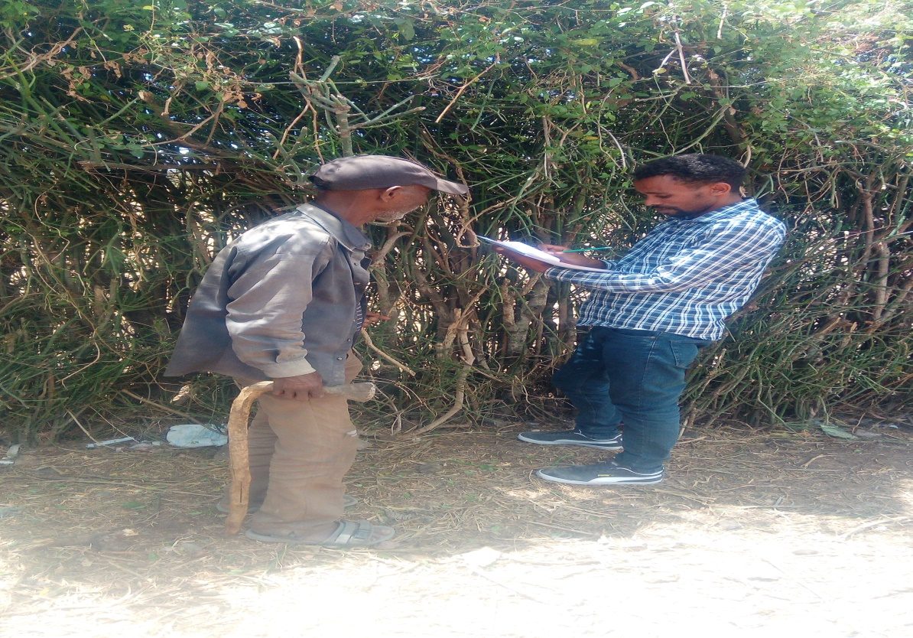

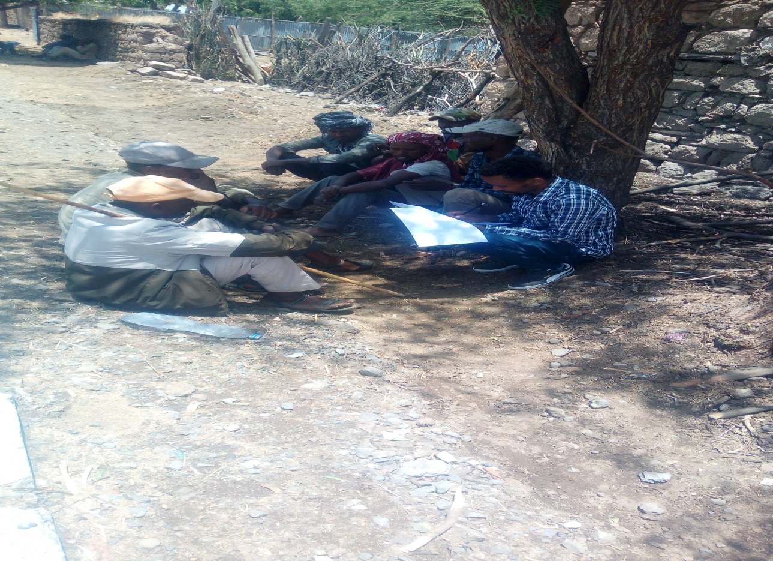

# Reference

* Alene, A. D., & Manyong, V. M. (2007). The effects of education on agricultural productivity under traditional and improved technology in northern Nigeria: An endogenous switching regression analysis. Empirical Economics, 32(1), 141–159. https://doi.org/ 10.1007/s00181-006-0076-3
* Carter D.W. and Milon J.W. 2005. Price Knowledge in Household Demand for Utility Services. Land Economics. 81 (2): 265- 283.
* Cleland J. 2013. World Population Growth; Past, Present, and Future. Environmental and Resource Economics 55. 10.1007/s10640-013-9675-6.
* Di Falco, S., Veronesi, M., & Yesuf, M. (2011). Does adaptation to climate change provide food security? A micro-perspective from Ethiopia. American Journal of Agricultural Economics, 93(3), 829–846. https://doi. org/10.1093/ajae/aar00
* Gebretsadik, H., Haile, M., & Yamoah, C. F. (2009). Tillage frequency, soil compaction and N-fertilizer rate effects on yield of teff (Eragrostis tef (Zucc) Trotter) in central zone of Tigray, Northern Ethiopia. Momona Ethiopian journal of science, 1(1).
* Habtewold, A. B., Challa, T. M., & Latha, D. A. (2021). Determinants of smallholder farmers in teff market supply in Ambo district, West Shoa Zone of Oromia, Ethiopia. International Journal of advanced research in management and social sciences, 6(2), 133-140
* Lokshin, M., & Sajaia, Z. (2004). Maximum likelihood estimation of endogenous switching regression models. The Stata Journal: Promoting Communications on Statistics and Stata, 4(3), 282–289. [https://doi.org/10. 1177/1536867X0400400306](https://doi.org/10.%201177/1536867X0400400306)
* Maddala G.S. 1985. Introduction to Econometrics. McMillan publishing company. New York.
* Rosenbaum, D. B. Rubin(1983) Assessing Sensitivity to an Unobserved Binary Covariate in an Observational Study with Binary Outcome <https://doi.org/10.1111/j.2517-6161.1983.tb01242.x>
* World Bank. (2016). Poverty and Shared Prosperity 2016: Taking on Inequality. Washington, DC: World Bank. DOI:10.1596/978- 1-4648-0958-3. License: Creative Commons Attribution CC BY 3.0 IGO Bello, O.L., L.J.S. Baiyegunhi, and G. Danso-Abbeam. 2020. Productivity Impact of Improved Rice Varieties’ Adoption: Case of Smallholder Rice Farmers in Nigeria. Economics of Innovation and New Technology. https://doi.org/10.1080/10438599.2020.1776488