

**BAHIRDAR UNIVERSITY**

**COLLAGE OF AGRICULTURE AND ENVIRONMENTAL SCIENCES, DEPARTMENT OF PLANT SCIENCES M.Sc. PROGRAM IN AGRONOMY**

**Influence of Different Rates of NP Fertilizers Application on Yield and Yield Components of Bread Wheat (*Triticum aestivum*) in Selected Districts of Wag -Himira Zone, North Eastern Ethiopia**

**M.Sc. Thesis**

By

**Alemu Lakew**

**October , 2018**

**Bahir Dar, Ethiopia**



**BAHIR DAR UNIVERSITY**

**COLLEGE OF AGRICULTURE AND ENVIRONMENTAL SCIENCES**

DEPARTMENT OF PLANT SCIENCES M.Sc. PROGRAM

**IN AGRONOMY**

**Influence of Different Rates of NP Fertilizers Application on Yield and Yield Components of Bread Wheat (*Triticum aestivum*) in Selected Districts of Wag -Himira Zone, North Eastern Ethiopia**

**MSc. Thesis**

**By**

**Alemu Lakew**

**Submitted to Department Graduate Council of Plant Sciences in**

**The Partial Fulfillment of the Requirements for the Degree of**

**Master of Science (M.Sc.) in Agronomy**

**Major advisor: Dr. Getachewu Alemayehu**

**Co-Advisor: Dr. Dereje Ayalew**

**October, 2018**

**Bahir Dar, Ethiopia**

# THESIS APPROVAL SHEET

As a member of the Board of Examiners of the Master of Sciences (M.Sc.) thesis open defense examination, we have read and evaluated this thesis prepared by **Mr. Alemu Lakew** entitled “**Influence of Different Rates of NP Fertilizers Application on Yield and Yield Components of Bread Wheat (Triticum aestivum) in Selected District of Wag -Himira Zone, North Eastern Ethiopia**”. We hereby certify that the thesis is accepted for fulfilling the requirements for the award of the degree of Master of Sciences (M.Sc.) in Agronomy.

**Board of Examiners**

________________________ ______________________ _______________

Name of External Examiner Signature Date

__________________________ _________________ _______________

Name of Internal Examiner Signature Date

__________________________ _________________ _______________

Name of Chairman Signature Date

# DECLARATION

This is to certify that this thesis entitled “***Influence of Different Rates of NP Fertilizers Application on Yield and Yield Components of Bread Wheat (****Triticum aestivum****) in Selected Districts of Wag -Himira Zone, North Eastern Ethiopia”***, Submitted in partial fulfillment of the requirements for the award of the degree of Master of Science in “Agronomy” by Mr. Alemu Lakew (BDU0906149 Pr) is an authentic work carried out by him under our guidance. The matter embodied in this thesis work has not been submitted earlier for the award of any degree or diploma to the best of our knowledge and belief.

**Name of the Student:** Alemu Lakew

**Name of the Advisors**

1**) Dr. Getachew Alemayehu** :( Major Advisor)

Signature & date___________________________

2) **Dr. Dereje Ayalew** :( Co-Advisor)

Signature & date___________________________

# ACKNOWLEDGMENTS

First, of all, I would like to thank the Almighty God for making all things possible for me, and my family for their, unlimited and gracious supply of unconditional support. There are always special people that made my success in this graduate study possible and memorable and others that even if not listed now they were a big part of it.

I would like to express my sincere thanks to my major advisor Dr. Getachew Alemayehu and my co-advisor Dr. Dereje Ayalew, whose help from the beginning to the end of this thesis was meticulously substantial. I am very much indebted to them for their maximum cooperation in providing me with the required scientific skill encouragements. The inputs they provided to me at various phases of this work through correcting the thesis were very valuable.

I would also like to thank Mr. Aemiro Bezabih and Mr. Tafere Birhanu for their valuable advice and relevant discussions on the subject of my MSc research. I would like to thank the Amhara Agriculture Research Institute (ARARI) for providing me the financial supports to my study. I am also indebted to the College of Agriculture and Environmental Sciences of Bahir Dar University for providing me the required MSc education and facilities.

# DEDICATION

This thesis is dedicated to my father Lakew Moges and My mother Weyzer Weldeyese for their all-rounded and unconditional support rendered to me for the betterment of my life.

# ABBREVIATIONS AND ACRONYMS

ARARI Amhara Regional Agricultural Research Institute

BY Biological yield

CSA Central Statistical Agency

CIMMYT International Maize and Wheat Improvement Center

CV Coefficient of variation

DH Days to 50% heading

DM Days to 90% physiological maturity

FAO Food and Agriculture Organization

GY Grain yield

HI Harvest index

LSD Least significant difference

NKPS Number of kernels per spike

NTT Number total tiller

NET Number of effective tillers

PH Plant height

RCBD Randomized complete block design

SDARC Sekota Dry land Agricultural Research Center

SL Spike length

TKW Thousand kernels weight

TABLE OF CONTENTS

THESIS APPROVAL SHEET I

DECLARATION II

ACKNOWLEDGMENTS III

DEDICATION IV

ABBREVIATIONS AND ACRONYMS V

LIST OF TABLES VIII

LIST OF FIGURES IX

LIST OF APPENDIX TABLES X

LIST OF APPENDIX FIGURES XI

ABSTRACT XII

CHAPTER 1: INTRODUCTION 1

1.1 Background and Justification 1

1.2 Statement of the Problem 2

1.3 Objective of the Study 3

1.3.1 General Objective 3

1.3.2 Specific Objective 3

1.4 Research Question 3

CHAPTER 2: LITERATURE REVIEW 4

2.1 Brief Description of Bread Wheat 4

2.2. Wheat Production in Ethiopia and its Major Constraints 6

2.3 Effect of Nitrogen and Phosphorous on Wheat Growth and Yield 7

2.3.1 Nitrogen (N) 7

2.3.2 Phosphorus (P) 9

2.3.3 Nitrogen and Phosphorous intraction ………………………………………………………………………………22

CHAPTER 3: MATERIALS AND METHODS 11

3.1 Description of the Study Areas 11

3.2 Planting Material Used for the Study 13

3.3 Experimental Treatments, Design and Procedures 13

3.4 Data Collection and Measurements 14

3.4.1 Phenological parameters 14

3.4.2 Vegetative growth parameters 15

3.4 Data Analysis 16

4.2 Vegetative Growth of Bread Wheat as Affected by Different Rates of Nitrogen and Phosphorous 19

4.2.1. Plant Height 19

4.2.1. Number of total tiller and productive tillers per 1meter row 21

4.4 Yield Related Traits as Influenced by Nitrogen and Phosphors Fertilizer 22

4.4.1 Spike length 22

4.4.2 Number of kernels per spike (NKPS) 23

4.4.3 Thousand-Kernel Weight (gm) 24

4.4.4 Straw yield (kg/ha-1) 25

4.4.5 Biomass yield (kg ha-1) 26

4.4.6 Harvest index (%) 27

4.4.7 Grain yield (kg ha-1) 29

4.6 Partial budget Analysis 33

5.1 Conclusion 36

5.2 Recommendations 36

REFERENCES 37

Appendix figure 52

BIOGRAPHICAL SKETCH 58

# LIST OF TABLES

Table 3.1 Treatment combinations used for the present study 15

Table 4.4.1: Main Effect of Nitrogen Fertlizer Rate and Phosphors Fertlizer Rate on Phenological parameter of Bread wheat in 2017 main cropping season at Weleh and Sayda 19

Table 4.4.2: Main Effect of Nitrogen Fertilizer Rate and Phosphors Fertilizer Rate on Plant Height of Bread Wheat at Sayda one way ANOVA .One way ANOVA plant height at Sayda Location 21

Table 4.4.3: Main Effect of Nitrogen and Phosphors Fertilizer Rate on Growth Parameter of Bread wheat in 2017 Main Cropping Season at Weleh and Sayda location 22

Table 4.4.4: Main effect of Nitrogen and Phosphors Fertilizer Rate on Grain related Trait of Bread Wheat at Sayda. 23

Table 4.4.5 : Main Effect of Nitrogen Fertilizer Rate and Phosphors Fertilizer Rate on Plant Height of Bread Wheat at Sayda one way ANOVA .One way ANOVA plant height at Sayda Location 29

Table 4.4.6: Main Effect of Nitrogen and Phosphors Fertilizer Rate on Grain yield and yield related trait of Bread wheat in 2017 Main Cropping Season at Weleh and Sayda location 31

Table 4.5.1 Correlation at weleh 32

Table 4.5.2 Correlation analysis at sayda 33

Table 4.6.1 Comprasion of net benefit with respect to marginal rate of return at Sayda 35

Table 4.6.2 Comparison of net benefit with respect to marginal rate of return at weleh 36

# LIST OF FIGURES

Figure 3.1 Location map of the experimental site 13

Figure 4.6.1 Graphical presentation of partial budget analyses at Sayda 35

# LIST OF APPENDIX TABLES

**page**

Appendix Table 1: ANOVA mean squares of phenological parameters of bread wheat as influenced by different rates of NP at Woleh and Sayda sites 50

Appendix Table 2: ANOVA mean squares of vegetative growth parameters of bread wheat as influenced by different rates of NP at Weleh and Sayda sites 51

Appendix Table 3: ANOVA mean squares of yield related traits as influenced by different rates of nitrogen and phosphorous at Woleh and Sayda 52

# LIST OF APPENDIX FIGURES

Appendix 1 Figure 1sowing at weleh 53

Appendix 2 Figure 2Sowing at sayda 54

Appendix 3 Figure 3weeding at weleh 54

Appendix 4 Figure 4 weeding at sayda 55

Appendix 5 Figure 5plant height measurment at sayda 57

Appendix 6Figure 6Performance at weleh 57

Appendix 7 Figure 7 measurment of thosand seed weight by seed counter m….. …….. 58

**Influence of Different Rates of NP Fertilizers Application on Yield and Yield Components of Bread Wheat (*Triticum aestivum*) in Selected Districts of Wag -Himira Zone, North Eastern Ethiopia**

By:

Alemu Lakewu

Major Advisor: Dr. Getachewu Alemayehu

Co Advisor: Dr. Dereje Ayalewu

# ABSTRACT

*A field experiment was conducted to study the performance of bread wheat sown under different nitrogen and phosphorous fertilizer rates during 2017/2018 main cropping season on farmer's field at Weleh and Sayda, North eastern Ethiopia. Factorial combinations of four nitrogen (10.25, 20.5 ,41 and 60.5 kg ha-1) and four phosphors rates (23, 46, 69, and 92 kg ha-1) were laid out in a Randomized complete block design (RCBD) with three replications .The analysis was done by using SAS soft ware and means were separated through list significance difference. The result showed that using a different NP rate of fertilizer had no significant effect (P≥0. 05) on the number of total and effective tillers in both locations. Similarly, at Sayda, different rate of nitrogen and phosphorus fertilizers did not show a significant effect on biomass yield, Straw yield and grain Yield. On the other hand, plant height was significantly affected by the interactions of nitrogen and phosphorus fertilizers. While days to 50% heading, days to 90% maturity, number of kernels per spike and thousand kernel weight were significantly affected by different rate of nitrogen fertilizer. Besides that, Spike length and number of kernels per spike were significantly affected by phosphorus fertilizer application. At Weleh Harvest, index was significantly affected by the interaction of nitrogen and phosphorous fertilizers. Moreover plant height, days to 90% maturity, number of kernels per spike were significantly affected by nitrogen fertilizer application. Since the homogeneity of error variance was significant, it indicates that both locations were not combine to gather, rather it was done separately. Based on the data wheat sown at 20.5N gave a higher grain yield (2700 kg* ***ha-1****) than the blanket 41 recommendations (2300 kg* ***ha-1****). According to the partial budget analysis, the combination of 20.5N/23P kg/ha was economically feasible at both location .* For future conducting of the researches in different seasons and location is important for sound recommendation.

**Keywords: Dry land, NP, partial budget analysis, wheat variety and yield component**

# CHAPTER 1: INTRODUCTION

## Background and Justification

Bread wheat (*Triticum aestivum* L.) is one of the most staple food crops in the world and it is one of the most important cereals cultivated in Ethiopia. Bread wheat in Ethiopia stands fourth in both area coverage and total annual production, and third in yield per hectare (CSA, 2013). It is also one of the most important crops in the Amhara Region. Both the country and in the region, its grain is used for making bread, porridge, soup and consumed as roasted and boiled forms. Moreover, the straw of bread wheat is an important feed for livestock, thatching roofs and bedding.

In spite of its tremendous importance, bread wheat production in the country as well as in the region has faced immense production constraints affecting both its yield potential and industrial quality. Among these constraints mainly farmers are using low yielding local varieties, and blanket recommendation of fertilizer inputs rather than location specific once . Bread wheat is produced by many small holder farmers in the Wag Himra Zone as well as in Amhara region. Bread wheat in Wag Himra Administration Zone stands fourth in area coverage and production next to sorghum, teff and barley. The average productivity of bread wheat in Wag-Himra is 13.82qt/ha and, while the national bread wheat productivity is 21qt/ha (CSA, 2013) and the world average is 30 qt ha-1 (FAOSTAT, 2010). According to Amhara National, State Agricultural Bureau Dryland Crop Production Package (2015) the blanket recommendations for bread wheat are 100k.g DAP(18%N&46P) with 50 Urea (46%N) kg/ha respectively. Sekota Dryland Agricultural Research Center also adopts the blanket fertilizer recommendation proposed by regional bureau of agriculture. Thise hence calls an urgent research works to find site specific NP fertlizer recommendations for bread wheat and the likes which are appropriate wag himira dry land areas.

**1.2 Statement of the Problem**

Nutrient depletion (mining) is a net loss of plant nutrients from the soil or production system due to a negative balance between inputs and outputs. Typical channels of nutrient depletion are nutrient removal through harvest, leaching, denitrification, soil erosion, and run off. As a result of this the average productivity of bread wheat in Wag Himira is very low; about 1.3 tons ha-1 CSA (2013) which is much below that of the world’s average about 3 ton ha-1 s (Amare Aleminew *et* *al*., 2015).

Among several restricting factors responsible for low yielding of bread wheat in the area is due to severe soil fertility depletion mainly nitrogen and phosphorus. Even an in adequate supply of N and P fertilizers can limit not to harness the potential productivity of the crop. On the other hand too much NP can also cause for the reduction of productivity and reduction of profitability.Determining the appropriate NP fertilizer rate hence necessary for maximazing economic yields .In the study area there is no any visible recommendation of NP for bread wheat as well as for other crops except the blanket recomndation of 23 N and 46 P2O5 kg ha-1.Even farmers don't applly NP fertlizers as per the blanket recommedation, rather they use less than the blanket recommendation rates .These all demand research works to study the effect of NP rates on bread wheat growth and yield so as to determine their optimal rates for achieving the potential productivity of bread wheat in the target areas.

.

**1.3 Objective of the Study**

**1.3.1 General Objective**

The main objective of the present study was: To trigger bread wheat production and productivity in the study areas through using the optimum rates of NP fertilizers

**1.3.2 Specific Objective**

* To study the effect of different rates of NP fertlizer on growth and yield of bread wheat in dry land areas of Wag-Himra Zone, northeastern Ethiopia; and;
* To suggest the optimum rates of NP fertilizers for maximizing bread wheat productivity in the study area

**1.4 Research Question**

* How is the effect of different rates of NP on yield and yield components of Bread wheat in Sekota District, Wag Himra Zone?
* What would be the optimal rate of NP fertilizers for bread wheat production in the study area?

# CHAPTER 2: LITERATURE REVIEW

## 2.1 Brief Description of Bread Wheat

Researchers note that wheat was the first domesticated cereal known to have been domesticated and originated in southwest Asia in the area known as the Fertile Crescent Kingfisher, (2004). Wheat is classed in the grass tribe (Triticeae) in the genus Triticum (Poehlman and Sleper, 1995).

All wheat species, whether wild or cultivated, belong to the genus *Triticum* and to the family *Poaceae* (a "grass family"). The genus Triticum contains about 30 types of wheat that have enough genetic differences to be separated in to species or sub-species (Breth, 1975). Based on their chromosome number, wheat species are grouped into diploid, tetraploid and hexaploid wheat. Feldman and Sears (1981) listed 13 diploid, 12 tetraploid and 5 hexaploid species of Triticum, of which only two species are of commercial importance (Poehlman and Sleper, 1995).

These two commercially important wheat species are the hexaploid species, *Triticum, aestivum*, the bread wheat and the principal wheat in commerce; and the tetraploid species, *Triticum turgidum*, the durum wheat which is used for making pasta and macaroni. The allohexaploid bread wheat has the genome constitution of AABBDD (2n=6x=42), formed through hybridization of T. urartu (AA) with an unknown diploid B genome (possibly Aegilopsspeltoides), and subsequent with a diploid D genome, (Vasil and Vasil, 1997; Gill and Friebe, 2002).

Evidence indicates that diploid and tetraploid wheat first appeared before 8000 BC in the “Fertile Crescent,” an area found within the drainage basins of the Euphrates and Tigris rivers in present-day Syria and Iraq, and most wheat grown today is hexaploid (Martin *et* *al*., 2006). It has been cultivated in southwestern Asia, which is considered as its geographic center of origin, for more than 10,000 years, wild species related to it grow in Lebanon, Syria, northern Israel, Iraq, and eastern Turkey (Quisenberry, 1967; Poehlman and Sleper, 1995). Later about 8000 years ago modern hexaploid bread wheat (*T.* *aestivum* L. em.Thell.) evolved and became abundant (Curtis, 2002).

Wheat (*Triticum* spp.) is the world’s leading cereal grain and most important food crop. It is one of the most important cereal crops worldwide in total production and use (Evans, 1998). The domestication of wheat, more than any other plant, has allowed food to be produced in sufficient quantities to support community settlement, religious/cultural development, and continuing population growth (Gooding and Davies, 1997). Its importance derives from the properties of wheat gluten, a cohesive network of tough endosperm proteins that stretch and expand with the fermenting dough, yet coagulate and hold together when heated to produce arisen loaf of bread (Poehlman and Sleper, 1995).

Only wheat, and to a lesser extent rye and triticale, has this property. The diversity of its uses, its nutritive content, and storage qualities has made wheat a staple food for more than one-third of the world’s population. It is used to make bread, flour, confectionery (cakes, cookies, and pretzels), unleavened bread, semolina, bulgar, and breakfast (Poehlman and Sleper, 1995).

Wheat is poorly adapted to warm or moist climates unless there is a comparatively cool, dry season that favors plant growth and retards parasitic diseases (Martin et *al.*, 2006). According to Martin *et* *al.* (2006) wheat crop is grown in temperate regions where the average annual rainfall is between 254 to 1780 mm. With the exception of drier irrigated areas; it is mostly grown in tropical regions having annual precipitation of 380 to 1,140 mm.

The ideal daily temperature varies for different stages of wheat development from 20 to 25oC for germination, 16 to 20oC for good tillering, and 20 to 23oC for proper plant development (Bekele *et al*., 2000). High rainfall, especially when accompanied by high temperature, is unfavorable for wheat because such condition promotes the development of wheat diseases (Martin et *al.*, 2006).

## 2.2. Wheat Production in Ethiopia and its Major Constraints

In terms of its place of production wheat is one of the most important cereals grown in the Ethiopian highlands. It is grown in altitudes ranging from 1500 to 3000 meters above sea level (m.a.s.l.). However, the most suitable altitude for producing wheat is between 1900 and 2700 m a.s.l where the rainfall has bimodal distribution ranging between 600 and 2000 mm per annum (Hailu Gebremaryam, 1991). Wheat grain is used to make industrially produced food items produced food qualities (both leavened and unleavened), traditional recipes and home made liquor and beverage.

Its straw provides a valuable fodder. It is also used for making baskets, thatching, package and bedding materials (Tesfaye Tesema and Getachew Belay, 1991).

Ethiopia is the largest wheat producer in sub- Saharan Africa. Both tetraploid and hexaploid wheat are grown in the country. According to Tesfaye Tesema and Jemal Mohamed (1982), estimated that tetraploid and hexaploid wheat occupy 60% and 40% of the total wheat area, respectively, and although the proportion is shifting against the former. The soil type used for wheat production varies from well drained to heavily logged Vertisols. The small-scale farmers under rain fed condition exclusively grow the tetraploid with Landrace varieties taking the largest share of the seed source. According to Tesfaye Tesema (1986), close to 85% of the cultivated durum wheat in Ethiopia are land races.

The major tetraploid wheat producing regions are the central and northern highlands.

Tetraploid (2n = 4x = 28) wheat has been under cultivation in Ethiopia since ancient times and the country is considered as the secondary center of diversity (Tesfaye Tesema and Getachew Belay, 1991). Wheat in Ethiopia is represented by seven species, *Triticum dicocum*, *Triticum durum*, *Triticum turgidum*, *Triticum polonicum*, *Triticum aestivum*, *Triticum compactum* and *Triticum pyramidal* (Abebe Demissie and Ghiorgis Hailemariam, 1991).

The two economically important wheat species grown in Ethiopia are tetraploid durum (Triticum durum) and hexaploid bread wheat (T. *aestivum)*. The production of bread wheat dominates the peasant farming systems in the mid to high altitude zones (Tanner *et* *al*., 1994). Its production is increasing rapidly (Amsal Tarekegn *et* *al,* 1995) due to both a high local demand of high-yielding, input-responsive cultivars adapted to heterogeneous environmental conditions (Hailu Gebremaryam, 1991; Payne *et* *al*., 1996). Area coverage of bread wheat has substantially expanded (Payne *et* al., 1996) mainly by replacing unimproved, input non-responsive traditional cereal crops such as teff (Eragrostis tef), durum wheat (T. *durum*) and barley (Hordeum vulgare) (Getachew Asmamaw *et* *al*., 1993).

Principal constraints to increasing productions are categorized into two groups : technical and socioeconomic. Low soil fertility, weeds, insect Pests and Diseases (Stem and leaf rust) are the principal disease problems in durum wheat. A principal disease affecting bread wheat is stripe (*Septaria tritici*). Lower yielding varieties are a major constraint to both bread and durum wheat production. Socioeconomic factors like unavailability of improved inputs, seasonal labor shortages, draft power shortage, land shortages, low prices, and lack of credit poses major constraint. In addition poor seedbed preparation, water logging of soils vertices and climatic problems rainfall distribution and amount affect production and productivity of wheat in Ethiopia (Tanner, *et al*, 1990).

## 2.3 Effect of Nitrogen and Phosphorous on Wheat Growth and Yield

### 2.3.1 Nitrogen (N)

Nitrogen is the major nutrient affecting wheat yield and quality (Fischer, 1989; Bacon, 1995). Yields of cereals have been reported as being roughly proportional to the amount of N applied (Greenwood, 1981). Increased yield of wheat occurs on all soils with the increased N rate, but such increases are reported more frequently on heavy clay soils (Sylvester- Bridget *et al.*, 1984). Several reports have also indicated that increased usage of N fertilizer is considered a primary means of increasing wheat grain in Ethiopia (Asnakew *et* *al*.1991; Tanner *et* al., 1993; Amsal *et* *al.*, 2000).

The overall effect of N application is to increase the resource capture of the plant as well as to increase the sink capacity, which is determined by the number and size of grain and their rates of growth (Hynes, 1986). Nitrogen is a key factor in achieving optimum cereal grain yield. Nitrogen nutrition affects crop performance through its effects on photosynthetic capacity (Genene Gezu 2003). The same author reported that for higher applied N fertilizer rate bread wheat varieties exhibited higher values for spikes/m2, plant height, harvest index, spike length, number of kernels/m2, straw yield, specific weight and grain yield.

In the highlands as substantial changes in yield and yield components have been affected by the application of N fertilizer Tilahun *et* *al.*, 1996; Schulthess *et* *al*., 1997; Amanuel *et al*., 2000; Tilahun *et* *al.*, 2000). From studies conducted in the Nit soil zones of the central highlands of Ethiopia, a positive and linear response of wheat to applied N fertilizer was noticed in selected agronomic parameters such as plant height, number of spike/m2, thousand kernel weight, grains/m2 and grain yield (Amsal *et al.*, 2000).

A similar experiment in the vertisol zones showed that the N content of the grain and straw of wheat increased by 36 and 57%, respectively, in response to the high rate of applied fertilizer N (164 kg N ha-1) relative to the control (Amsal and Tanner, 2001). Nitrogen increases chlorophyll contents, leaf size, and delays senescence; stimulates tillering, plant height and grain seed formation (Gooding and Davies, 1997).

Biomass yield of wheat increased due to N application (Fisseha, 1982; Fowler *et* *al*., 1990; Amanuel *et* *al.*, 1991; Most of the N uptake by wheat plants occurred before anthesis and grain N in the wheat is translocated primarily from vegetative parts after anthesis (Mossedaq and Smith, 1984; Rao, and Dao., 1996; Schultheis *et* *al*., 1997). N uptake was best when half of the N was applied at planting and the remainder at tillering (Asnakew *et* *al.*, 1991). Early application of N, either all at sowing or split applied between sowing and mid-tillering resulted in significantly increased plant height, biomass yield, grain yield ,while late application of N reduced these parameters (Lemma *et al*., 1992).

### 2.3.2 Phosphorus (P)

Phosphorus has long been known to be an essential element in the nutrition of plants. It plays key roles in cellular energy transfer, respiration, and photosynthesis (Price, 1970). In addition, Phosphorus plays an essential role in many physiological and biochemical processes (Mathews *et al*., 1998) and is an essential component of deoxyribonucleic acid (DNA) and ribonucleic acid (RNA) (Olsen and Khasawneh, 1980).

As stated by Degus (1973), phosphorus promotes the growth of root systems, activates seed formation, and hastens to ripen. In order to stimulate early growth and development, care should be taken to provide the crop with a sufficient amount of easily available P (Tisdale *et al*., 1993). Phosphorous has lower mobility than any other nutrients and does not remain in a free state for long (Parnes, 1990). Although nitrogen is generally the most limiting nutrient for crop production, soils are also low in available phosphorus (Schulthesis *et* *al*., 1997). Plants deficient in phosphorus are stunted and in contrast to those lacking nitrogen, are often dark green colors. Deficiency of P in wheat caused reduced tillering, reduced leaf area and increased susceptibility to a number of diseases. Besides, maturity is often delayed in P deficient plants as compared to plants containing abundant phosphate (Marschner, 1995).

Plant P uptake is influenced by P supply, characteristics of the soil and P requirement of crop plants. When P was withheld at early growth period of the plant, tillering and secondary root development was hindered. Early tillering was significantly higher and plants developed both root systems due to adequate P fertilization than only primary or adventitious roots under P deficient conditions (Strongh and Soper, 1974). Hamid and Sarwar (1977) reported that phosphorous absorption by wheat begins in the seedling stages. In early stages of development, crop plants absorb phosphorous faster from fertilizer than from soil and hence a high proportion of the total P absorbed by young plants is derived from the fertilizer. Therefore, P application at later stages of the crop may result in a greater P uptake but would have less effect on yield. On the contrary, applying P at the heading stage in wheat was found to be adequate to produce maximum dry matter and grain yield By far, a larger part of P taken up by the plant is accumulated in the grain (Degus, 1973).

2.3.3 Nitrogen and Phosphorus Interactions (NP)

Interactions occur when the supply of one nutrient affects the absorption, distribution, or function of another nutrient. The result may induce deficiencies, toxicities, modified growth responses and modified nutrient composition (Robson and Pitman, 1983). If two nutrients are limiting or nearly limiting growth or concentration where adding only one of the nutrients has little effect while adding both brings a considerable effect, the effect is a positive interaction. Similarly, if adding the two together brings less effect as compared to added separately, the effect is said to be negative interaction (Martin, 1993).

Nitrogen can increase P concentration in plants by increasing root growth, by increasing the ability of roots to absorb and translocate P, and by decreasing soil pH as the result of absorption of NH4+ and thus increasing the solubility of fertilizer P (Miller, 1974). Responses to both N and P are small at low levels of the other nutrients, but increase markedly for a combination of N and P at higher rates of N and P. Nitrogen stimulated the uptake of P and vice versa, because increased growth requires more nutrients to maintain tissue composition within acceptable

Increasing yields through the applying of nitrogen alone depletes the soil of other plant nutrients because higher yields take up greater amounts of other nutrients mainly phosphorus and potassium. Without applying phosphorus application, nitrogen efficiency declined, which indicates the existence of an interaction between these nutrients (FAO, 2000). Phosphorus is required for absorption and assimilation of nitrogen by cereal crops for translocation of nitrogen from vegetation to grain and for high grain yields which might indirectly affect protein concentration (Porter and Paulose, 1983).

# CHAPTER 3: MATERIALS AND METHODS

## 3.1 Description of the Study Areas

The study was conducted at Sekota district in 2017/2018 main cropping season in Wag Himra Zone North Eastern Ethiopia. Its latitude and longitude range lies 12.65N and 39.03E. This is the place where food insecurity is a chronic problem for the majority of the rural population. The town, Sekota is located 720 km north east of Adis Ababa and 430km from Bahir dar. The two sites of testing are with in Sekota district, namely Weleh and sayda. They are found in the latitude and longitude range of 12.60’N and 39.05’E and12.40′N and 38.20′E respectively. The site is far apart from Sekota about 15 and 16 km respectivelly. Weleh has altitude range of 2000 m abave sea level where as sayada has altitude range of 2200 m above sea level. With respect to rainfall sites has 566mm and 520 mm annual rain for weleh and Sayda respectivelly. The minimum temperature for both locations was 14(°C), while the maximum temperature was, 26 (°C) and 24 (°C) for weleh and sayda respectivelly. Beside that both of the experimental sites have black (Vertisol) soil type.

The dominant types of cropping system in the study area are mono-copping and crop rotation whereas inter-cropping is rarely practiced in the District. The common  
type of inter-cropping activities in the study site are: tef + , Saff flower and Sorghum +haricote bean Similarly, the common types of crop rotations practiced in the District are: Teff—barley--pulse crops—teff; Pulse crops-- teff---barley--pulse crops; and wheat/barley (Sekota District Agricultural and Rural Development Office, 2009).

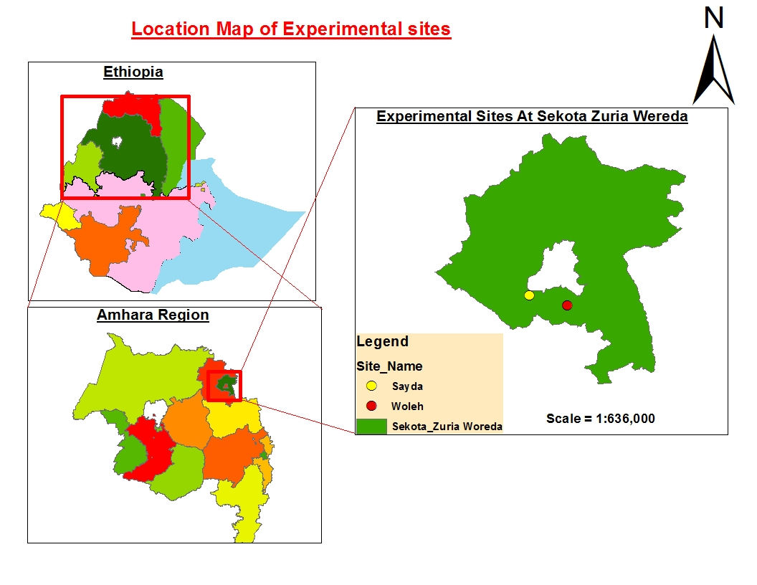

Figure 3.2.1 Location map of the experimental sites

**3.2 Planting Material Used for the Study**

A bread wheat variety "Sekota-1" was the planting material for the present study. The variety was officially released by Sekota Dry Land Agriculture Research Center in 2013 for moisture deficit areas of Eastern Amhara Region and similar agro-ecologies of the country. During its releasing, the variety had 30 % yield advantage over the local check and 10% over the standard check. Seed of the variety was drilled by 20cm row spacing on the experimental plots uniformly at 125 kg/ha seeding rate.

**3.3 Experimental Treatments, Design and Procedures**

A factorial combination of four N rates (10.25, 20.5, 41 and 60.5 kg/ha) and four rate of P2O5 23,46, 69 and 92 were laid out in randomized complete block design with three replications. After preparing the experimental plot repeatedly with oxen plow, the land was sub divided into blocks and plots as per the design and the treatments of the study .The gross plot size was 2.5 x 2.4 m (6 m2) with the net plot size of 2.3 x 2m (4.60 m2) excluding two outer rows and edge of 10cm length at both ends of each plot. Adjacent blocks and plots with in blocks were separated by 1.0m and 0.5m respectively. Using the lottery method, treatment combinations were assigned randomly to the experimental plots each block. DAP (18%N and 46%P2O5) and Urea (46%N) were used as sources of nitrogen and phosphorous. A full doses of P-treatments and half doses of N-treatments were applied in band at planting time, while the remaining half N-treatments were top dressed at a mid-tillering stage after the second weeding.

.

**Table 3.1Treatment combinations used for the present study**

|  |  |  |
| --- | --- | --- |
| **N Fertilizer Rate** | **P Fertilizer Rate** | **Possible Treatment Combination** |
| **N1(10.25)** |  |  |
|  | 23(P1) | NIP1(T1) |
|  | 46 (P2) | N1P2(T2) |
|  | 69 (P3) | N1P3(T3) |
|  | 92 (P4) | N1P4(T4) |
| **N2(20.5)** |  |  |
|  | 23(P1) | N2P1(T5) |
|  | 46 (P2) | N2P2(T6) |
|  | 69(P3) | N2P3(T7) |
|  | 92(P4) | N2P4(T8) |
| **N3(41)** |  |  |
|  | 23(P1) | N3P1(T9) |
|  | 46(P2) | N3P2(T10) |
|  | 69(P3) | N3P3(T11) |
|  | 92(P4) | N3P4(T12) |
| **N4(60.5)** |  |  |
|  | 23(P1) | N4P1(T13) |
|  | 46(P2) | N4P2(T14) |
|  | 69(P3) | N4P3(T15) |
|  | 92(P4) | N4P4(T16) |
|  |  |  |

.

**3.4 Data Collection and Measurements**

Data of important study parameters of bread wheat were collected on plant or plot basis. Data of Phenological parameters and different kinds of yield including biomass, grain and straw yields were collected on plot basis in the net plot areas, while ,vegetative growth and some yield parameters were collected on plant basis by taking 5 sample plants randomly in the net plot areas. Detailed methods and procedures used for collecting phenological, vegetative growth and yield related parameters are presented below.

**3.4.1** **Phenological parameters**

**Days to 50% heading (DH):** was measured as a number of days elapsed from sowing to the date on which 50% of the plants on the net plot area produce their first head.

**Days to 90% physiological maturity (DM):** were taken as a number of days elapsed from emergence to the stage when 50% of the plants in the net plot area reached physiological maturity.

**3.4.2** **Vegetative growth parameters**

**Plant height (cm)**: This was determined as a distance in centimeter from the soil surface to the tip of the spike excluding the awns at maturity and expressed as the average of five plants per plot.

**Number of total tillers:** This was determined by counting numbers of total tillers in 1m row length in the net plot areas during physiological maturity.

**Number of effective tillers per plant:** It was also estimated by counting plants that have heads/spikes in 1m row length in the center of the plots during physiological maturity **Spikes length (cm):** Average length of 5 randomly selected spikes of the main tiller measured during physiological maturity in cm from base to tip excluding the awn.

**3.4.3 Yield related traits**

**umber kernel per spike:** It was the average number of kernels of five randomly selected tillers of plants taken in the net plot areas.

**Thousand kernels weight (gm):** Weight in a gram of randomly taken sample of thousand seeds per plot after threshing and cleaning

**Biomass yield (t/ha):** Biomass yield (t/ha): It was determined by weighing the total air dried aboveground biomass harvested from net plot areas rows and expressed in t/ha.

**Grain yield (t/ha):** Grain yield per ha (t/ha): Weight of grains recovered from harvested wheat plants in the net plot areas after sun-drying threshing and cleaning converted into t/ha.

**Straw yield (t/ha**): It was estimated as the difference between biomass yield and grain yield

**Harvest index (%):** It was calculated as a ratio of dry weight of the grain to dry weight of the total aboveground biomass yield (%) multiplied by 100.

**Variable costs (Birr/ha)** NP fertilizer costs were considered to analyze the partial budget analysis.

**3.4 Data Analysis**

The collected data were subjected to analyses of variance (ANOVA) using SAS version 9.0. Combined analysis of the two site data was heterogeneous after testing the homogeneity of error variance using F test and gestalt software it was done separately. (Gomez and Gomeze,1984). Mean separation for statistically different treatments was done using least significant difference (LSD) method at 0.01 or 0.05 level of significance depending upon the ANOVA result. Simple correlation analysis was carried out by calculating simple calculation coefficients to see the relationship between yield and yield components as influenced by the application of different rates of NP.

Economic analysis was performed following the CIMMYT partial budget analysis methodology (CIMMYT, 1988) to identify economically profitable NP rate.

**CHAPTER 4: RESULTS AND DISCUSSION**

**4.1 Phenological Parameters of Bread Wheat as Influenced by Different Rates of Nitrogen and Phosphorous**

Results of analysis of variance showed that both days to 50% heading and 90 % maturity of bread wheat were significantly (P<0.05) affected by different rates of nitrogen at Sayda (Table 4.1). Whereas, at Weleh, days to heading and maturity were responded differently to different rates of nitrogen. Days to heading at Weleh was not significantly (P≥0.05) influenced by different rates of nitrogen, while days to maturity was influenced significantly (Table 4.1). As the rate of nitrogen increased, there was a prolonged trend of heading at Weleh and of both heading and maturity at Sayda.

On the contrary to nitrogen, different rates of phosphorous didn't significantly affect days to heading and maturity at Sayda and to maturity at Weleh, but days to heading at Weleh was exceptionally affected by different rates of phosphorous significantly (Table 4.1).

At both Weleh and Sayda, days to heading and maturity of bread wheat were not significantly (P≥0.05) affected by the interaction effect of nitrogen and phosphorous (Table 4.1).Delay of heading and maturity of bread wheat due to higher levels of nitrogen with in its optimum ranges would be associated with vegetative promoting effect of nitrogen. Similar to the present result, Russell, (2014) indicated that high levels of nitrogen promoted greater vegetative development before the beginning of reproductive phase and thereby attributed to the delay of and maturity. The present result is line with Yohannes Erkeno, (2014) who reported that day to heading of wheat plants was hastened under lower N rates compared to the higher N rates. According to this author the most prolonged duration of heading was recorded on plants grown at the rate of 60.5 kg N ha-1, whereas the shortest duration to heading was recorded on plants grown at the lowest amount of nitrogen rate.

In agreement with the present result, days to maturity were increased with the increase of nitrogen rates (Woinshet Tariku, 2007; Damene Darota, 2003)). Unlike the results of the present study, Cock and Ellis (1992) reported that optimum level of nitrogen application resulted in rapid growth and heading. According to these authors, too little N application resulted in slow growth rate and delayed heading, and growth, whereas excessive N application kept vegetative growth active and eventually finally resulted in delayed heading and flowering.

**Table 4.4.1: Main effect of nitrogen and phosphors fertlizer rate on the phenological parameter of bread wheat in 2017 main cropping season at weleh and sayda**

|  |  |  |  |  |
| --- | --- | --- | --- | --- |
| **The main effect of N (Kg)** | **Weleh** | | **Sayda** |  |
|  | **HD** | **MD** | **HD** | **MD** |
| **10.25** | 57.00 | 90.00c | 60.00bc | 93.00c |
| **20.50**  **41.00**  **60.50** | 59.00  57.00  57.00 | 96.00b  97.00ab  99.00a | 65.00ab  67.00a  66.00ab | 95.00bc  99.00a  96.00ab |
| **Sig. Difference** | ns | * | * | * |
| **The main effect of P (Kg)** |  |  |  |  |
| **23**  **46**  **69**  **92** | 50.00c  55.50b  57.92ab  59.66a | 96.58  96.50  96.25  96.66 | 67.67  64.49  65.35  65.91 | 98.86  97.20  98.98  96.74 |
| **Sig. Difference**  **NXP**  **CV**  **SE±** | *  ns  3.88  0.92 | ns  ns  0.70  1.78 | ns  ns  4.45  1.72 | ns  ns  6.78  1.82 |

**Means followed by the same letter within a column are not significantly different from each other at P< 0.05 according to Fishers LSD; DH = days to 50% heading; DM; = days to 90% maturity; SE± = standard error =; CV= coefficient of variation**

## 4.2 Vegetative Growth of Bread Wheat as Affected by Different Rates of Nitrogen and Phosphorous

### 4.2.1. Plant Height

The result of analysis of variance showed that the interactions between nitrogen and phosphorous rates were found to be significant (P < 0.05) to plant height at Sayda while, it was not significant at weleh. It was significantly increased due to main effect of Nitrogen (P<0.05) and phosphorus fertilizer application at weleh and on the contrary it was non sigficant at sayda (Table 4.4.2).

The average plant height for Sayda and Weleh was in the **76.87 -88.86** cm and **80.93 -86.07** cm ranges respectively.

The highest plant heights (**88.86** and **86.07 cm**) were recorded on conjointly interactions of **60.5Nx23P** at Sayda and individually act of **60.5N** and **69 P** fertilizer rate at weleh. Whereas the shortest plant heights (**76.87 cm** and **80.10 cm)** were recorded in the interaction of 10.25N X 23P fertilizer rate and main effect of 10.25N and 23P at Sayda and Weleh locations respectively. This finding confirms Plant height increasing tendency with increasing nitrogen application rates from 10.25 to 60.5 kg N ha-1.

Consequently, the maximum plant height (**85.36 cm**) was obtained when **60.5 kg ha-1** of N rates was applied to the soil followed by application of **41 kg ha-1 N** (**84.86 cm**), which was 6% higher over lowest rate with the mean of 80.93 cm in agreement with the findings of (Selamyihun *et* *al.,* 1999; Abdo *et* *al.*, 2012; Haile *et* *al.*, 2012;; Girma *et al*.,2012; Gerba *et* *al*., 2013). Increasing N rate increased plant height mean values for nitrogen rates showed that plant height increased with increase in nitrogen rates from the control to the highest rate. The increased plant height at the highest level of nitrogen was probably due to the availability of more nutrients, which helped, in the maximum vegetative growth of the wheat plant. This result was in line with Khan *et* *al*. (2000) who reported that increasing nitrogen rates increased the plant height.

Table 4.4.2: Intraction effect of NP Fertilizer Rate on Plant Height of Bread Wheat at Sayda Location

|  |  |  |
| --- | --- | --- |
|  | **Sayda** |  |
| **N** | **P** | **PH** |
| **10.25** |  |  |
|  | 23 | 76.87e |
|  | 46 | 79.86de |
|  | 69 | 80.93cde |
|  | 92 | 87.27ab |
| **20.50** | 23 | 84.53abcd |
|  | 46 | 84.86abcd |
|  | 69 | 83.20abcd |
|  | 92 | 80.93cde |
| **41.00** |  |  |
|  | 23 | 81.47cde |
|  | 46 | 83.06bcd |
|  | 69 | 86.20abc |
|  | 92 | 86.66abc |
| **60.5** |  |  |
|  | 23 | 88.86a |
|  | 46 | 83.87abcd |
|  | 69 | 84.86abcd |
|  | 92 | 86.46abc |
| **Sig.Difference(NXP)** |  | * |
| **CV** |  | 4.13 |
| **SE±** |  | 1.25 |

**Means followed by the same letter within a column are not significantly different from each other at P< 0.05 according to Fishers LSD; PH = Plant height; LSD = Least significant difference; CV=Coefficient of variation**

### 4.2.1. Number of total tiller and productive tillers per 1meter row

Result of analysis of variance showed that both total tiller and productive tiller were not significantly (P>0.05) affected by different rate of Nitrogen, Phosphorus fertilizer and their interaction at both locations (Table 4.4.3). It agrees with Asefa *et* *al*,(2017) who found that with respect to tiller number there is no significant between diﬀerent N levels of barley (Hordeum vulgare).

Wakened *et* *al*, (2014) report that NTT was not significantly affected by N and NP interaction. On the contrary Maqsood *et* *al* (1999) reported that the increase in the number of fertile tillers with the increase in nitrogen levels could be attributed to the well-accepted role of nitrogen in accelerating the vegetative growth of plants. It agrees with the result obtained by Prystupa *et* *al* (2004), who reported that number of productive tillers/1m row was significantly affected by the NP fertilizer application.

Table 4.4.3: Main Effect of Nitrogen and Phosphorus Fertilizer Rate on Growth Parameter of Bread wheat in 2017 Main Cropping Season at Weleh and Sayda location

|  |  |  |  |  |  |
| --- | --- | --- | --- | --- | --- |
| **Main Effect of N** |  | **Weleh** |  | **Sayda** |  |
|  | **PH(Cm)** | **NTT** | **NET** | **NTT** | **NET** |
| **10.25** | 81.95ab | 111.25 | 111.25 | 110.92 | 110.92 |
| **20.50** | 85.10a | 114.17 | 114.17 | 115.67 | 115.67 |
| **41.00** | 75.76c | 127.50 | 127.50 | 112.75 | 112.75 |
| **60.50** | 83.36ab | 127.50 | 127.50 | 125.33 | 125.33 |
| **Sig.Difference** | * | ns | ns | ns | ns |
| **Main Effect of P** |  |  |  |  |  |
| **23** | 80.80b | 116.00 | 116.00 | 115.56 | 115.56 |
| **46** | 83.38ab | 117.67 | 117.67 | 115.38 | 115.38 |
| **69** | 84.45a | 119.25 | 119.25 | 112.97 | 112.97 |
| **92** | 82.55ab | 114.17 | 114.17 | 120.76 | 120.76 |
| **Sig.Difference** | * | ns | ns | ns | ns |
| **Sig.Difference(NXP)** | ns | ns | ns | ns | ns |
| **CV** | 16.15 | 18.91 | 19.42 | 25.84 | 25.84 |
| **SE±** | 1.72 | 9.26 | 9.26 | 12.50 | 12.50 |

**Means followed by the same letter within a column are not significantly different from each other at P< 0.05 according to Fishers LSD; PH = Plant Height; NTT=Number of Total Tiller; NET =Number of Effective Tiller; SE± =Standard Error =; CV=Coefficient of variation**

## 4.4 Yield Related Traits as Influenced by Nitrogen and Phosphors Fertilizer

### 4.4.1 Spike length

Result of Analysis of variance showed that spike length was not signficantlly (P>0.05) affected by different rate of nitrogen at both location. On the contrary to nitrogen application of different rate of phosphorus fertilizer signficantlly affect spike length at weleh, while it was non signficantlly affect at sayda (Table 4.4.4). As the rate of Phosphorus increased there was a prolonged trend of spike length at weleh.

The interaction effect of these factors on the same parameter was not significant (P > 0.05). As indicated in (Table 4.4.4), the highest rate (92 P kg/ha) resulted in the highest spike length (8.03cm) and the lowest number of spikes (7.68cm) was obtained at the rate of (46PK.g/ha) indicating an increment of P shows a 5 % advantage over the blanket recommendation. Generally, each increment in the rate of applied P fertilizer resulted in significantly differing spike length.

Table 4.4.4: Main effect of Nitrogen and phosphorus fertilizer Rate on Grain related Trait of Bread Wheat at Weleh and Sayda

|  |  |  |  |  |  |  |  |  |
| --- | --- | --- | --- | --- | --- | --- | --- | --- |
|  | **Weleh** | | |  |  | **Sayda** | | |
| **Main Effect of N** | SL(Cm) | NKPS | TKW(Gr) |  |  | SL(Cm) | NKPS | TKW(Gr) | |
| **10.25** | 7.58 | 41ab | 32.77ab |  |  | 7.62 | 32ab | 18.02c | |
| **20.50** | 7.73 | 39ab | 25.26c |  |  | 7.52 | 28bc | 22.50ab | |
| **41.00** | 7.66 | 45a | 29.26b |  |  | 7.96 | 30ab | 20.66b | |
| **60.50** | 7.90 | 35c | 37.73a |  |  | 7.73 | 37a | 23.33a | |
| **Sig.Difference** | ns | * | * |  |  | ns | * | * | |
| **Main Effect of P** |  |  |  |  |  |  |  |  | |
| **23** | 7.68ab | 46ab | 83.75ab |  |  | 7.78 | 33bc | 21.66 | |
| **46** | 7.42c | 43c | 93.64a |  |  | 7.72 | 42a | 21.52 | |
| **69** | 7.69 b | 47a | 83.96ab |  |  | 7.60 | 39ab | 20.83 | |
| **92** | 8.03a | 42bc | 75.23b |  |  | 7.78 | 32c | 22.52 | |
| **Sig.Difference** | * | * | * |  |  | ns | * | ns | |
| **Sig.Difference(NXP)** | ns | ns | ns |  |  | ns | ns | ns | |
| **CV** | 7.38 | 10.32 | 21.47 |  |  | 0.22 | 7.15 | 17.69 | |
| **SE±** | 0.22 | 1.69 | 2.87 |  |  | 7.15 | 21.47 | 1.51 | |

**Means followed by the same letter within a column are not significantly different from each other at P< 0.05 according to Fishers LSD; SL = Spike Length; NKPS=Number Kernel per Spike; TKW =Thousand KernelWeight; SE± =Standard Error =; CV=Coefficient of variation**

### 4.4.2 Number of kernels per spike (NKPS)

Result of analysis of variance showed that number of kernels per spike was significantly (P<0.05) affected by nitrogen and Phosphorus fertlizer at both locations. However, the interaction effect of N and P on this parameter was not significant (P > 0.05). This finding confirms that the highest number of kernels per spike (**45/ 47)** was obtained with the application of NP at the rate of **41 kg N / 69P/ha** and the lowest kernel per spike (**35/42**) was recorded from the treatment combination of **10.25 N/ha/ 92P**/ha was applied at weleh and on the other hand at Sayda **60.5N/46P**/ha was the highest (**37/42)** and **20.5N/92P/ha** was the lowest (**28/32)** (Table 4.4.4). As the rate of nitrogen increased there was an increament trend of number of kernel per spike at both location .On the contrary to nitrogen, as the rate of Phosphorus increased there was a decrement trend of number of kernel per spike at both location.

This finding was in line with the data reported by Ali *et al.* (2003) who observed that an increased application of nitrogen increases the number of kernel per spike. Similarly, Kanugo and Rout (1994) indicated that increasing nitrogen rate up to optimum amount increase number kernels per spike.

# 4.4.3 Thousand-Kernel Weight (gm)

Result of analysis of variance showed that thousand kernel weight was signficantlly (P<, 0.05) affected by different rate of nitrogen at both location. In contrast to sayda different rate of phosphorus fertlizer was sigficantlly affect thousand kernel weight at weleh (Table 4.4.4). At both sayda and weleh thousand kernel weight did not signficantlly affect by an interaction effect of nitrogen and phosphorus fertilizer.

This result was in line Damene Darota, (2003).Moreover the main effect of neither P nor its interaction with N brought any significant change in thousand kernel weight. Similar results were reported by Gooding and Davies (1997), who, despite increased in yields found a significant reduction in thousand kernel weight of wheat by N fertilizer application, Melesse (2007) reported no significant effect of the application of different rates of N fertilizer on the thousand seed weight of bread wheat.

Gurmessa (2002) also indicated that neither the main effect of N and P nor their interaction brought about significant change in 1000 grain weight. Other similar reports, Gooding and Davies (1997), Mekonen (2005), Lemma *et* *al*. (1992) reported that a non-significant effect on 1000kernel weight due to different doses of N and P fertilizers.

Increased number of spikelets per spike and vigorous vegetative growth owing to high N application induce competition for carbohydrate available for grain filling and spikelet formation Hasegawa, T.Y. (1994). This reduced the grain weight because of insufficient supply of carbohydrate to the individual grain.

### 4.4.4 Straw yield (kg ha-1)

Result of analysis of variance revealed that straw yield was not sigficantlly affected (>0.05) by the main effect of nitrogen and phosphorus at sayda and their intraction at both location (Tables 4.4.6). In contrast to Sayda at Weleh, the main effect of the nitrogen and phosphorus fertlizer rate was significant( p < 0.05), influencing the straw yield ( table 4.4.6).

It increased with the increasing trend of N, the lowest straw yield was recorded at the lowest (6247kg ha-1) rate of nitrogen whereas the highest recorded was at the highest rate (7370 kg ha-1) at weleh.

The maximum straw yield of 7370kg ha-1was obtained with an application rate of 60.5Kg/ha which had 15 % advantage over the lowest rate N similar trend was observed by (Teklu and Teklewold. 2009; Abdo *et* *al*., 2012; Girma *et* *al*., 2012; Haile *et* *al*; 2012; Tolera *et* *al*. 2012). In terms of phosphorous fertilizer rate, the highest straw yield was recorded at 46kg ha-1 rate of P (7400kg ha-1) as compared to the highest rate of P(5300kg/ha-1) with statistical significance of (P>0.05). This result has been confirmed with the result of (Haileselassie *et* *al*, 2014).

### 4.4.5 Biomass yield (kg ha-1)

Result of analysis of variance showed that biological yield of bread wheat was sigficantlly (P <0.05) affect by both main effect of nitrogen and phosphorous fertlizer, but exceptionally intraction effect was not sigficantlly affect at weleh. On the contrary to weleh, both main effect as well as their intraction did not sigficantlly affect biological yield at sayda. Biological yield is the sum total of all dry matter produced through physiological and biochemical processes occurring in the plant system. Biological yield is an important factor because farmers are also interested in straw in addition to grain.

Increased biomass production was observed with increasing rates of N, due to this reason application of 60.5 kg N ha-1 increased the relative biomass by 1930.62 kg ha-1(19.36%) than the blanket recommendation. The highest (9970.62 kg ha-1) and lowest (8860kg ha-1) total biological yields were obtained with the application of 60.5 kg N/23P /ha and (10.25N/46P), respectively at weleh (Table 4.4.6). Generally, as N rates increased, the total biological yield also increased. Increase and decrease in biomass yield did not show a consistent trend with respect to P level increment.

The current results agree with the extent of yield component's response to nitrogen fertilizer be contingent on the expanse or quantity of the nutrient supplied (Teklu and Teklewold, 2009; Abdo *et al*., 2012;, Girma *et* *al.*, 2012; Haile *et* *al*., 2012; and Gerba *et* *al*., 2013). Similarly, the nitrogen application enhanced the vegetative growth of the wheat crop, which ultimately increased biological yield with an increase in biological yield Allam, A.Y (2003). The result obtained from this study was similar to the research findings of Minale *et* *al*. (1999) who reported that as N rate increased the biological yield also increased.

### 4.4.6 Harvest index (%)

### Result of analysis of variance indicated that harvest index of bread wheat was not sigficantlly (p>0.05) affect by main effect of different rate of nitrogen and phosphorous fertlizer at both location. While intraction effect of nitrogen and phosphorous fertlizer was sigficantlly (P<0.05) affect harvest index at weleh, but it was not sigficantlly (P>0.05) affect at sayda.

Harvest index is an indicator of dry matter partitioning towards the reproductive organs. The highest was a record on 41x92NP (41.55) but the lowest harvest index (16.58%) was obtained with lowest treatment combination 20.5NX23P. The finding was similar to Thakur, R. B. (1993), who reported an increasing trend of harvest index to a certain level of N and a decreasing one with a further increase in its rate of application.

|  |  |  |  |
| --- | --- | --- | --- |
|  | **Weleh** |  |  |
| **N** | **P** | **HI (%)** |  |
| 10.25 |  |  |  |
|  | 23 | 36.48ab |  |
|  | 46 | 21.12de |  |
|  | 69 | 16.58e |  |
|  | 92 | 26.26bcde |  |
| 20.50 | 23 | 21.20de |  |
|  | 46 | 26.85bcde |  |
|  | 69 | 26.52bcde |  |
|  | 92 | 33.62abc |  |
| 41.00 |  |  |  |
|  | 23 | 22.98cde |  |
|  | 46 | 25.44bcde |  |
|  | 69 | 33.48abc |  |
|  | 92 | 41.55a |  |
| 60.5 |  |  |  |
|  | 23 | 22.56bcde |  |
|  | 46 | 24.97bcde |  |
|  | 69 | 29.00bcd |  |
|  | 92 | 30.40abcd |  |
| **Sig.Difference(NXP)** |  | * |  |
| **CV** |  | 4.13 |  |
| **SE±** |  | 1.25 |  |

**Table 4.4.5: Intraction effect Nitrogen and Phosphors Fertilizer Rate on Plant Height of Bread Wheat at Sayda Location**

**Means followed by the same letter within a column are not significantly different from each other at P< 0.05 according to Fishers LSD; HI = Harvest Index; LSD = Least significant difference; CV=Coefficient of variation**

### 4.4.7 Grain yield (kg ha-1)

Result of analysis of variance showed that grain yield of bread wheat was not sigficantlly (p>0.05) affect by different rate of phosphorous fertilizer as well as though their intraction effect at both location (Table 4.4.6). However, application of different rate of nitrogen fertilizer significantly (P<0.05) affect grain yield at weleh but it was not sigficant at sayada.

The mean values for the grain yield were observed at Weleh in the range from 2300 kg ha-1 to 2700 kg ha-1.The maximum grain yield of 2700 kg ha-1 was obtained in plots that had a nitrogen rate of 20.50 kg ha-1 and the lowest was achieved at a rate of 41 kg ha-1

This finding is in line with Haileselassie et *al*., (2014) in which grain yields of wheat were not significantly affected by the main effect of phosphorus. In line with Damene Darota (2003), yields of wheat were not affected significantly due to the interaction effect of nitrogen and phosphorus fertilization in both experimental fields. The amount of nitrogen applied also significantly affected grain yield. Grain yield increased as the amount of nitrogen increased from the low level to 41 kg ha-1. This result agrees with the findings of Teklu and Teklewold, 2009; Abdo *et al*., 2012; Tolera *et al*., 2012, Girma *et al*., 2012; Haile *et al*., 2012; and Gerba *et al.*, 2013.

The highest grain yield of any crop is the result of the positive relationships of most yield components due to nitrogen fertilizer application (Teklu and Teklewold, 2009; Abdo *et al*., 2012; Girma *et al*., 2012; Haile *et al*., 2012; and Gerba *et al.*, 2013). The solicitation of N at the rate of 20.5 kg N/ha resulted in highest grain yield, which was significantly higher than N applied at the rates of 10.25, 41 and 60.5 kg/ha.

Table 4.4.6: Main Effect of Nitrogen and Phosphorus Fertilizer Rate on Grain yield and yield related trait of Bread wheat in 2017 Main Cropping Season at Weleh and Sayda location

|  |  |  |  |  |  |  |  |  |
| --- | --- | --- | --- | --- | --- | --- | --- | --- |
| **Main Effect of N** | **Weleh** | | |  | **Sayda** | | | |
|  | **SY(kg/ha)** | **BY(kg/ha)** | **GY(kg/ha)** |  | **SY(kg/ha)** | **BY(kg/ha)** | **GY(kg/ha)** | **HI(%** |
| **10.25** | 6400.40bc | 8860.60bc | 2260.20c |  | 1.80(7099.80) | 9340.30 | 2240.50 | 27.26 |
| **20.5** | 6247.70b | 9008.60b | 2760.90a |  | 1.80(5970.10) | 8220.10 | 2430.70 | 27.91 |
| **41** | 7650.00a | 9650.00ab | 2300.00c |  | 1.78(5859.40) | 8260.30 | 2400.90 | 29.87 |
| **60.5** | 7370.62ab | 9970.62a | 2600.00ab |  | 1.73(6506.90) | 8707.30 | 2230.10 | 29.77 |
| **Sig.Difference** | * | * | * |  | ns | ns | ns | ns |
| **Main Effect of P** |  |  |  |  |  |  |  |  |
| **23** | 6550.70 | 9270.80a | 2720.10 |  | 1.76(6409.60) | 8770.50 | 2360.90 | 26.72 |
| **46** | 7470.60bc | 8040.80b | 2420.30 |  | 1.79(6916.20) | 9306.40 | 2390.20 | 26.74 |
| **69** | 5329.70b | 9090.00ab | 2710.30 |  | 1.77(6090.60) | 8390.60 | 2300.60 | 26.88 |
| **92** | 6149.80a | 8560.10c | 2410.30 |  | 1.75(5121.90) | 7502.30 | 2380.40 | 26.98 |
| **Sig.Difference** | * | * | ns |  | ns | ns | ns | ns |
| **Sig.Difference(NXP)** | ns | ns | ns |  | ns | ns | ns | ns |
| **CV** | 24.25 | 16.15 | 405 |  | 8.10 | 16.15 | 12.71 | 9.94 |
| **SE±** | 517.14 | 116.45 | 402.98 |  | 115 | 222.17 | 311.26 | 2.27 |

**Means followed by the same letter within a column are not significantly different from each other at P< 0.05 according to Fishers LSD; SY = Straw Yield; BY=Biological Yield; G.Y; =Grain Yield; HI = Harvest Index; SE± =Standard Error =; CV=Coefficient of variation**

**4.5 Correlation Analysis**

At both location heading date and maturity date , number of total tiller and number of effective tillers show signficant positively correlation in both location. Biomass yiled and harvest index were signficantlly postivelly correlate at weleh, while at sayda it was significantly negatively correlated. The result revealed that grain yield with harvest index and thousand kernel weights were correlated highly significantly positively at both locations.

Thousand kernel weight and spike length with effective tillers per plant was non significantly positively correlated at both locations. Harvest index was strongly and positively correlated with grain yield at both locations. Beside biomass yield was negatively and strongly correlated with harvest index at both locations. The result revealed that Plant height with harvest index was significantly at sayada and non significantly correlated at weleh . Effective tiller at both locations correlated with harvest index positively, but not significantly (Table 5.1 & Table 5.2).

Table 4.5.1 Correlation at weleh

|  |  |  |  |  |  |  |  |  |  |  |
| --- | --- | --- | --- | --- | --- | --- | --- | --- | --- | --- |
|  | **HAD** | **MD** | **PH** | **NTT** | **NET** | **SL** | **TKW** | **SY** | **GY** | **HI** |
| **HAD** | 1.000 |  |  |  |  |  |  |  |  |  |
| **MD** | 0.045ns | 1.000 |  |  |  |  |  |  |  |  |
| **PH** | -0.085ns | -0.088ns | 1.000 |  |  |  |  |  |  |  |
| **NTT** | 0.071ns | -0.066ns | -0.021ns | 1.000 |  |  |  |  |  |  |
| **NET** | 0.241ns | -0.098ns | -0.098ns | -0.016ns | 1.000 |  |  |  |  |  |
| **SL** | 0.241ns | 0.098* | -0.098* | -0.016ns | 1.000 | 1.000 |  |  |  |  |
| **TKW** | 0.024ns | -0.092ns | -0.338ns | 0.317* | 0.030ns | 0.030ns | 1.000 |  |  |  |
| **SY** | -0.186ns | 0.003ns | 0.124ns | -0.155ns | -0.091ns | -0.091ns | -0.067ns | 1.000 |  |  |
| **GY** | 0.205ns | 0.180ns | 0.234* | 0.169ns | 0.025ns | 0.025ns | 0.001ns | -0.077ns | 1.000 |  |
| **HI** | 0.203ns | 0.042ns | -0.209ns | -0.042ns | -0.051* | -0.051ns | -0.227ns | 0.140ns | -0.069ns | 1.000 |

Table 4.5.2 Correlation analysis at sayda

|  |  |  |  |  |  |  |  |  |  |  |  |
| --- | --- | --- | --- | --- | --- | --- | --- | --- | --- | --- | --- |
|  | **HD** | **MD** | **PH** | **NT** | **NET** | **SL** | **NKPS** | **BM** | **SY** | **TKW** | **GY** |
| **HD** | 1.000 |  |  |  |  |  |  |  |  |  |  |
| **MD** | -0.101ns | 1.000 |  |  |  |  |  |  |  |  |  |
| **PH** | 0.058ns | -0.304ns | 1.000 |  |  |  |  |  |  |  |  |
| **NT** | -0.162ns | -0.109ns | 0.104ns | 1.000 |  |  |  |  |  |  |  |
| **NET** | 0.182ns | 0.128ns | 0.064ns | 0.252** | 1.000 |  |  |  |  |  |  |
| **SL** | 0.034ns | 0.031ns | -0.057ns | -0.236ns | 0.115ns | 1.000 |  |  |  |  |  |
| **NKPS** | 0.034ns | 0.031ns | -0.057* | -0.236ns | 0.115ns | 0.122ns | 1.000 |  |  |  |  |
| **BM** | .018nsns | 0.024ns | -0.051ns | 0.174** | 0.180* | 0.177* | 0.177ns | 1.000 |  |  |  |
| **SY** | -0.166ns | 0.104ns | 0.157* | 0.286* | 0.233* | -0.156ns | -0.156ns | 0.7** | 1.000 |  |  |
| **TKW** | -0.447ns | 0.070ns | -0.174* | -0.127ns | -0.417ns | -0.141ns | -0.141ns | -0.022ns | -0.188ns | 1.000 |  |
| **GY** | -0.441ns | 0.091ns | -0.174ns | -0.156 | 0.433** | -0.125ns | 0.5** | -0.019 | -0.183ns | 0.993** | 1.000 |

**4.6 Partial budget Analysis**

In the present study, the costs for the NP fertilizer rates was considered as variable cost where as other costs were constant for each treatment. In order to recommend the present finding in the study area, it is necessary to estimate the minimum rate of return acceptable to producers in the recommendation domain. Based on partial budjet analysis 20.5/23NP had better than in terms of net benefit(82455.07) and MRR ( 33.31) than 10.25/46NP which had the net benefit of (69038.41) and MRR (7.24) even though both were situated at the acceptable range at sayda. At weleh 10.25/46 NP fertlizer rate had highest MRR(55.34)and lowest net benefit (68404), while 20.5/23NP had the highest net benefit(84355.07) but its MRR was lowest as compared to 10.25/46 NP fertlizer rate (Table 4.6.1 and Table 4.6.2).

The partial budget was calculated to compare gain and losses between one treatment and another. It was done based on the following methodology prescribed by CIMMYT(1988).It was considered the analysis of gross benefit (GB) , total variable cost (TVC), the net benefit (NB) and finally the analysis of marginal rate of return(MRR).

G.B= (YAXPA) + (YBXPB).

TVC = (The sum of all the costs which vary between treatments.

NB=GB-TVC

Table 4.6.1 Comparison of net benefit with respect to the marginal rate at return at sayda

|  |  |  |  |  |  |  |  |  |  |
| --- | --- | --- | --- | --- | --- | --- | --- | --- | --- |
| **Treatments (NxP)** | **Unit price**  **Qt-1** | **GY (Qt ha-1** | **SY (Qt ha-1** | **Unit priceQt-1** | **TGB (Eth. birr/ha)** | **TVC (Eth.birr)** | **NB (Eth.bir)** | **DA** | **MRR(%** |
| 10.25/23.00 | 2500 | 23.03 | 58.66 | 150 | 66368.12 | 447.50 | 62952.50 |  | - |
| 10.25/46.00 | 2500 | 21.50 | 90.43 | 150 | 67308.89 | 561.59 | 69038.41 |  | 724.00 |
| 10.25/69.00 | 2500 | 25.00 | 89.22 | 150 | 75883.49 | 780.83 | 67219.17 | D | - |
| 10.25/92.00 | 2500 | 23.67 | 58.99 | 150 | 68026.93 | 789.85 | 67510.15 | D | - |
| 20.50/23.00 | 2500 | 24.56 | 68.22 | 150 | 77732.71 | 894.93 | 82455.70 |  | 3331.46 |
| 20.50/46.00 | 2500 | 24.32 | 61.62 | 150 | 70032.54 | 1018.11 | 79981.89 | D | - |
| 20.50/69.00 | 2500 | 23.00 | 65.02 | 150 | 68730.48 | 1114.17 | 77835.83 | D | - |
| 20.50/92.00 | 2500 | 24.40 | 61.77 | 150 | 70255.88 | 1123.19 | 70626.81 | D | - |
| 41.00/23.00 | 2500 | 24.24 | 61.93 | 150 | 69877.50 | 1228.26 | 81621.74 | D | - |
| 41.00/46.00 | 2500 | 23.19 | 55.84 | 150 | 66346.93 | 1447.50 | 63802.50 | D | - |
| 41.00/69.00 | 2500 | 23.19 | 55.78 | 150 | 66338.04 | 1456.52 | 68043.48 | D | - |
| 41.00/92.00 | 2500 | 24.88 | 57.22 | 150 | 70780.80 | 1561.59 | 53488.41 | D | - |
| 60.50/23.00 | 2500 | 15.30 | 35.39 | 150 | 43553.34 | 1684.78 | 52065.22 | D | - |
| 60.50/46.00 | 2500 | 19.89 | 59.53 | 150 | 58647.46 | 1789.85 | 60960.15 | D | - |
| 60.50/69.00 | 2500 | 24.56 | 44.25 | 150 | 68030.62 | 2018.11 | 64981.89 | D | - |
| 60.50/92.00 | 2500 | 24.56 | 45.72 | 150 | 68251.01 | 2180.00 | 73820.00 | D | - |

**TVC, GB, NB and MRR, Total gross benefit, Total variable cost, Net benefit and Marginal rate of return, respectively**

Figure 4.6.1 graphical presentation of partial budjet analyses at sayda

Table 4.6.3 Comparison of net benefit with respect to the marginal rate of return at weleh

|  |  |  |  |  |  |  |  |  |  |
| --- | --- | --- | --- | --- | --- | --- | --- | --- | --- |
| **Treatments (NxP)** | **Unit price Qt-1** | **GY(Qt ha-1** | **Sy(Qt ha-1** | **Unit priceQt-1** | **TGB (Eth. birr/a** | **TVC (Eth.birr** | **NB (Eth.birr** | **DoA** | **MRR(%)** |
| 10.25/23.00 | 2500 | 22.23 | 56 | 150 | 63400 | 447.50 | 62952.50 |  | - |
| 10.25/46.00 | 2500 | 24.56 | 64 | 150 | 69600 | 561.59 | 68404.00 |  | 5534.30 |
| 10.25/69.00 | 2500 | 23.15 | 70 | 150 | 68000 | 780.83 | 67219.17 | D |  |
| 10.25/92.00 | 2500 | 23.00 | 72 | 150 | 68300 | 789.85 | 67510.15 | D |  |
| 20.50/23.00 | 2500 | 29.00 | 85 | 150 | 85250 | 894.93 | 84355.07 |  | 4594.90 |
| 20.50/46.00 | 2500 | 27.00 | 90 | 150 | 81000 | 1018.11 | 79981.89 | D |  |
| 20.50/69.00 | 2500 | 26.85 | 93 | 150 | 78950 | 1114.17 | 77835.83 | D |  |
| 20.50/92.00 | 2500 | 23.62 | 95 | 150 | 71750 | 1123.19 | 70626.81 | D |  |
| 41.00/23.00 | 2500 | 28.00 | 99 | 150 | 84850 | 1228.26 | 83621.74 | D |  |
| 41.00/46.00 | 2500 | 21.00 | 85 | 150 | 65250 | 1447.50 | 63802.50 | D |  |
| 41.00/69.00 | 2500 | 23.58 | 80 | 150 | 69500 | 1456.52 | 68043.48 | D |  |
| 41.00/92.00 | 2500 | 18.56 | 67 | 150 | 55050 | 1561.59 | 53488.41 | D |  |
| 60.50/23.00 | 2500 | 17.30 | 75 | 150 | 53750 | 1684.78 | 52065.22 | D |  |
| 60.50/46.00 | 2500 | 20.21 | 85 | 150 | 62750 | 1789.85 | 60960.15 | D |  |
| 60.50/69.00 | 2500 | 22.82 | 80 | 150 | 67000 | 2018.11 | 64981.89 | D |  |
| 60.50/92.00 | 2500 | 25.24 | 90 | 150 | 76000 | 2180.00 | 73820.00 | D |  |

**TGB TGFB, TVC, NB and MRR, Total gross benefit, Total variable cost, Net benefit and Marginal rate of return, respectively**

**CHAPTER 5: CONCLUSION AND RECOMENDATIONS**

**5.1 Conclusion**

The result of this study clearly indicated that different nitrogen rate and phosphorus fertilizer rate had a significant effect on parameters of plant height, heading date spike length, number of kernels per spike, straw yield,harvest index and grain yield. However, a more careful analysis revealed that NP had no significant effect on a number of tillers, number of effective tillers, thousand kernel weight, number of kernels per spike, the weight of kernel per spike and harvest index. Phosphors fertilizer rate alone did not have a significant effect on parameters like 1000 kernel weight, maturity date, straw yield biological yield, and grain yield. The main effect of nitrogen was affected heading date, maturity date, straw yield, plant height, biological yield and grain yield. Based on the data wheat sown at NP rate of 20.5/23 gave a higher grain yield as well highest net benefit according to partial budget analysis at both location .

**5.2 Recommendations**

Based on the above data most parameters were statically significantly affected by main effect of nitrogen for most paramers and grain yield as well as main effect of phosphorous fertlizer was sigficantlly affect for spike length, heading date and maturity date. Therefore, based on the partial budget analysis it can recommended that 20.5 N kg/ha with 23 kg/ha phosphorous fertlizer rate is an appropriate and economically feasible for Sekota -1 variety in the study area and similar agro-ecologies. However, this finding was based on the one-year data or environment so it is better to repeat on wider temporal and spatial scale for better result.

# REFERENCES

Abebe Demissie and Ghiorgis Hailemariam, 1991.Ethiopia wheat germplasm collection, conservation, evaluation and utilization. pp. 327-334. In: Tanner, D.G., M. Van Ginkel and W. Muang (eds.).The Sixth regional Wheat Workshop for Eastern, central and Southern Africa. CIMMYT, Mexico.J. 3: 41-49.

Abdoulaye, T. and J. W. Marienville, (1999). The nitrate reductase activity of diverse grain sorghum genotypes and its relationship to nitrogen use efficiency. Agronomy Journal 91: 863-869.

AbdoWoyema, Geremew Bultosa, and Asefa Taa, (2012). Effect of different nitrogen fertilizer Rates on Yield and Yield Related Traits for Seven Durum wheat (Triticum turgidum L. var Durum) Cultivars grown at Sinana South Eastern Ethiopia. AJFAND 12 (3): 6079-6094

Addis Abraha, (2003). Genotype by Environment Interaction of Bread Wheat (Triticum aestivum L.)Genotypes under Dryland Growing Conditions of Tigray. M.Sc. Thesis in Agriculture (Plant Breeding), Alemaya University.

Allam, A.Y. (2003). The response of three wheat cultivars to split application  
nitrogen fertilization rates in sandy soils. *Aust. J. Agric. Sci*. 1: 1-14.

Ali, L., Q, Mdy-Ud-Din and M. Ali.(2003). Effect of different doses of nitrogen Fertilizer on the yield of wheat. Int. J. Agric. Biol., 5(4), 438- 439

Ammanuel Gorfu, Zewdu Yilma, Lemma Zewde, Tilahum Geleto and Eyasu Elias, (1990).A derivative of economic fertilizer recommendation for bread wheat in the Ethiopian highlands: On-farm trials in the peasant sector. pp. 63-72. In: Tanner, D.G., M. Van Ginkel, and W. Mwngi (eds.). Sixth Regional Wheat Workshop for Eastern and Central and Southern Africa.Mexico, D.F; CIMMYT.

Amanuel Gorfu, Assefa Taa, D.G. Tanner and W. Mwangi, (1991).On farm, research to derive fertilizer recommendations for small-scale bread wheat production: Methodological issues and technical results. Research Report No. 14, IAR. Addis Ababa, Ethiopia.

Amanuel Gorfu, Kefyalew Girma, D.G., Tanner, Assefa Taa, and Shambel Maru, (2000). Effect of crop rotation and fertilizer application on wheat yield performance across five years at two locations in South Eastern Ethiopia; In: The Seventh Regional Wheat Workshop for Eastern, Central and Southen Africa, Addis Ababa, Ethiopia.

Amanuel Gorfu., R.F. Kuhne,.D.G. Tanner and. P.L.G. Vlek, (2002.) Recovery of 15- N labeled urea applied to wheat in the Ethiopian Highlands as affected by P fertilization. Journal of Agronomy and Crop Science. 189:.30-38.

Amsal Tarekegn, D.G. Tanner and Getinet Gebeyehu, 1995 Improvement in yield of and practice, CTA (Technical center for agriculture and rural cooperation).

Amsal Tarekegn, and D.G., Tanner, (2001). Effects of fertilizer application on N and P uptake, recovery and use efficiency of bread wheat grown on two soil types in Central Ethiopia. Ethiopian Journal of Natural Resources 3(2): 219-244.

Amsal Tarekegn, D.G., Tanner, Taye Tessema and Chanyalew Mandefro, (2000).Agronomic and economic evaluation of the on-farm N and P response of bread wheat grown on two contrasting soil types in central Ethiopia. In: The Eleventh Regional Wheat Workshop for Eastern, Central, and Southern Africa. CIMMYT, Addis Ababa, Ethiopia.

Archer,J., (1988). Phosphorus. pp. 57-64. In: John Archer (ed.). Crop nutrition and fertilizer use. Farming Press Ltd.., USA.

Asnakew Woldeab, Tekalign Mamo, Mengesha Bekele, and Tefera Ajema,(1991),. Soil fertility management studies on wheat in Ethiopia. In: Eleventh Regional Wheat Workshop for Eastern, Central and Southern Africa. CIMMYT, Addis Ababa, Ethiopia.+

Assefa *et al,*2017 An international journal of plant Research Effect of Urea Fertlizer on Growth Response of food Barley.

Bacon,(1995). Nitrogen fertilization and the environment.Marcel Dekller, Inc., New York.

Bear, E. Firman, (1965). Soils in relation to crop growth.Reinhold Publishing Corporation, New York.

Bekele Hundie .Verkuiji, W Mawangi, and D. G. Tanner. 2000. Adaptation of improved wheat technologies in Addaba and Dodolaworedas of the Bale high lands of Ethiopia CIMMYT/EARO, Addis Ababa, Ethiopia. Bread wheat cultivars released in Ethiopia from 1949 to 1987.

A. K., (1998). The response of Scented rice (Oryza sativa) to nitrogen under transplanted condition. Indian Agronomy Journal.43 (1):64-67.

B.R. Bock, (1984). Efficient use of nitrogen in cropping systems. In: R.D., Hauck (eds.), Nitrogen in crop production, pp.273-293. ASA-CSSA-SSSA, Madison, WI, USA.

Botella, M.A., A.C. Cerda, and S.H. Lips,( 1993). Dry matter production, yield, and allocation of carbon-14 assimilate by wheat as affected by nitrogen source and salinity. Agronomy Journal.85 (5):1044-1049.

Brady, N.C., (1990). The Nature and Properties of Soils.10th edition.Collier Macmillan Publishers, London.

Brady, N.C. and R.R. Weil, (2002).The nature and properties of soils.13th ed. Pearson Education Inc. Upper Saddle River, New Jersey, USA.

Breth S. A., 1975. Durum wheat: new age for an old crop. CIMMYT Today 2:3

Briggle, L.W. (1980). Origin and botany of wheat. In E. Häfliger (ed.). Wheat documentation. Cibageigy, p. 6-13. Basle, Switzerland.

Broadbent, F.E., (1984). Plant use of soil nitrogen.pp.171-182. In: R.D. Hauk (ed.). Nitrogen in crop production.ASA, Madison, Wisconsin, USA.

CIMMYT.(1998).From agronomic data to farmer recommendations: An Economics Training Manual. Completely revised edition. Mexico. D.F

Cooke, G.W., (1975). Fertilizing for maximum yield.2nd ed. Granada Publishing Limited, London.

Cock, R.L. and B.G. Ellis.(1992). Soil management, a world view of conservation Krieger Publishing Company, Malabar, Florida. 413p.

Croswell, E.T., and D.C. Godwin, (1984). In: Mengel, K. and E.A. Kirkby, 1996.Principles of plantnutrition. Panama Publishing Corporation, New Delhi, India.

CSA (Centeral Statistical Authority), 2005.Agricultural Sample Survey 2004/2005. Report on Area and Production for Major crops: Private Peasant Holding ‘Meher’ Season. Statistical Bulletin 331.CSA,Addis Ababa, Ethiopia.

Central Statistical Agency (CSA) (2013). Report on area and production of crops. Statistical Bulletin 532, Volume I, Addis Ababa.

CSA (2017).Agricultural sample survey 2016/2017.Vol I. Report on the area and production for major crops (private peasant holdings, Meher Season Statistical Bulletin 532 Central Statistical Agency. Addis Ababa, Ethiopia.

Curtis, B. C., 2002. Bread Wheat Improvement and Production. FAO, Rome. Wheat in the world. Pp 1-17. In Curtis B. C., S. Rajaram and H. G. Macpherson (ed.)

Damene Darota, (2003). Yield response of bread wheat (Triticum aestivum L.) to applied levels of N and P fertilizers on Nitisol of Dawro Zone, Southwestern Ethiopia. M.Sc. Thesis in Agriculture, Alemaya University.

Day, P.R., (1965). Hydrometer method of particle size analysis. In: Back, C.A. (eds.), Methods of soil analysis. American Society of Agronomy Journal .9 (2):562-563

Debnaz, N.C. and S.K.Mandal, (1994).Effects of different nitrogenous fertilizers in the inorganic forms of phosphorus in soils. Journal of Indian Society of Soil science.32 (1): 165-177.

Degeus, J.G., (1973). Fertilizer guide for the tropics and subtropics. 2nd ed. Centered Etudede 1’ Azote.774.

Doyle, A.D. and I.C.R., Holford, (1993). The uptake of nitrogen by wheat, its agronomic efficiency and their relationship to soil and fertilizer. Journal of Agricultural Research 44:1245-58.

Evans, L.T., 1975). Crop Physiology, Cambridge University Press, London FAO, 1994. FAO Year book: production 1993.Vol.47. Rome, Italy.

Evans, L.T. 1998. Feeding the ten billions: Plants and population growth.Cambridge University Press.

FAO, (2000).Fertilizers and their use.4th.International Fertilizer Industry Association. Rome, Italy.

FAO, Food and Agriculture Organization of the United Nations.2010. FAOSTAT– FAO Statistical Databases.http://faostat.fao.org. Accessed in 4 August, 2010.

Fischer, R.A., (1989). Developments in wheat agronomy. In: E.G. Hyna, (ed.) Wheat and wheat improvement. Second edition. American Society of Agronomy. Madison, Wisconsin, USA.

Fisseha Itanna, (1982). Uptake and response of bead wheat, Triticum aestivum L., to nitrogen and phosphorus fertilization on Arsi-Negelle and Demberekella soils in the South Rift Valley. M.Sc. Thesis. Addis Ababa University, Ethiopia.

Foth, D. Henery, (1984). Fundamentals of soil science.7th edition, John Willey, and Sons, New York.

Fowler, D., B.J. Brydon, and R.J.Beker, (1990).Nitrogen fertilization in no-till winter wheat and rye. Influence on grain yield protein. Agronomy Journal 81.72-77.

Gasser, J.K., and I.G. Iordanou, (1967).Effects of ammonium sulfate and calcium nitrate on the growth, yield and N uptake of barley, wheat, and oats. Journal of Agricultural Sciences 68:307-316.

Gerba Leta, Getachew Belay, and Walelign Worku, (2013). Nitrogen FertilizationEffects on grain quality of durum wheat (Triticum turgidum L.var.durum) varieties In central Ethiopian Agricultural Sciences. Agricultural Sciences. 4(3): 123-130.

Genene Gezu, (2003). Yield and quality response of bread wheat varieties to rate and time of nitrogen fertilizer application in Kulumsa, Southeastern Ethiopia.An M.Sc. Thesis Presented to the School of Graduate Studies of Alemaya University, Alemaya

Getachew Asamenew, Hailu Beyene, WorknehNigatu and GezahegnAyele. 1993. A survey of the farming system of Vertisol areas of the Ethiopian highlands. pp.29-49.

Girma Fana, (2012). Grain Hardness, Hectoliter Weight, Nitrogen and Phosphorus Concentrations of Durum Wheat (Triticum turgidum L.var. Durum) as Influenced by Nitrogen and Phosphorus Fertilization World Applied Sciences Journal, 20(10):1322-1327.

Gomez, and H., Gomez, (1984). Statistical analysis for agricultural research.John Willy and Sons Inc. pp.120-155.

Gooding, M.J., and Davies, W.P., (1997). Wheat production and utilization, systems quality and the environment, CAB International, UK.

Greenwood, D.J., (1981). Fertilizer use and food production: World scene. Fertilizer Research2: 33-51.

Gurmessa Lelissa, (2002). The response of wheat (Triticum aestivum) to fertilizer N and P in Borona Zone, Ethiopia. An MSc Thesis Presented to the School of Graduate Studies of Alemaya University

Hailu Gebre-Mariam,(1991). Wheat production and research in Ethiopia.pp.1-15.In: Hailu Gebre-Mariam, Tanner, D.G., and Mengistu Hulluka (eds.) Wheat Research in Ethiopia: A Historical perspective, IAR/ CIMMYT, Addis Ababa, Ethiopia.

Haile Deressa, Nigusse Dechassa, and Amsalu Ayana, (2012). Nitrogen use efficiency Of bread wheat: Effects of nitrogen rate and time of application. Journal of Soil Science and Plant Nutrition.

Haileselassie, B., Habte, D., Haileselassie, M., &Gebremeskel, G.(2014). Effects of mineral nitrogen and phosphorus fertilizers on yield and nutrient utilization of bread wheat ( Triticumaestivum ) on the sandy soils of Hawzen District, Northern Ethiopia, *3*(3), 189–198.

Hamid, A, and G. Sarwar , (1977).Effect of method and time of application on phosphorus uptake by wheat. Rhodes Agricultural Research. 15(2): 339.

Hari, D.M., S.K. Katyal and S.P., Ohiman, (1997). Effect of nitrogen and seed rate in the nursery on growth and yield of hybrid rice (Oryza sativa).Indian Journal of Agronomy. 42 (2): 275-277.

Hasegawa, T.Y. (1994). The response of spikelet number to plant Nitrogen Concentration and dry weight in crops.

Hynes, R.J., (1986). Physiological ecology. Academic Press. Inc., New York.

Jackson, M.L., (1967). Soil chemical analysis. Practice Hall of India. New Delhi.

Johnson, V.A., Briggle, L.W., Axtel, J.D., Bauman, L.F., Leng, E.R. & Johnston, T.H. (1978).Grain crops. In: M. Milner, N.S. Scrimshaw and D.I.C. Wang (eds.). Protein resources and technology, p. 239-255. , AVI Publishing, Westport, CT, USA.

Johnston, A.M., and D.B. Fowler, (1991). No-till winter wheat production in response to spring Applied nitrogen fertilizer and placement. Agronomy Journal. 83: 722-728.

Kanugo and Rout. (1994). Responses of transplanted summer rice genotypes to varying level of fertility and plant density. Indian J. Agronomy39 (2): 216 - 219.

Khan M. A., I. Hussain and M. S. Baloch, (2000). Wheat yield potential current status and future strategies. Pakistan Journal of Biological Science, 3: 82-86.

Landon, J.R., (1984). Booker tropical soil manual. Longman, New York, USA.

Legesse Admassu, (2004). The response of Tef {(Eragrostis tef (Zucc.)Trotter} to P and Application in North Eastern Ethiopia. M.Sc. Thesis, Alemaya University.

Lemma ZY, Tanner DG, Eyasu E (1992).The effects of nitrogen fertilizer rates and application timing on bread wheat in Bale Region of Ethiopia. In: D.G. Tanner and W. Mwangi (eds.) Seventh Regional Wheat Workshop for Eastern, Central, and Southern Africa. Addis Ababa, Ethiopia.

Lemma Zewdie Yilma, D.G. Tanner, and Eyasu Elias, (1992).The effects of nitrogen fertilizer Rates and application timing on bread wheat in Bale Region of Ethiopia. In: D.G. Tanner and W. Mwangi (eds.) Seventh Regional Wheat Workshop for Eastern, Central, and Southern Africa. Addis Ababa, Ethiopia.

Lidgate, H.J., (1984). Nitrogen uptake of winter wheat pp.177-182. In: The nitrogen requirement of cereals. MOA, Fisheries and Food, Reference book 385, London.

Maqsood M, M Akbar, N Yousaf, MT Mahmoud, S Ahmad (1999). Effect of different rates of N, P and K combinations on Yield and components of Yield of wheat. International Journal of Agriculture and Biology 1 (4): 359-361

Marschner, H., (1995). Mineral nutrition of higher plants .2nd edition. Academic Press, London. New York.

Martin, J.H., R.P. Waldren and D.L. Stamp. 2006. Principles of field crop production (4thedn.). Pearson Prentice Hall. New Jersey, USA. 3-954 Pp.

A.P., (1993).Tropical soils and fertilizer use. Intermediate tropical agriculture series. University of Nairobi, Kenya.

Mathew, B.W., J.P. Tritschler and S.C. Miyasaka, (1998).Phosphorus management and sustainability. Crop Science 39: 395-399.

Mekonen Asrat, (2005). Response and uptake of barley (Hordeum irregular L.) to different rates of Orga- P and nitrogen fertilizers on Nitisols of Gozamin district, Ethiopia, M.Sc. Thesis, Alemaya University.

Mengel, K. and Kirkby, E.A., (1987). Principles of Plant nutrition. International Potash Institute, Bern, Switzerland.

Mengel, K. and E.A. Kirkby, (1996).Principlesof Plant Nutrition, Panimo Publishing Corporation, New Delhi, India.

Melesse Harfe.(2007). Response of bread wheat (Triticum aestivum L.) varieties to N and P fertilizer rates. M.Sc. Thesis, Haramaya University, Haramaya, Ethiopia

Miller, W. Raymond, Donahue, R. Luther, and J.U. Miller, (1995).Soils in our environment.7th edition, Englewood Cliff, NJ 07632, USA.

Miller, M.H., (1974). Effects of nitrogen on phosphorus absorption by plants.pp:643-683. In: E.W.E. (ed.). The plant root development. Proc Institute Southern Regional, Educational Board. Virginia Poly Institute and State University.5-16 July1971. University Press of Virginia, Charlottes Ville, V.A.

Minale Liben, Alemayehu Assefa, D.G. Tanner and Tilahun Tadesse.(1999).The response of bread wheat to nitrogen and phosphorous application under improved drainage on Bechena Vertisol in North Western Ethiopia. PP 298-303. In: The tenth Regional Wheat Workshop for Eastern, Central, and Southern Africa. Addis Ababa, Ethiopia: CIMMYT.

Moll, R. H., E.J. Kamprath, and W.A.Jackson, (1982).Analysis of nitrogen utilization. Agronomy Journal 74: 562-564.

Mooleki, S.P. and R.K. Foster,( 1993). Effects of N and P rates and proportional timing of N application on rain fed wheat in Zambia. Plant and Soil 149: 73-86.

Mossedaq, F., and D.H., Smith, (1984).Time of nitrogen fertilizer application to enhance spring wheat yields in the Mediterranean climate.AgronomyJournal.86(2): 221-226.

Mulatu Kassaye, (2005).Effect of integrated plant nutrient management on the productivity of Bread wheat landraces and assessment of factors affecting wheat genetic diversity in Enebse Sar Midir in Amhara Region. M.Sc. Thesis, Alemaya University.

Nuttonson, M.Y., (1955). Wheat-climatic relationships and the use of phenology in ascertaining the thermal and photo-thermal requirements of wheat. American Institute of Crop Ecology.Washington, DC.

Olsen, S.R., C.V., Cole, F.S., Watanabe and L.A., Dean, (1954).Estimation of available Phosphorus in soils by extraction with sodium bicarbonate. USA Circular 939:1-19.

Olsen, S.R.,and F.E. Khasawneh, (1980).Use and limitation of physical-chemical criteria for assessing the status of phosphorus in soils. In: Khasawneh (ed.). The Role of phosphorus in agriculture. Madison, Wisconsin, American Society of Agronomy.

Osman, A.M. and Z.M. Mohamed. (1981). Yield and yield component of wheat and Their interrelationships as influenced by N and seed rate in Sudan. J. Agri. Sci. Camb. 97: 611-618.

Orth, R.A. and Shellenberger, J.A. (1988).Origin, production, and utilization of wheat. In Y. Pomeranz, (ed.). Wheat chemistry and technology, vol. 3.St Paul, MN, USA, American Association of Cereal Chemists.

Olsen, S.R. and F.E. Khasawneh. 1980. Use and limitation of Physical and chemical criteria for assessing the status of phosphorus in soils, In: Khasawnech (eds.). The Role of Phosphorus in Agriculture. American Society of Agronomy. Madison Wisc

Ortiz-Monasterio, J. I., K.D. Sayre, S. Rajaram and M. McMahon, (1997). Genetic progress in wheat and nitrogen use efficiency under four rates. Crop Science. 37 (3): 898-904.

Pal, U.R., (1991).Effects of source and rate of nitrogen and phosphorus on yield and nutrient Uptake and apparent fertilizer recovery by maize in the Southern Guinea Savana. Journal of Agricultural Science Technology. 1:21-24.

Parnes, R. (1990). Fertile Soil: A Grower Guide to Organic and Inorganic Fertilizers, Agaccess, California, 190pp.Pieri,

Payne,T.S., (2002). Harvest and storage management of wheat. In: FAO,(2002). Bread Wheat Improvement and production pp.453-460. FAO, Rome.

Payne,T.S., Tanner, D.G. and O.S. Abdalla, (1996). Current issues in wheat research and Production in Eastern, Central,and Southern Africa: Changes and challenges pp.1-27. In: Tanner,D.G., Payne, T.S., and O.S., Abdalla (eds.). The 9th Regional Wheat Workshop for Eastern, Central,and Southern Africa. CYMMYT, Addis Ababa, Ethiopia

Poehlman, J. Milton and Sleper, A.David, (1995). Breeding field crops.4th edition, Lowe State University Press Corporation, USA.

Price C.A., (1970). Molecular approaches to plant physiology. McGraw-Hill Book Co., New York.

Prystupa P, G Slafer, A Savin (2004). Leaf appearance, tillering and their Coordination in response to NxP fertilization in barley. Springer, Netherlands Read, D.W.L. andF.G..

Quisenberry, K. S., 1967. Wheat and Wheat Improvement.American Society of Agronomy, Inc. USA.

Rao, C. S. and T.H.D.,( 1996). Nitrogen placement and tillage effects on dry matter and nitrogen accumulation and redistribution in winter wheat. Agronomy Journal. 88(3): 365-371.

Raun, W.R. and G.V. J., (1999).Improving nitrogen use efficiency for cereal production.Journal of Agronomy .357-363.

Robson, A.D. and M.G. Pitman .(1983). The interaction between nutrients in higher plants. A. Lauchli and R.L. Bielski (ed.). In: Encyclopedia of plant physiology. Pp: 147-180, Springer-Verlag, Berlin, Germany.

Russel, E.W., (2014). Soil condition and plant growth. Eleventh edition. Bath Press, Great Britain.

Sahlemedhin Sertsu, (1999). Draft guideline for regional soil testing laboratories. NFIA, Addis Abeba, Ethiopia.

Samuel Geleta, (1981). Uptake and response of Durum wheat (Triticum durum L.) to nitrogen and phosphorus fertilization on Koticha and Gombore Soils of Ada plains, M.Sc. Thesis, Addis Ababa University, Ethiopia.

Selamyihun Kidanu, Tanner, D.G. and Tekaleng Mamo, (1999). Effect Of nitrogen Fertilizer applied to tef on the yield and N response of succeeding tef and durum Wheat on A Highland Vertisol. African Crop Science Journal, 7(1): 35-46. ISSN: 1021-9730 EISSN: 2072-6589.

Schulthess, U. B. and F. J.,(1997). Yield independent variation in grain nitrogen and phosphorus concentration among Ethiopian wheat. Agronomy Journal. 89 (3):497-506.

Sekota District Agricultural and Rural Development Office, 2009)

Strongh, W.M. and R.J.Soper.1974. Phosphorus Utilization by flax, wheat, rape, and buckwheat from a band or pellet like application. Reactions zone root proliferation. Agron. J. 66:597-601

Tanner, D.G., van rdnkel, and H. '1990.Sixth Regional Wheat ~Workshop for Eastern, Centr"ll, nnd ~outhern Africa. r1exico, D.F.: CH1MYT.1990.

Tanner, D.G., ZewduYilma, Lemma Zewdie and Girmay Gebru. 1994. Potential for cereal-based double cropping in Bale region of southeastern Ethiopia. African Crop Sci. J. 2(2): 135-143.

Teklu Erkossa and Teklewold Hailemariam, (2009).Agronomic and economic Efficiency of manure and urea fertilizers use on vertisol in Ethiopian Highlands. Agricultural Sciences in China, 8(3):352-360.

Tesfaye Tesemma and Jammal Mohammed, 1982.A Review of wheat breeding in Ethiopia.

Tesfaye Tessema, 1986. Improvement of indigenous durum wheat land races in Ethiopia. In: Engels JMP (Eds.). pp. 232-238. Conservation and Utilization of Ethiopian germplasm. Proceeding of the International Symposium. Addis Ababa, Ethiopia.

Thakur, R. B. (1993). Performance of summer rice (Oryza sativa) to varying levels of nitrogen .Indian. Agron. 38 (2): 187 - 190.

Tsidale, S.L., W.L.Nelson, J.D. Beaton and J. L.Havlin. 1993. Soil Fertility and Fertilizers.5th edn. MacMilln Company, New York. pp. 634.

Vasil, I. K. and V. Vasil, 1997. Transgenic Cereals: Triticum aestivum(wheat). pp 133-147. In: I. K. Vasil (ed.), Molecular Improvement of Cereal Crops. Kluwer Academic Publishers, The Netherlands

Woinshet Tariku (2007). Effect of nitrogen fertilizer levels on grain yield and malt quality of different malt barley (Hordeum vulgare L.) varieties in Shashemane.

**Appendix tables**

|  |  |  |  |  |  |
| --- | --- | --- | --- | --- | --- |
| Source of variation | df | Weleh | | Sayda | |
|  |  | days to heading | days to maturity | days to heading | days to maturity |
| Block | 2 | 0.25ns | 3.93ns | 3.37ns | 23.62ns |
| Nitrogen rate(N) | 3 | 0.07ns | 5.72ns | 38.48ns | 19.36ns |
| Phosphorous rate(P) | 3 | 0.29ns | 0.38ns | 2.40ns | 14.58ns |
| Intraction(NXP) | 9 | 0.83ns | 4.33ns | 21.23ns | 6.26ns |
| Error | 30 | 4.82 | 3.82 | 19.91 | 7.46 |

Appendix Table 1: ANOVA mean squares of phenological parameters of bread wheat as influenced by different rates of NP at Woleh and Sayda sites

Appendix Table 2: ANOVA mean squares of vegetative growth parameters of bread wheat as influenced by different rates of NP at Weleh and Sayda sites

|  |  |  |  |  |  |  |  |  |  |  |  |  |  |
| --- | --- | --- | --- | --- | --- | --- | --- | --- | --- | --- | --- | --- | --- |
| Source of variation |  |  | Weleh | | | | |  | Sayda | | | | |
|  |  | df |  | PH | NTT | NET | SL |  | | PH | NTT | NET | SL | |
| Block |  | 2 |  | 6.82ns | 190.58ns | 190.58ns | 38.77ns |  | | 71.93ns | 3177.52ns | 3177.52ns | 0.05ns | |
| Nitrogen rate(N) |  | 3 |  | 41.87ns | 636.63ns | 636.63ns | 48.84ns |  | | 47.86** | 437.80ns | 437.80ns | 0.42ns | |
| Phosphorous rate(P) |  | 3 |  | 28.50ns | 57.29ns | 57.29ns | 72.65ns |  | | 15.48* | 616.25ns | 616.25NS | 0.80ns | |
| Intraction(NXP) |  | 9 |  | 9.93ns | 469.18ns | 469.18ns | 25.83ns |  | | 28.17* | 938.49ns | 938.49ns | 0.14ns | |
| Error |  | 30 |  | 20.84 | 376.25 | 376.25 | 0.22 |  | | 9.28 | 686.87 | 686.87 | 0.38 | |

Appendix Table 3: ANOVA mean squares of yield related traits as influenced by different rates of nitrogen and phosphorous at Woleh and Sayda

|  |  |  |  |  |  |  |  |  |  |  |  |  |  |  |  |
| --- | --- | --- | --- | --- | --- | --- | --- | --- | --- | --- | --- | --- | --- | --- | --- |
| **Source of variation** |  | **Weleh** | | | | | | |  | **Sayda** | | | | | |
|  | **df** | | **NKPS** | **TKW** | **BY** | **GY** | **SY** | **HI** |  | **NKPS** | **TKW** | **BY** | **GY** | **SY** | **HI** |
|  |  | |  |  |  |  |  |  |  |  |  |  |  |  |  |
| Block | 2 | | 38.77ns | 0.47ns | 973.56ns | 38.77ns | 38.77ns | 38.77ns |  | 34.92ns | 1.75ns | 3020.25ns | 5.08ns | 3207.63** | 250.02ns |
| Nitrogen rate(N) | 3 | | 48.84ns | 4.34ns | 1245.02ns | 48.84ns | 48.84ns | 48.84ns |  | 160.25ns | 28.97ns | 530.69ns | 13.64ns | 508.39ns | 20.85ns |
| Phosphorous rate(P) | 3 | | 72.65ns | 1.26ns | 855.26ns | 72.65ns | 72.65ns | 72.65ns |  | 38.83ns | 5.63ns | 157.21ns | 0.25ns | 157.21ns | 4.08ns |
| Intraction(NXP) | 9 | | 25.83ns | 2.47ns | 613.96ns | 25.83ns | 25.83ns | 25.83ns |  | 40.28ns | 10.08ns | 602.16ns | 4.39ns | 621.27ns | 53.012ns |
| Error | 30 | | 0.22 | 1.30 | 220.57 | 0.22 | 0.22 | 13.2 |  | 48.91 | 10.08 | 319.71 | 9.59 | 314.96 | 24.26 |

# Appendix figure

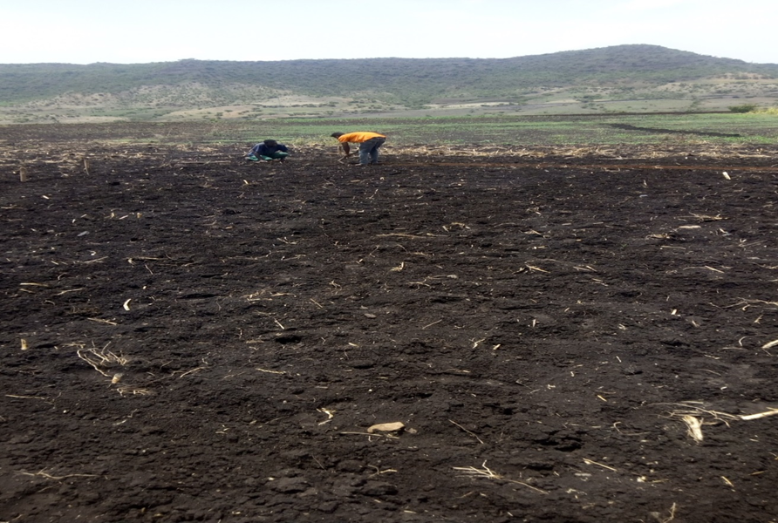

Appendix Figure 1 sowing at weleh

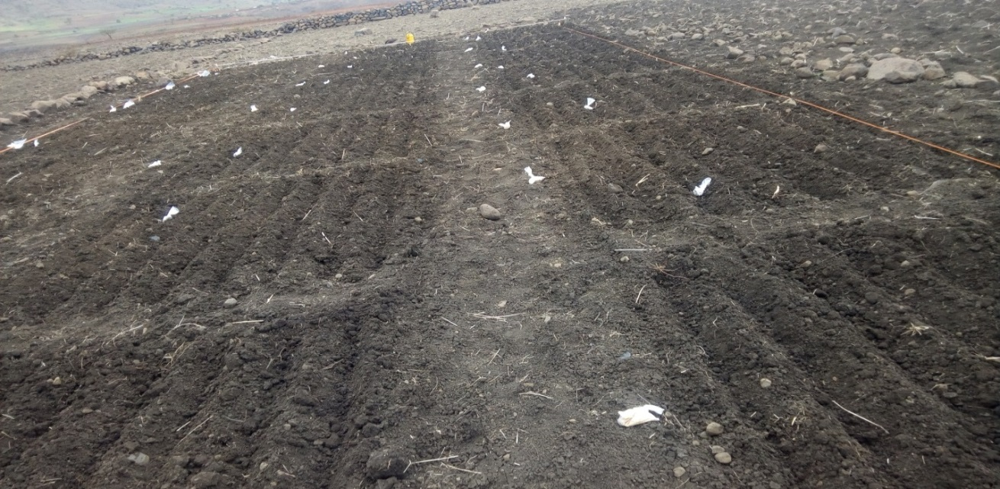

Appendix 2Figure Sowing at sayda

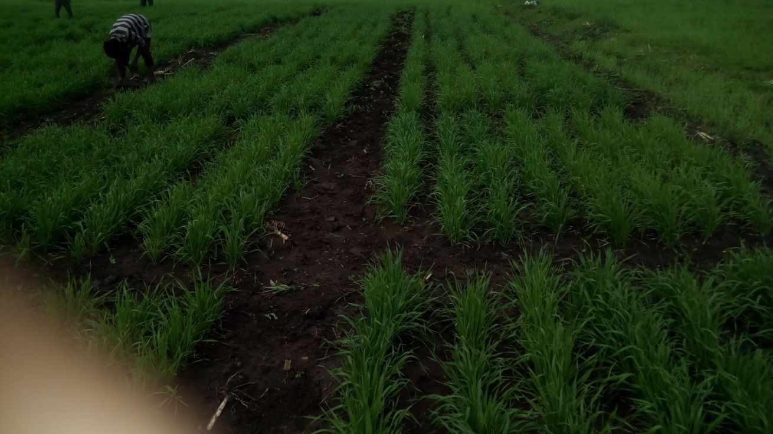

Appendix Figure 3 weeding at weleh

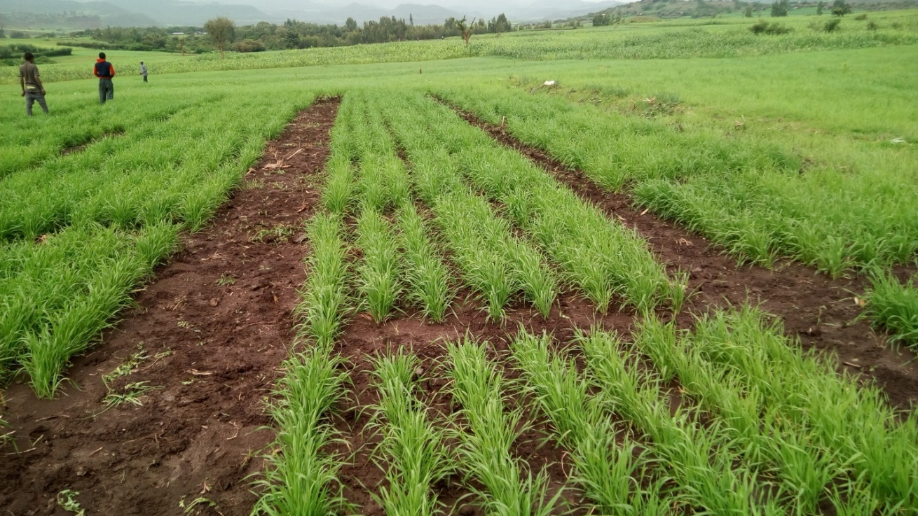

Appendix Figure 4 weeding at sayda

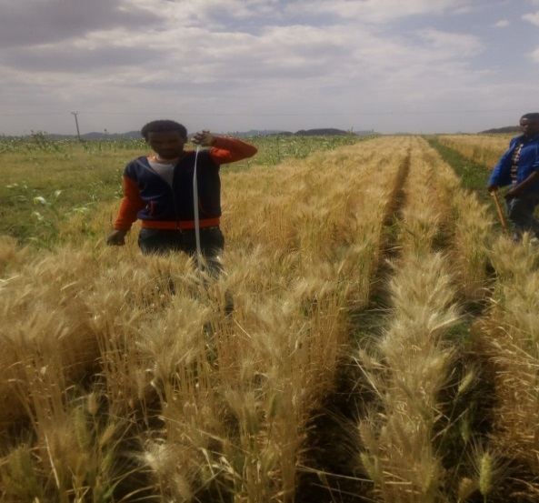

Appendix Figure 5 plant height measurement at sayda

‘

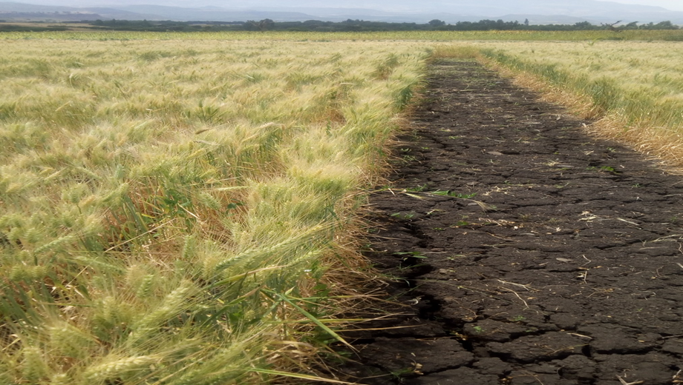

Appendix Figure 6 Performance at weleh



Appendix Figure 7 measurement of thousand seed weight by seed counter machine

# BIOGRAPHICAL SKETCH

The author was born in 1981 in Sekota district of Wag himra zone Amhara Regional State of Ethiopia to his father Lakewu Mogese and his mother Weyzer Lakewu. He attended primary and junior secondary education at Sekota School from 1989-1992 E.C at Azba and 1993-1995 at Medhnealem Junior School. He completed secondary education at Sekota Wag seyum Secondary School in 1999. He then joined Wollo University in 2000E.C and graduated with the Degree in Plant science in 2002.After graduation; he employed by the Ministry of Agriculture and assigned to work At Wag himra Administrative Zone, Dehana wereda as Wereda Expert. He worked in that wereda for two years. After that, he joined Sekota dry land agriculture research center as an Assistant researcher in agronomy in the Department of Crop Production and Protection,. Now He joined the School of Graduate Studies of Bahir dar University in 2016 to pursue a study leading to the Degree of Master of Science in Agronomy.