|  |  |
| --- | --- |
| ***BNJAR*** | **Blue Nile Journal of Agricultural Research (BNJAR)**  Vol. 5, Issue 2, December, 2024, pp. 14-29  Journal homepage: https://www.arari.gov.et/index_bnjar.php |

|  |  |  |  |
| --- | --- | --- | --- |
| **Response of maize yield to omitted nutrients on Nitisols and Vertisols of Tepid moist mid-highlands of Northwest Ethiopia** | | |  |
| Zerfu Bazie1*, Ayalew Addis1, Baye Ayalew1, Habtamu Getnet1, Getachew Agegnehu3, Frnus Haylie2, Melkamu Adane1,Tamrat Worku1, Tesfaye Feyisa2, and Tarekegn Ybabie1 | | |  |
| 1Gondar Agricultural Research Center, P.O.Box 1337, Gondar, Ethiopia,  2Amhara Agricultural Research Institute (ARARI), P.O.Box 527, Bahir Dar, Ethiopia,  3 International Crops Research Institute for the Semi-Arid Tropics  Corresponding author email: [zerfu24@hotmail.com](mailto:zerfu24@hotmail.com) | | | |
| Copyright: ©2024 The author(s). This article is published by BNJAR and is licensed under the CC BY 4.0 license (http://creativecommons.org/licenses/by/4.0/). | | | |
|  |  | **ABSTRACT** | |
|  |  |  | |
| **Received:** May 23, 2024  **Revised:** July 19, 2024  **Accepted:** December 20, 2024  **Available online:** January 25, 2025 |  | *Crop production has several biotic constraints, including soil nutrient depletion in Ethiopia. Understanding crop response to different nutrient types is required to determine the right fertilizer source for different soil types. Therefore, this experiment was conducted to fine-tune fertilizer sources and identify the yield limiting nutrient of maize in Northwestern Ethiopia. Nutrient omission trials were implemented at diverse farmers’ fields. The treatments were composed of four omitted nutrients such as K (NPSZnB-K), S (NPKZnBl-S), and Zn (NPKSB-Zn), and B (NPKSZnl-B), control which is no added nutrient, three NPKSZnB treatments from a single source of fertilizer, blended with K split and without split which are denoted by All-1, All-2 and All-3. Additionally, both N and P were added as one treatment (positive control) which gives a total of nine treatments. Applied nutrients significantly affected grain yield across locations and soil types. Both mixed and fixed model analysis of variance was performed for each site and across location yield datasets Maize grain yields ranged from 0.2 to 2.8 t ha-1 from the control treatment. In Vertisols, applying NPKSZn-B nutrients increased yields to 8.6 t/ha. The mean grain yield increased by 5.8 t ha-1 in Nitisols and 7.8 t ha-1 in Vertisols with NP nutrient application. Without NP nutrients, yields dropped by 94% in Vertisols and 70% in Nitisols. Grain yield did not significantly varied due to applying different forms of fertilizers. We can conclude that, both nitrogen and phosphorus were the major yield-limiting nutrients in study districts. Therefore, we suggest right nutrient at site-specific rate to improve maize productivity in the study areas and similar agroecologies of the farming system.* | |
| ***Keywords:*** *Fertilizer, Nitrogen, Limiting, Phosphorus, Productivity, Soil* |  |

2. **INTRODUCTION**

Maize is the most staple food crop among cereals in Ethiopia. It requires a large amount of nutrients (Aguiar et al., 2023). The production of maize has been increasing in area and productivity, along with production inputs. However, the current application of fertilizers in the mixed farming system has not yet minimized the yield gap. The major reasons are including to soil heterogeneity (EthioSIS, 2016; Aliyu et al., 2021; Tadele et al., 2022), soil nutrient depletion (Haileslassie et al., 2005; Tilahun et al., 2023), unresponsive soils to the applied different fertilizer types and climatic fluctuations (Tilahun et al., 2023). The decline of soil nutrients supply are among the main constraints of low maize yield (Arvind et al., 2021; ten Berge et al., 2019). Since soil nutrient depletion adversely affects agricultural productivity and soil fertility, it may be an issue for global food security (Tan et al., 2005).

Crops have been responding differently to applied fertilizers (Birhan et al., 2017). Maize yield, nutrient uptake and yield-limiting nutrients vary with soil types, environment and, management (Kolawole et al., 2018). Inadequate information about soil nutrient status could cause a mismatch between fertilizer applications and soil nutrient deficiencies for smallholder farmers (Kibrom et al., 2021). The use of fertilizers has been crucial for boosting agricultural productivity, crop production, and food security (Prem et al., 2015). To develop site-specific fertilizer recommendations needed by considering soil fertility status, farmers’ affordability, and environmental conditions, and determining yield-limiting nutrients is required (Kenea et al., 2021). Thus, understanding the factors affecting soil fertility that limit crop output is crucial for formulating effective recommendations for managing soil and nutrients (Job et al., 2016). In this study, different fertilizer forms are affects the efficiency of each nutrient uptake and investigate the effectiveness of different fertilizer types. The hypothesis tested was that applying various fertilizer forms could improve maize yield. Determining the right nutrient type for different soil types and agro-ecological zones is needed. Yet, the response of maize to applied different nutrient types has not investigated in Takusa and Alefa districts of Ethiopia. Thus, we conducted this study to fine-tune the source and form of fertilizers application and to identify the yield-limiting nutrient in the study areas.

1. **Materials and Methods**
   1. **Experimental location and design**

Nutrient omission trials to identify yield-limiting nutrients were implemented by randomly selecting the farmers’ fields in Takusa and Alefa districts (Figure 1). Both Nitisols and Vertisols were included during site selection. The Alefa and Takusa soils, part of the agricultural landscape in the Tana Basin of Ethiopia, exhibit a range of physicochemical properties that are crucial for farming and environmental sustainability. The soil properties indicates that a mean of pH level of 6.67 in the of study locations, which is slightly acidic and generally suitable for a wide range of crops. The availability of phosphorus is reported with 7.71 mg kg-1, along with a total nitrogen percentage of 0.125, this suggests moderate fertility. The mean organic matter content of study areas is at 2.23%, which can enhance soil structure and fertility. The cation exchange capacity is quite high at 52.323 Cmol/kg of soil, indicating a good potential for nutrient retention. The soil texture is predominantly silt, followed by clay and sand, classifying it as clay loam to heavy clay. This texture is typically good for water retention and nutrient supply but may require proper management to ensure good root penetration and air circulation.

Understanding soil characteristics is vital for effective soil management and ensuring sustainable agricultural productivity in Ethiopia (Mulat et al., 2021). The Vertisols are recognized for their high cation exchange capacity in the Alefa Takusa areas, indicating a substantial ability to retain essential nutrients (Getahun and Selassie, 2017). The pH levels of these soils are generally neutral to slightly alkaline, which is suitable for different crops. However, available phosphorous is often low to very low, necessitating careful management for optimal plant growth. Total nitrogen and organic matter contents also tend to be on the lower end, which could affect soil fertility and structure.

The treatments was arranged in a randomized complete block design (RCBD) with three replications. It was composed of 9 treatments with omission of six nutrient types (Table 1). The treatments included a control which is no nutrient added (NF), and three treatments that have six nutrient types (NPKSZnB) denoted with: All_1 (single source for each nutrient), All_2 (blended), and All-_3 (blended + K split), four treatments with the omission of K (NPSZnB_K), S (NPKZnB_S), Zn (NPKSB_Zn) and B (NPKSZn_B). Additionally, one treatment (NP only), or KSZnB_NP was added as a positive control which was used as a main source of fertilizer in the country for many years. The gross plot with a size of 4.5 m by 3 m and the net plot with a size of 3 m by 3 m was used.

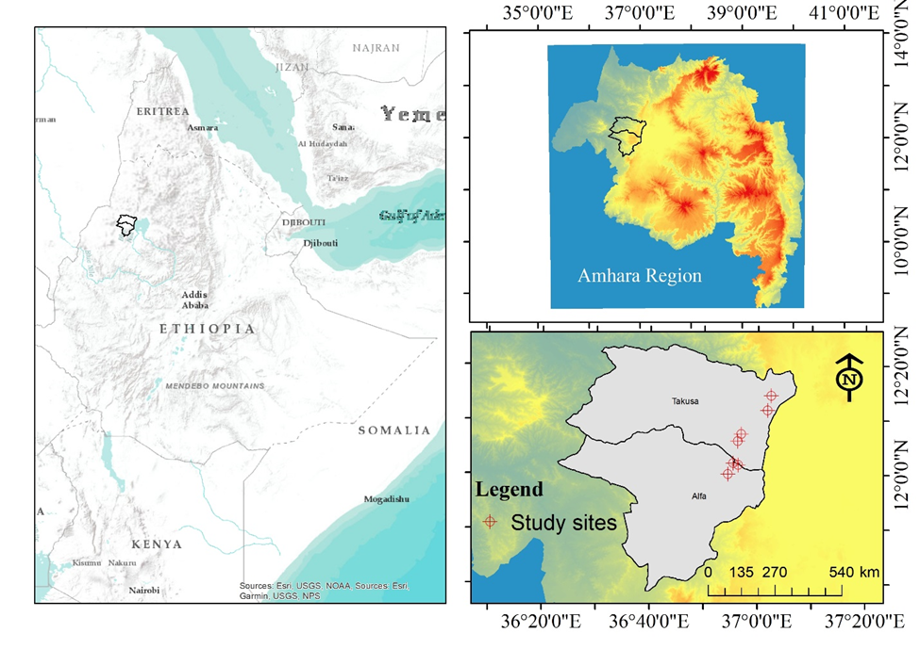

Figure 1. Location map of the study area

**Table 1. Details of treatments**

|  |  |  |
| --- | --- | --- |
| **Treatment numbers** | **Treatments** | **Descriptions** |
| **1** | All_1 | All (NPKSZnB) in blending form |
| **2** | NPKZnB_S | All-S |
| **3** | NPKSB_Zn | All-Zn |
| **4** | NPKSZn_B | All-B |
| **5** | NPSZnB_K | All-K |
| **6** | NP | NP(KSZnB_NP) |
| **7** | All_2 | All 2 (NPKSZnB nutrients are individually applied) |
| **8** | All_3 | All 3 (NPSZnB compound + K) OCP |
| **9** | NF | Control (no fertilizer) |

In the maize nutrient omission experiment the nutrient rates were used as follows: 120 kg ha-1 of N, 76 kg ha-1 P2O5, 60 kg ha-1 of K2O, 14.8 kg ha-1 of S, 1.5 kg ha-1 of Zn, and 0.5 kg ha-1 of B. DAP (18-46-0), NPS (19-38-70), and urea (46-0-0) were used for the sources of nitrogen whereas both DAP and NPS were also used for phosphorus sources. KCl (0-0-60), NPS (19-38-7), Zn sulfate monohydrate, and borax solubor were used as the sources of potassium, sulfur, zinc, and boron, respectively. BH 540 maize variety was used as a test crop.

All recommended agronomic management was done at the appropriate stage of the test crop. All amounts of PKSZnB nutrients and half of nitrogen fertilizer were applied at planting via drill method. Half of the nitrogen fertilizer was applied at as top dressing. However, half potassium for All-3 treatment was applied at tillering as split to see its effect on grain yield.

Grain yield, biomass yield, plant height, ear length, ear diameter, cob number, cob weight, and stand count data were collected and arranged for analysis. Composite soil samples were collected at planting from each trial site. The cost of each nutrient was collected from the nationally imported inputs. The farm gate price of yield was obtained from local market.

* 1. **Data Analysis**

Fixed model analysis of variance (ANOVA) was used for analysis of yield data at site level. The factors affecting yield as random were used an input for ANOVA analysis in mixed model. The model is expressed as follows:

Yijk = μ + Nti + (1|L)+ (Nt × S)ij + Sj+ Bk + Ɛijk ---------------------Formula 1

Yijk: represents the grain yield, μ: denotes the overall mean, Nti: captures the impact of nutrient types, Sj: accounts for soil types, (1|L): considers the random effect of location, (Nt × S)ij: represents the interaction effects of these factors, Bk: represents the block effect and Eijk: represents the error associated with each level of the factors.

Tukey's Honestly Significant Difference (HSD) test is a post-hoc statistical method used to determine a significant differences between group means in a dataset. This test is typically applied after an ANOVA indicates that there are statistically significant differences among the group means. Contrast analyses were also conducted to see the variability among the treatments. This statistical method allows for the comparison of specific predefined hypotheses about the means of different groups, when the ANOVA is significant. Graphs were generated after analysis of ANOVA using ggplot in R programing software version 4.1.3. Correlation analysis was performed among yield and yield related parameters to see their association due to omitted nutrients. Additionally, a partial budget analysis was conducted to evaluate the economic importance of the omitted nutrient types. To account for potential yield discrepancy, the mean grain yield was adjusted downward by 10% (CIMMYT, 1988).

1. **Results and Discussion**

**3.1 Results**

**3.1.1 Response of maize yield to applied nutrients**

Grain yield was significantly different for applied nutrients across all sites at p< 0.01. Figures 2 and 3 show that maize grain yields varied from site to site at both district and soil types. Maximum grain yield (8.6 t ha-1) was obtained from the application of NPKSZn-B at site 1 in the vertisols of Takusa district (Figure 3). Moreover, a higher yield (8.6 t ha-1) was also recorded from the application of NPKSZnB blended (All-1)

Higher grain yield was obtained from the application of NPKSZn-B fertilizer at nitisols in Alefa (Figure 3). While, negative control or without fertilizer treatment was given lower or no yield across the sites in the study districts. The lowest grain yield of 1.1 t ha-1 was recorded from no fertilizer application treatment at site 2 in Vertisols. Similarly, yield was not recorded without fertilizer application at site 7 in Nitisols. The grain yield obtained from NP nutrients alone ranged between 4.5-6.5 [5.8] and 5.5-7.0 [7.8] t ha-1 in nitisols and Vertisols respectively, however, not significantly different from the application of NP plus other added or omitted nutrients.

The vegetative performance of experiment clearly indicates that the deficiency of nitrogen and phosphorus was clearly observed from control plot at two soil types (Figure 4). The remaining treatment had no visible deficiency symptoms of other treatment in this study.

**3.1.2 The comparison of nitrogen and phosphorus with addition of KSZnB nutrients**

The contrast analysis showed that the application of NP plus KSZnB had no significant (p>0.05) yield advantage compared to NP nutrients alone in vertisols (Table 2). Higher maize yields were recorded in vertisols compared to nitisols. The omission of both NP fertilizers was reduced yield by 94% in vertosols. From the combined analysis, the highest grain yields of 7.44 and 5.58 t ha-1 were recorded from the application of NPKSZn nutrients in vertisols and nitisols, respectively (Table 2 and 3). A highly significant (p<0.0001) and higher yield (5 t ha-1) was reduced when NP nutrients are omitted in vertosols.

The omission of both NP fertilizers reduced yield by 70 % in nitisols (Table 5). A contrast analysis also showed that about 4.1 t ha-1 maize grain yield declined when both nitrogen and phosphorus nutrients were omitted. However, the applications of NP plus KSZnB had no significant yield advantage. The blended application of NPKSZnB significantly (p<0.019) varied with NP nutrients in nitisols (Table 5).

The combined analysis revealed that higher yield was observed from the application of NPKSB-Zn treatment across both soil types and locations (Figure 5). The absence of nitrogen and phosphorus nutrients significantly (p<0.0001) reduced grain yield by 4.8 t ha-1 (Table 4). Whereas the remaining nutrients did not show significant differences compared to nitrogen and phosphorus in the study area.

The correlation analysis indicated that the yield of maize obtained from the applications of NPKSZnB in different forms that is single sources (All_1) and OCP blended + K split (All_3) treatments compared with NP nutrients treatment were highly significant (p<0.001) correlated with r equals to 0.69 and 0.70 values (Figure 6), respectively. Whereas the association analysis between NP nutrient and All_2 (NPKSZnB) applied individually was highly significant (p<0.000) with r equals to 0.78.

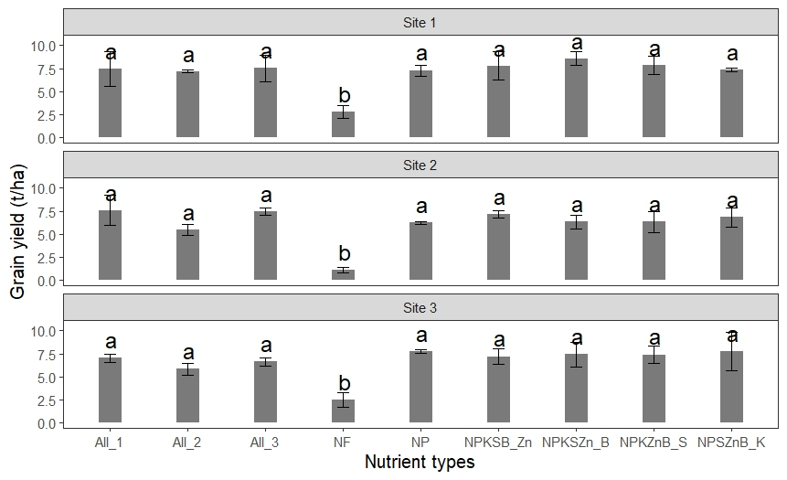

Figure 2. Maize yield response to applied nutrient types in Takusa district [Vertisols]. Short lines at the top of each bar denote the standard deviation among omitted nutrients, lowercase letter at the short lines bar indicates the difference among treatments.

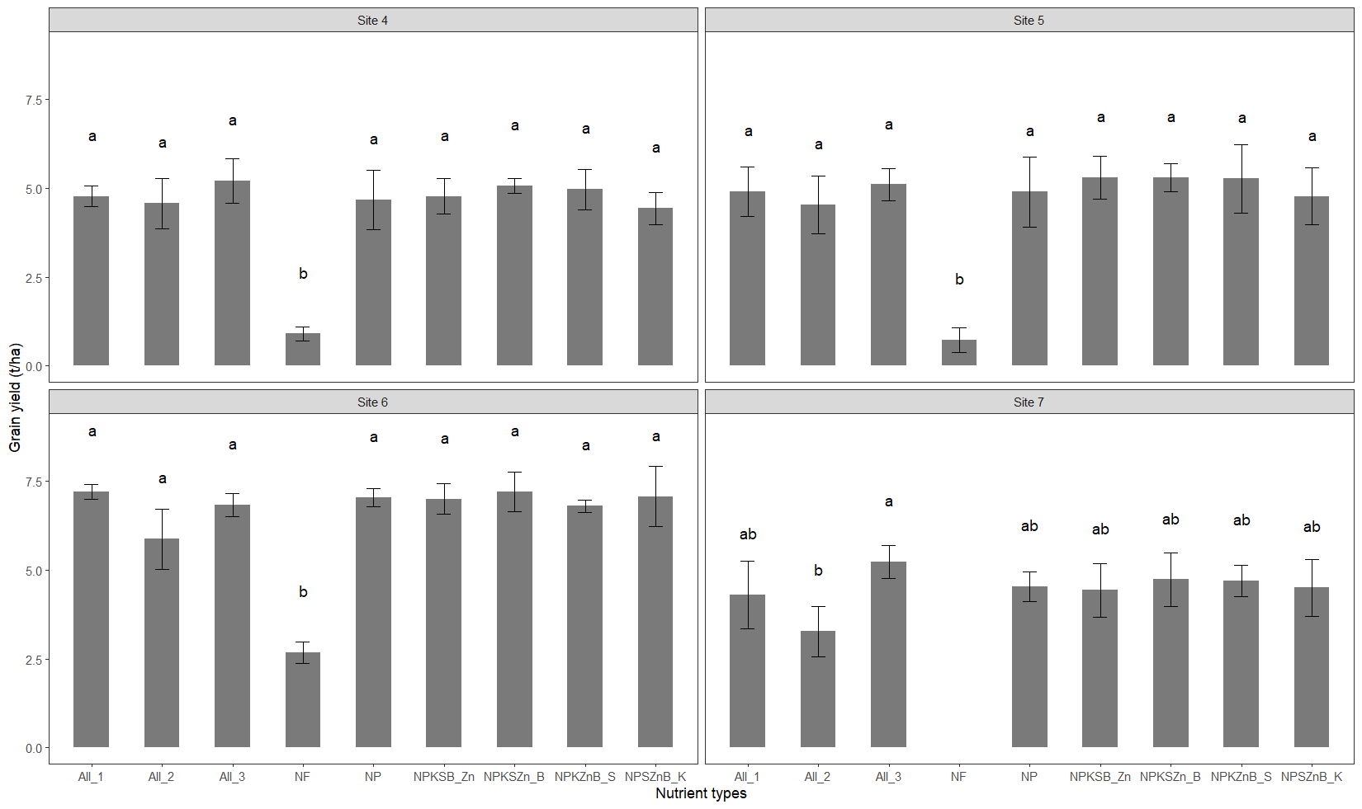

Figure 3. Maize yield response to applied nutrient types at three sites of Alefa and at 1 site in Takusa districts (Nitisols). Short lines at the top of each bar denote the standard deviation among omitted nutrients, lowercase letter at the short lines bar indicates the difference among treatments.

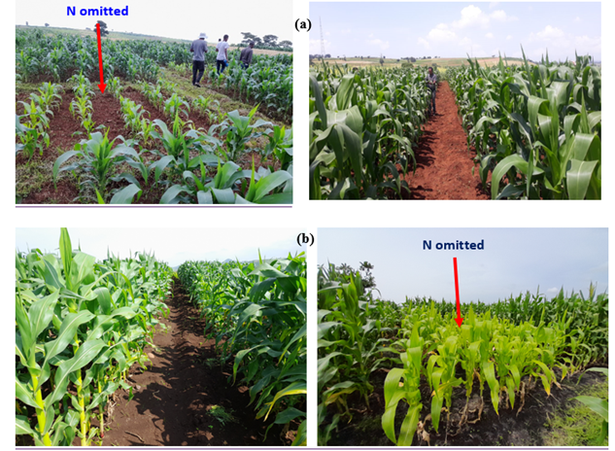

Figure 4. Vegetative performance of maize under nutrient omission trial in nitisols (a) and vertisols (b)

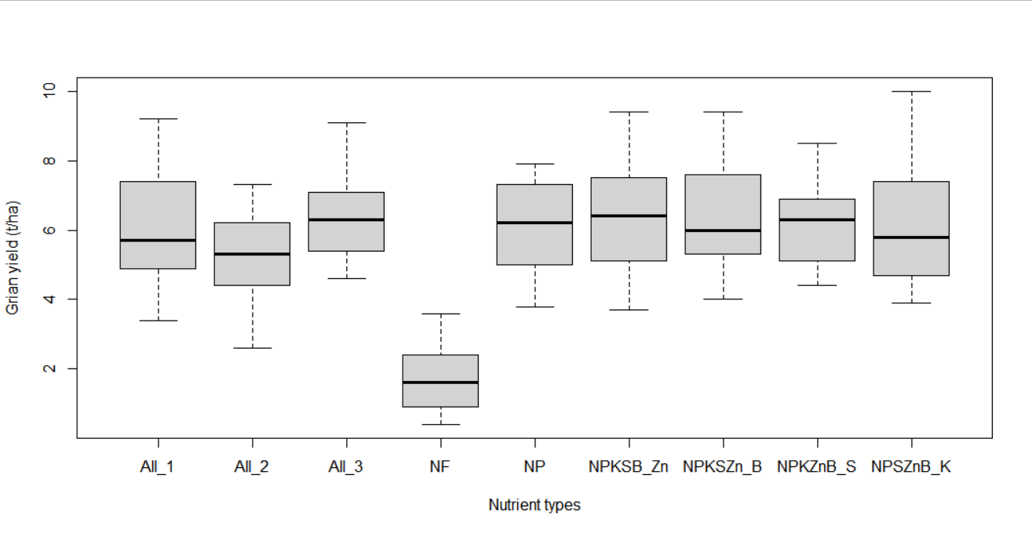

Figure 5. Boxplot of combined grain yield over all sites

**Table 2. Mean contrast of maize yield in vertisols**

|  |  |  |  |  |
| --- | --- | --- | --- | --- |
| **Contrast** | **Estimate** | **SE** | **t. ratio** | **p. value** |
| **All_1 vs NP** | 0.267 | 0.119 | 0.571 | 0.970 |
| **All_2 vs NP** | -0.933 | -0.814 | -1.998 | 0.257 |
| **All_3 vs NP** | 0.111 | 0.224 | 0.238 | 0.999 |
| **NF vs NP** | -4.956 | -4.541 | -10.609 | <.0001 |
| **NPKSB_Zn vs NP** | 0.289 | 0.176 | 0.618 | 0.961 |
| **NPKSZn_B vs NP** | 0.356 | 0.356 | 0.761 | 0.924 |
| **NPKZnB_S vs NP** | 0.100 | 0.129 | 0.214 | 0.999 |
| **NPSZnB_K vs NP** | 0.233 | 0.048 | 0.500 | 0.980 |

SE: standard error of the mean

**Table 3. Mean contrast of maize yield in nitisols**

|  |  |  |  |  |
| --- | --- | --- | --- | --- |
| Contrast | Estimate | SE | t.ratio | p.value |
| **All_1 vs NP** | 0.008 | 0.236 | 0.035 | 1.000 |
| **All_2 vs NP** | -0.725 | 0.236 | -3.076 | 0.019 |
| **All_3 vs NP** | 0.308 | 0.236 | 1.308 | 0.656 |
| **NF vs NP** | -4.122 | 0.257 | -16.049 | <.0001 |
| **NPKSB_Zn vs NP** | 0.092 | 0.236 | 0.389 | 0.992 |
| **NPKSZn_B vs NP** | 0.292 | 0.236 | 1.238 | 0.699 |
| **NPKZnB_S vs NP** | 0.150 | 0.236 | 0.636 | 0.957 |
| **NPSZnB_K vs NP** | -0.092 | 0.236 | -0.389 | 0.992 |

SE: standard error of the mean

**Table 4. Mean contrast of maize yield over location**

|  |  |  |  |  |
| --- | --- | --- | --- | --- |
| **Contrast** | **estimate** | **SE** | **t.ratio** | **p.value** |
| **All_1 vs NP** | -0.1048 | 0.119 | 0.50 | 0.980 |
| **All_2 vs NP** | -0.2238 | -0.814 | -3.43 | 0.006 |
| **All_3 vs NP** | -1.0381 | 0.224 | 0.94 | 0.857 |
| **NF vs NP** | -4.7643 | -4.541 | -18.28 | <.0001 |
| **NPKSB_Zn vs NP** | 0.1326 | 0.176 | 0.74 | 0.930 |
| **NPKSZn_B vs NP** | -0.1762 | 0.356 | 1.48 | 0.543 |
| **NPKZnB_S vs NP** | -0.0476 | 0.129 | 0.54 | 0.975 |
| **NPSZnB_K vs NP** | -0.0952 | 0.048 | 0.20 | 0.999 |

SE: standard error of the mean

**3.1.3 The effect of fertilizer form on maize yield**

The ANOVA result showed no significant differences in the grain yields of maize when different forms of nutrients were applied (Figure 7). So, the fertilizer application forms did not have a significant impact on maize yield, as long as all the necessary nutrients are applied a reduction of 0.73 t ha-1 yield was observed from NPKSZnB applied individually.

**3.1.4 The role nutrients on harvest index**

Similarly to grain yield, the results indicated a significant difference (p<0.000) in the harvest index between the unfertilized control and the other treatments (Table 5). The highest harvest index of 52.8% was obtained with the application of the NPKSB_Zn treatment.

The omission nutrients resulted variable net benefits (Table 6). The plot that did not receive fertilizer produced the lowest net benefit (42934 ETB ha-1). Among the nutrient omission treatments, the omission of Zinc (NPKSB_Zn) generated in the highest marginal rate of return (322 %) compared to the returns from the omission of NP nutrients. Accordingly, all treatments, except for the NPKSB_Zn omission, exhibited a lower marginal rate of return.

**3.2 Discussion**

**3.2.1 Response of maize to applied nutrients**

The yield of maize varied across locations and soil types due to numerous biotic and abiotic limitations, such as nutrient deficits (Wortmann et al., 2019). Both macro and micronutrients are vital in enhancing crop productivity; yet, their role is not well studied in Gondar areas. Both nitrogen and phosphorus omission significantly reduced maize yield in the study area. This indicates that both nutrients are essential for crop production (Chaudhary and Debbarma, 2023). As we know nitrogen is a vital nutrient for maize and a key determinant of grain yield, particularly through its role in photosynthesis and other biological processes (Yue et al., 2022). Nitrogen contributes about 45% to the yield of maize. Therefore, the rational application of N fertilizer is one of the effective measures to improve corn yield and quality (Asibi et al., 2019). Similarly, phosphorus is also a critical nutrient for cereal production and animals (Iqbal et al., 2003).

The application of phosphorus significantly increases maize grain yield (Jiang et al., 2019). However, phosphorus fertilizer efficiencies are once seen as very low. Optimizing the phosphorus application rate can increase grain yield while reducing both cost and environmental impact (Iqbal et al., 2003). This result agreed with many previous findings that reported that nitrogen and phosphorus nutrients are highly demanding nutrients to enhance maize productivity in the mixed farming system of Ethiopia (Habetamu et al., 2022; Tadele et al., 2022). The lower yield was obtained from no fertilizer treatment. This indicates that the application of fertilizers to address specific nutritional deficiencies can help overcome limitations and increase maize production.

Our finding confirmed that the omission of K, S, Zn, and B did not add significant (p>0.05) maize yield in both soil types, and locations. This is because these nutrients are naturally present in the soil, as evidenced by the similar yields from plots treated with only NP nutrients compared to those treated with NPKSZnB nutrients.

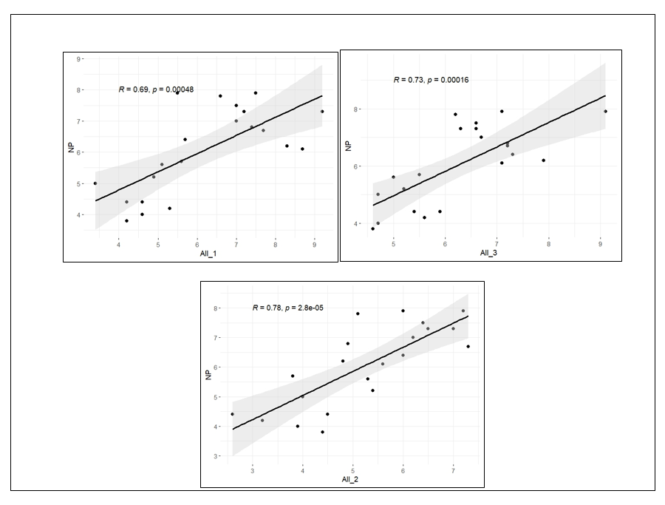

Figure 6. Correlation of maize yield from the application of single source All_1, All_2 and All_3 with NP nutrients.

From economic analysis, the application of added nutrients were also not bring higher marginal rate of return as compared to both NP nutrients except omission of Zn. This result is confirmed by Tadele et al. (2022), who reported that the adding of potassium, sulfur, zinc and boron nutrients does not significantly increase maize yield in farming systems of North West Ethiopia. However, Abebe et al. (2018) reported that K, S, Zn, and B nutrients are yield-limiting to cereal crops in soils of the Central highlands of Ethiopia. Contrary to our results, Ao and Sharma (2021) found a significant increase in maize yield with the application of boron. Other findings also reported that addition of K, S and B fertilizers is improve crop yield (Mugo et al., 2021). According to Khan et al. (2015), applying K fertilizer is unlikely to enhance crop yield. However, K deficiency causes abiotic stress, reducing crop yield (Adnan, 2020).

In deficient conditions, K fertilization enhances soil properties, maintains photosynthetic efficiency, and increases dry matter accumulation, resulting in stable, high maize yields (Adnan, 2020). It also aids maize in coping with drought by improving cell water balance and osmotic adjustment (Kandil et al., 2020). Therefore, it is necessary to accurately measure Exchangeable K in order to recommend K fertilizer application by considering inherent soil supply capacity (Bar-Yosef et al., 2015).

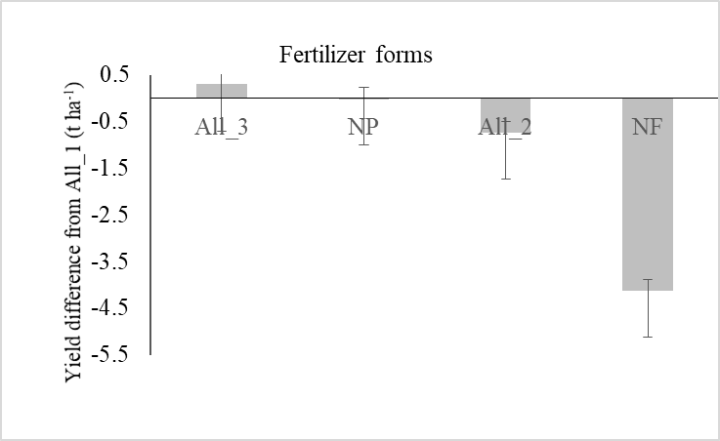

Figure 7. The contrast analysis of different forms of fertilizers on maize yield in the study area

**Table 5. Maize harvest index response to applied nutrient types in the study area**

|  |  |
| --- | --- |
| **Treatments** | **Harvest index (%)** |
| **NPKSB_Zn** | 52.8 ± 13.8a |
| **All_3** | 49.7 ± 8.8a |
| **NPKSZn_B** | 48.9 ± 11.0a |
| **All_2** | 48.8 ± 9.4a |
| **NPSZnB_K** | 48.3 ± 13.5a |
| **NPKZnB_S** | 47.3 ± 13.9a |
| **NP** | 46.1 ± 13.1a |
| **All_1** | 44.0 ± 12.7a |
| **NF** | 43.4 ± 23.1b |
| **p** | <0.000 |
| **CV** | 8.70 |

CV: coefficient of variation, numbers next mean harvest index indicates standard error of mean of treatments and lowercases letter indicates indicate the mean differences of each treatment. NF: Unfertilized pot.

Previous studies reported that sulfur fertilizer application significantly increased weight maize yield compared to the control treatment (Khan et al., 2006; Liu et al., 2020). Micronutrients are crucial for crop yield and grain quality. According to Stewart et al. (2021), understanding micronutrient deficiencies is essential before applying foliar treatments. Zinc, for example, is vital for plant metabolic processes, enhancing maize yield and quality by stimulating chlorophyll production, photosynthetic activity, nutrient uptake, and protein biosynthesis (Ariraman et al., 2022). Our experiment showed that adding micronutrients, particularly Zn and B, did not significantly increase maize yield in the study areas.

**Table 6. Partial budget analysis of nutrient omission for maize production in the study area**

|  |  |  |  |  |  |
| --- | --- | --- | --- | --- | --- |
| **Treatments** | **Adjusted yield (kg/ha)** | **Gross benefit (ETB/ha)** | **TVC (ETB/ha)** | **Net benefit (ETB/ha)** | **MRR over NP (%)** |
| **NF** | 1480.5 | 42934.5 | 0.0 | 42934.5 | * |
| **NP** | 5566.5 | 154207.5 | 7221.0 | 146986.6 | * |
| **All_1** | 5692.5 | 156036.5 | 9046.0 | 146990.5 | 0.2 |
| **All_3** | 5755.5 | 157863.5 | 9046.0 | 148817.5 | 100.3 |
| **All_2** | 4824.0 | 130850.0 | 9046.0 | 121804.0 | D |
| **NPSZnB_K** | 5629.5 | 155376.2 | 7879.3 | 147496.8 | 77.5 |
| **NPKZnB_S** | 5679.0 | 156029.8 | 8661.2 | 147368.6 | 26.5 |
| **NPKSB_Zn** | 5859.0 | 161065.2 | 8845.8 | 152219.5 | 322.1 |
| **NPKSZn_B** | 5742.0 | 157545.3 | 8972.7 | 148572.7 | 90.5 |

ETB: Ethiopian Birr, NF: Unfertilized pot, MRR: Marginal Rate of Return.

Similar studies on yield-limiting nutrients for maize found that improved maize varieties' potential yield is not significantly reduced due to zinc and boron deficiencies in most parts of Ethiopia (Eynde et al., 2022; Tadele et al., 2022). However, contrary to our findings, research by Wasaya et al. (2017) demonstrated that applying Zn and B improves maize yield. Other studies also found that B deficiency depresses maize grain yield (Yar, 2021) and that B application significantly enhances maize growth and yield (Ojha et al., 2023; Rerkasem et al., 2020). However, B has a narrow range between deficiency and toxicity, and inadequate boron supply negatively impacts agricultural plant production (Brdar-Jokanović, 2020). This variability is likely due to differences in soil types and locations.

Applying nutrients like NPKSZnB individually instead of in a blend can result in lower yields for several important reasons. Blended fertilizers offer the advantage of synergistic nutrient effects, resulting in improved nutrient efficiency. Individually applying nutrients can result in imbalances that harm plant growth and yield (Fageria et al., 2002). The use of blended nutrients guarantees even distribution of all nutrients throughout the field. Plant growth and yield can vary due to uneven nutrient distribution caused by individual applications (Havlin et al., 2013). Using blended fertilizers can save costs and reduce the need for labor compared to using multiple individual applications.

From economic analysis, the added nutrients were also not bring higher marginal rate of return as compared to both NP nutrients except omission of Zn. This highlights that the critical importance of N and P nutrients in enhancing maize yield and profitability in Ethiopia. This finding is supported by Melesse et al. (2018), which shows the significant importance of NP fertilization on improving maize productivity and ensuring better economic outcomes for farmers. In contrary to statistical analysis, all other nutrient omission treatments, except for NPKSB_Zn, exhibited a lower marginal rate of return. This indicates the economic significance of Zinc in profitability of maize production in Ethiopia (Abera et al., 2017).

The observed differences in harvest index among the treatments suggest that nutrient application substantially influences the efficiency of biomass conversion into harvestable product. The NPKSB_Zn treatment achieved the highest harvest index of 52.8%. These indicates that the balanced provision of essential nutrients can optimize the allocation of resources ensuring the availability of a multiple range of nutrients supports optimal growth during critical developmental stages, thus improving both yield and harvest index (Wondwosen and Sheleme, 2011).

1. **Conclusions and Recommendations**

Our result shows that yield was varied across experimental sites due to inherent soil heterogeneity. The absence of nitrogen and phosphorus nutrients reduced yield significantly. Vertisols had higher yield potential than Nitisols. The form and source of nutrient combinations have not given significant yield differences compared to nitrogen and phosphorus fertilizers. Yet, a relatively lower grain yield was obtained from the application of all nutrients (NPKSZnB) from single sources.

There was a significant differences in maize yield were observed among the various nutrient sources when applied in blended, compound, or individual forms. Nitrogen and phosphorus are the most important nutrients to enhance maize yield in both soil types. However, KSZnB nutrients are not yield limiting nutrients for maize production in the Takusa and Alefa districts. Thus, addressing the limiting nutrients to maize productivity is crucial for solving food insecurity. Developing the right amount of nutrients is advised to improve maize productivity in Takusa and Alefa areas. Finally, the future of maize production shall focus on addressing limiting nutrients based on soil test results for site-specific areas.

1. **Acknowledgments**

Let's take a moment to express our sincere gratitude to all the hardworking farmers in the study area. We would also like to thank organizations like ICRISAT, who are continuously working with our research institute and supporting this research by financing a sustainability of agriculture.

1. **References**

Abay, Kibrom A., Mehari H. Abay, Mulubrhan Amare, Guush Berhane, and Ermias Aynekulu. 2021. Mismatch between Soil Nutrient Deficiencies and Fertilizer Applications. *Agricultural Economics* 215-30. [https://doi.org/10 .1111/agec.12689](https://doi.org/10%20.1111/agec.12689).

Abebe Ayele, Girma Abera, and Sheleme Beyene. 2018. Assessment of the Limiting Nutrients for Wheat (Triticum Aestivum L.) Growth Using Diagnosis and Recommendation Integrated System (Dris). *Communications in Soil Science and Plant Analysis* 49 (21): 2653-63.

Abera, T., Tufa, A., and Tanner, D. (2017). Effect of Balanced Nutrient Application on Maize Yield and Profitability in Ethiopia. East African Journal of Sciences, 11(2), 99-107.

Adnan, M. Role of Potassium in Maize Production: A Review. *Op Acc J Bio Sci Res* 3 (5): 1-4.

Aguiar F.R., André C.F., Miguel H.R.F., Douglas P.V., Regina M.Q.L., and Reginaldo C. 2023. Application of Special Fertilizers and Their Effects on the Agronomic Aspects of Maize and Soil Fertility. *Bioscience Journal* 39. [https://doi.org/10.14393/BJ-v39n 0a2023-66915](https://doi.org/10.14393/BJ-v39n%200a2023-66915).

Amare Haileslassie, Joerg P., Edzo V., Demil Teketay, and Jan P.L. 2005. Assessment of Soil Nutrient Depletion and Its Spatial Variability on Smallholders’ Mixed Farming Systems in Ethiopia Using Partial Versus Full Nutrient Balances. *Agriculture, ecosystems & environment* 108(1): 1-16.

Ao M., and Y.K., Sharma. 2021. Influence of Lime, Phosphorus and Boron on Performance of Maize (Zea Mays L.) in Acidic Soil of Nagaland. *Annals of Plant and Soil Research* 23 (1): 54-60.

Ariraman R., S. Selvakumar, M. Mansingh, M. Karthikeyan, and Y.A. Vasline. 2022. Effect of Zinc Application on Growth, Yield Parameters, Nutrient Uptake, Yield and Economics of Maize. *Agricultural Reviews* 43 (1): 104-09.

Arvind K.S., Kumar B.S., Prakash C., Kumar P.A., Ch Srinivasa R., Kumar C.S., Das S., Kumar Singh A., and Green A. 2021. Assessing Multi-Micronutrients Deficiency in Agricultural Soils of India. *Sustainability* 13(9136). https://doi. org/10.3390/su13169136.

Asibi A.E., Qiang C., and Jeffrey A.C. 2019. Mechanisms of Nitrogen Use in Maize. *Agronomy* 9(12): 775.

Beyene, S., Kassie, M., and Shiferaw, B. (2021). Nutrient Management and Maize Production in Ethiopia: The Role of Fertilization in Enhancing Yield and Economic Returns. Journal of Agricultural Science, 9(3), 45-55.

Birhan Abdulkadir, Sofiya Kassa, Temesgen Desalegn, Kassu Tadesse, Mihreteab Haileselassie, Girma Fana, Tolera Abera, Tilahun Amede, and Degefie Tibebe. 2017. Crop Response to Fertilizer Application in Ethiopia: A Review.

Brdar-Jokanović M.2020. Boron Toxicity and Deficiency in Agricultural Plants. *International journal of molecular sciences* 21(4): 1424.

Chaudhary K., and Victor D. 2023. Response of Nitrogen and Phosphorus on Growth, Yield and Economics of Fodder Maize (Zea Mays L.). *International Journal of Plant & Soil Science* 35(14): 330-37.

CIMMYT (1988). From Agronomic Data to Farmer Recommendations: An Economics Training Manual. Completely Revised Edition. CIMMYT, Mexico.

Eynde E.V., Mirjam B., Regis C., Samuel N., Rob N.J.C., and Ellis H. 2022. Soil Zinc Fertilisation Does Not Increase Maize Yields but Improves Nutritional Quality. [https://doi.org/ 10.21203/rs.3.rs2113596/v1](https://doi.org/%2010.21203/rs.3.rs2113596/v1).

Fageria, N. K., Baligar, V. C., and Jones, C. A. (2010). *Growth and mineral nutrition of field crops*. CRC press.

Getahun Mekonnen, and Yihenew G.Selassie. 2017. Characterization, Classification and Mapping of Soils of Agricultural Landscape in Tana Basin, Amhara National Regional State, Ethiopia. *Social and Ecological System Dynamics: Characteristics, Trends, and Integration in the Lake Tana Basin, Ethiopia,* 93-115 P.

Habetamu Getinet, Yihenew G.Selassie. and Tesfaye Balemi. 2022. Yield Response and Nutrient Use Efficiencies of Maize (Zea Mays L.) as Determined through Nutrient Omission Trial in Jimma Zone, Southwestern Ethiopia. *J. Agric. Environ. Sci.* 7(1).

Havlin, J. L., Tisdale, S. L., Nelson, W. L., and Beaton, J. D. (2016). *Soil fertility and fertilizers*. Pearson Education India.

Iqbal Z., Abdul L., Sikander A., and M. M. Iqbal. 2003. Effect of Fertigated Phosphorus on P Use Efficiency and Yield of Wheat and Maize. *world* 25(6).

Jiang W., Xiaohu L., Xiukang W., Lihui Y., and Yuan Y. 2019. Improving Phosphorus Use Efficiency and Optimizing Phosphorus Application Rates for Maize in the Northeast Plain of China for Sustainable Agriculture. *Sustainability* 11(17): 4799.

Job K., Nziguheba G., Zingore S., Coulibaly A., Esilaba A., Kabambe V., Njorogec S., Palm C., and Huising J.. 2016. Understanding Variability in Crop Response to Fertilizer and Amendments in Sub-Saharan Africa. *Agriculture, Ecosystems and Environme* 229: 1-12. https://doi.org /10.1016/j.agee.2016.05.012.

Kandil E.E., Nader R.A., Mansour A.M., H.M.A., and Manzer H.S. 2020. Potentials of Organic Manure and Potassium Forms on Maize (Zea Mays L.) Growth and Production. *Scientific Reports* 10(1): 8752.

Kenea, Workneh Bekere, Pytrik R., Katrien D., Jairos R., Tesfaye Balemi, and Martin K. I. 2021. Variability in Yield Responses, Physiological Use Efficiencies and Recovery Fractions of Fertilizer Use in Maize in Ethiopia. *European Journal of Agronomy* 124: 1-12. https://doi. org/10.1016/j.eja. 2020.126228.

Khan M.J., Muhammad H.K., Riaz A.K., and Muhammad T.J. 2006. Response of Maize to Different Levels of Sulfur. *Communications in soil science and plant analysis* 37(1-2): 41-51.

Khan S.A , R.L, Mulvaney, and T.R, Ellsworth. 2015. The Potassium Paradox: Implications for Soil Fertility, Crop Production and Human Health. *Renewable Agriculture and Food Systems* 1-25. [https://doi.org/ 10.1017/S1742170513000318](https://doi.org/%2010.1017/S1742170513000318).

Liu S., Shuai C., Xue Z., Yin W., Guohua M., and Qiang G. 2020. Synergistic Regulation of Nitrogen and Sulfur on Redox Balance of Maize Leaves and Amino Acids Balance of Grains. *Frontiers in Plant Science* 11: 576718.

Mugo J.N., Nancy N.K, Charles K.G., Klaus D., Harun I.G., and Elmar S. 2021. Response of Potato. Crop to Selected Nutrients in Central and Eastern Highlands of Kenya. *Cogent Food & Agriculture* 7(1): 1898762.

Ojha A.K., Joy D., and Ashia R. 2023. Effect of Phosphorus and Boron on Growth, Yield and Economics of Sweet Corn (Zea Mays L.). *International Journal of Plant & Soil Science* 35(9): 91-98.

Prem S.B., Rabbinge R., Dimkpa C., Nagarajan L., and Roy A. Revisiting Fertilisers and Fertilisation Strategies for Improved Nutrient Uptake by Plants. *Biol Fertil Soils*. <https://doi>. org/ 10.1007/s00374-015- 1039-7.

Rerkasem B. Sansanee J., and Tonapha P. 2020. Productivity Limiting Impacts of Boron Deficiency, a Review. *Plant and Soil* 455: 23-40.

Stewart Z.P., Ellen T.P., Charles S.W., Prakash K.J., and Charles A.S. 2021. Effect of Foliar Micronutrients (B, Mn, Fe, Zn) on Maize Grain Yield, Micronutrient Recovery, Uptake, and Partitioning. *Plants* 10(3):528.

Tadele, Amare, Erkihun Alemu, Zerfu Bazie, Asmare Woubet, Selamyihun Kidanu, Beamlaku Alemayehu, Abrham Awoke, Assefa Derebe, Tesfaye Feyisa, Lulseged Tamene, Bitewlgn Kerebh, Sefinew Wale and Aweke Mulualem. 2022. Yield-Limiting Plant Nutrients for Maize Production in Northwest Ethiopia. *Experimental Agriculture* 58. https:// doi.org/10.1017/s0014479721000302.

Tan Z.X., R. Lal, and K.D. Wiebe. 2005. Global Soil Nutrient Depletion and Yield Reduction. *Journal of Sustainable Agriculture* 26(1): 123-46. [https://doi.org/10.1300/J064v26n 01_10](https://doi.org/10.1300/J064v26n%2001_10).

Ten Berge, H.F., Hijbeek, R., Van Loon, M.P., Rurinda, J., Tesfaye, K., Zingore, S., Craufurd, P., van Heerwaarden, J., Brentrup, F., Schröder, J.J. and Boogaard, H.L*.* 2019. Maize Crop Nutrient Input Requirements for Food Security in Sub-Saharan Africa. *Global Food Security* 23: 9-21. [https://doi.org/ 10.1016/j.gfs.2019.02.001](https://doi.org/%2010.1016/j.gfs.2019.02.001).

Tilahun Amede, Asiimwe K.A., Jacques M.J., and Bigirwa G. 2023. Sustainable Farming in Practice: Building Resilient and Profitable Smallholder Agricultural Systems in Sub-Saharan Africa. *sustainability* 15:5731. [https://doi.org/10.3390/su1 5075731](https://doi.org/10.3390/su1%205075731).

Wasaya A., Muhammad S.S., Mubshar H., Muhammad A., Ahsan A., Waseem H., and Ijaz A. Foliar Application of Zinc and Boron Improved the Productivity and Net Returns of Maize Grown under Rainfed Conditions of Pothwar Plateau. *Journal of soil science and plant nutrition* 17(1): 33-45.

Wondwosen Tena and Shimels Beyene. 2011. Identification of growth limiting nutrient (s) in Alfisols: soil physico-chemical properties, nutrient concentrations and biomass yield of maize.

Wortmann, C.S., Kaizzi, K.C., Maman, N., Cyamweshi, A., Dicko, M., Garba, M., Milner, M., Senkoro, C., Tarfa, B., Tettah, F. and Kibunja, C. *2019.* Diagnosis of Crop Secondary and Micro-Nutrient Deficiencies in Sub-Saharan Africa. *Nutr Cycl Agroecosyst*. [https://doi.org/10.1007/ s10705-018-09968-7](https://doi.org/10.1007/%20s10705-018-09968-7).

Yar A. 2021. Effect of Different Methods of Boron Application on Growth and Yield Attributes of Maize (Zea Mays L.). *J. Environ. Agric. Sci.* 23: 36-43.

Yue K., Lingling L., Junhong X., Yaoquan L., Jianhui X., Sumera A., and Setor K.F. 2022. Nitrogen Supply Affects Yield and Grain Filling of Maize by Regulating Starch Metabolizing Enzyme Activities and Endogenous Hormone Contents. *Frontiers in Plant Science* 12: 798119

Wassie, H., & Shiferaw, B. (2011). Response of Irish potato (Solanum tuberosum) to the application of potassium at scidic soils of Chencha, Southern Ethiopia. International Journal of Agricultural Biology 13: 595-598.

Zayed, B. A., Salem, A. K. M. & El Sharkawy, H. M. (2011). Effect of different micronutrient treatments on rice (Oriza sativa L.) growth and yield under saline soil conditions. World Journal of Agricultural Sciences 7 (2): 179-184.

Zhang, W. (2014).Fertilizer situation in China**.** Fertilizer outlook and technology conference, savannah, Nov 18‐20.