|  |  |
| --- | --- |
| ***BNJAR*** | **Blue Nile Journal of Agricultural Research (BNJAR)**  Vol. 3, Issue 1, June, 2022, pp. 25-36  Journal homepage: https://www.arari.gov.et/index_bnjar.php |

|  |  |  |  |
| --- | --- | --- | --- |
| **Characterization of Fish Production, Marketing and Consumption in Western Amhara Region** | | |  |
| Yibeltal Aragaw1*, Erkie Asmare1, and Tigist Genanew1  1\**Socio-economics and Research Extension, Bahir Dar Fishery and Other Aquatic Life Research Center, P.O.Box 794, Bahir Dar, Ethiopia*  *Corresponding author email:* [*yibeltaleco@gmail.com*](mailto:yibeltaleco@gmail.com) | | | |
| Copyright: ©2024 The author(s). This article is published by BNJAR and is licensed under the CC BY 4.0 license (http://creativecommons.org/licenses/by/4.0/). | | | |
|  |  | **ABSTRACT** | |
|  |  |  | |
| **Received:** February 20, 2022  **Revised:** May 17, 2022  **Accepted:** June 14, 2022  **Available online:** June 28, 2022 |  | *Fish and fisheries products are recognized as the healthiest food and contribute to the ongoing transformation of food systems by eliminating hunger, malnutrition, and stunted growth in the study area. However, the contribution of the fishery sector for food production, consumption, and marketing has gained less emphasis in the region. The study was mainly aimed to characterize fish production, marketing, and consumption in the area. It also aimed to assess the perception of fishers on the current fishing practices in Western Amhara Region. In this study, about 95 respondents from individual fishers and Common Interest Group (CIGS) members were participated. The data of the study were collected from both culture and capture fisheries. The data were analyzed by using detailed qualitative narration, descriptive statistics, and Likert scale scoring. The finding of the study showed that the average production level was about 4.8 kg and 116 kg from culture and capture fisheries, respectively. In the study area, fish farming practice was seriously affected by skill gaps such as poor management (water recirculation of pond, use formulated fish feed, integrated with other agricultural practices, post-harvest handling), how it could be delivered for market or consumers, how fish food prepared for their home consumption also, in general skill gaps started from production to consumption. Due to these, fishing practice in study area can be characterized as infant stage. Thus, the fishery sector needs to be modernized through intensive intervention and coordination of key stakeholders.* | |
| **Keywords:** *Fishery potential, Production, marketing and consumption, skill gap* |  |

1. **INTRODUCTION**

Aquaculture and fisheries have an important source of food, protein, nutrition, livelihood  
and employment for the majority of the rural population and fisheries sector has registered a sustainable and astounding growth rate over the last decade. The sector offers an attractive  
and promising future for employment, livelihood and food security (Das and Govindasamy 2021). The production of fish1 is estimated to have reached 179 million ton globally in 2018 with a first sale value of USD 401 billion, of which 82 million ton, or USD 250 billion, were produced by aquaculture. Human consumption contributed for 156 million ton of the total, or an estimated 20.5 kg per person year (FAO 2020).

Fishery products are essential for promoting human wellbeing because they offer food that is rich in nutrients and bio available For vulnerable communities in low- and middle-income countries in particular, they provide a crucial supply of animal protein and important micronutrients (Sampantamit et al 2021). Ethiopia has also many lakes and reservoirs, and a number of small water bodies and large floodplain areas distributed throughout the country and covering a total surface area of about 13,637 km2 (Gashaw and Wolf 2014). Thus, the country has substantial fishery resources in the inland lakes and rivers. Ethiopia’s annual fish production from water bodies (there are about 14 major rivers, 25 major lakes and 14 major reservoirs in Ethiopia) is around 94500 tons, while fish demand is projected to increase from 95000 tons in 2015 to 118000 tons in 2025. There are not less than 200 fish species in Ethiopia (Deng 2020)*.*

Production from aquaculture in Ethiopia has not really taken off, and it rather remained a potential than an actual practice (Erkie et al 2019)*.* Fish marketing and delivery are essential aspects of the fisheries sector in Ethiopia. Such a marketing strategy ensures that the ideal product is offered at the ideal time, place, and price to completely impress the consumer (Abebe et al 2015).Fish marketing, however, performs poorly in Ethiopia and the Amhara region (new penetration stage).

In Amhara region, there are many lakes and rivers that have the potential for fish production so as to satisfy the currently increasing demand for fish consumption and marketing are carried out mostly around lakes, such as Lake Tana. The remaining potential water bodies have remained idle or unexploited. In the study area, the fishery sector has faced various problems, such as illegal fishing, inappropriate fishery extension approach, inadequate technical support, absences of effective fish market, low habit of consumption (Erkie et al 2019).

Due to previous mentioned challenges, the contribution of the fishery sector for the region’s economic growth and societal value is negligible except for Lake Tana. Even accurate data on production volumes, the current state of the sector and users perception remained unidentified or not well-documented (Gadisa 2019). Therefore, filling of the above research gaps could have crucial role for future intervention by the government and other stakeholders. Hence, the study was initiated to characterize the production, marketing and consumption of fish in western Amhara Region Ethiopia. In addition, this study was motivated to assess the perception of fishers on fish production and consumption trend in the area.

1. **MATERIAL AND METHODS** 
   1. **Description of the study area**

Seven districts from western Amhara were chosen for the study. These areas were chosen because of their potential for and history with fishing. Jabitenan, Finote-Selam City, North Achefer from Weast Gojjam Zone, Debre-Eliyas, and Enarge-Enawega from the East Gojjam Zone, Dangila from Awi, and Farta district from South Gonder Zone were the districts chosen for this study.

However, because of its unique characteristics, this study did not cover Lake Tana fisherman. Lake Tana's fishing methods differ significantly from those used at other locations. The fishing input types, market types, and consumption are more formal in this lake. In this situation, combining the data from these two independent sources could produce false results. Therefore, this study does not include Lake Tana fishermen.

* 1. **Sampling procedure**

**Multi-stage technique**

For this study, multi-stage random sampling technique was employed. At first stage, four zones and the corresponding seven districts were purposively selected. In the second stage, potential Kebeles (both in capture and culture fisheries) were purposively selected. Kebele is the lowest administrative unit of the government system in Ethiopia. It refers to peasant associations and may contain several villages. In the third stage, Farmers who participated in fishing activities (from river or aquaculture) were selected with in consultation with District and Kebele fish experts. Finally, 95 fishers were randomly selected from 16 Kebeles, using yemans 1967, sample size formula. In study areas there were about 348 fishers (individual fishers (145) and CIG members (203). From these, the 9 fishers were discontinued fish production for two consecutive years CIGs were not use as individual fishers

* 1. **Data collection and analysis methods**

The primary data were collected using semi-structured questionnaire, key informant interview (KII), and focus group discussions (FGD). Secondary data were collected from livestock and fisheries resource development offices, literature reviews and institutional reports. In the study areas, the annual fish production from culture fishery was not more than once a year and was taken for one year only and annual production taken from sampled fishers using structured questionnaire method. In case of capture fishery, however, the average annual production data was taken by ranking seasons into three categories, namely high catch season, medium catch season and low catch season. Based on this, high catch seasons were from January to May, medium catch seasons from October to December and low catch season were from July to September.

* 1. **Methods of analysis**

Both qualitative and quantitative methods were used to assess the data that had been gathered. Descriptive statistics like mean, standard deviation, maximum, and minimum were used for quantitative data. However, in order to complement the quantitative data, the qualitative data were fully described utilizing a SWOT (strong, weakness, opportunity, and threat) analysis. Additionally, the Likert scale scoring method was used to assess the perception data.

1. **RESULTS AND DISCUSSIONS**
   1. **Aquaculture and management interventions**

The production of the ponds is consequently determined by the farmers' dedication to management. The backyards of the majority of homes in the study area are used for aquaculture, with ponds average 100 m2 and sizes ranging from 20 to 300 m2. The annual yield is modest due to poor pond management. About 4.8 kg of fish are produced year on average through aquaculture. Even with such a low level of output, there remains a severe continuity issue, meaning that households that produced in the past may stop doing so in the next year. The main causes of this discontinuity are low investment returns, limited fish growth, and inadequate integration with other agricultural methods.

The success or failure of aquaculture is determined by the purpose for which farmers prepare their ponds (Erkie et al 2019*).* Even though, Aquaculture practices have a long history, but aquaculture as a food production sector on a global scale is relatively young. The sector is growing steadily and the aquaculture sector represented 53% of the total seafood production from fisheries and aquaculture in 2015 (Oddss 2020).

As Table 1 depicts, sampled households doesn’t feed their fishes in a regular way. They also categorized the return from aquaculture as low level compared to their expectation. The overall management performance of aquaculture ponds is between low and medium. As the focus group discussion result indicates most of the aquaculture ponds are stocked with a mixed sex culture system. Because of high level of reproduction, such mixed sex culture system needs an intensive management and regular feeding with desired feed quality.

Table 1: The evaluation of aquaculture management interventions via Likert scale

|  |  |  |  |  |  |
| --- | --- | --- | --- | --- | --- |
| Characteristics of aquaculture practices | Level of management  intervention | | | |  |
| High | Medium | | Low | Likert. Score |
| fish stocking density-based recommendation | 4 | | 4 | 16 | 2.72 |
| use formulated feed regularly | 0 | | 1 | 21 | 2.96 |
| Water recirculation frequency | 9 | | 8 | 5 | 1.81 |
| Good Growth rate | 3 | | 4 | 15 | 2.55 |
| Integrated aquaculture with other activity | 4 | | 3 | 15 | 2.5 |
| Level of risk | 1 | | 3 | 8 | 2.14 |
| Level of return | 2 | | 4 | 16 | 2.64 |

NB: High=1 Medium=2 low=3

According to Table 1, results of the interviews and discussions show that, the role of fishery experts and pond owners (fishers) has been limited for aquaculture management, the problem that most study areas face is the results become fish growth held stunted, and the return from fish pond is unsatisfactory. Of the districts examined, the North Achefer district has relatively better pond management interventions than the others, and the district office has prioritized aquaculture and implemented above-average actions. Despite the previous difficulties, 43% of the sampled fishers indicated that the current year's fish production has improved.

Table 2: Annual productions of fish in Kg/year

|  |  |  |  |  |  |
| --- | --- | --- | --- | --- | --- |
| Production | N | Mean | Std. Dev. | Min | Max |
| Aquaculture | 95 | 4.795 | 12.656 | 0 | 72 |
| Capture | 95 | 132.9 | 199.2 | 0 | 1300 |

Source own survey

As Table 2, indicates that, river fishermen catch up to 1300 kg each year, with an average yield of 132.9 kg annually (Table 2). As discussion indicates that, the socioeconomic and geographic heterogeneity of fishers is connected to the variety of catch. In most area, the production level still has not attained at efficient level which is underutilized.

* 1. **Capture fishery and trends of river fishery**

As an element management practice, capture fishery is practiced on a small scale in the research area. More than 77.8 percent of the studied fishers employed the catch fishery type and the maximum fish production (1300 Kg)/year

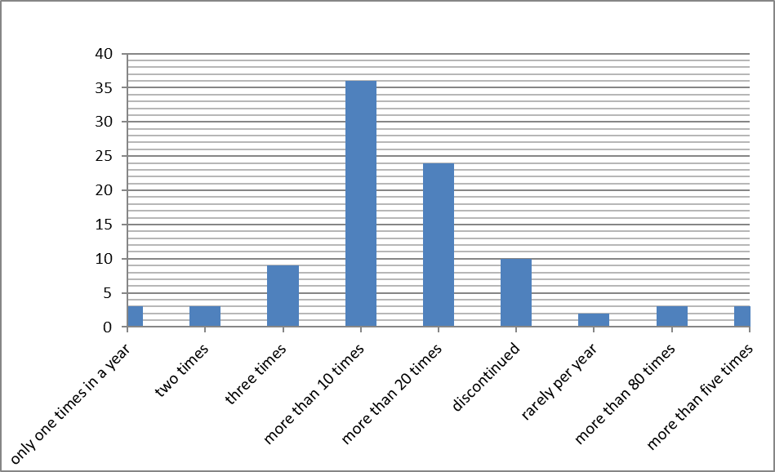

Figure 1. Capture fishery and trends of river fishery

As Figure 1, showing that, the data which collected from sampled fishers indicates that, In East Gojam Zone (Gozamin Woreda), Chemoga River is where the majority of fishers who catch frequently in a year found. In this area, fish harvested only for domestic consumption rather than for sale. However, the majority of fishers only used the catch fishing resource 10 times in

a single year. According to a group discussion of fishermen, the majority of them produce between 10 and 20 times a year whether they are fishing part-time or full-time. This suggests that they didn't produce for commercial purposes but rather for domestic consumption.

Table 3: Types of gearing materials

|  |  |  |
| --- | --- | --- |
| Types of gear | Frequency | Percent |
| Multi filament gillnet | 18 | 19.15 |
| Mono filament gillnet | 3 | 3.19 |
| Cast net | 25 | 26.60 |
| Hook | 13 | 13.83 |
| Use poisoning materials | 8 | 8.41 |
| Agober (local) | 10 | 10.64 |
| Fyke net | 6 | 6.38 |
| Fyke, Hook & cast net | 11 | 12.1 |
| Total (N=94) | 94 | 100 |

Source own survey As Table 3 depicts, fishers used both legal and illegal fishing methods depending on the nature of the water body. For instance, in Chemoga river fishery, most of the fishers used poisoning plant materials, cast net, fyke net and hook and line. Extremely poisonous substance destroys all aquatic life, including fish species, in a destructive fashion. Whereas, fishers who engaged in the reservoirs/irrigation dams they used multi and monofilament gillnet. Following a group discussion, it was determined that the majority of them stopped using it to collect fish because eating fish that had been poisonously obtained made them feel uneasy.

When fishers use poisoned materials, even in a single round of fishing, some species or subspecies of fish may be wiped off. The rehabilitation and regeneration of river fish species did not go well. As a result, if such interventions continued, it would be difficult to restore specific species that had been lost as a result of this destructive behavior.

For the sake of economic growth, poverty reduction, and food security, sustainable fisheries management is essential. Thus, the use of fisheries is considered as a key tactic in the

fight against poverty. It encourages better economic growth in Ethiopia (Selamu 2018).

* 1. **Fish marketing system**

Fish marketing system in western parts of Amhara region still non-functional activity, such inactive fish market resulted from fishers /producers didn’t produce sufficient amount for the purpose of market. Among sampled fishers, only (4%) of them produce for the purpose of market and the left of (77%) produce for home consumption. Due to the inadequate performance of the fish marketing system in the study area, some of them deliver their products on a contract basis to hotels or individuals because there is no formal market place for fish products that can be carried out efficiently. As a result, we cannot conclude that there is no market in the studied area.

Passive marketing and low demand for fish consumption at home, in hotels, and in social events like other sources of beef and food products are the main causes of inefficient production or capturing. If the fish resource is used effectively, it could be a key to reducing the need for food and improving nutrition. Even while there are trends in fish sale and consumption in some districts, the improvement isn't encouraging and fisheries resources are still sitting unused.

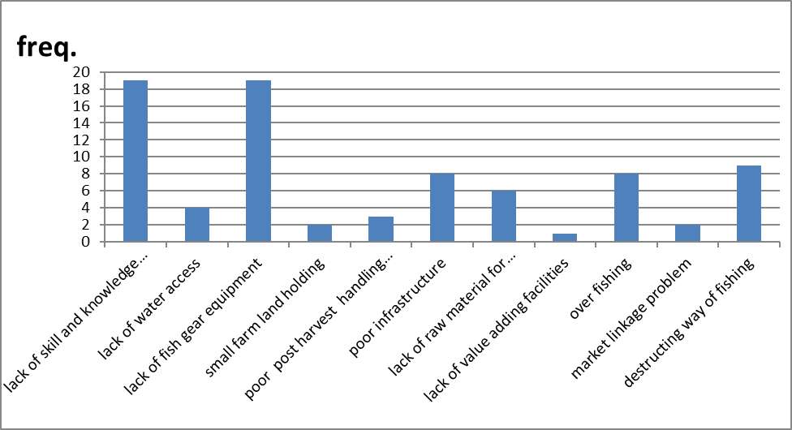

Figure 2. Sources and challenges of inefficient fish production

As Figure 2 indicates, that skill gap and lack of gearing equipment are equally challenged fishers, destructing of fishing including poisoning and under size catching on capturing fishery are seriously affected fish productions, even if these sources and challenges still uneven effects on fish production, in some area, no exploitation of fish whereas on other area exploited fish by using illegal materials like poison. However, the source of this illegality resulted from lack of skill and knowledge that can be reversing such problem to the right track.

As the study confident, most of the time, expert/DAs evaluations and recommendations to fishermen did not correspond to how fishermen were conducting their activities, including aquaculture and capturing. As at the time the study was conducted, there is no package that can be used as an aquaculture operating guide. Based on this finding, the government should be more concerned about the absence of training and crucial inputs that result in the lack of competence and knowledge of fishermen.

* 1. **Fish consumption**

Malnutrition is the serious problem in developing countries where access to varieties of food is limited to few and repetitive food items. Fish plays important role in reducing the problem of malnutrition, if consumed both at commercial places and at home (Daniel and Tekle 2019). By side of this fact, in western Amhara region the development of fish product and market development are invisibly proceeded due to lack of governmental focus which organize for a better exploitation. Fish product development, fish market development and Fish market penetration, all these three activities have low development stage /infant stage still.

Among (95) respondents /fishers who were sampled for this study 92 of them answer the question “*are there active fish markets in your area?*” about (85) percent saying No market around the area. There for, fish market penetration and market development should be accomplished simultaneously in western parts of the region. Fisher’s response (89.5%) indicates that they ate fish either enough amount or tiny amount and they might improve if created wide awareness. As Mulugeta Wakjire et al (2013) study, the current per capita fish consumption in Ethiopia (about 0.24 kg per year) is in the lower rank as compared to beef consumption which is as large as 8.4 kg per capita per year (Mulugeta et al 2013).

Table 4: Summary of marketing and consumption

|  |  |  |
| --- | --- | --- |
| Are there active fish marketing in your area? | Freq. | Percent |
| No | 78 | 84.78 |
| Yes | 14 | 15.22 |
| Total | 92 | 100 |
| Did you consume fish before? |  |  |
| No | 10 | 10.5 |
| Yes | 85 | 89.5 |
| Total | 95 | 100 |
| Does religious affects fish consumption level? |  |  |
| No | 88 | 92.63 |
| Yes | 7 | 7.37 |
| Total | 95 | 100 |

Source own study

As Table 4 indicates that, the annual consumption level per family still is not familiar except in some areas and families as exploit by formal and informal discussion carried out so far. On the hand religious didn’t affect their fish consumption, as

(92.6) percent of fishers justified and confirmed. Thus, the consumption and production of fish jointly need serious attention and concern by who all stakeholder.

Table 5: Perception of fishers on Fish consumption

|  |  |  |  |  |  |  |  |
| --- | --- | --- | --- | --- | --- | --- | --- |
| Statement | S/agree | Agree | Neutral | Disagree | S/disagree | Total | Likert Scale |
| Eating fish is good for human health | 71 | 17 | 7 | 0 | 0 | 95 | 1.3 |
| Eating fish as food is familiar (in area) | 42 | 37 | 4 | 5 | 7 | 95 | 1.9 |
| Religion affects fish consumption | 4 | 10 | 10 | 8 | 63 | 95 | 4.2 |
| Fish taste is good | 74 | 15 | 2 | 1 | 3 | 95 | 1.35 |

|  |  |  |  |  |  |  |  |
| --- | --- | --- | --- | --- | --- | --- | --- |
| There is no contamination concern in fish consumption | 45 | 22 | 13 | 10 | 5 | 95 | 2 |
| Fish food is qualified than beef | 70 | 10 | 5 | 2 | 8 | 95 | 1.6 |

|  |  |  |  |  |  |  |  |
| --- | --- | --- | --- | --- | --- | --- | --- |
| Fish dish preparation is not difficult in the area | 56 | 23 | 5 | 4 | 7 | 95 | 1.76 |

NB: - Value of given for each statement 1=strongly agree, 2=agree, 3=neutral, 4=disagree, 5= strongly disagree, WMI = $∑(Qi*wi)/N$. Where: Qi is the response rate to the ith factor, Wi is the weight of the ith factor, and N is the overall number of responses.

As Table 5 result, fishers have no doubt related to contamination of fish during consumption as the likert scale value indicates, they agree on there is no contamination concern to in fish consumption and they also agree fish is qualified than beef by its consistency of protein and important nutrient value. They can also prepare fish as food even if they are doing as traditional.

* 1. **Fish and sharing of fish as an item**

In the Western Amhara region, particularly in the river fishing under Chemoga and nearby areas, it is common tradition to share equipped fish with relatives, other families, neighbors, and elderly men and women. This shows that fish has been used as a food source. They promote themselves as a tremendous product in their environments, and induce fish use more and more if certain value-added activities are supplied by any concerned institutions.

Fish is a full and source of both macro- and micronutrients needed in a healthy diet. Fish consumption has both benefits and hazards; nevertheless, the benefits considerably outweigh the risks (Food and Agriculture Organization/World Health Organization 2011). Meanwhile, fish production in the reservoir using ponds might be an alternative source of protein for residents in adjacent towns and villages; it has offered a work opportunity for young people. Farmers can also engage in fishing as a supplemental livelihood in addition to their basic farming operations.

Fish is one of the known aquatic animals used for human consumption as food. Aquatic animals in general do contain a high-level of protein (17-29%) with an amino-acid profile, similar to that of the meat of land animals. The flesh of a fish is also readily digestible and immediately utilizable by the human body, which makes it suitable for complementing the high carbohydrate diets (Assefa 2014).

Fish can be accessible and affordable source of protein and a large proportion of people could be consumed fish as ordinary food, so it is possible for “*poor classes of people*”. Fisheries are one of livelihood strategies that have contributed much to people in developing countries. It is one of the vital strategies for the poor to achieve food, income and other social benefits (Erkie et al 2016).

* 1. **Fish production and Common Interest Groups (CIGs)**

In western Amhara region, among sampled districts there were 12 groups engaged on fish production, marketing activities mostly on capturing fishery on dams /reservoirs. From these CIGs, some of them were accomplished successfully. Whereas others still represent the name with null output, meanwhile the difference had existed due to some minor problems which are simply corrected.

These are the challenges that are present in the majority of CIGs: low levels of awareness among group members, poor work habits, improper rules for each member they control, a lack of materials, particularly post handling equipment, and a lack of concern for utilizing resources to their full ability. Even if these difficulties

are faced in the production of fish and enable the generation of wealth and capital, they can still be overcome by coordinating the efforts of the many stakeholders and using various methods of solution.

Therefore, CIGs are also essential wings and might work as a tool like institutions to demonstrate some practical events for the community, but as CIGS members justified with their group discussions during the study conducted, for utilization of fish resources to the optimal stage of production level.

Table 6: Common interest groups (CIGs) annual volume of fish production

|  |  |  |  |  |  |
| --- | --- | --- | --- | --- | --- |
| Fish product | N=(CIGs) | Mean | Std. Dev. | Min | Max |
| Total harvested (capture/kg) | 10 | 2660.5 | 3495.3 | 105 | 10800 |
| Total harvested (culture /kg) | 2 | 4 | 9.7 | 0 | 30 |
| Frequency of harvest | 12 | 102.2 | 82 | 0 | 210 |

Source own survey

As the result Table 6, indicated above, there is huge amount of annual fish product which is 108 quintal per year in one CIG and they harvested 210 times within 365 days. However, such groups are very few over the region according to the resource abundances.

* 1. **Challenges Associated with fish production and consumption**

The study looked into the overall institutional collective actions on the fishing sector, namely on production, marketing, and consumption, based on discussions and document analysis. In thoughtful conversations with specialists based on this, the following problems/drawbacks were addressed. One of the determinant factors for the success of aquaculture and amount of catch at river fishery is non-existence of common fish marketing site. Such market problem affects the production level and it’s efficient and fishery remains potential than actual in the study area. Weak linkage among actors for the development of the fishery sector was the other bottleneck.

In addition, fishers in the study area are not adequately aware and skilled about fish post-harvest handling up to consumption. With this skill gap, there is no an endeavor for the awareness creation from fishing to consumption, the problems of low consumption level at home and best practice in most area of Amhara region even including who do have the access of fish.

* 1. **The weakness of actor institutions for fishery sector**

Since the resource is unexploited as much as expected more numbers of institutions and organization needed to be acting continuously, whereas their contribution still out fish as the experts saying and status of fishery development shows, trainings deliver to fishery experts, kebele workers, even zonal experts and fishers is not applicable, not mature or had no impact on aquaculture, marketing and consumption. There are no packages which can be serving as manual for aquaculture implementation, as Amhara region, as far as the study conduct and checked by via document analysis. Even regional livestock production and fishery development Agency had given very low emphasis for fishery compare to other animal production activities such as, budgeting disbursement, employment of experts from top to kebele, still there is no fishery extension worker at kebele level even, in some districts have district fishery experts.

1. **CONCLUSIONS AND RECOMMENDATIONS**

Amhara region was naturally endowed with favorable environmental conditions, a large number of bodies of water (many rivers, natural and human made reservoirs, lakes, large area of wetlands) in Amhara region. However, the region continues to overlook the exploitation of fish and its use as a substitute approach for problems including youth unemployment, stunted growth, and food security. Fish productivity and output in the western Amhara region are still under-estimated, and the average annual catch from one pond is only 4.8 kg. low productivity, low level of awareness, low promotion, low emphasis of governmental and other organization, low consumption, no active market and like problems are associated in fishery sector for utilization in general.

Even still, there were not many fishers /farmers who possessed ponds, including inactive ones. The catch fishers had a better trend and experience than that of the pond owners because of their fishing, consumption, and volume of catch each year, which is about 132.9 kg. Currently, aquaculture management interventions are carried out without taking into account these three crucial pond management characteristics, including the gender of the fingerlings, the usage of formulated feed, and the separation of male from female fish stocks periodically throughout the year. However, Pond management and handling actually performs slightly better than others in north Achefer. On the other hand, fishermen in the Gozamen district had more experience with capture than those in other districts. Therefore, fish marketing system and strategies should be established in a formal function by collective actions of all stakeholders (institutions), without marketing, it is pointless for consumption and production even if these also needs enforced jointly. In addition, research centers and universities are needed to be creating artificial intelligences and technologies to simplify or reduce burden of aquaculture practices rather it going as usual. Those weaknesses reflected by fishers, institutions, CIGs and experts would alleviate and aquaculture being self-drive when giving more emphasis for fishery as an important resource.

**Indictors**

* Poor management
* Low production
* No marketing system
* Low consumption level
* Positive attitude with low awareness

**REFERENCES**

Abebe C, Hiwot T and Genanaw T (2015). *Opportunities and Challenges of Fish Marketing at Gelgel Gibe Dam in Ethiopia*. JAD, 5(1), 1–15. http://dx.doi.org/10.1038/s41551-019-0471-7.

Assefa Mitik (2014). *Fish Production, Consumption and Management in Ethiopia. International Journal of Economics & Management Sciences*, 03(03), 1–6. https://doi.org/10.4172/2162-6359.1000183.

Daniel and Tekle G (2019). *Fish Consumption Pattern and Marketing Efforts*. International Journal of Science and Research (IJSR), 8(4), 1049–1054.

Das D S and Govindasamy R (2021). *Aquaculture Production and Consumption of Fish in India*. Shanlax International Journal of Economics, 10(1)1. https://doi.org/10.34293/economics.v10i1.4443.

Deng G T (2020). *Assessment of Factors Affecting Fish Production and Marketing in Gambella Region, Ethiopia*. Scientific World Journal, 2020. https://doi.org/10.1155/2020/5260693.

Erkie A, Brehan M and Haimanot M (2019). *Assessment of Integrated Aquaculture Intervention System in Amhara Region , Ethiopia*. Ethiopian Journal of Economics, 17(2), 1–26.

Erkie A, Sewmehon D and Dereje T (2016). F*isheries of Jemma and Wonchit Rivers: As a Means of Livelihood Diversification and its Challenges in North Shewa Zone, Ethiopia*. Fisheries and Aquaculture Journal, 07(04), 1–6. https://doi.org/10.4172/2150-3508.1000182.

FAO (2020). T*he State of World Fisheries and Aquaculture 2020*. https://doi.org/10.4060/ca9231en.

Gadisa natea (2019). *Aquaculture Potential, Status, Constraints and Future Prospects in Ethiopia a Review*. International Journal of Advanced Research, 7(1), 336–343. https://doi.org/10.21474/ijar01/8332.

Gashaw T and Wolff M (2014). *The state of inland fisheries in Ethiopia: A synopsis with updated estimates of potential yield.*Ecohydrology and Hydrobiology, 14(3), 200–219. https://doi.org/10.1016/j.ecohyd.2014.05.001.

Mulugeta W, Taye tolemarima and Jeong D (2013). *Aquaculture Development in Ethiopia : Review on Potential and Strategy High Potential Zones for Aquaculture Development Policy Environment for Aquaculture the Current Status of Aquaculture*. Journal of Aquculture, Life and Environmental Sciences, 25(3), 20–25.

Mutambuki M (2011). *Marketing Strategies of Commercial Fish Farming Under*. African Journal of Tropical Hydrobiology and Fisherie, 1–79.

Oddsson G V (2020). *A definition of aquaculture intensity based on production functions-the aquaculture production intensity scale (APIS*). Water (Switzerland), 12(3). https://doi.org/10.3390/w12030765.

Rutaisire J, Char-Karisa C , Shoko A and Nyandat B (2010). Aquaculture for increased fish production in East Africa. African Journal of Tropical Hydrobiology and Fisheries, 12(1), 74–77. https://doi.org/10.4314/ajthf.v12i1.57379.

Sampantamit T H O, Lachat C ,Hanley-Cook G and Goethals P (2021). *The contribution of thai fisheries to sustainable seafood consumption: National trends and future projections*. Foods, 10(4), 1. https://doi.org/10.3390/foods10040880.

Selamu A (2018). *Challenges and socio-economic importance of fish production in Ethiopia*: Review. 9(3), 17–21.

Yonas M and Aemro W (2019). *Structure, Conduct and Performance of Fish Market in Central Ethiopia. Management Studies and Economic Systems (MSES)*4(4), 295–303. http://www.msaes.org/article_97169.html.