|  |  |
| --- | --- |
| ***BNJAR*** | **Blue Nile Journal of Agricultural Research (BNJAR)**  Vol. 5, Issue 2, December, 2024, pp. 30-42  Journal homepage: <https://arari.gov.et/index_bnjar.php> |

|  |  |  |  |
| --- | --- | --- | --- |
| **Teff (*Eragrostis tef* [Zucc.] Trotter) Variety Development for Moisture Deficit Areas in Northern Ethiopia** | | |  |
| Atinkut Fentahun1*, Sewagegne Tariku1, Gedefaw Misganaw1, Misganaw Ferede1, Atalay Fentahun1, Mukuken Bayable1, Zigale Dagnew1, Eyberu Abere2, and Aemiro Bezabih3 | | |  |
| 1 Adet Agricultural Research Center, P.O.Box 08, Bahir Dar, Ethiopia,  2 Sirinka Agricultural Research Center, P.O.Box 74, Wolidia, Ethiopia,  3 Debre Birha Agricultural Research Center, P.O.Box 112, Debre Birhan, Ethiopia  Corresponding author email:atinkut947@gmail.com | | | |
| Copyright: ©2024 The author(s). This article is published by BNJAR and is licensed under the CC BY 4.0 license (http://creativecommons.org/licenses/by/4.0/). | | | |
|  |  | **ABSTRACT** | |
|  |  |  | |
| **Received:** August 25, 2024  **Revised:** October 27, 2024  **Accepted:** December 20, 2024  **Available online:** December 30, 2024 |  | Teff is the most widely cultivated food crop in Ethiopia, accounting for around one‐third of the total acreage and one‐fifth of the gross grain production of all cereals cultivated in the country. In Ethiopia, more than fifty-eight improved teff varieties have been developed and released by agricultural research institutes. Most of these varieties were released for high-potential areas of the country except the very few early maturing varieties that were specifically released for the low moisture stress areas. The objective of this experiment was to identify and release stable and high-yielding teff genotypes which are preferred by farmers and adapted to the moisture deficit areas of Northern Ethiopia. Twenty selected teff genotypes including standard and local checks were evaluated at Ataye and Sirinka in 2019 and 2020, whereas during 2019 at Simada and at Shewarobit in 2021 cropping season using randomized complete block design with three replications. Analysis of variance detected significant differences among genotypes for all observed traits both separated and combined analysis. The combined ANOVA for grain yield across environments revealed genotypes are significantly affected by environments, Genotype and their interaction accounted for 70.5 %, 9.5 %, and 13.3 % respectively. Among the genotypes tested, DZ-01-974 XGA-10-3 (RILL-16) was found predominant in terms of yield and stability at tested moisture-stress environments. This genotype was later released as DZ-CR-459(RIL-16) or Ataye by the National Variety Release Committee in 2023, with a yield advantage of 21.3% and 35.2% over the standard (Mena) and local check, respectively. | |
| ***Keywords:*** *Ataye, Teff, Early maturity, Variety released, Yield* |  |

1. **INTRODUCTION**

Teff (Eragrostis tef [Zucc.] Trotter), is a tiny-seeded cereal with huge importance, has originated and diversified in Ethiopia (Vavilov, 1949). These crops are commonly known as orphan or underutilized crops due to the little scientific attention that they have received globally. On the other hand, in recent years, teff is receiving global attention among cash crops and has been attracting an export market due to attention for its nutritional and health-related benefits (Provost and Jobson, 2014), especially due to the absence of gluten, which makes it an alternative food for people with celiac disease (Fikadu *et al*., 2019). The low glycemic index (Wolter et al., 2013) and high iron content, as well as a high amount of lysine, a major limiting amino acid in cereals (Kavi Kishor *et al*., 2021), have resulted in teff being heralded as global ‘super food’(Provost and Jobson, 2014).

Teff is the most widely cultivated food crop in Ethiopia, accounting for around one‐third of the total acreage (29.3 %) and one‐fifth of the gross grain production (19.3 %) of all cereals cultivated in the country (ESS, 2022). It takes up more than 2.9 million hectares (29.3 percent of the cereals crop area), which is higher than any of the other major cereals crops, such as maize (25.6%), sorghum (13.5%) and wheat (18.7%) (ESS, 2022). In Ethiopia, teff is annually cultivated by over 6 million smallholder farmers, and it is the staple food for about more than 50 million people (Assefa *et al*., 2017) but its productivity is very low as compared to other cereal crops.

The most important bottlenecks constraining the productivity and production of teff in Ethiopia are: i) low yield potential of farmers’ varieties under widespread cultivation; ii) susceptibility to lodging particularly under growth and yield promoting conducive growing conditions; iii) biotic and abiotic stresses such as drought; iv) the culture and labor intensive nature of the teff husbandry; v) inadequate research investment to the improvement of the crop as it lacks global attention due to localized importance of the crop coupled with limited national attention; and vi) weak seed and extension system (Assefa *et al*., 2012). Among these yield limiting factors lack of cultivars tolerant to drought and lodging are the major factors (Assefa *et al*., 2011). The huge amount of yield reduction accounted by moisture stress during

vegetative and anthesis stage of teff reaches up to 40% (Mulu, 1993)and 77% (Takele, 2001)

In Ethiopia, in order to increase teff productivity, more than 58 improved varieties have been developed and released by national and regional agricultural research institutes (EAA, 2022) Most of these varieties were released for high-potential areas of the country except the very few early maturing varieties that were specifically released for the low moisture stress areas. Therefore the objective of the study was to identify and release stable and high-yielding teff genotypes which are preferred by farmers and adapted to the moisture deficit areas of Northern Ethiopia.

1. **Materials and Methods**
   1. **Experiemental sites**

The field experiment was conducted on four locations of six environments at Sirinka and Ataye in 2019 and 2020 for two years, whereas during 2019 at Simada and at Shewrobit in 2021 main cropping season under rain-fed condition. These test locations are selected as they are representative for moisture deficit areas in the Amhara Regional State. The location year-combinations represents six environments. The description of the experimental locations is indicating on the table (table1).

**2.2.Planting materials and experimental managements**

A total of twenty teff genotypes including the standard and local cheeks, inbreed lines bred for moisture deficit areas, and accessions collected from Ethiopian institute of biodiversity (table 2) were evaluated using a randomized complete block design with three replications on a plot size of 4m2 for each genotype ten rows of 2m length and 0.2m apart. Sowing was done by hand drilling on the surface of each of the ten rows at seeding rate 15kg ha-1, 6 g plot-1  on the plot area of 2m×2m with a net harvest area of 1.8m× 2m. The experimental plots were fertilized with Urea and NPS at the rate of 40 kg N and 60 kg P2O5 per hectare for light soil, and 60 kg N and 60 kg P2O5 per hectare for vertisols respectively. The whole NPS was applied at planting, while urea was applied two weeks after sowing and top-dressed at tillering stage. All other pre and post-planting management practices were done as per the recommendations for teff husbandry in all test locations.

**Table1. Description of the experimental locations**

|  |  |  |  |  |  |  |  |  |
| --- | --- | --- | --- | --- | --- | --- | --- | --- |
| Code | Name | Altitude (m.a.s.l.) | Geographical Location | | Soil type | Weather data | | |
| Latitude | Longitude |  | Rain fall (mm) | Temperature (°C) | |
| Maximum | Minimum |
| E1 | Simada-2019 | 1950 | 11051' N | 38001'E | Nitosol | 950 | 28 | 10 |
| E2 | Ataye-2019 | 1490 | 10029'N | 39091' E | Nitosol | 1040 | 28.1 | 14.7 |
| E3 | Sirinka-2019 | 1850 | 11045' N | 39036' E | Vertisol | 876 | 32 | 21 |
| E4 | Ataye-2020 | 1490 | 10029'N | 39091' E | Nitosol | 1040 | 28.1 | 14.7 |
| E5 | Sirinka-2020 | 1850 | 11045' N | 39036' E | Vertisol | 876 | 32 | 21 |
| E6 | Shewarobit-2021 | 1450 | 1000' N | 39054'E | Vertisol | 1089 | 32 | 16 |

m.a.s.l. = meter above sea level, E=east, N=north.

Source: (Tariku et al., 2020)

**Tabel 2. List of genotypes evaluated in the study**

|  |  |  |  |  |  |
| --- | --- | --- | --- | --- | --- |
| Genotype | Code | Source | Genotype | Code | Source |
| ACC#236766-2 | G-1 | EBI | DZ-Cr-387 X Alba(RILL-279) | G-11 | DZARC |
| ACC#236331-2 | G-2 | EBI | DZ-Cr-387 X Alba(RILL-226) | G-12 | DZARC |
| ACC#229228-1 | G-3 | EBI | DZ-01-974 XGA-10-3 (RILL-16) | G-13 | DZARC |
| ACC#219852-2 | G-4 | EBI | DZ-01-974 XGA-10-3 (RILL-17) | G-14 | DZARC |
| ACC#230774-3 | G-5 | EBI | DZ-01-974 XGA-10-3 (RILL-26) | G-15 | DZARC |
| ACC#236364-3 | G-6 | EBI | DZ-01-974 XGA-10-3 (RILL-34) | G-16 | DZARC |
| ACC#242138-3 | G-7 | EBI | DZ-01-974 XGA-10-3 (RILL-109) | G-17 | DZARC |
| ACC#242138-4 | G-8 | EBI | DZ-01-974 XGA-10-3 (RILL-121) | G-18 | DZARC |
| ACC#242139-1 | G-9 | EBI | Standard check Mena | G-19 | SARC |
| ACC#550114-3 | G-10 | EBI | Local check | G-20 | Each locations |

Note: EBI= Ethiopian Biodiversity Institute; DZARC=Debre Zeit Agricalture Reserch Center; SARC=Sirinka Agricalture Research Center

* 1. **Data collection**

Data on grain yield and yield-related traits were recorded on a plant and plot basis. Date of heading was taken once each plot accomplished 50% of heading (panicle emergence) and days to maturity were taken when the plant 85% physiological maturity stage on plant basis, and days were determined begin from the date of planting. Data for plant height (cm), panicle length (cm) were recorded from five sample plants that were randomly taken from each plot and therefore the average of five sample plants were utilized for analysis.

* 1. **Statistical analysis**

The analysis of variance was analyzed by using the Generalized Linear Model (GLM) procedure in (SAS, 2013) software to compute genotype and environment main and interaction effects, yield, and yield-related traits. Mean separation and significance test was performed using Least Significant Difference (LSD) at 5 % probability level. R software version 4.3.2 (Olivoto and Lúcio, 2020) was used to visualize GEI patterns. GGE biplot methodology, which is composed of two concepts, the GGE biplot and GGE concept (Yan *et al*., 2000) was used to visually analyze multi-environment data. This methodology uses a biplot to show the factors of genotype, environments, and their interaction that are important in genotype evaluation and the source of variation in GEI analysis of multi-environment data (Yan *et al*., 2000).

Yij-μ-βj=λ1ꜫi1ղj1 + λ2ꜫi2ղj2+ ꜫij

Where: Yij is the performance of the ith genotype in the jth environment; μ is the grand mean; βj is the main effect of the environment j; λ1 and λ2 are singular value for IPCA1 and IPCA2, respectively; ꜫi1 and ꜫi2 are Eigen vectors of genotype i IPCA1 and IPCA2, respectively; ղi1 and ղi2 are Eigen vectors of environment j for IPCA1 and IPCA2, respectively; ꜫij is the residual associated with genotype i and environment j.

Pair-wise correlation analysis among the traits was done using R software to see the relationship between traits that contribute to improved grain yield (Malik *et al*., 2005).

1. **Result and Discussion**

**3.1. Genotype performance variations**

According to the results of the combined analysis of variance over environments (Table 3), grain yield was highly significantly (P<0.0001) affected by genotypes, environments, and their interaction, which accounted for about 9.5%, 70.5% and 13.3 of the total variance, respectively. This indicates the presence of wide variability among the genotypes as well as environments under which the experiment was conducted. In this case, the variation explained by the environment was about seven times higher than what was explained by genotype. The large sum of square and highly significant mean square of environment indicated that the environments were diverse, with the large differences among environmental means causing most of the variation in grain yield. The significant difference in the combined analysis of variance on the grain yield performance indicates that needs further stability analysis. This result was in agreement with the findings of (Ashamo and Belay, 2012; Fentahun *et al*., 2022; Worede *et al*., 2020), in teff multi-location trials. The significant difference among test locations might be due to variations in temperature, soil type, rainfall, and other environmental factors as also reported by (Kassa and Fufa, 2006).

Highly significant variations among the genotypes were observed in days to heading, days to maturity, grain filling period, plant height, and panicle length, shoot biomass yield, grain yield and harvest index across locations (Table 4). Similar significant results were reported for most traits in earlier studies (Fentahun *et al*., 2022).

**Table 3. Sum of squares, mean squares and percent of variance explained by different sources of variation from the analyses of variance of grain yield of 20 teff genotypes tested at six environments**

|  |  |  |  |  |  |
| --- | --- | --- | --- | --- | --- |
| Source of variation | DF | S.S | M.S | Explained variance (%) | Pr>F |
| Environment | 5 | 238521729.0 | 47704345.8 | 70.5 | <.0001 |
| Blocks (Environments) | 12 | 2974264.8 | 247855.4 | 0.88 | .001 |
| Genotype | 19 | 32307232.3 | 1700380.6 | 9.51 | <.0001 |
| Genotype × Environment | 95 | 45016440.4 | 473857.3 | 13.3 | <.0001 |
| Error | 228 | 19681167.9 | 86320.9 | 5.81 |  |
| Total | 359 | 338500834.5 |  | 100 |  |
| Mean=2131.2 CV (%) =13.8 R2=0.94 | | | | | |

Note: CV= coefficient of variation, R2= Coefficient of determination, DF= degree of freedom, SS= sum square, MS= mean square

**Table 4. Mean performance of 20 teff genotypes for measured agronomic traits evaluated in the regional variety trial across 6 location-year environments**

|  |  |  |  |  |  |  |  |  |  |
| --- | --- | --- | --- | --- | --- | --- | --- | --- | --- |
| **Code no.** | **Genotypes** | **Days to heading** | **Days to maturity** | **Grain filling period** | **Plant height (cm)** | **Panicle length (cm)** | **Shoot biomass (Kg/ha)** | **Grain yield (Kg/ha)** | **Harvest index** |
| 1 | ACC#236766-2 | 46.9 | 97.2 | 50.2 | 107 | 40.2 | 8711.2 | 2016.1 | 23.6 |
| 2 | ACC#236331-2 | 50.2 | 97.9 | 47.7 | 110 | 39.6 | 8423.1 | 1663.0 | 20.1 |
| 3 | ACC#229228-1 | 50.7 | 97.1 | 46.4 | 106 | 38.5 | 8811.8 | 1505.0 | 17.2 |
| 4 | ACC#219852-2 | 43.4 | 95.3 | 51.8 | 104 | 38.6 | 8728.9 | 2093.9 | 23.6 |
| 5 | ACC#230774-3 | 47.7 | 95.3 | 47.6 | 108 | 39.4 | 10012.5 | 2355.2 | 23.9 |
| 6 | ACC#236364-3 | 48.3 | 96.2 | 47.8 | 106 | 41.8 | 8620.2 | 1988.4 | 23.0 |
| 7 | ACC#242138-3 | 48.7 | 97.1 | 48.3 | 109 | 42.7 | 8820.0 | 2141.3 | 24.2 |
| 8 | ACC#242138-4 | 49.9 | 96.1 | 46.2 | 105 | 38.7 | 7872.5 | 1784.8 | 22.6 |
| 9 | ACC#242139-1 | 47.6 | 96.5 | 48.9 | 103 | 39.8 | 8324.8 | 1883.7 | 22.7 |
| 10 | ACC#550114-3 | 49.3 | 96.5 | 47.2 | 112 | 43.6 | 9075.0 | 2074.2 | 23.0 |
| 11 | DZ-Cr-387 X Alba(RILL-279) | 48.6 | 96.7 | 48.1 | 113 | 43.4 | 8460.7 | 2087.5 | 24.6 |
| 12 | DZ-Cr-387 X Alba(RILL-226) | 49.3 | 97.1 | 47.8 | 111 | 44.7 | 9601.2 | 2266.9 | 23.0 |
| 13 | DZ-01-974 XGA-10-3 (RILL-16) | **47.5** | **92.7** | **45.2** | **113** | **45.2** | **9608.6** | **2682.9** | **27.5** |
| 14 | DZ-01-974 XGA-10-3 (RILL-17) | 49.0 | 96.9 | 47.8 | 107 | 40.4 | 8447.0 | 1947.5 | 22.8 |
| 15 | DZ-01-974 XGA-10-3 (RILL-26) | 46.3 | 97.6 | 51.2 | 112 | 41.2 | 8275.8 | 2458.4 | 28.8 |
| 16 | DZ-01-974 XGA-10-3 (RILL-34) | 48.6 | 97.4 | 48.8 | 113 | 43.7 | 10088.3 | 2435.1 | 23.9 |
| 17 | DZ-01-974 XGA-10-3 (RILL-109) | 45.3 | 97.9 | 52.6 | 110 | 44.2 | 9295.4 | 2628.7 | 27.9 |
| 18 | DZ-01-974 XGA-10-3 (RILL-121) | 44.8 | 96.7 | 51.8 | 112 | 41.6 | 8659.7 | 2414.5 | 27.2 |
| 19 | Mena | 47.3 | 98.1 | 50.8 | 108 | 43.6 | 9500.2 | 2212.3 | 23.8 |
| 20 | Local check | 45.4 | 97.2 | 51.8 | 109 | 39.5 | 8845.9 | 1984.9 | 22.3 |
|  | **Mean** | 47.8 | 96.7 | 48.9 | 108.9 | 41.5 | 8909.1 | 2131.2 | 23.8 |
|  | **CV (%)** | 3.7 | 2.0 | 5.0 | 7.7 | 8.4 | 14.2 | 13.8 | 11.6 |
|  | **LSD (5%)** | 1.15 | 1.3 | 1.5 | 5.5 | 2.3 | 830 | 193 | 1.81 |
|  | **Genotype (G)** | ** | ** | ** | ** | ** | ** | ** | ** |
|  | **Environment ( E)** | ** | ** | ** | ** | ** | ** | ** | ** |
|  | **G*E** | ** | ** | ** | ** | ** | ** | ** | ** |
|  | **R2** | 98.3 | 98.5 | 96.8 | 86.2 | 85.9 | 86.6 | 94.2 | 89.5 |

Note: **= highly significant, LSD= least significant difference, CV=coefficient of variation, R2= Coefficient of determina tión, G*E= genotype by environment

**Table 5. Mean grain yield (kg ha-1) performance of teff genotypes evaluated in regional variety trial (for moisture deficit areas) across six environments**

|  |  |  |  |  |  |  |  |  |
| --- | --- | --- | --- | --- | --- | --- | --- | --- |
| No. | Genotypes | E1 | E2 | E3 | E4 | E5 | E6 | Mean |
| 1 | ACC#236766-2 | 1549 | 2070 | 1533 | 3121 | 2797 | 1027 | 2016 |
| 2 | ACC#236331-2 | 1288 | 1698 | 1421 | 2211 | 2244 | 1117 | 1663 |
| 3 | ACC#229228-1 | 1050 | 1432 | 1088 | 1842 | 2642 | 977 | 1505 |
| 4 | ACC#219852-2 | 1742 | 2001 | 1123 | 3333 | 3306 | 1060 | 2094 |
| 5 | ACC#230774-3 | 1277 | 2227 | 1514 | 4395 | 2981 | 1738 | 2355 |
| 6 | ACC#236364-3 | 1714 | 2254 | 1371 | 2260 | 3378 | 953 | 1988 |
| 7 | ACC#242138-3 | 1546 | 2356 | 1637 | 3648 | 2552 | 1110 | 2141 |
| 8 | ACC#242138-4 | 1225 | 2083 | 1037 | 2128 | 3192 | 1043 | 1785 |
| 9 | ACC#242139-1 | 1283 | 1986 | 1683 | 2062 | 3351 | 937 | 1884 |
| 10 | ACC#550114-3 | 1421 | 2352 | 1361 | 3323 | 2929 | 1060 | 2074 |
| 11 | DZ-Cr-387 X Alba(RILL-279) | 1360 | 2543 | 1773 | 2833 | 3002 | 1013 | 2088 |
| 12 | DZ-Cr-387 X Alba(RILL-226) | 1664 | 3077 | 1245 | 3422 | 3084 | 1110 | 2267 |
| 13 | DZ-01-974 XGA-10-3 (RILL-16) | 1832 | 2763 | 1971 | 4515 | 3266 | 1750 | 2683 |
| 14 | DZ-01-974 XGA-10-3 (RILL-17) | 1192 | 2050 | 1319 | 2793 | 3252 | 1080 | 1948 |
| 15 | DZ-01-974 XGA-10-3 (RILL-26) | 1695 | 2272 | 1615 | 4586 | 3104 | 1479 | 2458 |
| 16 | DZ-01-974 XGA-10-3 (RILL-34) | 1651 | 2791 | 1978 | 3761 | 3270 | 1160 | 2435 |
| 17 | DZ-01-974 XGA-10-3 (RILL-109) | 1667 | 2254 | 1960 | 4886 | 3299 | 1706 | 2629 |
| 18 | DZ-01-974 XGA-10-3 (RILL-121) | 1258 | 1898 | 1808 | 4753 | 3233 | 1539 | 2415 |
| 19 | Mena | 1606 | 2293 | 1843 | 3404 | 3052 | 1075 | 2212 |
| 20 | Local check | 1403 | 1920 | 1497 | 3399 | 2975 | 715 | 1985 |
|  | **Mean** | 1471 | 2216 | 1539 | 3334 | 3045 | 1182 | 2131 |
|  | **CV(%)** | 9.1 | 16.2 | 12.1 | 12.6 | 12.8 | 7.5 | 13.8 |
|  | **LSD (5%)** | 221.3 | 594.1 | 308.3 | 695.4 | 642.6 | 146.5 | 192.9 |

Note: LSD= least significant difference, CV=coefficient of variation

According to Table 4, the newly released teff variety DZ-01-974 XGA-10-3 (RILL-16) reaches a plant height of 110 cm, a panicle length of 44 cm, a panicle emergence stage of 47 days, and a physiological maturity of 93 days after sowing in overall averaged environments. These desirable traits can be suggested for fast-track release and to be used as parental lines for future teff breeding programs. DZ-01-974 X GA-10-3 (RILL-16) is ranked 1st in average total panicle length among other genotypes across all environments. The relationship between plant height and panicle lengthindicates the possibility of increasing grain yield and biomass yield by improving either of the two traits (Table 4). The average grain yield of DZ-01-974 XGA-10-3 (RILL-16) was (2682.9 kg ha-1) and shoot biomass yield (9608.6 kg ha-1) (Table 4), which is the 1st in grain yield and 3rd in biomass yield recorded among tested genotypes across pooled environments. This genotype "DZ-01-974 XGA-10-3 (RILL-16)” scored a grain yield advantage of 21.3% and 35.2 % over the standard (Mena) and local check across environments, respectively. The genotype DZ-01-974 XGA-10-3 (RILL-16) ranked first in grain yield performance in half of the six environments (Simada and Sirinka in 2018 and Shewarobit in 2021) (Table 5). It performs very well in areas having an altitude 1450-1950 m above sea level (Table 6), thus being suitable for low rainfall and terminal low moisture stress areas of the country. Therefore, based on multi-location data, DZ-01-974 XGA-10-3 (RILL-16) has been selected for its high grain yield and moisture stress tolerance as well as other desirable traits. Consequently, the candidate line was then tested in a variety verification trial during the main cropping season of 2023, and the National Variety Release Committee approved for release in 2023. This study indicated the presence of substantial variations among teff genotypes for all measured traits. These results are in agreement with that of Jifar *et al*. (2011) who reported that highly significant genotype variation for days to panicle emergence and maturity, plant height, culm and panicle length, basal culm diameter, shoot biomass and grain yield, harvest index, lodging index, and thousand seed weight. Similarly, highly significant (P<0.01) genotype differences for days to panicle emergence, lodging percentage, thousands kernel weight, grain yield per plant and grain yield per hectare were also reported by Ayalneh *et al*. (2012). The tested genotypes expressed their grain yield potential at Ataye and Sirinka in 2020, where the crop management was excellent and there was no unexpected rainfall, which reduces the grain shattering. However, unexpected rainfall at the maturity stage in 2019 resulted in significant grain yield shattering, leading to low grain yield in both locations.

**3.2. GGE Biplot analysis**

GGE biplot identifies GEI patterns of multi-location data and clearly shows which variety performs best in which location. In the present study, the first principal component axis (PC1) explained 76.55 % of total variation while the second principal component (PC2) explained 10.81%. Thus, the two axes together accounted for 87.36 % of the GGE variation of grain yield (Figure 1 &2).

**3.3. Which genotypes (s) won where**?

Yan and Kang (2003) indicated that the polygon view of a biplot is the best way to visualize the interaction patterns between genotypes and environments. Figure 1 represents a polygon view of teff genotype multi-environment data. In the polygon view, genotypes found to be extremely far from the origin are the vertex genotypes having the highest yield in their respective sectors (Farshadfar et al., 2011). The genotype code "13 (DZ-01-974 XGA-10-3 (RILL-16)," 12 (DZ-Cr-387 X Alba (RILL-226)", "17 (DZ-01-974 XGA-10-3 (RILL-109))", "18 (DZ-01-974 XGA-10-3 (RILL-121)", "6 (ACC#236364-3)" and "3 (ACC#229228-1)" were the corner or vertex genotypes (Figure 1). This infers that the genotype code "13 (DZ-01-974 XGA-10-3 (RILL-16))" best performed in grain yield at three environments. The environments of Ataye and Shewarobit fell in the sector in which genotype code "17 (DZ-01-974 XGA-10-3 (RILL-109))" was the vertex genotype. This means that the genotype code "17 (DZ-01-974 XGA-10-3 (RILL-109))" was the best genotype for those environments. Among the tested genotypes, the genotype code "13 (DZ-01-974 XGA-10-3 (RILL-16))" had the highest mean yield, followed by genotype code "17 (DZ-01-974 XGA-10-3 (RILL-109))" and "15 (DZ-01-974 XGA-10-3 (RILL-26))", whereas genotype code "2 (ACC#229228-1)" and "3 (ACC#236331-2)” had the lowest mean yield. Similar findings were reported on teff using similar methodology (Fentahun *et al*., 2022; Tariku *et al*., 2018).

**3.4. Comparison of genotypes relative to ideal genotype**

A genotype which is found at the center of concentric circle is considered as an ideal genotype with its high mean yield and stable characteristics and genotypes close to an ideal genotype are considered as desirable genotypes. Accordingly, genotype code "13 (DZ-01-974 XGA-10-3 (RILL-16))" being near to the center of concentric circle and is considered as relatively an ideal genotype with high mean yield and stable characteristics, whereas genotype code "16 (DZ-01-974 XGA-10-3 (RILL-34))" and "15 (DZ-01-974 XGA-10-3 (RILL-26))” that were close to the ideal genotypes are considered as desirable genotypes based on their yield performance as well as stability. On the other hand, genotype code "3 (ACC#236331-2)”, "2 (ACC#229228-1)" and "8 (ACC#242139-1)" are located farther from the ideal genotype (center of concentric circle) were undesirable genotypes (Figure2). Similar findings were reported on teff multi-location trial using similar methodology (Worede, 2021; Worede *et al*., 2020).

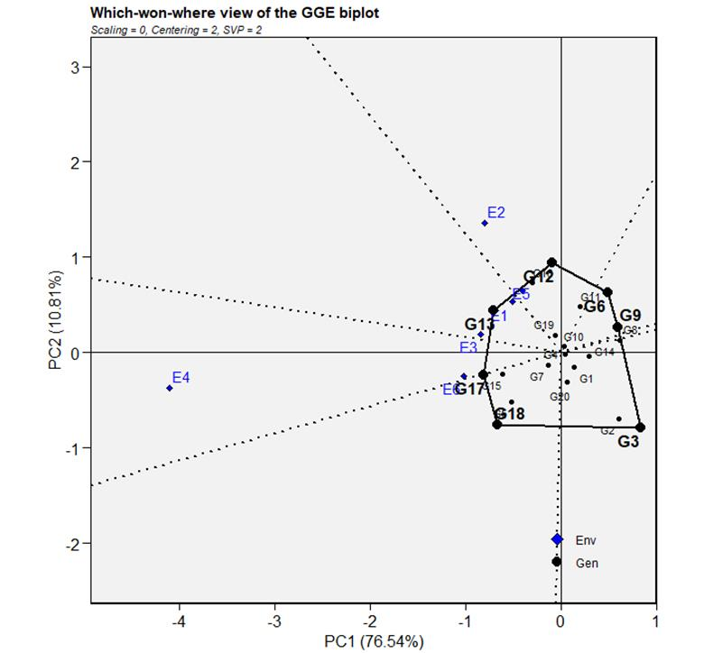

Figure 1. Which won where or which is best for what view based on genotype by environment interaction yield data of 20 genotypes evaluated in six environments. Environment and genotype code is indicated in Table 1 and 2

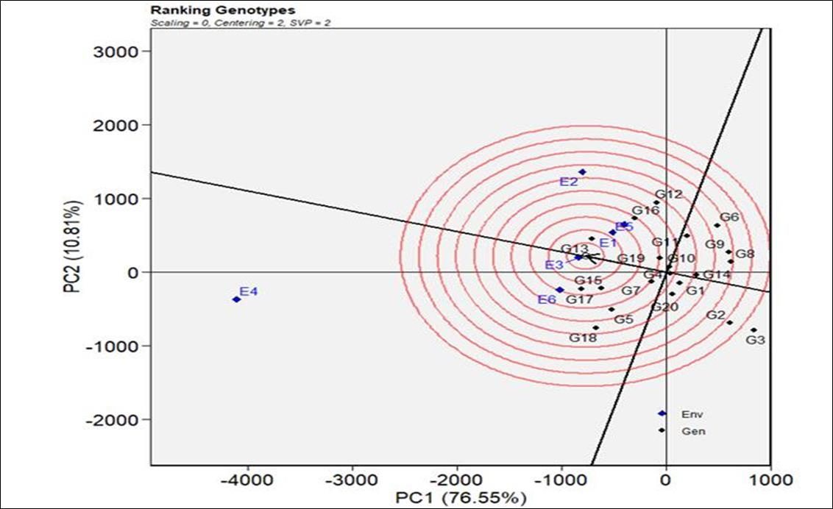

Figure 2. GGE-biplot based on genotype-focused scaling for comparison of the genotypes with the ideal genotype Environment and genotype code is indicated in Table 1 and

**3.5. Association of grain yield with yield and yield-related traits**

Yield is the result of the sum of agronomic and phonological traits resulting from the interaction of genetic and environmental factors (Tshikunde et al., 2019) Therefore, it is important to identify the association of genetic and phonological traits with yield. Studies of correlations among different traits enable the determination of the level and magnitude of the components that affect a character. In the present study, panicle length, harvest index, and dry shoot biomass showed a highly significant correlation with grain yield (Fig. 3). The result of this study is in line with the reports of (Asaye, 2017; Assefa *et al*., 2022). A strong correlation coefficient among grain yield, dry shoot biomass, and plant height had a direct contribution to grain yield and became used to improve yield productivity. Likewise, Bekana *et al*. (2022) reported a high direct effect of above-ground dry shoot biomass on grain yield. However, days to heading and maturity have been negatively correlated with grain yield (Fig. 3). This may be due to an insufficient amount of moisture at the test locations at the time of heading and maturity. The test locations are moisture-deficient areas, and as a result, long-maturing genotypes will be affected by moisture stress. The huge amount of yield reduction accounted by moisture stress during vegetative and anthesis stages of teff reaches up to 40% (Mulu, 1993; Takele, 2001). Similarly, Asaye (2017) reported that days to heading and grain filling periods are negatively correlated with grain yield.

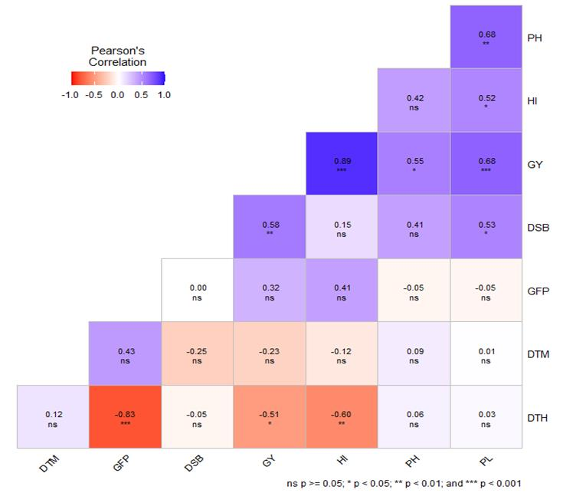

Figure 3. Correlation coefficient for yield and yield related traits

Note: DTM=days to maturity, GFP=grain filling period, DSB=dry shoot biomass, GY=grain yield, Hi=harvest index, PH= plant height and PL=panicle length

**3.6. Description of the new teff variety DZ-01-974 XGA-10-3 (RILL-16)**

An effective crossing was done in 2011 between varieties Dukem (DZ-01-974) and GA-10-3 (RILL-16) by the Debre Zeit Agricultural Research Center. Dukem (DZ-01-974) was used as a female parent for its high yielding potential, and GA-10-3 (RILL-16), which derived from Tseday via TILLING, was used as a male parent for its dwarfliness, earliness, and white seed color. The cross was made to combine the earliness of Tseday and the high yield potential of Dukem into one elite variety. Consequently, intraspecific recombinant-inbred lines (RILs) have been developed, and multi-stage multi-location evaluations of the lines have been conducted. The description of the new variety Dz-CR-459 (RIL-16) is indicated in Table 6.

Table 6. Summary description of the new teff variety DZ-CR-459(RIL-16)

|  |  |
| --- | --- |
| Descriptor parameter | Description |
| Breeders name | DZ-CR-459(RIL-16) |
| Pedigree | DZ-01-974XGA-10-3 (RILL-16) |
| Vernacular name | Ataye |
| Days to heading | 38-61 |
| Days to maturity | 83-96 |
| Plant height (cm) | 99-128 |
| Panicle length (cm) | 32-51 |
| Lemma color | White |
| Seed color | White |
| Panicle form | Loose |
| Average grain yield | 2683 |
| O n station (Kg/ha) | 2683 |
| On farm (Kg/ha) | 18-24 |
| Straw yield (Kg/ha) | 9600 |

1. **CONCLUSIONS**

The results of this study revealed that, genotypes had sufficient variability for identifying stable and high-yielding teff genotypes. Analysis of variance for combined over six environments showed significant differences among genotypes, environments, and genotypes × environments interaction (GEI) for grain yield, and the genotype DZ-01-974 XGA-10-3 (RILL-16), gave the highest average grain yield of 2683 kg ha-1 across all environments. The significant GEI effects indicated the inconsistent performance of genotypes across the tested environments except DZ-01-974 XGA-10-3 (RILL-16) which is relatively stable and best performance genotype at all tested environments, which had a grain yield advantage of 21.3% and 35.2 % over the standard (Mena) and local check across environments, respectively. This newly released genotype (DZ-CR-459(RIL-16)) with the vernacular name of “Ataye” can be used as parental material in the genetic improvements of teff.

1. **ACKNOWLEDGEMENTS**

We are very grateful to Amhara Agricultural Research Institute (ARARI) and Adet Agricultural Research Center for financial support for the development of the variety. We also greatly acknowledge all collaborative regional research centers, researchers, and technical assistants for supporting the implantation of the experiments.

1. **CONFLICT OF INTEREST**: There is no conflict of interest.
2. **REFERENCES**

Asaye Demelash, A. D. (2017). Screening of teff (*Eragrostis tef*) varieties for genotypic and phenotypic traits in Dejen Woreda, East Gojjam Zone.

Ashamo, M., and Belay, G. (2012). Genotype x environment interaction analysis of tef grown in southern Ethiopia using additive main effects and multiplicative interaction model. Journal of Biology, Agriculture and Healthcare 2, 66-72.

Assefa, K., Aliye, S., Belay, G., Metaferia, G., Tefera, H., and Sorrells, M. E. (2012). Quncho: the first popular tef variety in Ethiopia. In "Sustainable Intensification", pp. 25-34. Routledge.

Assefa, K., Chanyalew, S., Genet, Y., Asfaw, M., Fikre, T., Jifar, H., Hussen, N., Sellassie, M. H., Chemeda, G., and Assefa, M. (2017). Tef (Eragrostis tef) variety kora. Ethiopian Journal of Agricultural Sciences 27, 137-140.

Assefa, K., Chanyalew, S., Girma, D., and Tadele, Z. (2022). Principles and Practices of Tef Improvement. Ethiopian Institute of Agricultural Research (EIAR) and Agricultural Transformation Institute (ATI), Addis Ababa, Ethiopia.

Assefa, K., Yu, J. K., Zeid, M., Belay, G., Tefera, H., and Sorrells, M. (2011). Breeding tef [*Eragrostis tef* (Zucc.) trotter]: conventional and molecular approaches. Plant breeding 130, 1-9.

Ayalneh, T., Amsalu, A., and Habtamu, Z. (2012). Genetic divergence, trait association and path analysis of tef [*Eragrostis tef* (Zucc.) Trotter] lines. World J Agr Sci 8, 642-646.

Bekana, G., Mosisa, F., and Sisay, A. (2022). Tef (*Eragrostis tef*) Production and Soil Acidity Problem in Ethiopia: A Review. Journal of Industrial Engineering and Management 11, 2169-0316.22.

EAA (2022). Ethiopian Agriculture Authority, Plant Variety Release, Protection and Seed Quality Control Directorate, Crop Variety Register, Issue No. 25, June 2022, Addis Ababa, Ethiopia.

ESS (2022). Ethiopian Statistical Services). 2022. Report on Area and Production of Major Crops (private peasant holdings, Meher season). Volume I, Statistical Bulletin 593, Addis Ababa, Ethiopia.

Farshadfar, E., Vaisi, Z., and Yaghotipoor, A. (2011). Non parametric estimation of phenotypic stability in wheat-barley disomic addition lines. Annals of Biological Research 2, 586-598.

Fentahun, A., Dejene, T., and Assefa, K. (2022). Genotype x environment interaction and grain yield stability of improved Teff [*Eragrostis tef* (Zucc.) Trotter] varieties in Northwestern Ethiopia. East African Journal of Sciences 16, 77-92.

Fikadu, A., Wedu, T. D., and Derseh, E. (2019). Review on economics of teff in Ethiopia. Open Access Biostatistics & Bioinformatics 2, 1-8.

Jifar, H., Assefa, K., and Bekele, E. (2011). Genetic variability in released tef [*Eragrostis tef* (Zucc.) Trotter] varieties of Ethiopia. In "Proceedings of the Thirteenth Biennial Conferences of Crop Science Society of Ethiopia", pp. 160-169.

Kassa, L., * Smith, MF**, and Fufa, H. (2006). Stability analysis of grain yield of tef (*Eragrostis tef*) using the mixed model approach. South African Journal of Plant and Soil 23, 38-42.

Kavi Kishor, P., Anil Kumar, S., Naravula, J., Hima Kumari, P., Kummari, D., Guddimalli, R., Edupuganti, S., Karumanchi, A. R., Venkatachalam, P., and Suravajhala, P. (2021). Improvement of small seed for big nutritional feed. Physiology and Molecular Biology of Plants, 1-14.

Malik, H. N., Malik, S. I., Hussain, M., Chughtai, S., and Javed, H. I. (2005). Genetic correlation among various quantitative characters in maize (Zea mays L.) hybrids. Journal of Agriculture & Social Sciences 3, 262-265.

Mulu, A. (1993). Use of excised leaf water content in breeding tef [*Eragrostis tef* (Zucc). Trotter] for moisture stress area. Acta Agronomica Hungarica 42, 261-265.

Olivoto, T., and Lúcio, A. D. C. (2020). metan: An R package for multi‐environment trial analysis. Methods in Ecology and Evolution 11, 783-789.

Provost, C., and Jobson, E. (2014). Move over quinoa, Ethiopia's teff poised to be next big super grain. The Guardian 1, 23.

SAS, I. (2013). Statistical Analysis Software. Users’ Guide Statistics Version 9.4. SAS Institute Inc., Cary. Users’ Guide Statistics Version 9.4. SAS Institute Inc., Cary

Takele, A. (2001). Canopy temperatures and excised leaf water loss of tef (*Eragrostis TEF* [Zucc.] trotter.) cultivars under water deficit conditions at anthesis. Acta Agronomica Hungarica 49, 109-117.

Tariku, S., Fantahun, A., and Fentahu, A. (2018). Participatory evaluation and selection of improved tef varieties in a researcher managed trial in western Ethiopia. Int J Emerging Technol Adv Eng 8, 28-42.

Tariku, S., Fentahun, A., Misganaw, G., Fentahun, A., Alemayehu, T., Legesse, A., and Mitiku, S. (2020). GGE biplot analysis and agronomic performance of tef genotypes in moisture deficit stress areas of eastern Amhara Regional State. Blue Nile Journal of Agricultural Research 1, 1-17.

Tshikunde, N. M., Mashilo, J., Shimelis, H., and Odindo, A. (2019). Agronomic and physiological traits, and associated quantitative trait loci (QTL) affecting yield response in wheat (Triticum aestivum L.): a review. Frontiers in plant science 10, 1428.

Vavilov, N. I. (1949). The origin, variation, immunity and breeding of cultivated plants.

Wolter, A., Hager, A.-S., Zannini, E., and Arendt, E. K. (2013). In vitro starch digestibility and predicted glycaemic indexes of buckwheat, oat, quinoa, sorghum, teff and commercial gluten-free bread. Journal of Cereal Science 58, 431-436.

Worede, F. (2021). Use of multivariate stability statistics to identify superior tef (*Eragrostis tef* [Zucc.] Trotter) genotypes in Northeast Ethiopia. Black Sea Journal of Agriculture 4, 124-129.

Worede, F., Mehadi, T., and Wondimu, S. (2020). Stability analyses of tef (*Eragrostis tef* [Zucc.] Trotter) grain yield in dryland areas of Northeast Ethiopia. Cogent Food & Agriculture 6, 1847760.

Yan, W., Hunt, L. A., Sheng, Q., and Szlavnics, Z. (2000). Cultivar evaluation and mega‐environment investigation based on the GGE biplot. Crop science 40, 597-605.

Yan WeiKai, Y. W., and Kang, M. (2003). GGE biplot analysis: a graphical tool for breeders, geneticists, and agronomists.