|  |  |
| --- | --- |
| ***BNJAR*** | **Blue Nile Journal of Agricultural Research (BNJAR)**  Vol. 4, Issue. 2, December, 2023, pp. 1-19  Journal homepage: https://www.arari.gov.et/index_bnjar.php |

|  |  |  |  |
| --- | --- | --- | --- |
| **Phenotypic BLUP and drought tolerance indices of stay green introgressed sorghum lines grown under two different water management conditions in Ethiopia** | | |  |
| *Aemiro Bezabih Woldeyohannes1*, Firew Mekbib2, Setegn Gebeyhu 3 and Mulualm Kassa4*  *1*Debre Birhan Agricultural Research Center, P.O. Box, 112, Debre Birhan, Ethiopia*  *2Haramaya University, P.O. Box, 138, Dire Dawa, Ethiopia*  *3International Potato Center, Addis Ababa, Ethiopia*  *4Agriculture and Agri-Food Canada, Cereal Research Centre, Manitoba, Canada*  *\*Corresponding author email: aemibwg@gmail.com* | | | |
| Copyright: ©2024 The author(s). This article is published by BNJAR and is licensed under the CC BY 4.0 license (http://creativecommons.org/licenses/by/4.0/). | | | |
|  |  | **ABSTRACT** | |
|  |  |  | |
| **Received:** August 12, 2023  **Revised:** November 22, 2023  **Accepted:** December 15, 2023  **Available online:** December 22, 2023 |  | *Post-flowering drought stress is one of the main abiotic factors affecting sorghum production and threatening food security globally, including Ethiopia, Therefore, it is crucial to develop high-yielding and drought-tolerant sorghum varieties that are adapted to drought environments in the country. The objectives of this study were to analyze the yield potential of the stay green QTLs introgressed sorghum lines and their parents and to identify useful drought tolerant indices. A field evaluation was conducted using a 5x5 triple lattice design under non-stress (Ns) and drought stress (Ds) growing conditions.at the Kobo testing site during the post-rainy cropping season of 2012. The results showed that genotypic differences were highly significant for grain yield (Y), staygreen (SG), total chlorophyll per unit area (TCM), chlorophyll contents at flowering (CF) and maturity (CM) traits in Ns and Ds growth conditions as well as for all drought tolerance indices. Some stay green introgressed sorghum lines showed increased Y and traits linked to chlorophyll related traits compared to the recurrent parents and stay green donor parent in Ds. The drought tolerance indices of mean productivity, geometric mean productivity, harmonic mean, yield index and stress tolerance index were positively and significantly associated with NsY and DsY, allowing for the selection of high yielding and drought tolerant genotypes in drought-prone growing environments. Based on their drought tolerance indices, yield potential, and chlorophyll-related traits, five stay green QTLs introgressed sorghum lines (Meko x B-35-8, Meko x B-35-25-15, Meko x B-35-13, Teshale x B-35-12, and Gambella x B-35-01) could be given priority for valorization in sorghum improvement programs. Further research on marker-assisted introgression is required in order to incorporate multiple stay green QTLs into the genome of the high yielding sorghum varieties. This could aid in determining which stay-green QTL allele combinations are most likely to work together synergistically in drought-stressed environments.* | |
| ***Keywords****: Backcross progenies, chlorophyll, drought tolerance, introgression, sorghum* |  |

1. **INTRODUCTION**

Sorghum (Sorghum bicolor (L.) Moench, 2n=20), a self-pollinating member of the Poaceae family and a widely grown C4 crop (Doggett, 1970), with a 730 Mb genome size (Paterson et al., 2009). It is one of the top cereal crops grown in the world's subtropical, tropical, and temperate regions for grain production. The crop is the fifth most valuable crop in the world, after wheat (Triticum aestivum L.), rice (Oryza sativa L.), maize (Zea mays L.) and barley (Hordeum vulgare L.) (FAOSTAT, 2019). More than 500 million people depend on it as a staple food in the semi-arid tropical regions of Asia and Africa, which account for more than 80% of the global production area. Research findings showed the nutritional makeup of sorghum, including the following: protein (4.4–21.1%), fat (2.1–7.6%), crude fiber (1.0–3.4%), total carbohydrates (57.0–80.6%), starch (55.6-75.2%), and total minerals as ash (1.3–3.5%) (Waseem et al., 2022). It also contains phenolic compounds, such as antioxidants, and can be consumed as a substitute meal by people with celiac disease.

Sorghum is one of the major cereals in terms of social and economic importance for millions of growers and consumers in Ethiopia (MoA, 2020). It ranks fourth in terms of area coverage in hectares, number of stallholder farmers producing it, and total grain production in Ethiopia, behind the three major crops, teff, maize, and wheat (CSA, 2021). Currently, more than 4 million smallholder farmers grow it widely, covering more than 1.7 million hectares of the nation's sorghum-growing land annually (CSA, 2021). It is used in various ways by millions of people across the country. The grains are used to make cereal food items like Porridge, "Nefro", infant food, syrup, and local beverages like "Tella" and "Arekie". Furthermore, the leaf and stalk are used for animal feed. The stalks are also used to construct fences and homes, as well as fuel wood (EAA, 2021). However, the crop productivity is very low (~2.7 tons/hectare) in the country (CSA, 2021). Drought stress, especially during the reproductive developmental stages of sorghum (panicle development, flowering and grain filling stages), is the primary cause of this low productivity (Kebede et al., 2001; Prasad et al., 2008; Teklay et al., 2020). Drought spells in Ethiopia frequently coincide with flowering and grain filling stages (Simane and Struik, 1993; Mamo, 2005), affecting crop productivity and threatening food security of resource poor farmers. Moreover, unexpected short or lengthy periods of drought and/or high temperatures are likely to occur in certain sorghum production locations in the future, which could result in large yield losses (Prasad et al., 2021). Thus, development of high yielding and stable varieties that could adapted in heat and drought stress environments is a central objective of the sorghum improvement program in Ethiopia.

Drought stress limits sorghum yield by lowering carbon assimilation, stomatal conductance, and cell turgor, which inhibits normal crop growth and development. The wilting of leaves and reduction in leaf area, flower production, as well as overall growth and yield, are observable indications of water deficit on crop plants (Djanaguiraman et al., 2020). Identification of the traits that enable crops to adapt to drought stress growth conditions may facilitate the selection of genotypes that are drought-tolerant (Zaharieva, 2001; Almeida, 2008; Prasad et al., 2021). Previous studies have showed that the Ethiopian genetic resource for sorghum (such as landraces, elite and derivative lines, and wild relatives) contains a wide range of useful traits, including phenological, morphological, agronomic and drought related traits for enhancing grain yield potential (Kebede, 1991; Borrell et al., 2000; Mekbib, 2007; Tesso et al., 2008; Abraha et al., 2015 ; Wondimu et al., 2020; Enyew et al., 2022) and good grain quality (e.g. huge source of high lysine) (Singh and Axtell, 1973). Stay green is a constitutive trait and an integrated drought adaptive in sorghum. It is regarded as crucial breeding targets and a desired trait for dual-purpose crops that are used for both food and feed (Subudhi et al., 2000; Thomas and Howarth, 2000; Haussmann et al., 2002). It has been widely used in crop breeding to improve yield potential under drought stress environment. Research reports showed that the stay green trait can increase the amount of grains per ear (Luche et al., 2015), improve stem lodging resistance (Adeyanju et al., 2016), and have greater tolerance for biotic stress, such as spot blotch infection (Joshi et al., 2007) and yield enhancement under heat and drought stress environments (Kamal et al., 2019). The major five cereal crops, including sorghum, have undergone quantitative trait loci (QTL) mapping for stay green. Thus, selection and valorization of drought tolerant lines from stay-green QTL introgression sorghum (marker assisted backcrossing derivatives) germplasm could support to tackle the challenge of post flowering drought stress (Kamal et al., 2019; Prasad et al., 2021), which is less exploited in the breeding program in Ethiopia.

Drought indices provide a measure for grain yield loss under drought stress growing conditions as compared to favorable growing conditions in identifying drought tolerant genotypes (Fernandez, 1992; Mitra, 2001). These selection indices have been commonly used for screening drought tolerant lines in sorghum (Mwamahonje et al., 2021), barley (Agegn et al., 2018; Feize et al., 2020). Drought susceptibility index (S) is used to identify drought tolerant genotypes under both favorable and drought stress conditions and the genotypes with lower S value (S < 1) are more tolerant to drought stress growing condition (Fischer and Maurer, 1978). In addition, a low tolerance index (TOL) (Rosielle and Hamblin, 1981) values corresponds to high drought tolerance. Genotypes with high values for geometric mean productivity (GMP) (Fernandez, 1992), harmonic mean (HM) (Jafari et al., 2009), mean productivity (MP) (Rosielle and Hamblin, 1981), yield index (YI) (Gavuzzi, 1997), yield stability index (YSI) (Bouslama and Schapaugh, 1984), and stress tolerance index (STI) (Fernandez, 1992) and drought resistance index (DI) (Lan, 1998) are the most effective approach to breed drought tolerant genotypes.

Recognizing the significance of drought tolerance for sorghum productivity in the Semi-Arid Tropics, the National Sorghum Improvement Program at Melkassa Agricultural Research Center (Ethiopia) and the International Crop Research Institute for Semi-Arid Tropics (ICRISAT) developed and selected marker assisted backcrossing derivatives from the introgression of stay-green QTLs into a range of elite and locally adapted sorghum varieties. This approach aims to boost the availability of the stay-green trait to national research programs in the major Semi-Arid Tropics (SAT) and enhance the terminal drought tolerance of farmer-preferred sorghum varieties. However, previous studies showed that a limited set of drought tolerance selection indices were used to assess the stay green introgressed sorghum lines; none of these studies employed the Best Linear Unbiased Prediction (BLUP) statically approach (Teklay et al., 2020; Djanaguiraman et al., 2021), which provides extremely accurate average estimates compared to other procedures, especially in mixed models. Therefore, the objectives of this study were to analyze the yield potential of the stay green QTLs introgressed sorghum lines and their parents in both nonstress and drought stressed field growing condition and to identify useful drought tolerant indices from grain yield for future breeding program.

1. **MATERIAL AND METHOD**
   1. **Plant materials**

A series of crosses and backcrosses were carried out to introgress drought tolerant genes from the known donor parent (as pollen source) into adapted sorghum cultivars in the Melkassa Agricultural Research Center (MARC), in Ethiopia. Four improved varieties (Teshale, Meko, 76T1#23, and Gambella) were backcrossed with B35, a known staygreen QTLs donor parent. The progenies of backcrossing were advanced to BC3F1 with genotyping to confirm the QTL introgression in each generation. Then two generations of self-pollination to BC3F3 to fix the introgressed stay green QTLs in the adapted sorghum varieties. Twenty-five sorghum lines were ultimately chosen for the study, comprising 20 stay-green QTLs introgression sorghum lines, one stay-green donor parent, and four recurrent parents (Table 1). All sorghum lines were sourced from the national sorghum improvement research project of Melkassa Agricultural Reseach Center (MARC). The recurrent parents are high yielding varieties released and introduced to local farming community of Ethiopia (EAA, 2021). The stay-green donor parent, B35, is the best characterized source of stay-green for terminal drought tolerance in sorghum (Rosenow et al., 1983).

**Table 1:** List of parents and stay green QTLs introgression sorghum lines used for the study

|  |  |  |
| --- | --- | --- |
| No | Pedigree | Stay green QTLs profile |
| 1 | 76T1#23 |  |
| 2 | 76T1#23 x B-35-07 | StgA |
| 3 | 76T1#23 x B-35-14 | Stg4 |
| 4 | 76T1#23 x B-35-03 | StgB |
| 5 | 76T1# 23 x B-35-44 | StgA |
| 6 | Meko |  |
| 7 | Meko x B-35-13 | Stg1 |
| 8 | Meko x B-35-19-15 | Stg1 and 4 |
| 9 | Meko x B-35-28 | Stg1 |
| 10 | Meko x B-35-08 | Stg1 and Stg4 |
| 11 | Meko x B-35-07 | Stg4 |
| 12 | Meko x B-35-12 | Stg1 |
| 13 | Meko x B-35-25-15 | Stg1 and Stg4 |
| 14 | Teshale |  |
| 15 | Teshale x B-35-12 | Stg2 |
| 16 | Teshale x B-35-19 | Stg4 |
| 17 | Teshale x B-35-20 | Stg2 |
| 18 | Teshale x B-35-13 | Stg2 |
| 19 | Gambella |  |
| 20 | Gambella x B-35-01 | Stg A and 4 |
| 21 | Gambella x B-35-04 | Stg A |
| 22 | Gambella x B-35-21 | Stg4 |
| 23 | Gambella x B-35-05 | Stg4 |
| 24 | Gambella x B-35-37 | Stg4 |
| 25 | B-35 | Particular stay green loci that support the expression of the stay green trait in sorghum include Stg1 and Stg2 on chromosome 3, Stg3 on chromosome 2, and Stg4 on chromosome 5(Xu *et* *al*., 2000a). |

* 1. **Field evaluation**

The field evaluation was conducted at Kobo, the irrigation sub Center of Sirinka Agricultural Research Center (North Wollo, Amhara, Ethiopia, 120 08’ 21’’ North, 390 38’ 21’’ East, and 1470 meter above sea level). It has a semi-arid climate with mean annual minimum and maximum air temperatures of 15 0C and 29.73 0C, respectively and mean annual rain fall of 619.13 mm ([www.ethiomet.gov.et](http://www.ethiomet.gov.et)). The twenty-five sorghum lines were planted in a 5x5 triple lattice design under two soil moisture regimes, non-stress (Ns) and drought stress (Ds) growth conditions. The lines were evaluated during 2012 post-rainy cropping season and the two contrasting soil moisture regimes were created through varying frequency of irrigation. Both the Ns and Ds growing conditions were situated adjacent to each other. The sorghum seeds were drilled directly into three rows of four-meter length with spacing of 75 cm between rows and two weeks after planting seedlings were thinned to an interplant spacing of 15 cm to obtain a plant population of 88,888 plants ha-1. The fertilizer was applied at the recommended rates of 100 kg ha-1 diammonium phosphate (DAP; 18% N and 46% P2O5) and 50 kg ha-1 urea (46% N). Before planting, a half-portion of the urea and the whole amount of DAP were added into the soil. Between leaf stages six and eight, the remaining urea was applied as a side dressing. Lambda Cyhalothrin (Karate) 5% E.C was applied at the rate of 300 ml ha-1 in to the leaf using a knapsack sprayer due to the incidence of stem borers. All recommended management practices (weeding, cultivation etc.) were applied uniformly for both growing conditions. During the growing season, the CROPWAT model was used to determine the crop's water requirement and irrigation scheduling. Water was supplied to the crop at predetermined intervals for each stage following planting. To compute the CWR,

the necessary soil, rainfall, and climate data were retrieved along with the crop files and the corresponding planting dates. The irrigation water was applied using the furrow irrigation method. Under Ns and Ds, the field received about 311.5 mm of water in seven irrigations until flowering. However, after flowering for the Ds was deprived of irrigation water to induce post-flowering drought (grain filling prolonged drought). On the other hand, the Ns received four additional irrigation of 139 mm water after flowering so that, essentially, no Ds could occur at any stage.

* 1. **Data collection**

The sorghum lines were evaluated for grain yield (Y in grams of grain produced per plot and then converted to t/ha) and chlorophyll related traits, chlorophyll content at flowering (CF in %) and physiological maturity (CM in %) and visual stay green ratings (SG, 1 to 5 scale, 1 = death of 76 to 100% of the leaves and stem and 5= no leaf death) were recorded on plot basis following protocols described by IBGR and ICRISAT (1993). Chlorophyll content of the leaves was measured using a Minolta Chlorophyll Meter, SPAD-502 (Dwyer *et al.,* 1991). The SPAD values were translated to the actual value of total chlorophyll per unit area (TCM, mg/cm2) using the equation (Xu et al., 2000b);

* 1. **Data analysis**

All measured data were examined using the R program, Version 4.2 (R development core Team, 2022). Best linear unbiased prediction (BLUP) values of genotypes and variance components for grain yield and chlorophyll related traits were obtained using software META-R (Gregorio et al., 2016). The best BLUP prediction method is also utilized to assess multi-environment trials data (MET), as it provides highly accurate average estimates, particularly in mixed models. An associations plot among NsY and DsY and drought tolerance indices were produced using the corrplot () function in R software. A principal component analysis (PCA) was conducted using the autoplot.prcomp () function to summarize the variation in drought resistance indices. Simple linear regression analysis was used to investigate the relationship between the leaf chlorophyll content at maturity (CM) and stay-green rating (SG) using gg_scatter () function in R software. A box plot along with a t test value were produced to determine the significance between Ds and Ns for grain yield and chlorophyll-related traits using the compare means () function in R software.

**Drought indices estimation**

Different drought tolerance selection indices, including S, MP, GMP, PR, HM, YI, YSI, DI, STI and TOL were estimated from the Best linear unbiased prediction (BLUP) values of grain yield under Ns and Ds growing conditions. The description of drought indices and their equation are indicated in Table 2.

**Table 2:** Drought indices estimated from the Best Linear Unbiased Prediction values of grain yield (Y) under non-stress (Ns) and drought stress (Ds) growing conditions

|  |  |  |
| --- | --- | --- |
| Drought indices | Equation | Reference |
| Drought susceptibility index (S) | $1-\left(\frac{YDs}{YNs}\right)/$ $1-\left(\frac{{\overline{YD}}_{s}}{{\overline{Y}}_{Ns}}\right)$ | Fischer and Maurer, 1978 |
| Mean productivity (MP) | $$\left(YDs+YNs\right)/2$$ | Rosielle and Hamblin, 1981 |
| Geometric mean productivity (GMP) | $$\sqrt{YDs*YNs}$$ | Fernandez 1992 |
| Percent Reduction (PR) | 100 $\left[1-\left(\frac{YDs}{YNs}\right)\right]$ | Abebe et al., 1998 |
| Harmonic mean (HM) | ((YDs*YNs) *2)/(YDs+YNs) | Jafari et al., 2009 |
| Yield index (YI) | YDs/Y ̅Ds | Gavuzzi, 1997 |
| Yield stability index (YSI) | Ys/Yns | Bouslama and Schapaugh, 1984 |
| Drought resistance index (DI) | (YDs * (YDs/YNs))/Y ̅Ds | Lan, 1998 |
| Stress tolerance index (STI) | $$\frac{YDs*YNs}{\overline{Y}{Ns}^{2}}$$ | Fernandez, 1992 |
| Tolerance index (TOL) | YNs -YDs | Rosielle and Hamblin, 1981 |

*Note: YDs = Grain yield under drought stress; YNs = Grain yield under non-drought stress for each genotype; ${\overline{YD}}_{s}$ = Mean grain yield under stress for all genotypes; ${\overline{Y}}_{NS}$ = Mean grain yield under non-stress for all genotypes.*

1. **RESULTS AND DISCUSSION**
   1. **Variation in grain yield and traits related to chlorophyll**

Genotype variance was highly significant for phenotypic BLUP mean of grain yield (Y) and chlorophyll related traits under Ns and Ds conditions (Table 3). Sufficient genetic diversity is required for plant breeding programs to assist development of new improved cultivars against various stresses and increase of yield (Abraha et al., 2015). The observed phenotypic variation in this study and previous studies on Ethiopian sorghum (Girma et al., 2019; Enyew et al., 2021) suggests that tolerant

genotypes to abiotic stresses can be obtained through screening its diverse gene pool. A boxplot was used to visualize the variation in BLUP mean of Y and chlorophyll traits between Ns and Ds conditions are represented in Figure 1. The BLUP means for Y, CM, TMC, and SG were all significantly lower under Ds than Ns; however, CF showed no difference between the two conditions (Table 3). Sorghum lines in our study showed a 33 % reduction in Y due to drought stress at flowering period (Table 3). Previous studies on sorghum (Menezes et al., 2015; Batista et al., 2017 and Girma et al., 2020) demonstrated that drought stress resulted in losses in grain yields of 19% to 65%. Drought related yield loss may be caused by reduced photosynthetic activity, smaller active leaf area, increased rates of leaf senescence, lower crop chlorophyll concentrations (Ludlow and Muchow, 1990; Reddy et al., 2004) and decreased yield related traits (Prasad et al., 2008; Khaton et al., 2016). In the current study, indeed, chlorophyll related traits like CM, SG, and TCM were significantly decreased as a result of the induced Ds in the recurrent parents (Table 4). Previous study showed that during the post-flowering stage, non-stay green sorghum genotypes undergo a high rate of senescence due to drought stress (Borrell et al., 2014). In post-flowering conditions, sorghum leaves and stalks senesce due to a notable characteristic associated with chlorophyll loss (Xu et al., 2000b).

Our result showed that genotype variance was highly significant for Y in the sorghum lines under Ns and Ds (Table 3), indicating substantial variation for yield potential that could be exploited in sorghum breeding (Negesh et al., 2021). Phenotypic BLUP mean of Y varied from 2.6 to 4.8 ton/ha, with an average value of 4.2 ton/ha under Ns, while the mean of Y varied from 2.4 to 3.4 ton/ha, with an average value of 2.8 ton/ha under Ds. Six of the sorghum introgression lines in the Ds condition (Meko x B-35-13, Meko x B-35-25-15, Teshale x B-35-12, Teshale x B-35-13, Gambella x B-35-01, and Gambella x B-35-21) outperformed their corresponding recurrent parents for Y. The stay green donor parent, B35, produced lower yields than the recurrent parents and stay green introgressed sorghum lines in both growing conditions (Table 4) this may be due to its short plant height, tiny panicle size, and few grains per panicle (Rosenow et al., 1983). Our results showed that sorghum lines with two QTLs stay green had greater grain yield and traits related to chlorophyll than QTL with only one stay green sorghum line.

Under Ds conditions, Meko x B-35-8 with QTL Stg1 and Stg4 had the highest Y (3.36 ton/ha), which was followed by Meko x B-35-25-15 with QTL Stg1 and Stg4 (3.14 ton/ha) and Gambella x B-35-01 with StgA and Stg4 (3.11 ton/ha). Similarly, these sorghum lines had highest chlorophyll related traits including CM, TCM and SG traits at physiological maturity under DS condition. Little is known about the significance of various stay-green QTLs and the most beneficial combinations of stay-green QTLs that influence drought tolerance and yield related traits. Indeed, little is known about the significance of various stay-green QTLs and the best combinations of stay-green QTLs that influence yield-related traits and drought tolerance. Earlier study on NILs containing Stg2 and Stg4 showed that this combination functions synergistically during extreme terminal drought (Borrell *et* *al*., 2014). Further study on marker-assisted introgression is therefore required in order to transfer multiple stay-green (Stg1, Stg2, Stg3, and Stg4) genes into the genome of a single high-yielding sorghum cultivar. This could aid in determining which stay-green QTL allele combinations are most likely to work together synergistically in drought stressed environments.

Genotype variance was highly significant for chlorophyll related traits including chlorophyll content (CM), actual value of total chlorophyll per unit area (TCM) and stay green (SG) traits at physiological maturity in the sorghum lines under Ns and Ds condition (Table 3). These traits varied from 42 to 52% for BLUP mean of CF, 32.6 to 45% for CM, 0.05 to 0.09 mg/cm2 for TCM, 3.9 to 4.6 for SG under Ns, while under Ds, these chlorophyll related traits were varied from 42 to 53% for CF, 20 to 38 % for CM, 0.01 to 0.06 mg/cm2 for TCM, 2.7 to 4.2 for SG. This considerable variation for chlorophyll-related traits under DS growth condition could be employed in the development of drought-tolerant varieties in sorghum breeding. The trait related to chlorophyll content can help cereal crops like maize (Pommel *et al*., 2006), sorghum (Borrell et al., 2000), wheat (Gao et al., 2017), and maize (Zheng et al., 2009), which is less exploited in a breeding program in Ethiopia, enhance their grain yield potential under drought stress conditions. The current result showed a positive correlation between Y and traits associated to chlorophyll in the Ds condition (Figure A). The significant positive correlation observed among the chlorophyll content and grain yield is in agreement with previous studies in sorghum (Ochieng et al., 2020; Abreha et al., 2022) and other crops (Kamal et al., 2019). High chlorophyll content has also been associated with improved stay-green in sorghum and reduces post-flowering drought-induced senescence (Harris et al., 2007).

**Table 3:** Measured trait values of the stay green QTLs introgression lines and parents of sorghum genotypes evaluated under stress and none stress growing condition, Ethiopia.

|  |  |  |  |  |  |  |  |  |  |  |  |  |  |
| --- | --- | --- | --- | --- | --- | --- | --- | --- | --- | --- | --- | --- | --- |
| Trait | Non-stress | | | | | | Drought stress | | | | | | PR (%) |
| Min | Max | GM | 2g | P-value | CV | Min | Max | GM | 2g | P-value | CV |
| Y | 2.6 | 4.8 | 4.2 | 0.09 | ** | 14 | 2.4 | 3.4 | 2.8 | 0.03 | ** | 18 | 33 |
| CF | 42 | 52 | 45.4 | 4.81 | *** | 6 | 42 | 53 | 45.3 | 7.2 | *** | 7 | - |
| CM | 32.6 | 45 | 36.8 | 5.4 | *** | 4 | 20.4 | 38 | 27.6 | 13.6 | *** | 10 | 25 |
| TCM | 0.05 | 0.09 | 0.06 | 5E-05 | *** | 7 | 0.01 | 0.06 | 0.03 | 0.0001 | *** | 24 | 44 |
| SG | 3.9 | 4.6 | 4.2 | 0.03 | ** | 6 | 2.7 | 4.2 | 3.3 | 0.1 | *** | 11 | 21 |

*Note: Y = Grain yield; CF = Chlorophyll content at flowering; CM = Chlorophyll content at maturity; TCM = Value of total chlorophyll per unit area; SG =Stay green score; Min = Minimum; Max= Maximum; GM= Best Linear Unbiased Prediction mean values; σ2 g = Estimate of genotype variance; CV = Coefficient of variation; PR= percent of reduction, * = Significant at P ≤ 0.05; ** = Significant at P ≤* *0.01; *** = Significant at P ≤ 0.001.*

In Ds, there was a significant linear relationship between CM and visual SG (R2 = 0.83) (Figure 1F), indicating that visual stay green rating is a trustable indicator of leaf maturity chlorophyll content and may be useful to breeders as a screening method for post-flowering drought resistance. In both growing conditions, the stay green donor parent (B35), expressed significantly more CM, TCM and SG than any of the recurrent parents and backcross lines (Table 4). Indeed, B35 carries the "stay green" phenotype and is commonly employed as a source of stay green traits for terminal drought tolerance across countries (Prasad *et al.,* 2021). This result is consistent with the reports made by Xu et al. (2000b), Coulibaly (2002), and Kassahun et al. (2010) who found that B35 displayed significantly better chlorophyll content and stay green rating than the recurrent parents and progenies at physiological maturity. Previous finding indicated that the four QTLs found in "B35" are the most significant and stable, and they are currently being introduced by marker-assisted breeding into a number of genetic backgrounds (Kassahun et al., 2010). In addition to B35, other drought-tolerant genotypes from Ethiopia, Sudan, and Nigeria have also been utilized in drought tolerance sorghum breeding and improvement. This includes the genotypes E-36-1, SC33, SC-56, MN7645, QL41, and BTx642 (Haussmann et al., 2002; Mahalakshmi and Bidinger, 2002; Sukumaran et al., 2016). In general, research showed that Ethiopian sorghum germplasm for drought tolerance in general and in the stay green sorghum genotypes has substantial phenotypic and genetic variation (Tesso et al., 2008; Adugna 2014; Abraha et al., 2015; Girma et al., 2020; Wondimu et al., 2020; Enyew et al., 2022).

In Ds, top ten yielder stay green introgressed sorghum lines had relatively higher Y, CM and SG than the respective recurrent parents (Table 4). This may imply the incorporation of putative stay-green QTLs that may be responsible for the increase in the leaf chlorophyll content at physiology maturity and thus improved yield potential. This is interesting as it suggests that at least some of the stay green QTLs introgressed into recurrent parents were functional and are expressed in the genetic background of locally adapted sorghum varieties (recurrent parents). As reported by Kassahun et al. (2010) and Teklay Abebe et al. (2020) and Mwamahonje et al. (2021), some stay green introgressed sorghum lines showed higher leaf chlorophyll concentration at physiological maturity, which increased photosynthesis and improved the availability of food reserves for grain filling, which results in an increase in grain yield. A previous study shown that a single stay-green gene (Stg1 to Stg4) can increase grain yield in sorghum during drought conditions by changing canopy growth and water uptake patterns (Borrell et al., 2014). Since phenotypic selection may have had only limited success (Teklay et al., 2020), marker-assisted backcrossing has the potential to increase the effectiveness of backcross breeding programs by incorporating and identifying targeted genes from a donor parent into the background of a locally adapted elite variety (recurrent parent) to enhance drought tolerance in sorghum (Mwamahonje et al., 2021).

**Table 4:** The mean performance of the top ten sorghum lines ranked by the Best Linear Unbiased Prediction means values of traits and compared with the recurrent parents (4 locally adapted sorghum varieties) and stay green donor parent.

|  |  |  |  |  |  |
| --- | --- | --- | --- | --- | --- |
|  | **Traits** | | | | |
| Y | CF | CM | TCM | SG |
| **Non-stress** |  |  |  |  |  |
| Recurrent parents (4) | 4.42 | 45.05 | 37.21 | 0.064 | 4.27 |
| Donor parent (1) | 2.65 | 46.73 | 45.11 | 0.087 | 4.62 |
| Stay-green QTLs introgressed sorghum lines (10) | 4.45 | 46.75 | 37.37 | 0.064 | 4.16 |
| **Overall mean (25)** | **4.2** | **45.4** | **36.8** | **0.06** | **4.2** |
| **Drought stress** |  |  |  |  |  |
| Recurrent parents (4) | 2.86 | 44.9 | 28.28 | 0.037 | 3.21 |
| Donor parent (1) | 2.35 | 44 | 38.35 | 0.067 | 4.2 |
| Stay-green QTLs introgressed sorghum lines (10) | 3.04 | 45.5 | 31.10 | 0.045 | 3.5 |
| **Over all (25)** | **2.8** | **45** | **27.6** | **0.03** | **3.3** |

*Note: Y = Grain yield; CF = Chlorophyll content at flowering; CM = Chlorophyll content at maturity; TCM = Value of total chlorophyll per unit area; SG =Stay green score*

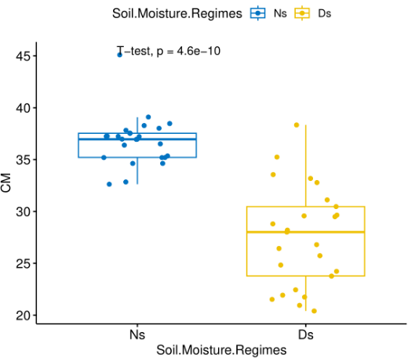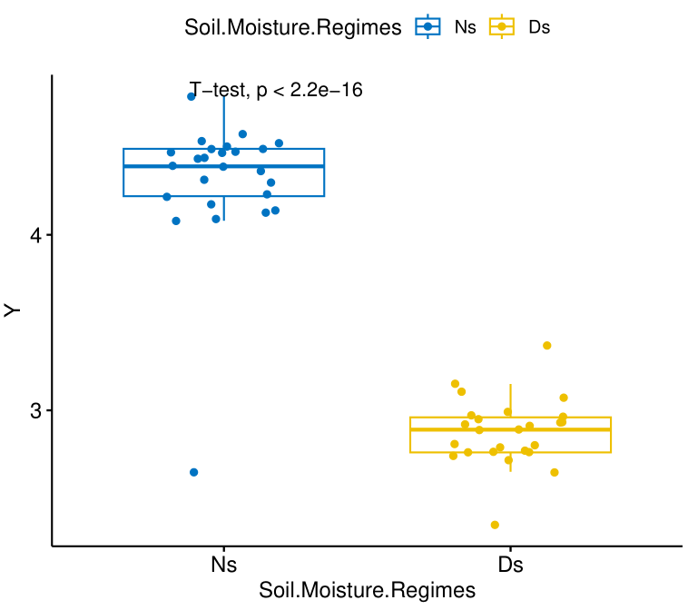 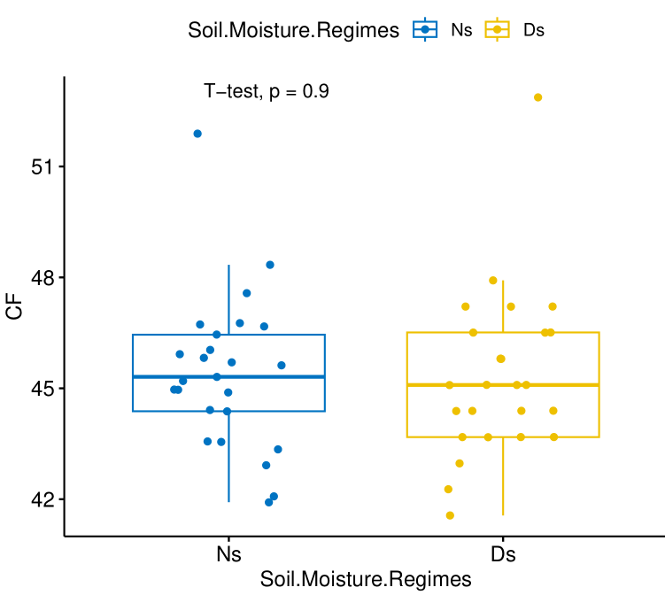

1. **B. C.**

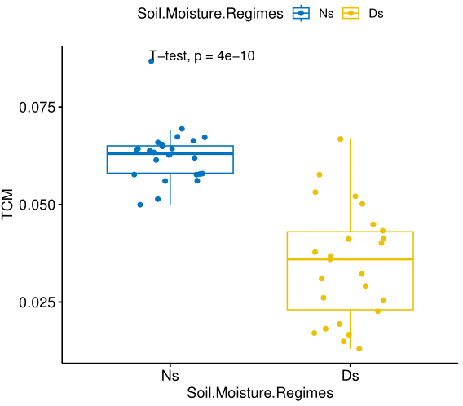 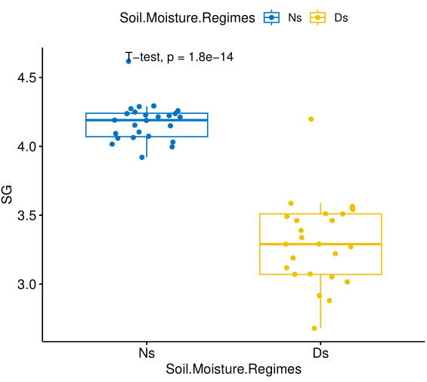 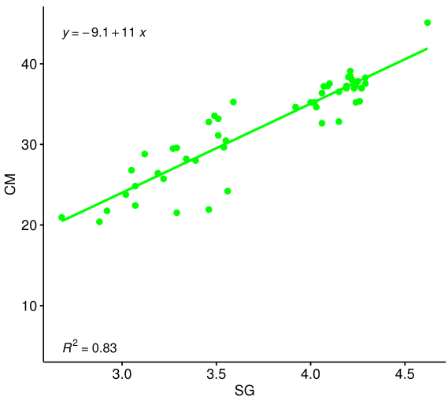

**D. E. F.**

Figure 1: Comparison of BLUP grain yield and chlorophyll related traits variation among sorghum lines under non-stress (Ns) and drought stress (Ds) growing conditions (A, B, C, D and E). On X-axis, Ns and Ds growing conditions are individually represented. On the Y axis, the estimated phenotypic traits values, grain yield (Y, ton/ha), leaves chlorophyll content at flowering stage (CF, in %), and leaves chlorophyll content at maturity (CM, in %) , actual value of total chlorophyll per unit area at maturity (TCM, in mg/cm2) and stay green (SG, 1 to5). F. The relationship of the leaf chlorophyll content (CM) and visual stay green rating at physiological maturity.

**Grain yield combined with indices of drought resistance**

Grain yield (Y) under Ns and Ds growth conditions ranged from 3.6 to 4.5 ton/ha and 2.6 to 3.0 ton/ha with BLUP mean Y of 4.2 and 2.8 ton/ha, respectively (Table 3). Based on Ns and Ds growing conditions, various selection indices for drought tolerance were computed (Table 5). The result showed that the ten drought tolerance indices for sorghum lines, the stress susceptibility index (S), mean productivity (MP), geometric mean productivity (GMP), tolerance (TOL), stress tolerance index (STI), yield stability index (YSI), yield index (YI), harmonic mean (HM), and drought sensitivity index (DSI), varied widely, suggesting the presence of high variation for drought tolerance among the tested genotypes (Agegn et al., 2018). The mean drought indices for S, MP, GMP, PR, HM, YI, YSI, DI, STI and TOL, were 0.99, 3.6, 3.5, 33, 3.44, 1.01, 0.67, 0.68, 12, and 1.43, respectively (Table 5). High drought tolerance indices difference was detected for all estimated indices except for DI among parents and stay green QTLs introgressed sorghum lines (Table 3).

The drought susceptibility index (S) values of eleven stay green introgeressed sorghum lines (Meko x B-35-28, Meko x B-35 -8, T76T1# 23 x B-35 -07, Meko x B-35-25-15, Teshale x B-35 -12, GambellaxB-35-01, GambellaxB-35-05, MekoxB-35-13, Mekox B-35 -19-15, GambellaxB-35-37, and MekoxB-35-12) were less than one compared to their respective recurrent parents, which suggests the existence of drought tolerant sorghum lines. Similar results were reported in various cereal crops including sorghum (Mwamahonje et al., 2021), and barley (Agegn et al., 2018). On the other hand, the S values of the three recurrent parents Meko, Teshale, and Gambella were greater than 1, indicating that they are drought sensitive. This implies that Ds was mild yet sufficient in this study to enable the selection of drought tolerant lines (Patel et al., 2019).Among the introgression lines, five derived sorghum lines (Meko x B-35-8, Meko x B-35-25-15, Gambella x B-35-01, Teshale x B-35-12, and Meko x B-35 -13 ) had highest values of GMP, HM, MP, YI, YSI , DI and STI than the respective recurrent parents and research report showed that genotypes with high values of these indices can be selected as tolerant genotypes to drought stress condition , which indicates that these indices are equal for screening of crop genotypes.

**Table 5:** Distribution of drought indices estimated in sorghum lines.

|  |  |  |  |  |  |  |  |
| --- | --- | --- | --- | --- | --- | --- | --- |
| Drought indices | Mean square | | Significance | Min | Max | GM | StDev |
| Group (2) | Residual (22) |
| Drought susceptibility index (S) | 0.21 | 0.01 | *** | 0.34 | 1.13 | 0.99 | 0.15 |
| Mean productivity (MP) | 0.61 | 0.02 | *** | 2.5 | 4.08 | 3.6 | 0.27 |
| Geometric mean productivity (GMP) | 0.54 | 0.03 | *** | 2.5 | 4.00 | 3.5 | 0.26 |
| Percent Reduction (PR) | 243 | 7.4 | *** | 11 | 38.17 | 32.79 | 5.20 |
| Harmonic mean (HM) | 0.47 | 0.03 | *** | 2.5 | 4 | 3.44 | 0.25 |
| Yield index (YI) | 0.018 | 0.003 | * | 0.83 | 1.19 | 1.01 | 0.07 |
| Yield stability index (YSI) | 0.03 | 0.001 | *** | 0.62 | 0.89 | 0.67 | 0.05 |
| Drought resistance index (DI) | 0.003 | 0.004 | ns | 0.58 | 0.83 | 0.68 | 0.06 |
| Stress tolerance index (STI) | 20 | 1.3 | *** | 6.23 | 16.12 | 12.44 | 1.7 |
| Tolerance index (TOL) | 0.68 | 0.02 | *** | 0.3 | 1.71 | 1.43 | 0.27 |

Note: Min = Minimum; Max= Maximum; GM= Grand mean values; StDev = Estimate of the standard deviation;

According to the association plot between NsY, DsY and other drought indices (Figure 2A), NsY exhibited a significantly positive association with DsY, indicating that sorghum lines which performed good under Ns also performed well under Ds. This supports up the results of Teklay et al. (2020) and Mwamahonje et al. (2021) for sorghum, Patel et al. (2019) for wheat, Agegn et al. (2018) for barley and Mau et al. (2019) for rice, that choosing genotype for yield under near optimal conditions would be a suitable strategy for choosing genotypes evaluated under drought stress conditions. Further, NsY and DsY were positively and significantly associated with drought resistance indices of MP, GMP, HM, YI and STI (Figure 2A), and these indices may be used as potential drought indices to choose high yielding and drought resistant sorghum genotypes under drought prone growing environments. As per studies, the best genotypes can be chosen using drought tolerance indices that can be generated from Y and traits that have a significant positive association with Y (Patel et al., 2019).

Using drought tolerance indices, principal component analysis (PCA) showed the variability of sorghum lines (Figure 2C). Further, PCA is crucial for identifying yielding potential and drought tolerance in crop breeding program (Feizi et al., 2020). The first principal component (PC1) and the second principal component (PC2) of the PCA on drought tolerance indices, respectively, described 69.9% and 29.8% of the total variation. PC1 was strongly and positively associated with NsY, DsY, S, MP, GMP, PR, YI, HM, and STI and TOL, and negatively associated with YSI (Figure 2C). The sorghum lines Meko x B-35-8, Meko x B-35-25-15 and Gambella x B-35 -01 that stay green introduced had high PC-1 values and were more appropriate for Ds and Ns growing environments. Similarly, Feizi et al. (2020) and Mwamahonje et al. (2021) found that the genotypes chosen can yield well in both stress-free and stressful environments based on the positive and high value of PC-1 on PCA biplots. PC2 was significantly and positively associated with DsY, YI, YSI, DI and negatively correlated with S, PR, and TOL. The drought indices were clustered by PCA into three categories. The first group consists of DsY, GMP, MP, HM, YI, STI, DI and NsY, the second category consists of PR, S and TOL, and the third category is made up of YSI. In our study, the relationships between the drought indices were interpreted using PCA, and the results were supported by association plot (Figure 2A).

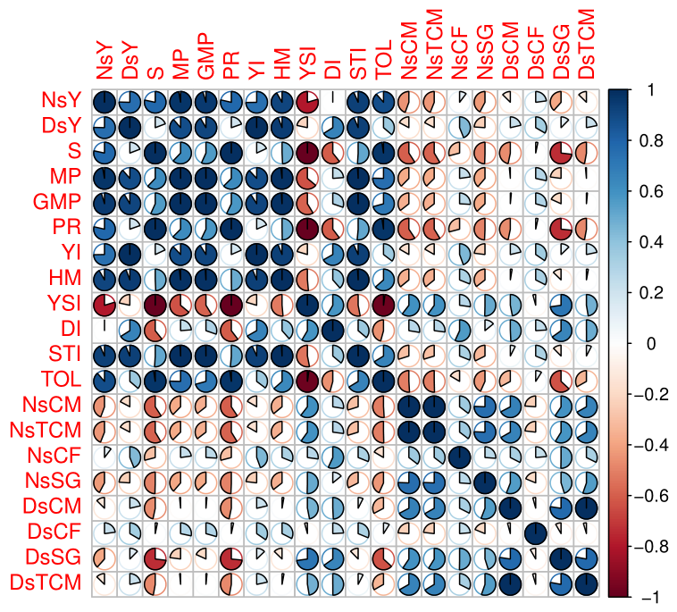 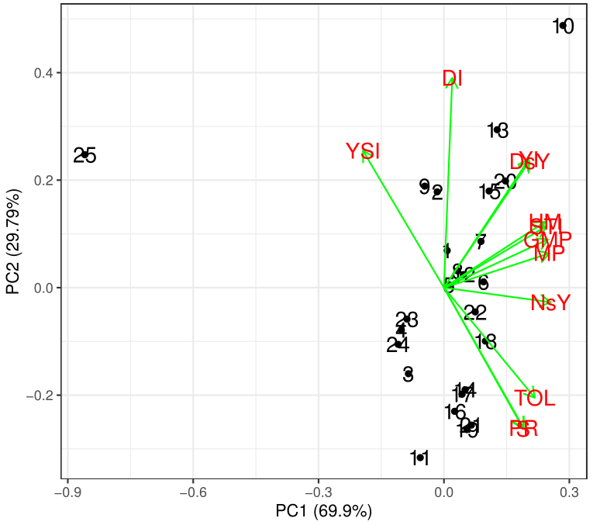

1. **B.**

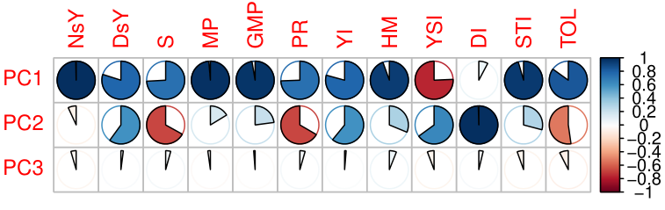

**C.**

Figure 2: Variation and relationship among stay green introgressed sorghum lines for grain yield, chlorophyll related traits and drought resistance indices under contrasting growing condition in Ethiopia. (A). Correlations among NsY, DsY, drought resistance indices and chlorophyll related traits under non-stress (Ns) and drought stress (Ds) growing conditions. (B) PC representing Y under Ns and Ds, and drought resistance indices of sorghum genotypes evaluated under Ns and Ds. Colored dots are derived lines, recurrent and donor parents, according to the legend to the right. Green vectors represent the traits in the PCA. PC1 and PC2 are shown on X and Y axis, respectively, aside their explained variance. (C) Correlations between derived PC variables and original variables in the drought resistance indices and Y under Ns and Ds. Correlation coefficients are reported in colors, blue and red for positive and negative direction, respectively, according to the legend to the right.

1. **CONCLUSION AND RECOMMENDATION**

Marker-assisted backcrossing can be used to identify the introgression of a target gene into the genome and enhance the efficiency of backcross breeding operations, hence improving grain yield and stress resistance in crops. The analyzed chlorophyll related traits, such as CM, TCM, and SG, can be employed to screen sorghum genotypes for drought tolerance. The effective drought tolerance indices of GMP, MP, HM, YI, and STI, which were positively and significantly correlated with NsY and DsY, would be excellent tools for selecting high yielding and drought tolerant genotypes for sorghum improvement projects in both favorable and drought-prone growing environments. Based on their drought tolerance indices, yield potential, and chlorophyll related traits, five stay green QTLs introgressed sorghum lines (Meko x B-35-8, Meko x B-35-25-15, Meko x B-35-13, Teshale x B-35-12, and Gambella x B-35-01) could be given priority for valorization in sorghum improvement programs. The result encourages working on marker-assisted introgression and a subsequent field performance evaluation in order to transfer multiple stay-green (Stg1, Stg2, Stg3, and Stg4) genes into the genome of single high yielding sorghum cultivars and to develop new sorghum variety. This could help identify which combinations of stay green QTL alleles are most likely to function cooperatively in drought-stressed environments. Moreover, the current study contributes to our understanding of how various stay green introgressed sorghum lines and their parents respond to drought on the basis of several drought indices and yield and chlorophyll related traits.

**ACKNOWLEDGEMENTS**

We are grateful that this study was financed by the International Crop

Research Institute for Semi-Arid Tropics (ICRISAT). Also, we would like to thank SWHISA (sustainable water harvesting and institutional strengthening project), which contributed funds to help with the construction of the rain-out shelter. The national and regional sorghum improvement project team at the Melkasa and Sirinka Agricultural Research Center is greatly appreciated.

**REFERENCES**

Abraha, T., Githiri, S. M., Kasili, R., Araia, W., & Nyende, A. B. (2015). Genetic variation among sorghum (Sorghum bicolor L. Moench) landraces from Eritrea under post-flowering drought stress conditions. American Journal of Plant Sciences, 6(9), 1410-1424.

Abreha, K. B., Enyew, M., Carlsson, A. S., Vetukuri, R. R., Feyissa, T., Motlhaodi, T., ... & Geleta, M. (2022). Sorghum in dryland: morphological, physiological, and molecular responses of sorghum under drought stress. *Planta*, *255*, 1-23.

Adeyanju, A., Yu, J., Little, C., Rooney, W., Klein, P., Burke, J., & Tesso, T. (2016). Sorghum RILs Segregating for Stay‐Green QTL and Leaf Dhurrin Content Show Differential Reaction to Stalk Rot Diseases. *Crop Science*, *56*(6), 2895-2903.

Adugna, A. (2014). Analysis of in situ diversity and population structure in Ethiopian cultivated *Sorghum bicolor (L.)* landraces using phenotypic traits and SSR markers. *Springer Plus* 3: 1–14. DOI: 10.1186/2193-1801-3-212

Agegn, S., Alamerew, S., Lakew, B., & Teshome, K. (2018). Evaluation of barley (Hordeumvulgare L.) Pure lines for drought tolerance. *Ethiopian Journal of Applied Science and Technology*, *9*(2), 39-54.

Almeida, M. D. S., Silva, J. A. G. D., Enciso, J., Sharma, V., & Jifon, J. (2008). Yield components as indicators of drought tolerance of sugarcane. *Scientia Agricola*, *65*, 620-627.

Batista, P. S. C., Menezes, C. B., Carvalho, A. J., Portugal, A. F., Bastos, E. A., Cardoso, M. J., ... & Julio, M. P. M. (2017). Performance of grain sorghum hybrids under drought stress using GGE biplot analyses. *Genetics and molecular research*, 10.4238/gmr16039761.

Borrell, A. K., Hammer, G. L., & Henzell, R. G. (2000). Does maintaining green leaf area in sorghum improve yield under drought? II. Dry matter production and yield. *Crop science*, *40*(4), 1037-1048.

Borrell, A. K., van Oosterom, E. J., Mullet, J. E., George‐Jaeggli, B., Jordan, D. R., Klein, P. E., & Hammer, G. L. (2014). Stay‐green alleles individually enhance grain yield in sorghum under drought by modifying canopy development and water uptake patterns. *New Phytologist*, *203*(3), 817-830. DOI: 10.1111/nph.12869.

Bouslama, M., & Schapaugh, W. T. (1984). Stress tolerance in soybean. Part 1: evaluation of three screening techniques forheat and drought tolerance. CropSci. 24: 933-937.

Central Statistical Agency (CSA)(2021). Report on area and production of major crops of private peasant holdings survey 2020/2021 Meher season. Statistical Bulletin 590. CSA, Addis Ababa, Ethiopia.

Coulibaly, S.B. (2002). Evaluation of backcross progenies and recombinant inbred line populations of sorghum (*Sorghum bicolor L. Moench*). PhD dissertation in agronomy. University of Texas Tech.

Djanaguiraman, M., Prasad, P.V.V., Ciampitti, I.A., & Talwar, H.S. (2020). Impact of abiotic stress on sorghum physiology. In Sorghum in the 21st Century: Food Fodder Feed Fuel for a Rapidly Changing World; *Springer Nature*: Singapore, 157-188.

Doggett, H. (1970). Sorghum. Tropical Agriculture Series. London, England: Longman.

Enyew, M., Carlsson, A.S., Geleta, M., Tesfaye, K., Hammenhag, C., Seyoum, A., & Feyissa, T. (2022). Novel sources of drought tolerance in sorghum landraces revealed via the analyses of genotype-by environment interactions. *Frontiers in Plant Science,* 13:1062984. DOI: 10.3389/fpls.2022.1062984

Ethiopian Agriculture Authority (EAA) (2021). Plant Variety Release, Protection and Seed Quality Control Directorate. Crop variety register, issue No. 24, Addis Ababa, Ethiopia.

Feizi, M., Solouki, M., Sadeghzadeh, B., Fakheri, B., & Mohammad, S.A. (2020). Evaluation of drought tolerance indices for barley landraces under irrigated and dry conditions. Bioscience Journal, 36(5) :1518-1527, DOI:10.14393/bj-v36n5a2020-41864.

Fernandez, G.C. (1992). Effective selection criteria for assessing stress tolerance. In: Kou, C.G. (ed.). Proceedings of International Symposium on Adaptation of Vegetables and Other Food Crops in Temperature and Water Stress, Publication, Tainan, Taiwan. Taiwan, 13–16 Aug. 1992. By: C. G. Kuo. AVRDC.

Firezer, G., Firew, M., Taye, T., Temesgen, M., & Kassahun, B. (2020). Phenotyping sorghum (Sorghum bicolor (L.) Moench) for drought tolerance with special emphasis to root angle. African Journal of Agricultural Research 16(8): 1213-1222, DOI: 10.5897/AJAR2020.14801.

Fischer, R.A., & Maurer, R. (1978). Drought resistance in spring wheat cultivars. Australian journal of Agriculture Research, 29: 897–912.

Food and Agriculture Organization (FAO) (2019). Food and Agriculture Organization of the United Nations, Rome, Italy. Available online: http://www.fao.org/faostat/en/#data (accessed on 20 November 2019).

Gao, F., Ma, D., Yin, G., Rasheed, A., Dong, Y., & Xiao, Y. (2017). Genetic progress in grain yield and physiological traits in Chinese wheat cultivars of southern Yellow and Huai Valley since 1950. Crop Science 57:760–773. doi: 10.2135/cropsci2016.05.0362.

Gavuzzi, P., Rizza, F., Palumbo, M., Campaline, R.G., Ricciardi, G.L., & Borghi, B. (1997). Canadian Journal of Plant Science, 77:523-531.

Haussmann, B.I., Hess, D.E., Seetharama, H.G., and Geiger, H.H. (2002). Construction of a combined sorghum linkage map from two recombinant inbred populations using markers and comparison with other sorghum maps. Theoretical and Applied Genetics, 105: 629-637.

Kamal, N.M., Yasir, S.A.G., Mostafa, A., Eltayb, A., & Hisashi, T. (2019). Stay-Green Trait: A Prospective Approach for Yield Potential, and Drought and Heat Stress Adaptation in Globally Important Cereals. International Journal of Molecular Sciences,5837; DOI:10.3390/ijms20235837.

Kassahun, B., Bidinger, F.R., Hash, C.T., & Kuruvinashetti, M.S. (2010). Stay-green expression in early generation Sorghum (Sorghum bicolor (L.) Moench) QTL introgression lines. Euphytica , 172, 351–362. [DOI.org/10.1007/s10681-009-0108](https://doi.org/10.1007/s10681-009-0108).

Kebede, Y. (1991). The role of Ethiopian sorghum germplasm resources in the national breeding programme. Plant Genetic Resources of Ethiopia. Cambridge University Press, Cambridge, 315-322.

Kebede, P.K., Subudhi, D.T., Rosenow, & Nguyen, H.T. (2001). Quantitative trait loci influencing drought tolerance in grain sorghum. Theoretical Applied Genetics, 103: 266-276.

Khaton, M.A., Sagar, A., Tajkia, J.E., Islam, M.S., Mahmud, M.S., & Hossain, A.K.M.Z. (2016). Effect of moisture stress on morphological and yield attributes of four sorghum varieties. Progressive Agriculture 27(3): 265-271.

Luche, H.S., Silva, J.A.G., Nörnberg, R., Silveira, F.S., Baretta, D., Groli, E.L., Maia, L.C., & Oliveira, A.C. (2015). Stay-green: A potentiality in plant breeding. Ciência Rural, 45:1755-1760.

Mahalakshmi, V., & Bidinger, F.R., (2002). Evaluation of stay-green sorghum germplasm lines at ICRISAT. Crop Science, 42:965-974. [DoI.org/10.2135/cropsci2002.9650](https://doi.org/10.2135/cropsci2002.9650)

Mamo, G. (2005). Using Seasonal Climate Outlook to Advise on Sorghum Production in the Central Rift Valley of Ethiopia, PhD thesis, Blomefontein, Republic of South Africa.

Mehrabi, P., Homayoun, H., & Daliri, M.S. (2011). Study of drought tolerance of corn genotypes using STI index.Middle-East Journal of Scientific Research 9(1): 68-70.

Menezes, C.B., Ribeiro, A.S., Tardin, F.D., & Carvalho, A.J. (2015). Adaptabilidade e estabilidade de linhagens de sorgo em ambientes com e sem restrição hídrica. Brazilian Journal of Maize and Sorghum 14: 101-115. DOI.org/10.18512/1980-6477/ rbms.v14n1

Mekbib, F. (2007). Infra-specific folk taxonomy in sorghum (Sorghum bicolor (L.) Moench ) in Ethiopia : Folk nomenclature, classification and criteria. 18:1–18. [DOI.org/10.1186/1746-4269-3-38](https://doi.org/10.1186/1746-4269-3-38).

Mwamahonje, A., Eleblu, J.S.Y., Ofori, K., Feyissa, T., Deshpande, S., & Tongoona, P. (2021). Evaluation of Traits Performance Contributing to Drought Tolerance in Sorghum. Agronomy, 11, 1698. DOI.org/10.3390/ 11091698

Ochieng, G., Ngugi, K., Wamalwa, L., Manyasa, E., Muchira, N., & Nyamongo, D. (2020). Novel sources of drought tolerance from landraces and wild sorghum relatives. Crop Science 61:104–118. DOI: 10.1002/csc2.20300

Patel, J.M., Patel, A.S., Patel, C.R., Mamrutha, H.M., Pradeep, S., & Pachchigar, K.P. (2019). Evaluation of selection indices in screening durum wheat genotypes combining drought tolerance and high yield potential. International Journal of Current Microbiology and Applied Sciences, 8, 1165–1178.

Pommel, B., Gallais, A., Coque, M., Quillerce, I., Hirel, B., Prioul, J.L., Andrieu, B., & Floriot., M. (2006). Carbon and nitrogen allocation and grain filling in three maize hybrids differing in leaf senescence. European Journal of Agronomy 24: 203-211.

Prasad, V.B.R., Govindaraj, M., Djanaguiraman, M., Djalovic, I., Shailani, A., Rawat, N., Singla-Pareek, S.L., Pareek, A., & Prasad, P.V.V. (2021). Drought and High Temperature Stress in Sorghum: Physiological, Genetic, and Molecular Insights and Breeding Approaches. International Journal of Molecular Sciences, 22, 9826. DOI.org/ 10.3390/ijms2218982

Prasad, P.V., Pisipati, S.R., Mutava, R.N., & Tuinstra, M.R. (2008). Sensitivity of grain sorghum to high temperature stress during reproductive development. Crop Science 48(5):1911-7.

Prasad, P.V.V., Staggenborg, S., & Ristic, Z. (2008). Impacts of drought and/or heat stress on physiological, developmental, growth, and yield processes of crop plants. In Response of Crops to Limited Water: Understanding and Modeling Water Stress Effects on Plant Growth Processes; Ahuja, L.R., Reddy, V. R., Saseendran, S.A., Yu, Q., Eds.; ASA CSSA, SSSA: Madison, WI, USA, 301–355.

Reddy, A.R., Chaitanya, K.V., & Vivekanandan, M. (2004). Drought induced responses of photosynthesis and antioxidant in higher plants. Journal of Plant Physiology, 161(11):1189-1202.

Rosenow, D.T. (1983). Breeding for resistance to root and stalk rots in Texas, in sorghum Root and Stalk Rots, a Critical Review, edited by L K Mughogho. International Crops Research Institute for the Semi-Arid Tropics, Patancheru, AP, India, 209-217

Rosielle, A.A., & Hamblin, J. (1981). Theoretical aspects of selection for yield in stress and non-stress environment. Crop Science 21: 943- 946.

Simane, B., & Struik, P. (1993). Agroclimatic analysis: a tool for planning sustainable durum wheat (Triticum turgidum var. durum) production in Ethiopia. Agriculture, Ecosystems and Environment, 47: 31– 46. [DOI.org/10.1016/0167-8809(93)90134](https://doi.org/10.1016/0167-8809(93)90134)

Singh, R., & Axtell, J.D. (1973). High lysine mutant gene (hl that improves protein quality and biological value of grain Sorghum.Crop Science 13: 535 – 539.

Subudhi, P.K., Rosenow, D.T., & Nguyen, H.T. (2000). Quantitative trait loci for the stay green trait in sorghum (Sorghum bicolor L. Moench): Consistency across genetic backgrounds and environments. Theoretical and Applied Genetics, 101: 733-741.

Sukumaran, S., Li, X., Li, X., Zhu, C., Bai, G., & Perumal, R. (2016). QTL mapping for grain yield, flowering time, and stay-green traits in sorghum with genotyping-by-sequencing markers. Crop Science 56 :1429–1442. DOI: 10.2135/ cropsci2015.02.0097

Teklay, A., Gurja, B., Taye, T., & Gemechu, K. (2020). Selection efficiency of yield based drought tolerance indices to identify superior sorghum (Sorghum bicolor (L.) Moench) genotypes under two-contrasting environments. African Journal of Agricultural Research,15(3): 379-392, DOI: 10.5897/AJAR2020.14699.

Tesso, T., Tirfessa, A., & Mohammed, H. (2011). Association between morphological traits and yield components in the durra sorghums of Ethiopia. Heredita, 148(3),98–109. [DOI.org/10.1111/j.1601-5223.2011.02229](https://doi.org/10.1111/j.1601-5223.2011.02229).

Thomas, H., & Howarth, C. (2000). Five ways to stay green. Journal of Botany, 51: 329-337.

Waseem, K., Anwar, A., Muhammad, S., Arshad, F.A., Ramish, A., Azhari, S., Safura, K., Muhammad, A.R., Afifa, A., Zahra, M., & Ayesha, S. (2022). Nutrients and bioactive compounds of Sorghum bicolor L. used to prepare functional foods: A review on the efficacy against different chronic disorders. International Journal of Food Properties, 25:1045-1062, DOI: 10.1080/10942912.2071293.

Wondimu, Z., Bantte, K., Paterson, A., & Worku, W. (2020). Agromorphological diversity of Ethiopian sorghum (Sorghum bicolor (L.) Moench) landraces under water limited environments. Genetic Resourese Crop Evolution 67: 2149–2160. DOI: 10.1007/s10722-020-00968-7

Xu, W.W., Subudhi, P.K., Crasta, O.R., Rosenow, D.T., Mullet, J.E., & Nguyen, H.T. (2000a). Molecular mapping of QTLs conferring stay-green in grain sorghum (Sorghum bicolor L. Moench). Genome, 43: 461–469.

Xu, W.W., Rosenow, D.T., & Nguyen, H.T. (2000b). Stay-green trait in grain sorghum (Sorghum bicolor L. Moench): Relationship between visual rating and leaf chlorophyll concentration. Plant Breeding, 119: 365-367.

Zaharieva, M., Gaulin, E., Havaux, M., Acevedo, E., & Monnevaux, P. (2001). Drought and heat responses in the wild wheat relative Aegilops

geniculata roth. Crop Science, 41: 1321-1329.

Zheng, H.J., Wu, A.Z., Zheng, C.C., Wang, Y.F., Cai, R., Shen, X. F., Xu, R.R., Liu, P., Kong, L.J., & Dong, S.T. (2009). QTL mapping of maize (Zea mays) stay-green traits and their relationship to yield. Plant Breeding, 128:54- 62.