|  |  |
| --- | --- |
| ***BNJAR*** | **Blue Nile Journal of Agricultural Research (BNJAR)**  Vol. 5, Issue 2, December, 2022, pp. 14-25  Journal homepage: https://www.arari.gov.et/index_bnjar.php |

|  |  |  |  |
| --- | --- | --- | --- |
| **Scenario-based land management options for the highland of Ethiopia: a decision support tool to implement rural land use plans** | | |  |
| *Menale Wondie1*, Wolde Mekuria2, Dagninet Amare1 and Klaus Katzensteiner3*  *1*Amhara Agricultural Research Institute, Bahir Dar, Ethiopia*  *2International Water Management Institute, Addis Ababa, Ethiopia*  *3University of Natural Resources and Life Sciences, Vienna, Austria*  *Corresponding author email:* [*menalewondie@yahoo.com*](mailto:menalewondie@yahoo.com) | | | |
| Copyright: ©2024 The author(s). This article is published by BNJAR and is licensed under the CC BY 4.0 license (http://creativecommons.org/licenses/by/4.0/). | | | |
|  |  | **ABSTRACT** | |
|  |  |  | |
| **Received:** August 15, 2022  **Revised:** November 24, 2022  **Accepted:** December 10, 2022  **Available online:** December 27, 2022 |  | *The implementation of locally acceptable improved land management practices is crucial to improve the livelihoods of local communities and reduce the degradation of ecosystem services (ESs). This study was conducted in Tara Gedam watershed, northwestern Ethiopia, to identify suitable land management options from four ecosystem service-based scenarios: business as usual (BAU), transition agriculture (TAG), intensified agriculture (INA), and optimized ecosystem services (OPE) using the Analytic Hierarchy Process method of Multi-criteria Decision Analysis tools. A stakeholder workshop and group discussions with farmers and agricultural experts were conducted to set criteria for selecting the best management option. Livelihood benefits and environmental improvements were rated highest and are therefore the most influencing factors for the selection of land management options. These two criteria were responsible for the best performance of the OPE and INA. INA and/or TAG were also the preferred options by the perspective of farmers. This is attributed to the fact that these options provide benefits within a shorter period of time compared to OPE. Smallholder farmers should be provided with financial and technical support to implement improved management options such as OPE. The results of this study will contribute to the knowledge base of agricultural experts for future implementation of Ethiopian rural land use planning.* | |
| **Keywords:** *Analytic hierarchy process, Ecosystem services, Optimized ecosystem services* |  |

1. **INTRODUCTION**

Land resources in the highlands of Ethiopia are facing intense pressure due to human activities and this has led to severe land degradation (Mekuria et al 2017). Major causes of land degradation include deforestation, agricultural land expansion, overgrazing and absence of land use plan (Kirui and Mirzabaev 2016). Land degradation in the highlands of Ethiopia has resulted in a persistent decline in the quality of forest resources, agricultural biodiversity and ecosystem services (Amare et al 2017). In response to the problem of land degradation, the Ethiopian government in collaboration with donors and local communities has put a number of land restoration interventions for the last 30 to 40 years (Egoh et al 2008; Amare et al 2017; Mekuria et al 2018). However, the biggest challenge is to ensure that such interventions are sustainable and meet the livelihood goals of local communities (Mekuria et al 2017).

In this line, the Ethiopian land use policy states that land use plan and management shall be prepared by the respective experts based on ecosystem approach (Amare et al 2019). Yet, this policy has not been implemented due to the lack of implementation guidelines, knowledge gaps and decision support tools (Amare et al 2019). Thus, designing a decision support tool that incorporates the ecosystem approach and farmers knowledge maintains the implementation of the county’s land use policy and context-based development plan to achieve both environmental and livelihood goals.

Studies (e.g., Linkov et al 2006; Fontana et al 2013) demonstrated that Multi-criteria Decision Analysis (MCDA) provides reasonable and objective results with the participation of different (i.e., in terms of interests and bacKgrounds) stakeholders. Several studies have used the MCDA concept to aid a decision for different purposes, for example, for making decision on farm management (Tiwari et al 1999; Rozman et al 2006; Pazek et al 2010), environmental management (Munda et al 1994; Kiker et al 2005; Linkov et al 2006; Steele et al 2009), forest management (Ananda and Herath 2009; Jactel et al 2012; Acosta and Corral 2015),

choice of bioenergy system (Buchholz et al 2009), river rehabilitation (Langhans and Lienert 2016), and integrated land management for ecosystem services (Schwenk et al 2012). Studies (e.g., Mendoza and Prabhu 2003; Mendoza-González et al 2012; Khalili and Duecker 2013) also indicated that MCDA is well suited to address interdisciplinary and complex environmental problems.

Yet, the most appropriate natural resources management interventions for improving livelihood and ecosystems vary regionally, depending on both environmental and socioeconomic settings (Fontana et al 2013). Also, the results of the above cited studies appear to be nontransferable to the north-western Ethiopia, as there are differences in socio-economic conditions, land use practices, rainfall amount and distribution, key soil properties, and natural resource management practices. Therefore, the present study was conducted in the north-western Ethiopia to: (a) identify natural resources management interventions that can improve the livelihood of local communities, while maintaining or improving the environment; and (b) draw lessons for future land use planning in the region under smallholders circumstances. The novelty of this study lies on its contribution to the implementation of Ethiopian rural land use policy in general, and site-specific development initiatives in particular, by enabling local landuse practitioners make informed decisions.

1. **MATERIALS AND METHODS**
   1. **Study Area**

This study was conducted in Tara Gedam watershed located in north-western Ethiopia (Figure 1). It is characterized by rugged topography with elevation ranges from 2000 to 2600 m above sea level and covers an area of 8.9 Km2. The watershed is drained by a stream, Aguat Mefesesha, which is a tributary of the Arno River. The soils are of volcanic origin, dominated by Nitisols, followed by Cambisols, Leptosols and Luvisols (Abiyu 2012; Feyisa 2012). The mean monthly temperature ranges from 18 to 34°C. The average annual rainfall is 1175 mm. Mixed farming, which integrates crop with livestock production is the major livelihood activities in the watershed. Crops are grown both for household consumption and income generation. The land cover of the area is dominated by cropland (49.6%) and forestland (24.8%) with shrublands constituting the rest (Wondie et al 2016).

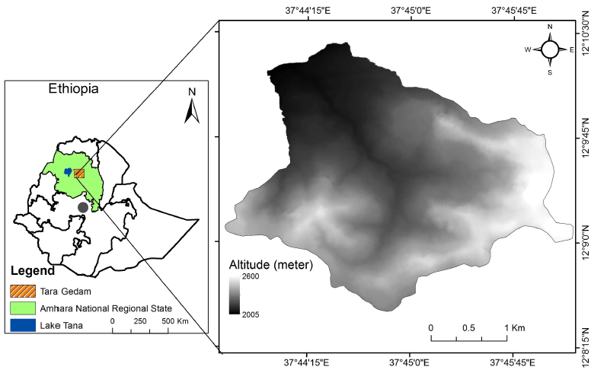

Figure 1: Location of the study area

* 1. **Modelling Land Management Options**

Scenario modeling was employed (Wondie 2015) to investigate land management options that can enhance agricultural productivity, while maintaining or improving ecosystem services. For this study, we proposed four land management options: (a) business as usual (BAU), (b) transition agriculture (TAG), (c) intensive agriculture (INA), and (d) optimized ecosystem services (OPE) (Table 1, Wondie 2015).

Table 1: Description of the four scenarios designed as land management options

| Land management options | Description |
| --- | --- |
| Business as usual (BAU)* | Refers the current land use and land management systems. Also, this scenario assumed annual population growth of 3.1% negative impact of farming practices on ecosystem services, and that the community is characterized by a food-self-insufficient and low-income community. |
| Transition agriculture  (TAG)** | In this scenario, it was assumed that priority is given to food security, while less attention is given to conservation and environmental protection. Other assumptions include annual population growth of 2.7%, average annual agricultural production increase of 1% in the whole watershed using wheat equivalent, average wheat demand of 407 Kg year-1 (207 Kg for food and 200 Kg for other household expenses). |
| Intensive agriculture  (INA)*** | This scenario is based on the assumption that the selected land management options targets both agricultural production for consumption and market, annual population growth of 2.4% (CSA 2013) for Ethiopia, annual average agricultural production growth of 6.6%, and food security can be achieved in the short-term. |
| Optimized ecosystem services (OPE) | In this scenario, it was assumed that well-designed land use plan focusing on improving food production and restoring degraded lands, and annual population growth of 1.8% (CSA 2013) for Amhara Region, overall annual production increases of 7% for the first 10 years and then by 10%. This scenario based on the assumption that use of ecosystem-based approach to increase agricultural productivity, while maintaining or improving the environment. A win–win situation exists between conservation and development. |

*The assumption regarding the annual population growth is based on field survey results

**The assumption regarding the annual population growth is based on expert judgment.

***The land management options included in this scenario comprises of forage production, agroforestry practices, production of cash crops, water harvesting technologies, small scale irrigation, watershed management, and using agricultural inputs that increase agricultural productivity.

* 1. **Selecting the Best Land Management Option or Scenario**

We used MCDA to select the best management option for the studied watershed. Selecting the best option from the four proposed scenarios (Table 1) was a complex process and required the use of appropriate analytical tool. The analytic hierarchy process (AHP) was adopted to decompose the complex MCDA into simplified analytical processes. AHP is one of the MCDA methods used to facilitate the decision-making process and involves subjective judgment (Satty 1990). It has been widely used to undertake various environmental management decisions under complex social and environmental conditions (Kasperczyk and Knickel 2004; Linkov et al 2006; Convertino et al 2013). AHP

uses weighting and hierarchical decision-making in a participatory and interdisciplinary manner (Macharis et al 2004); and relies on the judgments of experts (Kasperczyk and Knickel 2004). It involves quantifying, scoring and weighting a range of quantitative and qualitative criteria to rank scenarios or development options (Fontana et al 2013; Favretto et al 2016). AHP is comprised of three levels of components (Figure 2). The first level is the goal of the decision (i.e., food security and sustainable land management), the second level of the hierarchy represents the criteria used to conduct comparisons among proposed scenarios, and the third level represents the proposed development options.

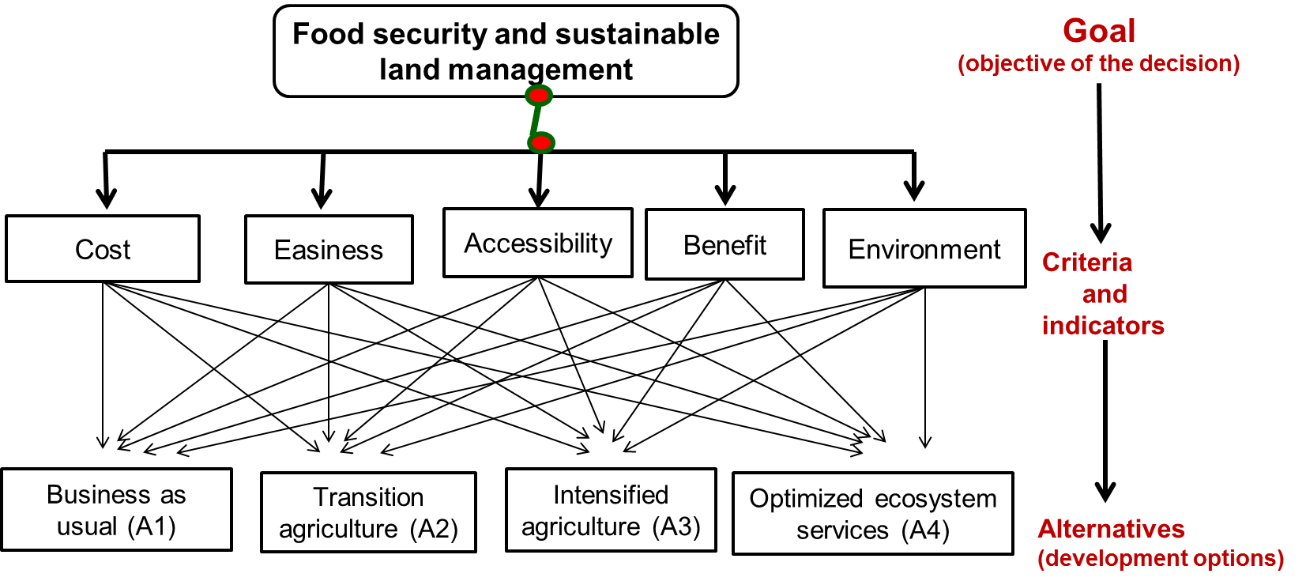

Figure 2: Hierarchy model: setting the goal, criteria and alternatives

This study followed five steps to reach a decision on best practices using the AHP approach (Belton and Goodwin 1996; Sun et al 2013). The steps were: (a) identification of the problem and setting the objectives, (b) selection of criteria, (c) comparison and weighting of the criteria chosen to evaluate the land management options, (d) ranking of alternatives, and (e) conducting MCDA evaluation. Different approaches (both quantitative and qualitative) were employed to gather data for identification of problems, setting criteria, comparison and weighing of the criteria, and ranking of alternatives (land management options) (Wondie 2015; Wondie et al 2016). The approaches used include field observation, household survey, workshop, land cover change analyses, and estimation of crop production and productivity. Three focus group discussions, each having a size of 6-8 farmers were conducted. Also, a stakeholder validation workshop was conducted with agriculture experts for three consecutive days. The agricultural experts comprised of natural resources management, crop production, livestock production, soil management, forestry, economics and social science. Prior to gathering data using the stakeholder validation workshop, the proposed land management options (Table 1) and proposed criteria (Figure 2) were briefly described for the stakeholders.

Following the presentation of the proposed land management options and criteria for selecting the best alternative, the participants of the stakeholder validation workshop were divided into two groups, each comprising 7 individuals. Both groups were asked to set criteria for selecting the best alternative among the proposed options. This was done to reduce bias and errors in setting criteria. Each group had a facilitator and a rapporteur elected by the participants. The facilitator presented ideas and discussion points based on pre-determined alternatives (development options). The participants discussed about the suggested criteria and chose amongst the alternatives. The workshop and group discussions were designed in such a way that every participant contributes ideas and suggestions on the proposed criteria. Once each group summarized their own set of criteria, the two groups met together, and found consensus on common set of criteria to evaluate the proposed land management options. These were: cost, easiness, accessibility, benefits, and environmental improvement (Table 2).

Table 2: Criteria used to evaluate the proposed management options

|  |  |
| --- | --- |
| Criteria | Description |
| Cost | This refers to the initial investment cost incurred to plan, implement and monitor each proposed land management option/scenario; affordability of initial investment cost in the perspective of farmers; timing of getting benefits; subsidies (e.g., construction of road and electricity). |
| Easiness | This refers to the compatibility of the proposed land management options with the existing farming system, culture and values of the local communities. |
| Accessibility | This refers to the physical accessibility of technologies, presence of choices and availability of inputs to implement the alternatives. |
| Economic benefit | This refers to the economic benefits obtained following the implementation land management options. |
| Environmental improvement/ecosystem service | This refers to the contribution of proposed land management option to minimizing land degradation, rehabilitating degraded lands, reducing soil erosion, improving soil fertility, conserving biodiversity, and improving micro-climate. |

After setting criteria (Table 2), the participants of the stakeholder workshop defined a weight for each decision criterion. These weights were values that indicated the relative importance of the different criteria selected for comparing the proposed land management options. Then, the participants were asked to perform pairwise comparison to reflect the relative importance of each choice (Favretto et al 2016), and choose the best alternative among the four proposed options The matrix for pairwise comparison of alternatives Ai=[aij], determined using equation 1, represents the preference between individual pairs of alternatives (scenarios). The participants compared pairs of alternatives/criteria using the scale of importance developed by Satty (1990).

W=[wi/wj]= $\left(\begin{matrix}\begin{matrix}\frac{w1}{w1} \\ \\ \frac{w2}{w1}\end{matrix} & \begin{matrix}\frac{w1}{w2} \\ \\ \frac{w2}{w2}\end{matrix} & \begin{matrix}. & . & \begin{matrix}. & \frac{w1}{wn}\end{matrix} \\ & & \begin{matrix} & \end{matrix} \\ . & . & \begin{matrix}. & \frac{w2}{wn}\end{matrix}\end{matrix} \\ \begin{matrix}. \\ . \\ .\end{matrix} & \begin{matrix}. \\ . \\ .\end{matrix} & \begin{matrix} & & \begin{matrix} & .\end{matrix} \\ & & \begin{matrix} & .\end{matrix} \\ & & \begin{matrix} & .\end{matrix}\end{matrix} \\ \frac{wn}{w1} & \frac{wn}{w2} & \begin{matrix}. & \begin{matrix}. & . & \frac{wn}{wn}\end{matrix}\end{matrix}\end{matrix}\right)$ W=[aij]= $\left(\begin{matrix}\begin{matrix}1 \\ \\ \frac{1}{a12}\end{matrix} & \begin{matrix}a12 \\ \\ 1\end{matrix} & \begin{matrix}a13 & a14 & \\ & & \\ a23 & a24 & \end{matrix} \\ \begin{matrix}. \\ \frac{1}{a13} \\ \end{matrix} & \frac{1}{a23} & \begin{matrix} & & \\ 1 & a34 & \\ & & \end{matrix} \\ \frac{1}{a14} & \frac{1}{a24} & \begin{matrix}\frac{1}{a34} & \begin{matrix} & 1 & \end{matrix}\end{matrix}\end{matrix}\right)…$ Eq 1

Where, aij gives the relative importance of the criteria/alternative i and j.

Pairwise comparisons were made among land management options (alternatives) with respect to each criterion. Following pairwise comparisons, the rank was obtained from the normalized score table using matrix analysis. The matrix was developed to evaluate the alternatives in accordance with criteria. The matrix allowed sorting the best one by identifying the relative importance, strengths and weaknesses. The scoring of each alternative was done based on the rating of relative importance (Table 3).

The consistency of the judgment was evaluated and checked by using consistency ratio (CR) and the consistency index (CI) (Satty, 1990). The CR is calculated as:

CR= $\frac{CI}{RI}$, CI= $\frac{{}_{max} - n}{n-1}$…. Eq. 2

Where λmax is eigenvalue, RI is the random index using the (Satty 1990) scale (Table 3). The CR is acceptable if and only if CR< 10%. The AHP analysis i.e., the consistency ratio, the consistency index and weighting were calculated using Microsoft Excel 2010.

Table 3: Value of RI for the corresponding number of criteria/alternatives (Satty 1990)

|  |  |  |  |  |  |  |  |  |  |  |
| --- | --- | --- | --- | --- | --- | --- | --- | --- | --- | --- |
| Size | 1 | 2 | 3 | 4 | 5 | 6 | 7 | 8 | 9 | 10 |
| RI | 0.00 | 0.00 | 0.58 | 0.90 | 1.12 | 1.24 | 1.32 | 1.41 | 1.45 | 1.49 |

1. **RESULTS AND DISCUSSION**
   1. **Importance of Criteria Used to Evaluate Land Management Options**

The results indicated that local communities prefer land management options that provided livelihood benefit within short period of time (Table 4). This selection can be attributed either to the poverty of the local communities and the need for immediate support to sustain their life (Wondie 2015), or the difficulty of quantifying all environmental benefits (e.g., the values of aesthetic benefits, eco-tourism and carbon sequestration) of management options. In this line, Probstl-Haider et al (2016) demonstrated that farmers prefer land management option that

maximize economic benefits, which will ultimately impact ESs, tourism opportunities, and biodiversity. Land management options that support the environment and enhance ESs ranked 2nd. In this line, a study by Favretto et al (2016) indicated that the value of a land use is not only linked to the availability of an ecosystem service, but also to its relative importance to society. Cost also contributed 10% of the weighting value to choose the given development options suggesting that initial investment costs of the proposed land management options was not considered as a major problem.

Table 4: Criteria weighting based on the rating technique with inputs from stakeholders

|  |  |  |  |  |  |  |  |  |
| --- | --- | --- | --- | --- | --- | --- | --- | --- |
|  | Cost | Easiness | Accessibility | Benefit | Environment | Weight | |  | | --- | | Lambda (λmax) | |
| Cost | 1.0 | 6.0 | 2.0 | 0.1 | 0.2 | 0.11 | 5.2 |
| Easiness | 0.2 | 1.0 | 0.4 | 0.1 | 0.1 | 0.03 | 5.1 |
| Accessibility | 0.5 | 2.5 | 1.0 | 0.1 | 0.1 | 0.06 | 5.2 |
| Benefit | 7.1 | 8.0 | 8.0 | 1.0 | 2.0 | 0.46 | 5.7 |
| Environment | 5.0 | 8.0 | 10.0 | 0.5 | 1.0 | 0.34 | 5.7 |

* 1. **Evaluation of Land Management Options**

The selection of a management option is dependent on the demand or objective of the stakeholders and criteria used to evaluate the options (Figure 3). For example, BAU can be preferred if cost is used as the most important evaluation criterion, while OPE can be selected if environmental benefits are given highest weight (Figure 3). However, according to the decision matrix ultimate scores, OPE provides the greatest benefits (Figure 4). It achieved the highest weighted score (39%). INA was chosen

as a second development option. The highest scores assigned to OPE were influenced by the type and amount of ecosystem services, and the contribution of the scenario for the sustainability through environmental improvement. Environmental deterioration, food insecurity and soil erosion were rampant owe to its highland and mountainous geographic context. Hence, selection of OPE and INA management options by the stakeholders was a reflection of the environmental situation rather than mere benefit-oriented objectives.

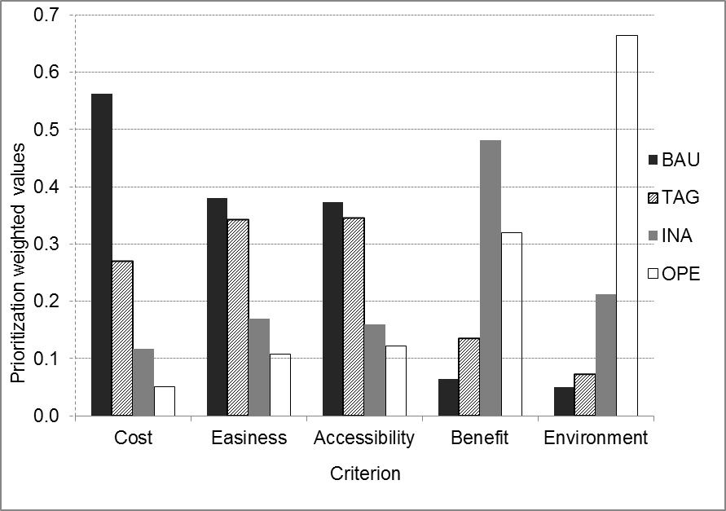

Figure 3: Weighted value of each alternative with respect to the criteria

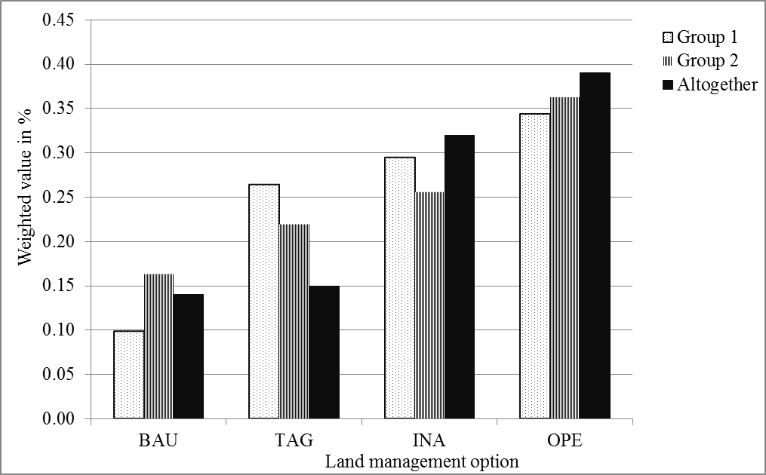

Figure 4: Ranking resulted from the two groups (1 and 2) independently and all group together (altogether)

A study conducted in the highlands of Ethiopia (Wondie 2015) reported a similar result in that the OPE and INA were selected as the two best land management options. In this study, however, the two groups gave different weighting values for each land management option due to differences in group composition and knowledge differences in describing the land management options (Figure 4). Also, the rank result was different when groups were brought together. The variation among groups (both separately and in aggregation) is attributed to the difference in skill and experience of the facilitator and participant stakeholders. The result of this study was consistent with the finding of other studies in that assigning weight to each criterion can be influenced by the knowledge, experience and preference of participating decision makers (e.g., Kumar et al 2017; Pamucar et al 2018).

The proposed options were most influenced by livelihood and environmental improvement benefits/objectives. These two criteria contributed positively to the best performance of the OPE and INA. Both options provided higher provisioning (e.g., food, feed and wood) and regulating (e.g., water regulation, biodiversity conservation, protection of the environment) ecosystem services compared to other proposed options. However, it is worth to mention that INA and TAG were the most preferred options in the perspective of farmers. This is attributed to their ability to deliver benefits within short period of time compared to OPE. On the other hand, BAU got the lowest values and was not selected. This is attributed to the negative effects of BAU in maintaining the environment and associated ecosystem services, which could in turn contribute to worsening food insecurity, land degradation and poverty. The evaluation results correspond to the local decision makers’ expectations and were in line with the suggestion of Wondie (2015). The highest evaluation was obtained for OPE since food security and sustainable land management can be achieved in the long run (Wondie 2015). The potential delivery of diversified ecosystem services and additional non-marketable products further contributed to the selection of this alternative. The result can be additionally explained by the estimated high values for marketable products. This judgment was based on the fact that most products are supposed to be organic and will obtain high revenue in the market.

* 1. **Implications for Future Interventions**

The increases in human and livestock population increased the demand for food, feed and energy. This cannot be achieved with the current land management practices (i.e., BAU). BAU shows low investment costs, but less diversified ecosystem services and simple production procedure. Improved management options are required to meet the increasing demand for food and energy. However, to implement improved management practices such as OPE; farmers should be provided with financial and technical support. In the long-run OPE would be more beneficial than INA; however, local communities prefer INA, as it generates benefits in the short run. Thus, INA can be used as an entry point to improve the resource use in the watershed, and through time there could be a possibility to shift from INA to OPE, provided that local communities would be provided incentives that support the adoption of long-term land management options.

1. **CONCLUSIONS**

The results demonstrated that livelihood benefits and environmental improvement were the influential criteria for decision on land management options. We observed that farmers prefer INA to implement as a development option compared to other proposed land management options. It supports to achieve food security and reduce natural resources degradation. However, the aggregated result including the preferences of experts indicated that OPE was the most preferred land management option. Based on the findings of this study, the following suggestions are made. Rather than mere stakeholder-based management options, integrating farmers preferences promises sustainability of interventions as it harmonizes livelihood activities with environmental benefits. Identifying key stakeholders and facilitators (as demonstrated by the variation of ranking of options between groups) is fundamental to properly evaluate different land management options and develop sustainable watershed management strategies. Further, studies are required to fully quantify the environmental benefits of the investigated land management options. Particularly, quantifying and estimating the economic benefits of the changes in soil fertility, micro-climate and carbon sequestration, following the implementation the different management options is crucial to make informed decisions.

**ACKNOWLEDGEMENT**

We acknowledge the researchers of Amhara Agricultural Research Institute (ARARI), the experts and local decision makers of Libokemkem district/Tara Gedam watershed for their contribution to the selection of the development option. The farmers of the Tara Gedam watershed are highly acknowledged for their role from the beginning to the end of the study in all aspects including hosting the first author during field work.

**REFERENCES**

Abiyu A (2012). The role of seed dispersal, exclosures, nurse shrubs and trees around churches and farms for restoration of ecosystem diversity and productivity in the Ethiopian highlands (Issue April). University of Natural Resources and Life Sciences, Vienna, Austria.

Acosta M and Corral, S (2015). Participatory multi-criteria assessment of forest planning policies in conflicting situations: The case of Tenerife. Forests, 6(11), 3946–3969. https://doi.org/10.3390/f6113946

Amare D, Mekuria W, Wondie M, Teketay D, Eshete A and Darr D (2017). Wood Extraction Among the Households of Zege Peninsula, Northern Ethiopia. Ecological Economics, 142. https://doi.org/10.1016/j.ecolecon.2017.06.002

Amare D, Wondie M, Mekuria W and Darr D (2019). Agroforestry of Smallholder Farmers in Ethiopia: Practices and Benefits. Small-Scale Forestry, 18(1). https://doi.org/10.1007/s11842-018-9405-6

Belton V and Goodwin P (1996). Remarks on the application of the analytic hierarchy process to judgmental forecasting. International Journal of Forecasting 12(1), 155–161.

Buchholz T, Rametsteiner E, Volk T A and Luzadis V A (2009). Multi Criteria Analysis for bioenergy systems assessments. Energy Policy, 37(2), 484–495. https://doi.org/10.1016/j.enpol.2008.09.054

Convertino M, Baker K M, Vogel J T, Lu C, Suedel B and Linkov I (2013). Multi-criteria decision analysis to select metrics for design and monitoring of sustainable ecosystem restorations. Ecological Indicators, 26, 76–86. https://doi.org/10.1016/j.ecolind.2012.10.005

CSA (2013). Population Projection of Ethiopia for All Regions At Wereda Level from 2014 – 2017. Federal Democratic Republic of Ethiopia Central Statistical Agency, Addis Ababa, Ethiopia. http://www.csa.gov.et/images/general/news/pop_pro_wer_2014-2017_final accessed 0 (Issue August 2013). www.csa.gov.et

Egoh B, Reyers B, Rouget M, Richardson D M, Le Maitre D C and van Jaarsveld A S (2008). Mapping ecosystem services for planning and management. Agriculture, Ecosystems and Environment, 127(1–2), 135–140. https://doi.org/10.1016/j.agee.2008.03.013

Favretto N, Stringer L C, Dougill A J, Dallimer M, Perkins J S, Reed M S, Atlhopheng J R and Mulale K (2016). Multi-Criteria Decision Analysis to identify dryland ecosystem service trade-offs under different rangeland land uses. Ecosystem Services, 17, 142–151. https://doi.org/10.1016/j.ecoser.2015.12.005

Feyisa T (2012). Field indicators of soil physical and chemical properties as an aid for the development of sustainable management strategies in northwest Ethiopia. University of Natural and Life Sciences, Vienna, Austria

Fontana V, Radtke A, Bossi Fedrigotti V, Tappeiner U, Tasser E, Zerbe S and Buchholz T (2013). Comparing land-use alternatives: Using the ecosystem services concept to define a multi-criteria decision analysis. Ecological Economics, 93, 128–136. https://doi.org/10.1016/j.ecolecon.2013.05.007

Jactel H, Branco M and Duncker P (2012). A multicriteria risk analysis to evaluate impacts of forest management alternatives on forest health in Europe. Ecology and Society, 17(4), 52. https://doi.org/10.5751/es-04897-170452

Kasperczyk N and Knickel K (2004). Analytic hierarchy process (AHP). IVM Institute, 1–6.

Khalili N R and Duecker S (2013). Application of multi-criteria decision analysis in design of sustainable environmental management system framework. Journal of Cleaner Production, 47, 188–198. https://doi.org/10.1016/j.jclepro.2012.10.044

Kiker G , Bridges T S, Varghese A, Seager P T P and Linkov I (2005). Application of multicriteria decision analysis in environmental decision making. Integrated Environmental Assessment and Management, 1(2), 95–108. https://doi.org/10.1897/IEAM_2004a-015.1

Kirui O K and Mirzabaev A (2016). Cost of land degradation and improvement in Eastern Africa. 5th International Conference of African Association of Agricultural Economists, September 23 - 26, 2016, Addis Ababa, Ethiopia.

Langhans S D and Lienert J (2016). Four Common Simplifications of Multi-Criteria Decision Analysis do not hold for River Rehabilitation. Plos One, 11(3), 1–27. https://doi.org/10.1371/journal.pone.0150695

Linkov I, Satterstrom F K, Kiker G, Seager T P, Bridges T, Gardner K H, Rogers S H, Belluck D A and Meyer A (2006). Multicriteria Decision Analysis : A Comprehensive Decision Approach for Management of Contaminated Sediments. 26(1). https://doi.org/10.1111/j.1539-6924.2006.00713.x

Macharis C, Springael J, De Brucker K and Verbeke A (2004). PROMETHEE and AHP: The design of operational synergies in multicriteria analysis - Strengthening PROMETHEE with ideas of AHP. European Journal of Operational Research, 153(2), 307–317. https://doi.org/10.1016/S0377-2217(03)00153-X

Mekuria W, Langan S, Noble A and Johnston R (2016). SOIL RESTORATION AFTER SEVEN YEARS OF EXCLOSURE MANAGEMENT IN NORTHWESTERN ETHIOPIA. Land Degradation and Development. https://doi.org/10.1002/ldr.2527

Mekuria W, Langan S, Noble A and Johnston R (2017). Soil Restoration after seven Years of Exclosure Management in Northwestern Ethiopia. Land Degradation and Development, 28(4), 1287–1297. https://doi.org/10.1002/ldr.2527

Mekuria W, Wondie M, Amare T, Wubet A, Feyisa T and Yitaferu B (2018). Restoration of degraded landscapes for ecosystem services in North-Western Ethiopia. Heliyon, 4(February). https://doi.org/10.1016/j.heliyon.2018.e00764

Mendoza-González G, Martínez M L, Lithgow D, Pérez-Maqueo O and Simonin P (2012). Land use change and its effects on the value of ecosystem services along the coast of the Gulf of Mexico. Ecological Economics, 82(July 2012), 23–32.

Mendoza G A and Prabhu R (2003). Qualitative multi-criteria approaches to assessing indicators of sustainable forest resource management. Forest Ecology and Management, 174(1–3), 329–343. https://doi.org/10.1016/S0378-1127(02)00044-0

Munda G, Nijkamp P and Rietveld P (1994). Qualitative multicriteria evaluation for environmental management. Ecological Economics, 10(2), 97–112.

Pazek K, Rozman C, Bavec F, Borec A and Bavec M (2010). A Multi-Criteria Decision Analysis Framework Tool for the Selection of Farm Business Models on Organic Mountain Farms. Journal of Sustainable Agriculture, 34, 778–799.

Rozman C, Pzek K, Bavec F, Bavec M, Turk J and Majkovic D (2006). A Multi-Criteria Analysis of Spelt Food Processing Alternatives on Small Organic Farms. Journal of Sustainable Agriculture, 28(2), 159–179. https://doi.org/10.1300/J064v28n02

Satty T L (1990). How to make a decision: The Analytic Hierarchy Process. European Journal of Operational Research, 48, 9–26.

Schwenk W S, Donovan T M, Keeton W S and Nunery J S (2012). Carbon storage, timber production, and biodiversity: Comparing ecosystem services with multi-criteria

decision analysis. Ecological Applications, 22(5), 1612–1627. https://doi.org/10.1890/11-0864.1

Steele K, Carmel Y, Cross J and Wilcox C (2009). Uses and misuses of multicriteria decision analysis

(MCDA) in environmental decision making. In Risk

Analysis (Vol. 29, Issue 1, pp. 26–33). https://doi.org/10.1111/j.1539-6924.2008.01130.x

Sun L, Liu Z, Zheng M, Cai Q and Fang H (2013). Temporal variations of ecological security with soil and water loss stress in black soil region of northeast China : a case study on Baiquan County. SpringerPlus, 2(Suppl 1), 1–6. https://doi.org/10.1186/2193-1801-2-S1-S6

Tiwari D N, Loof R and Paudyal G N (1999). Environmental-economic decision-

making in lowland irrigated agriculture using multi-criteria analysis techniques. Agriculture Systems, 60, 99–112.

Wondie M (2015). Spatial and temporal analysis of management impacts on ecosystem services-scenario modeling in a highland watershed of Northwest Ethiopia. University of Natural

Resources and Life Sciences, Vienna, Austria.

Wondie M, Schneider W, Katzensteiner K, Mansberger R and Teketay D (2016). Modelling the dynamics of landscape transformations and population growth in the highlands of Ethiopia using remote-sensing data. International Journal of Remote Sensing, 37(23). https://doi.org/10.1080/01431161.2016.1246773

Wondie M, Schneider W, Katzensteiner K and Teketay D (2016). Modelling the dynamics of landscape transformations and population growth in the highlands of Ethiopia using remote-sensing data. International Journal of Remote Sensing, 37(23), 5647–5667. https://doi.org/10.1080/01431161.2016.1246773