|  |  |
| --- | --- |
| ***BNJAR*** | **Blue Nile Journal of Agricultural Research (BNJAR)**  Vol. 5, Issue 2, December, 2022, pp. 26-40  Journal homepage: https://www.arari.gov.et/index_bnjar.php |

|  |  |  |  |
| --- | --- | --- | --- |
| **Malt barley based cropping system intensification for improving food security through double cropping and nitrogen fertilization** | | |  |
| Adamu Molla1*  *1*Debre Birhan Agricultural Research Center, P.O.Box 112, Debre Birhan*  *Corresponding author email:* [*adamumolla65@gmail.com*](mailto:adamu_molla@yahoo.com) | | | |
| Copyright: ©2024 The author(s). This article is published by BNJAR and is licensed under the CC BY 4.0 license (http://creativecommons.org/licenses/by/4.0/). | | | |
|  |  | **ABSTRACT** | |
|  |  |  | |
| **Received:** August 13, 2022  **Revised:** November 7, 2022  **Accepted:** December 10, 2022  **Available online:** December 27, 2022 |  | *Double cropping is one of the cropping system intensification options for improving food security although it is rarely practiced due to rainfall amount and distribution stresses, and lack of right combination of crops in the bimodal rainfall areas of Ethiopian highlands. On the other hand, there is a pressing need to produce malt barley twice a year through double cropping. Therefore, this study compared lentil, potato, malt barley, and field pea (each receiving recommended N-P fertilizer rate) planted in Belg season as main plots, followed by planting of malt barley in Meher season in four sub plots receiving four nitrogen fertilizer levels (0, 18, 36 and 54 Kg N ha-1). These treatments were laid out in a split plot of RCBD, replicated four times in 2012 and 2013 at Ankober. The results showed that double cropping of potato in Belg season (giving marketable tuber yield of 18.75-27.08 t ha-1) with malt barley in Meher season (giving grain yield of 2,516 Kg ha-1) significantly improved malt barley and system productivity. Production of malt barley in Meher season following malt barley in Belg season gave the lowest grain yield of 1,123 Kg ha-1. Yield of Meher season malt barley increased with increasing N rates tested. The results suggest that potato production in Belg season fits well with malt barley production in Meher season with the application of N rates as high as 54 Kg N ha-1 to improve production and food security through double cropping in the bimodal rainfall highlands of Ethiopia. However, optimum N rate that does not compromise malt barley grain quality should be determined for this double cropping system. The observed failure of malt barley production in Belg season implies twice malt barley production in Belg and Meher seasons per year in the double cropping system is not feasible.* | |
| **Keywords:** *Bimodal rainfall, double cropping, field pea, lentil, malt barley, nitrogen fertilizer, potato* |  |

1. **INTRODUCTION**

Cropping system intensification includes use of improved higher yielding crop varieties, improved agronomic management practices supporting higher yielding crop varieties, and multiple cropping (intensification of crop production in time and space through cropping systems such as double cropping, triple cropping, quadruple cropping, and intercropping) wherever environmental resources are available to increase productivity and improve food security in the ever dwindling of available land for agriculture (Abraham et al 2014; Cochrane 2014; Pereira 2012). One of the key causes of food insecurity is inadequate food production (Sasson 2012).

Some parts of Ethiopian highlands have a bimodal rainfall during the *Belg* (January/February to May/June which is also called small rainy season) and *Meher* (June/July to October/November which is also called main rainy season) seasons. Crop production sample survey in 2010-11 revealed that about 1,173,047 ha was planted to grain crops (cereals, pulses and oil crops) by smallholder farmers during the *Belg* season producing 900,823 tons; and 11,822,786 ha during the *Meher* season with an estimated production of 20,348,529 t (CSA 2011a, 2011b). However, inter-annual and seasonal variability of rainfall led to fluctuations in production and is a major cause of food insecurity in the country (Bewket 2009). *Since the mid-1970s* the problem has been exacerbated due to continuous decline in rainfall by as much as 15-20% during the *Belg and Meher seasons in some parts of Ethiopia (USAID 2012).* Agricultural sample survey conducted by Central Statistical Agency (CSA 2011b) on production of *Belg* season crops indicated that, except in few pocket areas in Oromia and Sothern Nations, Nationalities and Peoples Regional States, the overall performance of the 2007-08 and 2010-11 *Belg* season crop production activity was found to be poor in all *Belg* crop producing areas of the country due to the prolonged delay of rain onset, low amount and poor distribution of rainfall frequented by dry spells and desiccating windy days. As a result, considerable number of *Belg* dependent

farmers were forced to leave their farm plots fallow and those who were able to harshly prepare and sow their crop fields, however, faced problems due to shortage of *Belg* rains. In 1999, failure of the *Belg* rains in many regions of the country led to a five year high of 6.8 million people depending upon food aid (USAID 2000). This shows that appropriate crop selection to fit into the ever-unpredictable *Belg* season rainfall in its onset, amount and distribution is important area of research to improve productivity and food security of smallholder farmers (El-Beltagy and Madkour 2012). So far, no drought tolerant grain legume and cereal crops are available for such environments in Ethiopia.

On the other hand, the ever-increasing Ethiopian population is demanding for intensive agriculture for improving productivity and production to feed two million mouths being added every year (Population Census Commission 2008; Ringheim 2009; USAID 2000). Because of the ever-increasing human population, the average size of rural arable land holdings per household has fallen from 0.5 ha in 1960 to 0.21 in 1999, levels often too small to maintain on-farm livelihoods (Ringheim 2009). In such scenario’s, double cropping system has been reported to be one of time and space intensifications of crop production, allowing for multiple crops in a calendar year in order to improve food security to feed the ever-increasing Ethiopian population (Dybro and Hansen 2018; El-Beltagy and Madkour 2012). However, double cropping is not a common practice among farmers due to drought stress and sprouting problem of *Belg* season planted cereals like wheat (*Triticum spp*) and barley (*Hordeum vulgare*) as crops mature in July coinciding with rainfall during the *Meher* season which makes harvesting and drying difficult (Tanner 1994), in addition to hail damage in July. Therefore, most farmers prefer to fallow the land during one of the two cropping seasons to maintain soil fertility. Double cropping by farmers is rarely successful only when rainfall starts in December or January and have enough amount and distribution to support production to have harvest in late May to early June, just before *Meher* season rain sets in. Therefore, appropriate crop selection for production in *Belg* season and best fit to combine with *Meher* season malt barley production for the double cropping system in this scenario is a priority area of research for improving productivity and food security of smallholder farmers.

On the other hand, the malt barley demand from the booming brewery industry in Ethiopia has been putting pressure to expand malt barley production both in *Belg* and *Meher* seasons in a double cropping system per unit of land in year although not yet been supported by research results. Increasing production of malt barley has huge impact on import substitution and income of smallholder farmers. However due to low productivity and very limited expansion of malt barley production, Ethiopia has been a net importer of malt barley and this has increased from 22,000 t in 2007 (Legese et al 2007) to 26,711 t costing $26 million in 2012 (Mekonnen 2013). The expansion of the existing breweries and the establishment of new ones will increase the malt barley demand at alarming rate. Because of such pressing demands, breweries are expected to pay premium price for quality malt barley production. This practice is assumed to encourage farmers use improved management practices and inputs to increase productivity and production to get more benefit from price incentives. However, the suitability of both seasons for malt barley production, and fertilizer requirement, especially nitrogen fertilizer, of *Meher* season malt barley in the double cropping system has not yet been determined.

Major crops under production in *Belg* season in high altitude areas (> 2400 m asl) include barley, field pea and lentil; but until 2011, no report on tuber crops production like potato in *Belg* season (CSA 2011b). However, the author of this paper had observed few farmers produce potato during *Belg* season in areas of the experimental site of this study in 2010. They used the same improved potato variety called Gorebella that was released in 2003 for *Meher* season production (Asredie et al 2007). Therefore, this study was designed to compare compatibility and productivity of *Belg* season precursor crops for double cropping with *Meher* season malt barley under different N rates to improve productivity of cropping systems intensification and food security.

1. **MATERIALS AND METHODS**
   1. **Description of the Study Area**

This experiment was conducted in 2012 and 2013 in *Belg* and *Meher* seaons in Ankober District at Ankober testing site of Debre Birhan Agricultural Research Center. Geographical coordinates of the testing site are 9o38’N and 39o45’E with the altitude of 3140m above sea level (Figure 1).

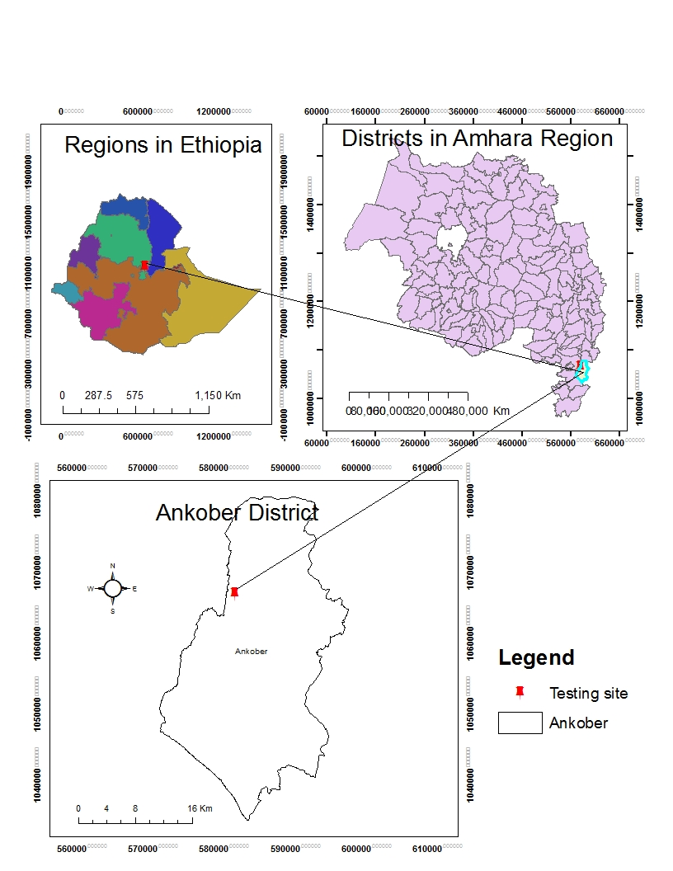

Figure 1: Map showing the relative location

of the Ankober testing site in Ankober district.

Even though its reliability is questionable, average of seven years, selected for having full rainfall data set, over the period of 1981-2011 at Ankober showed that *Belg* and *Meher* seasons’ rainfalls were 37.4 and 59.2%, respectively, of the annual rainfall of 1744.7 mm (Unpublished data of National Meteorology Agency of Ethiopia in Table 1). The total amount of rainfall for each season is not a problem; it is the distribution that critically limits productivity, particularly in *Belg* season (Table 1). The soils of Ankober at the testing site are well drained Eutric Cambisols, moderately acidic and medium to high fertility in total N, available P and total organic carbon (Table 2).

Table 1: Rainfall data of selected years having full data set over the period of 1981-2011 at Ankober

|  |  |  |  |  |  |  |  |  |
| --- | --- | --- | --- | --- | --- | --- | --- | --- |
| **Months** | **Rainfall data (mm) of selected years** | | | | | | | **Monthly average** |
| **1981** | **1998** | **2001** | **2002** | **2004** | **2005** | **2006** |

|  |  |  |  |  |  |  |  |  |
| --- | --- | --- | --- | --- | --- | --- | --- | --- |
| January | 10.2 | 210.9 | 54.4 | 149.5 | 232.5 | 57.0 | 96.0 | **115.8** |
| February | 0.0 | 126.7 | 74.4 | 0.0 | 67.0 | 0.0 | 54.0 | **46.0** |
| March | 320.1 | 104.5 | 466.5 | 118.1 | 108.0 | 166.0 | 365.0 | **235.5** |

|  |  |  |  |  |  |  |  |  |
| --- | --- | --- | --- | --- | --- | --- | --- | --- |
| April | 83.2 | 70.8 | 101.3 | 62.6 | 530.0 | 163.0 | 214.0 | **175.0** |
| May | 50.9 | 107.3 | 57.8 | 55.5 | 5.0 | 272.5 | 12.5 | **80.2** |
| June | 1.3 | 45.6 | 267.9 | 52.5 | 134.8 | 71.0 | 78.0 | **93.0** |
| July | 182.5 | 297.7 | 406.5 | 237.8 | 479.5 | 413.0 | 297.0 | **330.6** |
| August | 196.0 | 394.6 | 111.6 | 370.1 | 563.6 | 614.0 | 392.0 | **377.4** |
| September | 123.0 | 128.4 | 35.8 | 168.6 | 195.6 | 264.0 | 171.0 | **155.2** |
| October | 61.2 | 185.5 | 13.1 | 0.0 | 159.0 | 0 | 118.0 | **76.7** |
| November | 0.0 | 3.5 | 21.3 | 0.0 | 20.6 | 16.0 | 0.0 | **8.8** |
| December | 1.3 | 0.0 | 30.4 | 126.1 | 47.9 | 0 | 148.0 | **50.5** |
| **Yearly total** | **1029.7** | **1675.5** | **1641.0** | **1340.8** | **2543.5** | **2036.5** | **1945.5** | **1744.7** |

Table 2: Selected properties and nutrient status of the testing site areas sampled to the depth of 0-20 cm at Ankober

|  |  |  |  |  |
| --- | --- | --- | --- | --- |
| **Properties & nutrient status** | **Values** | **Rating range** | **Rating** | **Analysis method** |
| pH | 5.99 | 5.6-6.0 | Moderately acidic | 1:2.5 soil to water ratio |
| Organic C (%) | 2.28 | 1.26-2.50 | Medium | Walkley-Black |
| Total N (%) | 0.27 | 0.226-0.300 | High | Kjeldahl |
| Available P (ppm) | 6.87 | 5-10 | Medium | Olsen |
| Texture |  | *Texture class* |  |  |
| Clay (%) | 33 | Clay loam |  | Aggregate dispersant and hydrometer |
| Silt (%) | 42 |  |
| Sand (%) | 25 |  |

***Note:*** *Each value was average of samples from 2 sites, each with composite of 5 core samples taken in zigzag sampling pattern.*

**Sources of rating:** Agriculture and Fisheries of the Nethelands 1989; Thiagalingam 2000

* 1. **Experimental Design, Treatments and Management Practices**

The experiment was conducted for two years at one location in a split plot of RCBD with four replications. Four precursor crops (lentil, potato,

malt barley, and field pea) were planted as main plots in *Belg* season with the application of recommended N-P fertilizers. After harvest, each plot of these crops was split into four sub plots for testing four N rates (0, 18, 36 and 54 Kg N ha-1) on malt barley in *Meher* season. Plot size for each of main and sub plot was 31.5 m2, and 6.3 m2, respectively. The width of separation alley between experimental plots and between replications was 0.5 and 1.0 m, respectively.

The selection of these four *Belg* season precursor crops, and the four N rates application on *Meher* season malt barley was based on previous experiences and emerging demands. As indicated in the bacKground section of this study, lentil, field pea and barley had been major crops being produced in *Belg* season in bimodal rainfall highlands of Ethiopia. However, failures of these crops have been common phenomena due to the prevailing climate change. On the other hand, the recently appearing production of potato in *Belg* season has not yet been expanded regardless of observed cases by some innovative farmers. The increasing demand of breweries for expanding malt barley production in *Belg* and *Meher* seasons also received the attention of this study. The basis to select the four (0, 18, 36, 54 Kg N ha-1) N fertilizer rates to test on *Meher* season malt barley is the malt barley grain N content requirement by breweries, and expected N inputs from the test legume precursor crops (lentil and field pea) in the *Belg* season. Some details about the crop types and varieties, and management practices of experimental plots in *Belg* and *Meher* season are presented in Table 3.

Table 3: Some details of experimental management practices

|  |  |  |  |  |  |
| --- | --- | --- | --- | --- | --- |
| **Management practices for crops planted in *Belg* season** | | | | | |
| **Crops** | **Variety** | **Planting time in 2012** | **Planting time in 2013** | **Recommended seed rate (Kg ha-1)** | **Applied fertilizer rate (N-P Kg ha-1)** |
| Lentil | Local | April | February | 80 | 18-20 |
| Field pea | Local | April | February | 150 | 18-20 |
| Potato | Gorebiella | April | February | 1800-2000 | 124-30 |
| Malt barley | Holker | April | February | 125 | 41-20 |
| Management practices for the test crop planted in *Meher* season after the harvest of *Belg* season crops | | | | | |
| Malt barley | Holker | Late August | 11 July | 125 | 0-0, 18-20, 36-20, 54-20 |

***Note:*** *All seed and fertilizer rate recommendations are for Meher season production since no recommendation for Belg season. Seed rate of potato in terms of weight depends on tuber size and moisture content. Therefore, to avoid this variation planting was done by planting one tuber per hill with the inter tuber spacing of 30 cm and inter-row spacing of 75cm. Planting time in Belg season was based on the onset of rainfall.*

In *Belg* season, two plowings, using oxen drawn local plow, were done before sowing while manual hoeing was done for seed covering at sowing. Sowing of precursor crops was done in April 2012 and in February 2013 depending on the amount and distribution of *Belg* season rainfall to support seed germination and seedling establishment. Sources of nitrogen and phosphorus fertilizers were di-ammonium phosphate (DAP) and urea. All DAP fertilizer was broadcasted at sowing while urea was top-dressed at tillering stage for *Belg* season malt barley, and soon after full emergence during first earthening along ridges for potato. Weeds were controlled by twice manual hand weeding.

In *Meher* season, sowing of the test crop, malt barley, was done soon after the harvest of *Belg* season precursor crops in each year. Harvesting of *Belg* season precursor crops in 2012 was delayed to late August at which sowing of the test crop *Meher* season malt barley was done as

well. In 2013, sowing of the test crop was done in 11 July following the harvest of *Belg* season precursor crops of potato, field pea and lentil on 10 July. *Belg* season malt barley sown as precursor crop was late to mature and hence harvested in 20 August 2013 and the test crop

*Meher* season malt barley was sown to these plots on the same date. Only manual hoeing was done to cover seeds after sowing of *Meher* season malt barley on the stubble of each *Belg* season precursor. However, potato had no stubble; all stems and leaves were removed from each plot while harvesting tubers. Even though double cropping is a rare practice (Ziku et al 2014), farmers practicing double cropping usually sow the second crop directly on the stubble of the first crop and then plow under to cover seed to save time and meet suitable sowing soil condition in the face of the imminent high rainfall of *Meher* season. Similar to the *Belg* season, sources of nitrogen and phosphorus fertilizers were DAP and urea. All DAP was broadcasted at sowing while urea was applied at tillering stage of *Meher* season malt barley so as to match the requirements of plots that require more than 18 Kg N ha-1 amongthe treatments of the four N rates. DAP of 100 Kg contains 18-20 Kg N-P while 100 Kg urea contains 46-0 Kg N-P. Manual hand weeding was done twice to control weeds. Harvesting was done in February in 2012, and in November in 2013. However, establishment and growth of malt barley in *Meher* season following *Belg* season malt barley precursor was very poor due to late sowing and hence there was no harvest in 2013.

* 1. **Data Collection and Analysis**

Rainfall data measurements for the testing site were collected from the rain-gauge established

at the experimental site to have reliable data for the experimental period. Yield was estimated from the harvest of whole main plot of each precursor in *Belg* season, and whole sub plot of each of the four nitrogen fertilizer rate treatments applied on *Meher* season malt barley growing after the harvest of each *Belg* season precursor crop. All reported grain and straw yields were sun dried while potato tuber yield and field pea green pods were fresh weights. Unless complete damage occurred, yield loss due to hail damage on malt barley grain was estimated by counting intact and lost seeds per spike. *Meher* season malt barley grown after the harvest of *Belg* season malt barley in 2013 had no harvestable yield and hence was treated as missing for that specified year in analysis of variance. Analysis of variance was done by using R version 3.1.1 software (R Core Team 2014). Year, replication nested in year and precursor by replication interaction nested in year were treated as random terms while main and interaction effects of the four *Belg* season precursor crops and the four N rates applied on *Meher* season malt barley growing after the harvest of *Belg* season precursor crops were fixed in combined analysis of split plot in RCBD over years. A random term with zero variance components was eliminated from analysis whenever it was encountered. Stepwise regressions of N levels with grain and straw yields were done by using SAS software (SAS 2002). Probability level of 5% was used for entering and retaining each term.

1. **RESULTS AND DISCUSSIONS**
   1. ***Belg* Season**

Crop establishment of field pea and lentil was very poor due to low amount and uneven distribution of *Belg* season rainfall in 2012 (Table 4). After planting, there was no rain for two weeks in April, but received 56 mm rain in 29 April to 5 May, after which there was no rain till 23 June 2012. Moreover, maturity of lentil and field pea pods was uneven (extended up to late August 2012) due to extended growth caused by the inception of *Meher* season rainfall (Table 4). Matured pods at the bottom height shattered while those in the middle and at the top which constituted the largest proportion were green. Thus, there was no grain harvest for lentil and field pea as indicated in Table 5. Maturity for potato and malt barley also extended to late August 2012; however, these two crops established well and matured under such poor distribution of rainfall. Therefore, potato gave 18.75 t ha-1 marketable tubers yield; and malt barley gave grain yield of 15.71 t ha-1 after 35% estimated loss due to hail damage (Table 5).

Table 4: Weekly rainfall distribution and amount during *Belg* and *Meher* seasons of the trial period in 2012-2013 at Ankober

|  |  |  |  |  |  |
| --- | --- | --- | --- | --- | --- |
| **Weeks at seven days interval in *Belg* season** | **Rainfall amount (mm) in each year** | | **Weeks at seven days interval in *Meher* season** | **Rainfall amount (mm) in each year** | |
| **2012** | **2013** | **2012** | **2013** |
| 1-7 January | 0.0 | 14.6 | 3-9 June | 0.0 | 0.0 |
| 8-14 January | 0.0 | 0.0 | 10-16 June | 0.0 | 16.4 |
| 15-21 January | 0.0 | 0.0 | 17-23 June | 0.0 | 0.0 |
| 22-28 January | 0.0 | 0.0 | 24-30 June | 12.0 | 0.0 |
| 29 Jan-4 Feb | 0.0 | 6.1 | 1-7 July | 45.0 | 23.2 |
| 5-11 Feb | 0.0 | 4.2 | 8-14 July | 96.6 | 114.0 |
| 12-18 Feb | 0.0 | 0.0 | 15-21 July | 64.0 | 111.4 |
| 19-25 Feb | 0.0 | 0.0 | 22-28 July | 48.7 | 81.0 |
| 26 Feb-3 Mar | 0.0 | 0.0 | 29 July-4 August | 56.3 | 37.5 |
| 4-10 Mar | 0.0 | 0.0 | 5-11 August | 112.3 | 55.4 |
| 11-17 Mar | 0.0 | 0.0 | 12-18 August | 36.8 | 76.7 |
| 18-24 Mar | 20.0 | 20.0 | 19-25 August | 32.3 | 88.7 |
| 25-31 Mar | 0.0 | 0.0 | 26 August-1September | 80.2 | 16.0 |
| 1-7 April | 0.0 | 16.2 | 2-8 September | 44.6 | 59.4 |
| 8-14 April | 0.0 | 0.0 | 9-15 September | 0.0 | 10.0 |
| 15-21 April | 40.0 | 11.2 | 16-22 September | 44.0 | 12.0 |
| 22-28 April | 0.0 | 38.2 | 23-29 September | 0.0 | 8.4 |
| 29 April-5 May | 56.0 | 20.4 | 30 September-6 October | 0.0 | 32.8 |
| 6-12 May | 0 | 44.2 | 7-13 October | 0.0 | 52.4 |
| 13-19 May | 0 | 0.0 | 14-20 October | 4.2 | 0.0 |
| 20-26 May | 0 | 20.0 | 21-27 October | 0.0 | 0.0 |
| 27 May-2 June | 0 | 0.0 | 28 October-3 November | 0.0 | 0.0 |
| ***Belg* season total** | **116.0** | **202.1** | ***Meher* season total** | **677.0** | **795.3** |
| ***Annual rainfall in 2012 was 809.2 mm*** | | | | | |
| ***Annual rainfall in 2013 was 997.4 mm*** | | | | | |

In 2013 *Belg* season, field pea and lentil established better and produced yield (Table 5) since the rainfall amount and distribution was better than that of 2012 (Table 4). However, seed yield of lentil was still lower (about 1 t ha-1) while yield of field pea was in green pods (8.10 t ha-1) as indicated in Table 5. Green pods could be good source of income for smallholder farmers for there are demands from the urban population. The major problem is frequent crop failures due to uneven distribution and low amount of *Belg* season rainfall. Malt barley had similar problem of poor establishment in the face of uneven distribution and low amount of rainfall in *Belg* season. Unless it is sown in January to February, malt barley growth period extends up to late July to late August, which exposes it to hail damage. Not only hail damage but also absence of dry spells to harvest and thresh matured grain of malt barley is also a big problem and spoils grain quality. This suggests that *Belg* season in the highlands of Ankober and similar areas in Ethiopia are not suitable for malt barley production that meets malt quality standards.

Table 5: Productivity of precursor crops in *Belg* season in each year; averaged over four replications

|  |  |  |  |  |
| --- | --- | --- | --- | --- |
| **Precursors** | **Grain/tuber/pod yield (t ha-1) in each year** | | **Straw yield (t ha-1) in each year** | |
| **2012** | **2013** | **2012** | **2013** |
| Lentil | 0 | 1.04 | 1.33 | 1.43 |
| Potato | 18.75 | 27.08 | 0 | 0 |
| Malt barley | 1.57* | Damaged by hail storm | 2.06 | 1.25 |
| Field pea | 0 | 8.10# | 0.16 | 3.89 |

*\*There was 35% seed loss caused by hail storm; #yield from field pea was well filled green pod harvest.*

***Note:*** *Statistical comparison of precursor crops within Belg season across years was not possible because of total failure of lentil and field pea in 2012; and hail damage on malt barley in 2013.*

* 1. ***Meher* Season**

Combined analyses of the effects of precursor crops and nitrogen fertilizer effects on grain and straw yield of the test crop, *Meher* season malt barley, showed that only main effects had significant (p<0.05) difference. Potato precursor in *Belg* season gave the highest grain (about 2.52 t ha-1) and straw (about 4.26 t ha-1) yield of malt barley in *Meher* season, which was statistically significant (p<0.05) in most cases (Table 6). A five years’ rotation experiment conducted in Iran also reported that potato precursor crop gave higher grain and biomass yield of wheat than those of sugar beet, maize and wheat precursors (Feizabadi and Koocheki 2012). Malt barley productivity in *Belg* season potato double cropping with *Meher* season malt barley may also be improved by replacing the late maturing variety, Holker, with the recently released early maturing malt barley variety, IBON-174/03 (MoANR 2016). The unpublished data of the author in 2015-2016 also indicated that IBON-174/03 headed 14 days earlier than the late maturing Holker variety that gave 5.3% higher grain yield.

Malt barley in *Meher* season following malt barley precursor in *Belg* season gave the lowest yield; about 1.12 t ha-1 grain and 2.17 t ha-1 straw yields. The performance of lentil precursor in *Belg* season on productivity of malt barley in *Meher* season was not significantly different from that of malt barley precursor (Table 6). Poor establishment of lentil as precursor crop in *Belg* season also contributed to low productivity of the test crop in *Meher* season; otherwise, lentil has been known to be one of the best legume precursor crops for cereal crops production (Shafi et al 2010; Sinclair and Vadez 2012; Singh et al 2009). Contrast comparisons in Table 7 showed that all N levels significantly (p<0.05) differed, except pair-wise comparison of unfertilized control versus application of 18 Kg N ha-1 for straw yield, in their contribution to malt barley productivity. Yield of the test crop increased with increasing nitrogen fertilizer levels (Figure 2) that unfertilized control and the highest N level (54 Kg ha-1) gave the respective lowest and highest grain yield of about 1.38 and 2.12 t ha-1; and straw yield of about 2.87 and 3.84 t ha-1.

Table 6: Contrast comparisons of main effects of precursors on yield of malt barley in *Meher* season; averaged over two years, four replications and four N levels

|  |  |  |  |  |
| --- | --- | --- | --- | --- |
| **Precursors** | **Grain yield (Kg ha-1) of malt barley in *Meher* season** | | **Straw yield of malt barley (Kg ha-1) in *Meher* season** | |
| Lentil | 1360.34 | | 3196.00 | |
| Potato | 2515.97 | | 4257.63 | |
| Malt barley | 1123.03 | | 2170.05 | |
| Field pea | 2022.34 | | 3585.44 | |
| **Contrasts of precursors’ effects** | **Grain yield difference** | **p value** | **Straw yield difference** | **p value** |
| Lentil-Potato | -1155.6 | <0.0001 | -1061.63 | 0.0043 |
| Lentil-Malt barley | 237.3 | 0.3909 | 1025.95 | 0.0252 |
| Lentil-Field pea | -662.0 | 0.0044 | -389.44 | 0.2442 |
| Potato-Malt barley | 1392.9 | <0.0001 | 2087.58 | 0.0001 |
| Potato-Field pea | 493.6 | 0.0274 | 672.19 | 0.0527 |
| Malt barley-Field pea | -899.3 | 0.0030 | -1415.39 | 0.0035 |
| Grain yield: SE = 271.42; DF = 23.09 for comparisons with malt barley means | | | | |
| Grain yield: SE = 209.57; DF = 23.0 for comparisons of means other than malt barley means | | | | |
| Straw yield: SE = 418.09; DF = 17.08 for comparisons with malt barley means | | | | |
| Straw yield: SE = 322.85; DF = 17.01 for comparisons of means other than malt barley means | | | | |

Unpublished research results of the author in 2010 to 2012 showed that even application of 120 Kg N ha-1 N for malt barley production in the highlands of North Shewa in most cases met grain protein content standards for the simple reason that high grain yield increment due to the application of nitrogen fertilizer had dilution effect on grain protein content per se. Therefore, application of 54 Kg N ha-1 is believed to meet protein content standards of malt barley as Ankober was the test location represented by six sites in previous fertilizer rate determination study in 2010 to 2012. Reported results of elsewhere also show that application of 100 Kg N ha-1 increased grain yield by 25% as compared to 8% increment in grain protein content of spring wheat, the respective absolute grain yield and grain protein content being 3.4 t ha-1 and 10.57% for unfertilized control on loamy sand soil after potato precursor (Jermuss and Vigovskis 2008). Nitrogen fertilizer rates of 21, 41 and 62 Kg N ha-1 tested on four malt barley varieties (Beka, Holker, HB-52, and HB-120) in an on-farm experiment at Ankober in 2004 also showed no significant difference in malt quality parameters of germination after 72 hours, grain protein content and sieve test for plumpness; all met standard requirements (Muhe 2011).

Stepwise regression on applied N fertilizer rates with grain yield of *Meher* season malt barley grown after the harvest of *Belg* season potato and field pea showed significantly linear response while it was non-linear on *Meher* season malt barley grown in 2013 after the harvest of *Belg* season lentil precursor (Figure 3). The establishment and performance of field pea precursor in *Belg* season was by far better in 2013 *Belg* season than in 2012 and therefore became best followed by *Belg* season potato precursor in contributing towards better productivity of *Meher* season malt barley. Previous researches also established that field pea is one of the best precursor crops for malt barley and/or barley in the highlands of Ethiopia (Abera et al 2011; Agegnehu et al 2014).

Table 7: Contrast comparisons of main effects of nitrogen fertilizer levels on yield of *Meher* season malt barley; averaged over two years, four precursor crops and four replications

|  |  |  |  |  |
| --- | --- | --- | --- | --- |
| **N fertilizer rates**  **(Kg ha-1)** | **Grain yield (Kg ha-1) of malt barley in *Meher* season** | | **Straw yield of malt barley (Kg ha-1) in *Meher* season** | |
| 0 | 1381.60 | | 2872.62 | |
| 18 | 1630.63 | | 3093.87 | |
| 36 | 1893.23 | | 3402.31 | |
| 54 | 2116.23 | | 3840.31 | |
| **Contrasts of nitrogen fertilizer rates’ effects** | **Grain yield difference** | **p value** | **Straw yield difference** | **p value** |
| N0-N18 | -249.03 | 0.0019 | -221.25 | 0.0857 |
| N0-N36 | -511.63 | <0.0001 | -529.69 | 0.0001 |
| N0-N54 | -734.63 | <0.0001 | -967.69 | <0.0001 |
| N18-N36 | -262.59 | 0.0011 | -308.44 | 0.0176 |
| N18-N54 | -485.59 | <0.0001 | -746.44 | <0.0001 |
| N36-N54 | -223.00 | 0.0051 | -438.00 | 0.0009 |
|  | SE = 77.13; DF = 72 | | SE = 126.98; DF = 72 | |

To summarize, double cropping of potato in *Belg* season (giving 18.75 to 27.08 t ha-1 marketable tuber yield in two years) and malt barley in *Meher* season was feasible in terms of productivity and obtaining dry spells during maturity for having quality harvest. The productivity of potato variety Gorebella in this study during *Belg* season is more than its marketable yield ranging from 10.14-21.41 t ha-1 reported during the study conducted in 1999-2003 over seven locations in *Meher* season for which it was released (Asredie et al 2007). The recent large-scale promotion of potato-malt barley double cropping results of this study demonstrated that production of potato in *Belg* season followed by *Meher* season malt barley could give a net economic benefit of US$ 9000 per hectare (US$ 8150 from potato and US$ 850 from malt barley) (Kemal 2016). This relatively high level of productivity and economic benefit per unit of land per year through double cropping system is impossible to achieve with one harvest per year through the old traditional production of malt barley in *Meher* season. Therefore, the results of this experiment could be expected to bring about behavioral changes in terms of decisions to use such improved technologies and engage in double cropping by selecting the right crop combinations according to the prevailing environments and management practices. This shall evolve to enabling farmers increase productivity and income per unit area per year. These gains would translate into improving food security.

Just to mention one gap of this study is the use of relatively late maturing potato and malt barley varieties which resulted in low yield although this combination is by far productive than lentil-malt barley, field pea-malt barley and malt barley-malt barley combinations in the double cropping system on the same unit of land per year. Therefore, there is high opportunity of improving productivity of potato-malt barley double cropping system by using early maturing varieties of both crops.

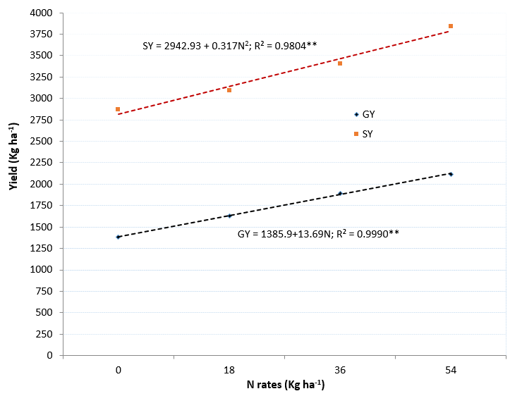

Figure 2: Yield response of malt barley to applied nitrogen fertilizer rates in *Meher* season; averaged over two years, four replications and three precursor crops. *\*\*Significant at <0.01 probability level; GY: grain yield; SY: straw yield*

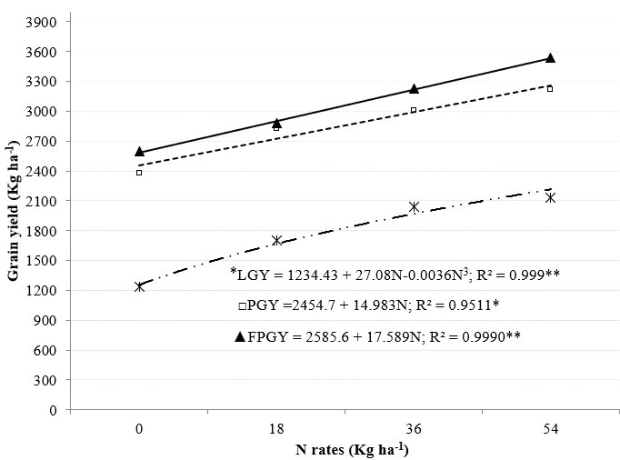

Figure 3: Response of malt barley grain yield to N fertilizer levels and precursor crops in Meher season of 2013. *LGY: grain yield of malt barley following lentil precursor; PGY: grain yield of malt barley following potato precursor; FPGY: grain yield of malt barley following field pea precursor*

1. **CONCLUSIONS AND RECOMMENDATIONS**

In conclusion the test location results of this experiment showed that malt barley based cropping system intensification through double cropping in similar bimodal rainfall highlands of Ethiopia to improve productivity and food security is possible so long as appropriate crop combinations are selected. Potato production in *Belg* season well fits with malt barley production in *Meher* season in order to improve production and food security through double cropping in the bimodal rainfall highlands of Ethiopia under the prevailing climate change. Using early maturing varieties of potato and malt barley than the tested ones in this study may also improve the possible best-fit combination and further improve productivity. Therefore, promotion and scaling up/out of potato-malt barley double cropping is suggested to be a priority future work in the recommendation areas.

Increasing yield of *Meher* season malt barley with increasing N rates implies that further intensification is possible to improve productivity and food security so long as malt barley grain quality is not compromised. Therefore, further study on higher rates of nitrogen for malt barley in the potato-malt barley double cropping system is suggested in the

recommendation areas to enhance productivity without compromising malt barley grain quality. Failure of tested malt barley production in *Belg* season implies that malt barley production twice a year (*Belg* malt barley followed by *Meher* malt barley) in the double cropping system is not feasible. The results of this study are also expected to bring about behavioral changes in terms of decisions to use such improved technologies and engage in double cropping by selecting the right crop combinations according to the prevailing environments and management practices. This shall evolve to enabling farmers at large increase productivity and income per unit area per year. These gains would translate into improving food security.

**ACKNOWLEDGEMENTS**

This research was supported financially by Public-Private Partnership Project for “Strengthening Malt Barley Research and Technology Transfer: A Support Project”. Debre Birhan Agricultural Research Center provided logistical support. Able (fieldwork) and Mr. Getachew Hailu who collect data is also highly acknowledged.

**REFERENCES**

Abera T, Molla A, Feyissa A, Liben M, Woyema A, Admassu L and Bekele A (2011). Research achievements in barley cultural practices in Ethiopia. Proceedings of the 2nd National Barley Research and Development Review Workshop. 28-30 November 2006, Holetta, Ethiopia. ICARDA, PO Box 5466, Aleppo, Syria; p.

113-126.

Abraham B, Araya H, Berhe T, Edwards S,

Gujja B, Khadka R B, Koma Y S, Sen D, Sharif A, Styger E, Uphoff N and Verma A (2014). The system of crop intensification: Reports from the field on improving agricultural production, food security, and

resilience to climate change for multiple crops.

*Agriculture & Food Security*, 3:4.

<http://www.agricultureandfoodsecurity.com/content/3/1/4>

Agegnehu G, Lakew B and Nelson P N

(2014). Cropping sequence and nitrogen fertilizer effects on the productivity and quality of malting barley and soil fertility in the Ethiopian highlands. *Archives of Agronomy and Soil Science*, 60(9): 1261-1275.

Agriculture and Fisheries of the Nethelands (1989). Agricultural compendium for rural development in the tropics and sub-tropics. Third edition. Elsevier Science Publishers, Amsterdam, The Netherlands.

Asredie S, Aliyi A and Yohannes A (2007). Review of potato and sweet potato research achievements in North Shewa. First annual regional conference proceedings on completed crop research activities, 14 to 17 August 2006, Bahir Dar. Amhara Region Agricultural Research Institute, Bahir Dar, Ethiopia; p. 191-205.

Bewket W (2009). Rainfall variability and crop production in Ethiopia: Case study in the Amhara Region. Proceedings of the 16th International Conference of Ethiopian Studies. Trondheim; p. 823-836

CSA (Central Statistical Agency) (2011a). Agriculture sample survey report on area and production of Meher season major crops for private peasant holdings. Volume I. CSA, Addis Ababa, Ethiopia*.*

CSA (2011b). Agriculture sample survey report on area and production of Belg season crops for private peasant holdings. Volume V, statistical bulletin no. 505. CSA, Addis Abeba, Ethiopia.

Cochrane L (2014). Agricultural intensification in Ethiopia: Review of recent research. *Afr. J. Agric. Res.* 9(31): 2377-2390. DOI: 10.5897/AJAR2014.8732

Dybro N and Hansen A C (2018). Sustainable intensification of global agronomic output. *Journal of Agricultural Science*,10(3): 30-41.doi:10.5539/jas.v10n3p30.

El-Beltagy A and Madkour M (2012). Impact of climate change on arid lands agriculture. *Agriculture & Food Security*, 1:3. <http://www.agricultureandfoodsecurity.com/content/1/1/3>

Feizabadi A Z and Koocheki A (2012). Effects of different crop rotations on yield and yield components of wheat in cold regions of Iran. *International Journal of Agriculture and Crop Sciences*,4(10): 616-621.

Jermuss A and Vigovskis J (2008). Nitrogen management effects on spring wheat yield and protein. *Latvian Journal of Agronomy*, 11: 224-229.

Kemal S A (2016). Final report: Narrowing the yield gaps of barley-faba bean based cropping systems through knowledge-based pest management practices for improved food systems of smallholder farmers in the highlands of Ethiopia. <http://www.repo.mel.cgiar.org/handle/20.500.11766/6542>

Legese G, Debebe S and Alemu T (2007). Assessing the uncompanative advantage of malt barley production in Ethiopia: Application of a policy analysis matrix. African Crop Science Conference Proceedings, Vol. 8, 27-31 October 2007. El-Minia, Egypt; P. 1227-1230

Mekonnen B (2013). The malt effect: How the growing beer industry creates opportunities for barley farmers. <http://eco-opia.org/2013/11/22/the-malt-effect-how-the-growing-beer-industry-creates-opportunities-for-barley-farmers/>

Ministry of Agriculture and Natural Resource, MoANR (2016). Crop variety register issue no. 18. MoNR, Addis Ababa, Ethiopia.

Muhe K (2011). Opportunities and challenges in malt barley research and production in North Shewa of the Amhara Region. Proceedings of the 2nd National Barley Research and Development Review Workshop, 28-30 November 2006. Holetta, Ethiopia. ICARDA, Aleppo, Syria; p.73-76

Pereira P A A, Jr G B M, Santana C A M and Alves E (2012). The development of Brazilian agriculture: future technological challenges and opportunities. *Agriculture & Food Security*, 1:4. <http://www.agricultureandfoodsecurity.com/content/1/1/4>

Population Census Commission (2008). Summary and Statistical report of the 2007 population and

housing census. Population Census Commission, Addis Ababa, Ethiopia.

R Core Team (2014). R: A language and environment for statistical computing. R Foundation for Statistical Computing, Vienna, Austria. URL <http://www.R-project.org/>

Ringheim K, Teller C and Sines E (2009). Ethiopia at a crossroads: Demography, gender, and development. Population

Reference Bureau (PRB), Washington, USA.

SAS (2002). SAS software, version 9.00, SAS Institute Inc., Cary, NC, USA.

Sasson A (2012). Food security for Africa: an urgent global challenge. *Agriculture & Food*

*Security,* 1:2. <http://www.agricultureandfoodsecurity.com/content/1/1/2>

Shafi M, Bakht J, Attaullah J and Khan M A (2010). Effect of crop sequence and crop residues on soil c, soil n and yield of maize. *Pakistan Journal of Botany*, 42(3): 1651-1664.

Singh K K, Ali M and Venkatesh M S (2009). Pulses in Cropping Systems. Technical Bulletin, IIPR, Kanpur; pp 39.

Sinclair T R and Vadez V (2012). The future

of grain legumes in cropping systems. *Crop and Pasture*

*Science*, 63: 501–512.

Tanner DG, Yilma Z, Zewdie L and Gebru G (1994). Potential for cereal-based double cropping in Bale Region of southeastern Ethiopia. *African Crop Science Journal*, 2(2): 135-143.

Thiagalingam K (2000). Soil and plant sample collection, preparation and interpretation of chemical analysis: A training manual and guide. AusAID, Adelaide, Australia.

USAID (2012). Famine Early Warning Systems Network: A Climate Trend Analysis of Ethiopia. [http://www.usaid.gov/sites/default/files/documents/1860/**A**%20Climate%20Trend%20Analysis%20of%20Ethiopia.pdf](http://www.usaid.gov/sites/default/files/documents/1860/A%20Climate%20Trend%20Analysis%20of%20Ethiopia.pdf)

USAID (2000). USAID Collaborative Research Support Programs Team: Amhara National Regional State food security research assessment repor. <https://www.ctahr.hawaii.edu/sm-crsp/phase1/pdf/amhara.pdf>

Ziku N, Molla A and Tsegahun A (2014). Evaluation of Meher season fallow replacement options in the highlands of Ankober. **In:** Proceedings of the 6th and 7th Annual Regional Conference on Livestock Completed Livestock Research Activities, 25-27 January 2012 and 22-24 January 2013 (eds. Zeleke Mekuriaw, Getnet Zeleke and Likawent Yeheyis). Amhara Region Agricultural Research Institute. Bahir Dar, Ethiopia; p. 159-171