|  |  |
| --- | --- |
| ***BNJAR*** | **Blue Nile Journal of Agricultural Research (BNJAR)**  Vol. 2, Issue. 2, December, 2021, pp. 24-33  Journal homepage: https://www.arari.gov.et/index_bnjar.php |

|  |  |  |  |
| --- | --- | --- | --- |
| **Participatory evaluation of hedgerow leguminous shrub effect on soil loss reduction and alley maize yield in Koshire sub-watershed, Demba Goffa District, Southern Ethiopia** | | |  |
| Desta Hamore1*, Degefu Asfaw1 and Redat Aysa1  1*Arba Minch Agricultural Research Center, South Agricultural Research Institute  Corresponding author email: [destahm3799@gmail.com](mailto:destahm3799@gmail.com) | | | |
| Copyright: ©2024 The author(s). This article is published by BNJAR and is licensed under the CC BY 4.0 license (http://creativecommons.org/licenses/by/4.0/). | | | |
|  |  | **ABSTRACT** | |
|  |  |  | |
| **Received:** August 16, 2021  **Revised:** November 23, 2021  **Accepted:** December 9, 2021  **Available online:** December 27, 2021 |  | *The livelihood of humankind is closely related to the soil resources. Soil erosion is a worldwide environmental problem that reduces the productivity of all natural ecosystems and agriculture. Soil erosion by water is the greatest factor limiting agricultural productivity in humid tropical regions. Several methods exist for controlling soil erosion. The trees in the hedges act as vegetative barriers along the contour of a slope and maintain the organic matter through leaf fall and root residues, while the area between the hedges is used for agricultural production. Koshire sub-watershed is one of the watersheds found in the Demba Goffa district which face a higher runoff problem during rainy season. This study was initiated to evaluate the potential of leguminous shrub hedgerow on reduction of soil loss by runoff and its impact on yield of alley maize. The study was conducted from 2019 to 2020 using three leguminous shrub species (Leucaena leucocephala, Cajanus cajan and Sesbania susban) and one sole maize in hedgerow agroforestry practice using four farmers as replication. Collected data were subjected to ANOVA to analyze variations of parameters among the treatments. LSD tests were used to identify mean differences at 5 % level of significance. The yield of the maize grain yield and yield components did not show a significant variation, but the soil loss was significantly (P≤ 0.05) varied between treatments. The present study concluded that woody shrubs with a fast growth rate work better than those having lower growth rate. Thus, Cajanus cajan can be used with alley maize in hedgerow agroforestry practice to control soil erosion in short time to attain consistent and better erosion control measure. Since the present study was conducted only for two years, further research is ought to be conducted for prolonged time to evaluate their effect on soil loss.* | |
| ***Keywords:*** *Agroforestry, Soil erosion, Runoff, Soil conservation, Vegetative hedgerow* |  |

1. **INTRODUCTION**

The livelihood of humankind is closely related to the soil resources. Soil provides food, clean water, and air which is a major carrier of biodiversity (Katsuyuki 2009; Keesstra et al 2016). Soil erosion is a worldwide environmental problem that reduces the productivity of all natural ecosystems and agriculture, which threatens the lives of most smallholder farmers (Gessesse et al 2015; Ochoa-Cueva et al 2015; Taguas et al 2015; Prosdocimi et al 2016). Soil erosion by water is the greatest factor limiting agricultural productivity in the humid tropical regions (Sunday et al 2012). Several methods exist for controlling soil erosion by water. Most soil conservation efforts have focused on the use of contour plowing, residue lines (windows), rows of stones, terraces, mulching, and cutoff drains, all aimed at reducing the slope and increasing the infiltration of rainwater. Farmers, however, may adopt soil conservation measures that provide benefits in addition to erosion control, such as the use of tree and shrub hedgerows on contours for fodder production (Nair 1984; Ohlsson and Shepherd 1992).

The trees in hedgerows act as vegetative barriers along the contour of a slope and maintain soil organic matter through leaf fall and root residues, while the area between hedges is used for agricultural production (McDonald 1997). Carefu selection and introduction of trees to farmland is useful in mitigating pest damage that heterogeneity in species composition is desirable in regulating pest populations (Pimentel 1961). Tree introduction to farmland also increases the soil moisture content, and the variation in soil moisture content leads to changes in the structure and function of the ecosystems. These changes could favor few species to establish and also could become responsible for the removal of some species (Sheil 1999). It is also a low-input technology, which contribute to the enhancement of food production while ensuring sustainability (Garrity 2012). Agroforestry is a sustainable land management option because of its ecological, economic, and social attributes and improves food security through increased income from tree products and enhanced crop production (Coulibaly et al 2017), it may also reduce it by lowering crop yields (Ndoli et al 2017) under trees due to competition for resources shared between trees and crops, but the reduction in crop yield is compensated by tree products (Kho 2000).

Hedgerows lead to progressive development of terraces through accumulation of soil upslope of the hedge and stabilization of terrace banks by stems and roots (Young and Sinclair 1997). Such systems provide sustainable alternatives for areas where the human population density is increasing rapidly; reaching the point where large-scale land management is no longer possible and marginal lands are coming under cultivation (Gessesse et al 2015). Akinnifesi et al (2005a) indicated that crop plants growing in the agroforestry plots had significantly higher growth and yield than those in purely arable crop plots. Farmers in the mid-altitudes of SNNPRs carry out farming on originally rich soils that are now degrading because of high land pressure, erosion and lack of good soil management practices to maintain its fertility. The Koshire sub-watershed is one of the watersheds found in Demba Goffa district, which faces a higher runoff problem during the rainy season and causes washing of agricultural land and the accumulation of silt in irrigation schemes. Therefore, this problem needs solution to alleviate runoff and irrigation scheme sustainability. This study was initiated to evaluate the potential of leguminous shrub hedgerow on reduction of soil loss by runoff and its impact on yield of alley maize in Demba Goffa district, southern Ethiopia.

1. **MATERIALS AND METHODS**
   1. **Description of the Study Areas**

The study was carried out at the Koshire sub-watershed of Denba Gofa woreda, which is located in the Goffa zone. It is found 435 km south of Addis Ababa and 168 km west of Arba Minch. The watershed is located (37°0′30″–37°5′30″ E and 6°25′0″– 6°28′30″ N) with an altitude range of 982 to 2654 m above sea level. The upper stream of the watershed is very steeply sloped (above 45%), serving as the main source of water that feeds the downstream Koshire irrigation scheme. The total area of the watershed is 2172.6 hectares. The area is characterized by irregularities and insufficiency of rainfall. Meteorological records reveal that rainfall pattern in Demba Goffa is bimodal with mean annual rainfall ranges between 1000 mm - 1500 mm, whereas the average temperature is 25oc, varying between 20oC – 30oC. The soil of the study site is characterized by a clay texture and a gentle slope.

Table 1: Monthly temperature, rainfall, and relative humidity of the Koshere sub-watershed, Dembagofa Woreda, southern Ethiopia during the study seasons (2019-2020)

|  |  |  |  |  |  |  |  |  |
| --- | --- | --- | --- | --- | --- | --- | --- | --- |
| Month | 2019 | | | | 2020 | | | |
| Max T (oC) | Min T (oC) | Rainfall (mm) | RH (%) | Max T (oC) | Min T (oC) | Rainfall (mm) | RH (%) |
| January | 35.19 | 11.15 | 58.01 | 31.56 | 29.68 | 12.58 | 0 | 68.56 |
| February | 35.99 | 16.19 | 89.65 | 40.12 | 32.4 | 15.53 | 21.09 | 64.06 |
| March | 36.51 | 18.05 | 131.84 | 51.88 | 33.19 | 15.69 | 89.65 | 71.31 |
| April | 31.62 | 17.07 | 437.7 | 74.44 | 31.53 | 16.48 | 258.4 | 76.81 |
| May | 28.22 | 15.91 | 321.68 | 80.69 | 26.11 | 16.9 | 179.3 | 84.88 |
| June | 25.83 | 15.92 | 131.84 | 85.81 | 25.62 | 15.03 | 110.74 | 86.44 |
| July | 26.21 | 14.75 | 116.02 | 81.75 | 24.84 | 14.02 | 116.02 | 84.81 |
| August | 25.44 | 14.18 | 152.93 | 78.62 | 25.11 | 14 | 126.56 | 84.44 |
| September | 27.28 | 13.89 | 221.48 | 76.25 | 25.83 | 14.83 | 158.2 | 80.12 |
| October | 26.18 | 14.84 | 105.47 | 79.44 | 25.98 | 13.78 | 300.59 | 77 |
| November | 26.09 | 13.99 | 110.74 | 79.19 | 26.35 | 12.14 | 184.57 | 70.25 |
| December | 26.44 | 12.71 | 237.3 | 75 | 30.37 | 11.21 | 79.1 | 57.81 |
| Mean | 29.250 | 14.888 | 176.222 | 69.563 | 28.084 | 14.349 | 135.352 | 75.541 |

*Source: National Meteorological Agency, Hawassa Branch (2021). Max T= maximum temperature, Min T= minimum temperature, RH= relative humidity*

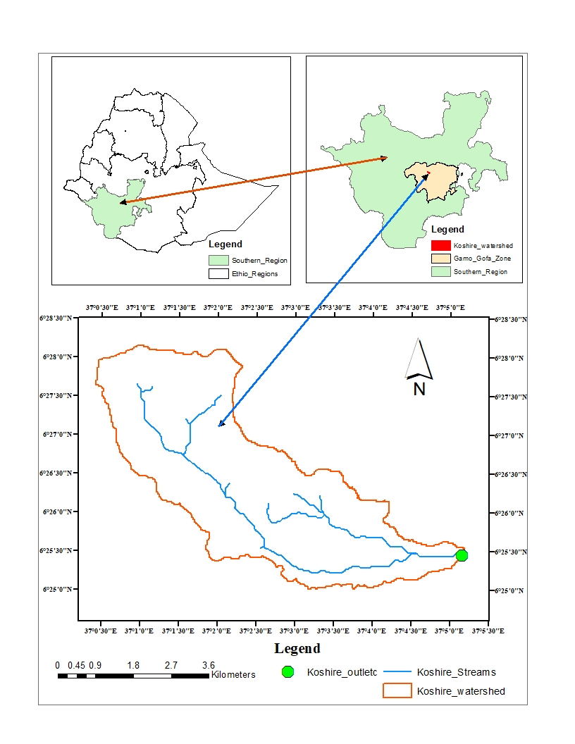

Figure 1. Location map of the study area

**Experimental Design and Field Layout**

The study was conducted from 2019 to 2020 using three leguminous shrub species (Leucaena leucocephala, Cajanus cajan and Sesbania susban) and sole maize plot as control in alley agroforestry practice. Four farmers were used as replications. The hedgerows were established using the direct sowing method with double rows of 15 cm spacing between shrubs 20 cm between shrub lines in a staggered manner. The length hedgerow and width of the alley was five meters. It was laid out with independent plots. Four farmers were used as replications. Recommended NPS and urea fertilizers were applied to the alley maize. Urea was used in split application, 50kg-1 at the beginning and 50kg-1 after 40 days (after 7 leaves per maize seedling occurred). The BH-540 maize variety was planted 0.75 m from the hedgerow in the alleys and a 75cm x 25 cm was kept between rows and plants were maintained, respectively. All recommended agronomic and shrub management practices were followed. Catch pits were installed 0.5 meters below hedgerow of legumes to trap soil loss for quantification. The length, depth and width of the catch pits were 5, 0.4 and 0.5 meters, respectively. The catch pits were covered by geomembranes and the soil trapped was weighed after sunlight dried.

**Data Collection and Analysis**

Data on fresh shrub biomass (SBW) was collected by cutting 0.75m above ground and weighing using spring balance. Maize biomass data was collected by weighing all above ground biomass of ten plants from central row of each plot. Maize grain yield data was also collected in ten plants from central rows of each plot. The soil loss data was collected by oven drying the soil sample collected from the catch pit at 105 0C for 24 hours in the laboratory. The data collected was subjected to analysis of variance (ANOVA) to analyze the variations of the parameters between treatments. LSD tests were used to identify mean differences at 5 % level of significance. All data analyses were done with GenStat software (version 16th).

1. **RESULTS AND DISCUSSION**
   1. **Influence of Hedgerows on Maize Yield**

In the present study, maize yield and yield parameters did not show significant variations (p <0.05) between treatments and cropping seasons when compared to the control plot (Table 1). However, a numerical grain yield reduction was observed between shrub species and cropping seasons. Thus, Cajanus cajan showed numerically lower grain yields (8% in the first cropping season and 10% in the second cropping season) than other treatments. It ranged from 5% to 7% and 0% to 5% in the case of Leucaena leucocephala and Sesbania susban in the first and second cropping seasons, respectively. The reduction in grain yield and yield component by shrub hedgerow could be due to the competition above and below the ground for sunlight and soil nutrients. Higher growth performance of Cajanus cajan adversely affected maize growth performance and grain yield compared to other treatments. On the other hand, the low biomass yield of Sesbania susban and Leucaena leucocephala could facilitate better sunlight penetration for maize plants than Cajanus cajan. This could lead to get better grain and biomass yield of maize.

Reduced growth and yield of annual crops due to intercepted photosynthetically active radiation (IPAR) has been reported by Sinclair and Muchow (1999) and Liu et al (2012). Competitive interactions for resources (water, light, and nutrients) between the tree component and crops in alley-cropping systems have been documented in a variety of practices (Cannell et al 12006; Akonde et al 2006; Tilander and Ong 2009). Plants require light, nutrients, and water for their growth and survival; trees, crops, and weeds have the same requirement in this regard. Tree-crop competition is often believed to be responsible for declining crop yields at the hedgerow-crop interface commonly observed in many alley-cropping trials (MacLean et al 2012). Studies on tree-crop competition in alley cropping have mostly focused on indirect competition through exploitation of shared resources (MacLean et al 2012). Many trials report low yields of crops grown adjacent to hedgerows that negate the benefits from yield increases in the center of the alleys (Kang and Shannon 2011).

* 1. **Influence of Hedgerows on Soil Loss**

The soil loss of different treatments from both cropping season (2019 to 2020) is given in Table 1. All shrub hedgerow treatments did not show significant differences (p ≤ 0.05) except Cajanus cajan in both cropping seasons. The difference between other treatments was not statistically significant compared with control plot. Therefore, the Cajanus cajan, Sesbania susban and Leucaena leucocephala hedgerows reduced soil loss by 67%, 8% and 3% in the first cropping season and 72%, 17% and 7% in the second cropping season, respectively, showing incredible effectiveness of the hedgerows in controlling soil loss (Table 1 and Figure 1). The mean soil loss during second cropping season was lower than first cropping season (Figure 2). Our experimental results showed that shrub hedgerow played an effective role on soil conservation. The reasons for the reduction of the high soil loss due to Cajanus cajan treatments could be greater vegetation coverage and root density.

The reduction difference between years might be due to the rainfall difference (Figure 2). This implies more runoff in the treatments with hedgerow was infiltrated into soil as reported by (Dunkerley et al 2001) and the hedgerow acted as permeable barriers for slowing down runoff (James et al 2008). Additionally, the above ground parts of hedgerow intercepted part of the sediment particles. A study in South-western Nigeria indicated that Leucaena hedgerows on a tropical alfisol were very effective and reduced water runoff in a maize crop to 3% and erosion to 0.10 t ha-1 (Lal 1989). Another five-year study in Philippines showed that contour hedgerows of Gliricidia and Paspalum conjugatum (GPas) reduced soil loss by 67% at the Compact site and by 77% at the Cabacungan site (Agus 1999). Another study conducted in China by Sun discussed the effect of alley cropping on controlling soil erosion (Xu et al 1999), Cai analyzed the mechanism of alley cropping controlling soil erosion and held that mechanical interception could be the main reason for reducing soil loss by alley cropping (Sun H. et al 1999). Also, this bio-terrace considerably reduced soil nutrient loss and increased organic matter, facilitating N, P, and other nutrients moving toward the root zone (Cai et al 1998). According to most of the studies conducted in southwestern China, alley cropping has been proven to have great potential in both economic and environmental advancement (Sun et al 1999a, 1999b; Zhang 2001; Zhu and Chen 2006).

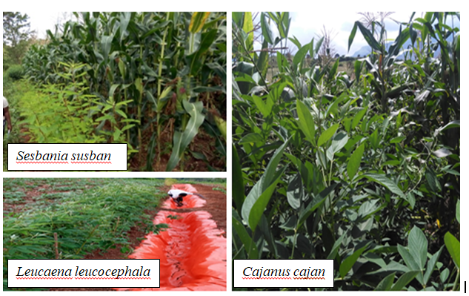

Figure 2. Trial photo in field

Table 1: Effect of the leguminous shrub hedgerow on alley maize yield and soil loss reduction at Koshire sub-watershed, Demba Goffa District, Southern Ethiopia

|  |  |  |  |  |  |  |  |  |  |  |  |  |  |  |
| --- | --- | --- | --- | --- | --- | --- | --- | --- | --- | --- | --- | --- | --- | --- |
| Treatment | First cropping season (2019) | | | | | | Second cropping season (2020) | | | | | | | |
| SBW  (t ha-1) | MPH  (cm) | GY  (t ha-1) | MBM  (t ha-1) | 100SW (g) | Soil loss (t ha-1) | | SBW  (t ha-1) | Ph  (cm) | GY  (t ha-1) | | BM (t ha-1) | 100SW  (g) | Soil loss (t ha-1) | |
| *Cajanus c*.*maize | 91.3a | 251.2 | 6.0 | 11.7 | 34 | 0.66 b | | 111.4a | 2.55 | 5.84 | | 8.42 | 42.87 | 0.53 b | |
| *Sesbania s*. *maize | 70.1b | 250.6 | 6.3 | 11.3 | 37.5 | 1.78a | | 84.8b | 2.65 | 6.14 | | 9.72 | 41.53 | 1.59a | |
| *Leucaena l*. *maize | 21c | 243.6 | 6.2 | 10.5 | 35.5 | 1.88a | | 37.3c | 2.59 | 6.04 | | 9.02 | 41.47 | 1.77a | |
| Sole maize | - | 246.6 | 6.5 | 11.5 | 34.5 | 1.94a | | - | 2.55 | 6.45 | | 9.45 | 44.59 | 1.91a | |
| LSD (5%) | 18.15 | NS | NS | NS | NS | 0.96 | | 22.6 | NS | NS | | NS | NS | 0.94 | |
| CV% | 20.38 | 3.4 | 9.9 | 10.5 | 3.56 | 17 | | 35.4 | 3.5 | 6.1 | | 9.1 | 5.1 | 39.8 | |
| *SBW= biomass of fresh shrub, MPH= maize plant height, GY= grain weight, MBM= maize biomass weight, SW= seed weight* | | | | | | | | | | |

1. **CONCLUSION AND RECOMMENDATIONS**

Soil erosion and runoff can be markedly reduced by hedgerows soon after hedgerow establishment. The present study concluded that soil loss due to runoff can be reduced by integrating the hedgerow of leguminous shrubs on agricultural lands. The bund formed by hedgerows can reduce the slope, and form natural terraces on sloping lands. Woody shrubs with fast growth rate work better than those having lower growth rate. Erosion reduction ability was related with the growth rate of shrubs in both cropping seasons. Maize crop was more suppressed by the treatment that showed fast and higher growth rate that why lower yield was recorded. Cajanus cajan can be used with alley maize in hedgerow agroforestry practice to control soil erosion in a short time to achieve a consistent and better erosion control measure. Since the present study was conducted only for two years, further research is ought to be conducted for prolonged time to evaluate their effect on soil loss.

**ACKNOWLEDGMENT**

The authors thank PASSIDP program and South Agricultural Research Institute for financial assistance and facilitation of the research work. Furthermore, we extend our gratitude to the experts from Docha Dembela kebele development agents for their commitment and inputs. Finally, our gratitude goes to field assistants of the natural resource research work process of the Arba Minch agricultural research center.

**REFERENCES**

Agus F, Garrity D P and Cassel D K (1999). Soil fertility in contour hedgerow systems on sloping oxisols in Mindanao, Philippines. Soil Tillage Res. 50, 159–167.

Akinnifesi F K, Makumba W I and Kwesiga F R (2005a). Fertilizer trees and Malawi’s new food security initiative. A policy briefing on the potential of fertilizer trees. World Agroforestry Centre (ICRAF), Lilongwe Malawi, 8 pp.

Akonde T P, Leihner D E and Steinmuller N (2006). Alley cropping on an Ultisol in subhumid Benin. Part 1: Longterm effect on maize, cassava and tree productivity. Agrofor Syst 34:1-12.

Cai Q G and Li S L (1998). Effect of Contour Hedgerows on Control of Soil Erosion. Journal of Soil Erosion and Soil and Water Conservation, 1998, 4(2): 55–60.

Cannell M G R, van Noordwijk M and Ong C K (2006). The central agroforestry hypothesis: The trees must acquire resources that the crop would not otherwise acquire. Agrofory Syst 34: 27-31.

Coulibaly J Y, Chiputwa B, Nakelse T and Kundhlande G (2017). Adoption of agroforestry and the impact on household food security among farmers in Malawi. Agricultural Systems, 155, 52–69.

Dunkerley D, Domelow P and Tooth D (2001). Frictional retardation of laminar flow by plant litter and surface stones on dry land surfaces: a laboratory study. Water Resour. Res. 37, 1417–1423.

Garrity D (2012). Agroforestry and the future of global land use. In P. K. R. Nair & D. Garrity (Eds.), Agroforestry - the future of global

land use (pp. 21–27). Dordrecht: Springer Netherlands.

Gessesse B, Bewket W and Bräuning (2015). A model-based characterization and monitoring of runoff and soil erosion in response to land use/land cover changes in the Modjo watershed, Ethiopia,Land Degrad. Dev., 26, 711–724.

James K M, Daniel N M, Louis V V and James B K (2008). Combining napier grass with leguminous shrubs in contour hedgerows controls soil erosion without competing with crops. Agroforest. Syst. 74, 37–49.

Kang B T and Shannon D A (2011). Agroforestry with focus on alley cropping. Sustaining Soil Fertility in West Africa. SSSA Special Publication No. 58. Soil Science Society of America and American Society of Agronomy, Madison, Wisconsin.

Katsuyuki M (2009). Culture, civilization, livelihood and health, Soil Sci. Plant Nutr., 55, 603–615.

Keesstra S, Pereira P, Novara A, Brevik E. C, Azorin- Molina C, Parras-Alcántara L, Jordán A and Cerdà A (2016). Effects of soil management techniques on soil water erosion in apricot orchards, Sci. Total Environ., 551, 357–366.

Kho R M (2000). On crop production and the balance of available resources. Agriculture Ecosystems & Environment, 80(1), 71–85

Lal R (1989). Agroforestry systems and soil surface management of a tropical alfisol: II: water runoff, soil erosion, and nutrient loss. Agroforest. Syst. 8,97–111.

Liu T, Liu S, Song F and Zhu X (2012). Light interception and radiation use efficiency response to narrow-wide row planting patterns Tropical and Subtropical Agro-ecosystems, 19 (2016): 227 – 236.

MacLean R H, Litsinger J A, Moody K and Watson A K (2012). The impact of alley cropping Gliricidia sepium and Cassia spectabilis on upland rice and maize production. Agrofor Syst 20:213-228.

Nair P K R (1984). Soil productivity aspects of agroforestry. Science and Practice of Agroforestry 1:63-73.

Ndoli A, Baudron F, Schut A G T, Mukuralinda A and Giller K E (2017). Disentangling the positive and negative effects of trees on maize performance in smallholdings of northern Rwanda. Field Crops Research, 213, 1–11. https://doi.org/10.1016/j.fcr.2017.07.020.

Ochoa-Cueva P, Fries A, Montesinos P, Rodríguez-Díaz J A and Boll J (2015). Spatial estimation of soil erosion risk by land-cover change in the Andes of Southern Ecuador, Land Degrad. Dev.,26, 565–573.

Ohlsson S E D and Shepherd K D (1992). Soil fertility management on small-scale farmers in western Kenya. Nairobi: International Center for Research in Agroforestry (I CRAF). Agroforestry Research Networks for Africa (AFRENA) Report No. 58.

Pimentel D (1961). Some species diversity and insect population outbreaks. Ann. Entomol. Soc. Am. 54, 76—86.

Prosdocimi M, Cerdà A and Tarolli P (2016). Soil water erosion on Mediterranean vineyards: A review, Catena, 141, 1–21.

Sheil D (1999). Tropical forest diversity, environmental change and species augmentation: after intermediate disturbance hypothesis. Journal of Vegetation Science 10(6): 851-860.

Sinclair T R and Muchow R C (1999). Radiation use efficiency. Advances in Agronomy 65: 215-265.

Sun H, Tang Y and Chen K M (1999). Effect of Contour Hedgerow System on Slope Lands Erosion Control, Bulletin of Soil and Water Conservation, 1999, 19(6): 1–5.

Sun H, Tang Y, Chen K M and He Y H (1999a). Effect of contour hedgerow system on erosion control on slope lands. Bull. Soil Water Conserv. 19 (6), 1–6 (in Chinese).

Sun H, Tang Y, Chen K M and He Y H (1999b). Effects of contour hedgerow system of nitrogen-fixing plants on soil fertility improvement of degraded sloping agricultural lands. Chin. J. Appl. Environ. Biol. 5 (5), 473–477 (in Chinese).

Sunday E O, Mohammed M B, John C N, Hermansah Y W, Charles A and Toshiyuki W (2012). Soil degradation induced decline in productivity of sub-Saharan African soils: the prospects of looking downwards the lowlands with the Sawah ecotechnology, Appl. Environ. Soil Sci., 2012, 673926.

Taguas E V, Arroyo C, Lora A, Guzmán G, Vanderlinden K and Gómez J A (2015). Exploring the linkage between spontaneous grass cover biodiversity and soil degradation in two olive orchard microcatchments with contrasting environmental and management conditions, SOIL, 1, 651–664.

Tilander Y and Ong C K (2009). Conservation of and competition for water and nutrients in semi-arid agroforestry. Annals of Arid Zone 38: 309-334.

Xu F, Cai Q G and Wu SH A (1999). Effect of Contour Hedgerows on Soil Nutrient Loss in Slopeland. Journal of Soil Erosion and Soil and Water Conservation, 1999, 5(2): 23–29.

Young A and Sinclair F L (1997). The effectiveness of contour hedgerows for soil and water conservation.

Agroforestry Systems 8:2-4.

Zhang P (2001). Application and extension of hedgerow in Southern Shanxi. Soil Water Conserv. China (9), 30 (in Chinese).

Zhu Z L and Chen Y B (2006). Study on

types of hedgerow and their ecological and economical benefits. Southwest J. Agric. Sci. 18, 715–718 (in Chinese).