|  |  |
| --- | --- |
| ***BNJAR*** | **Blue Nile Journal of Agricultural Research (BNJAR)**  Vol. 4, Issue. 2, December, 2023, pp. 65-80  Journal homepage: https://www.arari.gov.et/index_bnjar.php |

|  |  |  |  |
| --- | --- | --- | --- |
| **Response of maize to applied nitrogen and phosphorus rates under maize-sweet lupine intercrop system in Northwestern Ethiopia** | | |  |
| *Alemayehu Assefa1****\*****, Bitwoded Derebe2, Nigatu Gebrie2 and Wudu Getahun2*  *1****\*****Amhara Agricultural Research Institute, P. O. Box 527, Bahir Dar, Ethiopia*  *2Adet Agricultural Research Center, P. O. Box 08, Bahir Dar, Ethiopia Corresponding author email: alemayehuassefa03@gmail.com* | | | |
| Copyright: ©2024 The author(s). This article is published by BNJAR and is licensed under the CC BY 4.0 license (http://creativecommons.org/licenses/by/4.0/). | | | |
|  |  | **ABSTRACT** | |
|  |  |  | |
| **Received:** August 18, 2023  **Revised:** November 29, 2023  **Accepted:** December 18, 2023  **Available online:** December 27, 2023 |  | Maize-sweet lupine intercrop is the most compatible cropping system in maize-based cropping of northwestern Ethiopia. However, nitrogen and phosphorus requirement was not optimized for the system that limits its production potential and sustainable intensification. A fertilizer experiment was conducted during 2017 and 2018 main cropping seasons to determine the yield response of maize to applied nitrogen and phosphorous rates under maize-lupine intercrop system in northwestern Ethiopia. The experiment was conducted at two districts in a total of four environments. Treatments were consisted of four levels of nitrogen (0, 80, 160 and 240 kg N ha-1) and phosphorus (0, 20, 40 and 60 kg P ha-1) arranged in factorial Randomized Complete Block Design with three replications. Data on grain yield, plant height, no. of kernels ear-1, ear plant-1, thousand kernel weight of maize, and grain yield of lupine were collected. The response of maize equivalent yield to nitrogen, phosphorus, and their interaction either for its linearity or quadratic was detected using single degree of freedom orthogonal contrast test. Polynomial response function used to compute optimal level of nitrogen and phosphorus. Results indicated that significantly a quadratic response of maize equivalent yield was observed to applied nitrogen, phosphorus and their interaction. The highest maize equivalent yield (9135 kg ha-1) was obtained at 159/63 N/P kg ha-1 with yield advantage of 5724 kg ha-1 relative to the unfertilized (3411 kg ha-1). Economic optimum N/P rates not greatly affected by fertilizer cost fluctuations and are ranged from 145 to 150 kg N ha-1 and 58 to 61 kg P ha-1. Therefore, maize growing farmers in South Achefer and Mecha areas of northwestern Ethiopia are recommended to use N rates ranged from 145 to 150 kg N ha-1 and P rates ranged from 58 to 61 kg P ha-1 for maize-sweet lupine intercrop system. | |
| ***Keywords****: Achefer, cropping system, intensification, maize equivalent yield, Mecha* |  |

1. **INTRODUCTION**

Maize (*Zea mays L*) is one of the most important stable food crops and a target of most food security programs in Ethiopia. In the country it ranks first in total production of the annual grain crops and second in area coverage cultivated next to tef (CSA, 2021). Maize stands first in area coverage (CSA, 2021) in West Gojam of northwestern Ethiopia and the trend in its total cropping area is expanding. However, maize productivity is limited to 4.18 t ha-1 (CSA, 2021). Sweet lupine (*Lupineus angustifolius*) is used as feed (Yeheyis et al., 2012) and also an alternative to haricot bean and soybean for human consumption (Islam et al., 2011). Sweet lupine contains low level of bitter-tasting and therefore no risk of toxicity for animals and humans (Martínez-Villaluenga et al., 2006).

Over the years, food requirements have increased while land availability has become less. To resolve this problem, maximize the utilization of limited agricultural land through multiple cropping is one approach to increase productivity per unit area of available land (Seran and Brintha, 2010; Khan et al., 2014). Particularly, cereal-legumes intercropping benefit farmers in resource-limited conditions (Ghosh et al., 2006). Traditionally, intercropping is being used by small farmers to increase the diversity of their products and stability of their output. It benefits by increasing yield through efficient resource use (Nasri et al., 2014), brings stability (Mousavi and Eskandari, 2011), reduces incidence of diseases (Eskandari, 2012), improves soil fertility (Swer and Dkhar, 2014), sustains productivity (Gao et al., 2014) and enhances weed and insect control (Mitiku et al., 2014; Uddin and Adewale, 2014). Imran et al. (2011) also reported that selection of compatible crops integrated with nutrient management and agronomic practices is basic for the intercrop to be efficient and economical.

Shrinking farm size is a prime challenge in Ethiopia where there is a rapid population growth. Pure culture of high-yielding and input demanding varieties promoted as a way of enhancing food production in the country. The major challenges associated with mono-culture (cereal to cereal) is nutrient depletion. There was an estimation of nitrogen depletion of greater than 120 kg N ha-1 yr-1 for cereal-based farming systems in Ethiopia (Haileslassie et al., 2005). Intercropping uses comparatively low inputs, ensures multiple benefits like enhancement of yield, environmental security, production sustainability and greater ecosystem services (Maitra et al., 2021). Latati et al. (2016) reported that in maize-common bean intercropping P availability significantly increased in the rhizosphere of both species when they intercropped under P-deficient soil conditions. This is mainly associated with high efficiency in use of the rhizobial symbiosis, plant growth, and N and P use efficiency. Maize-sweet lupine intercrop in paired planting arrangement of the component crops is the most compatible and significantly increased system productivity in maize-based cropping of north western Ethiopia where availability of P was limited due soil acidity problem (Assefa et al., 2016). For maximal production and sustainable intensification of maize-based cropping system there was a need to optimize nitrogen and phosphorus requirement for the system. Therefore, the objectives of this study was to examine the yield response of maize to applied fertilizer and determine most economical nitrogen and phosphorous rates under maize-lupine intercrop system in northwestern Ethiopia.

1. **MATERIALS AND METHODS**
   1. **Description of the study area**

The experiment was conducted in 2017 and 2018 main cropping season on Nitosols at South Achefer and Mecha districts in a total of four environments (one site in each location in each year). South Achefer and Mecha districts represents the major maize growing areas of northwestern Ethiopia. South Achefer district located on latitude ranging from 11o 14′ to 11o 38′ N and longitude from 36o 28′ to 37o 4′ E with altitude ranging from 1103-2578 meter above sea level. Whereas Mecha district is located on latitude ranging from 11o 6′ to 11o 38′ N and longitude from 37o 22′ to 38o 58′ E with altitude ranging from 1807-3183 meter above sea level. Soil sample analyzed during the experimentation period indicated the sites had pH (H20) 1:2.5 ranged from 4.87- 4.99 which belongs to strongly acid (4.5–5.2) according to Tadesse et al. (1991), organic carbon (%) 4.31- 6.25, total nitrogen (%) 1.86-2.10, available P (ppm) (Bray, mg kg-1) 0.17 and cation exchange capacity (+)/kg soil (NHAc) 29.35-29.78.

**Treatments and experimental design**

Treatments were consisted of four levels of nitrogen (0, 80, 160 and 240 kg ha-1 N)

and four levels of phosphorus (0, 20, 40 and 60 kg ha-1 P) with factorial arrangement in RCBD design with three replications. There were a total of 16 treatment combinations. Urea (46% N) and triple super phosphate (TSP, 20% P) fertilizers were used as sources of nitrogen and phosphorus nutrients. Fertilizers were applied to maize rows only under the maize-lupine intercrop in paired row planting arrangement. All phosphorus and 1/3 of nitrogen were applied at planting while the remaining 2/3 of nitrogen was side-dressed at knee height (8 to 10 leaf stage) of maize (Tadesse et al., 2013). Crop varieties BH-540 for maize and Sanabor for sweet lupine were planted on plot size of 3 m x 3 m consisting of four rows of maize and two rows of sweet lupine with 3 m row length. In addition, a border row of maize at each of the two sides of a plot were planted to protect the border effect. The net plot was the four rows of maize with 2.4 m length, excluding a plant at both ends of rows (3m x 2.4 m = 7.2 m2). Both crops were planted simultaneously on the second week of June, maize as main crop while lupine as supplementary (30% of sole crop stands) with paired intercrop planting arrangement (Figure 1).

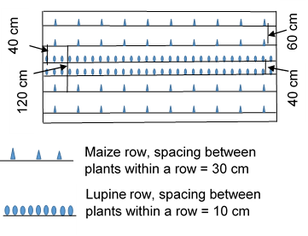

Figure 1: Maize-lupine paired row intercrop planting arrangement

**Data collection and measurements**

Data on grain yield, plant height, no. of kernels ear-1, ear plant-1, thousand kernel weight of maize, and grain yield of lupine were collected in a total of four environments. Maize and lupine grain yield collected from net plot size of the four and two rows of 2.4 m length, respectively. Plant height at physiological maturity, ear plant-1 and kernel ear-1 were determined from 10 randomly sampled maize plants in the middle four rows of 2.4 m length plot. Plant height was measured from the ground level to the tip of maize tassel. Thousand kernel weight of maize was determined from randomly sampled grain at moisture content of 12.5%. Accordingly final grain yield adjusted to the standard moisture content of 10 and 12.5% for lupine and maize, respectively.

**System productivity**

Maize equivalent yield (MEY) was calculated to see overall productivity of the intercrop system. Maize equivalent yield is the sum of maize grain yield in the intercrop system and the converted sweet lupine grain yield to maize grain yield. As maize was the main crop, grain yield of sweet lupine in the intercrop system was converted to maize grain yield by multiplying the sweet lupine grain yield with sweet lupine/maize price ratio. MEY = YML + (YLM x PL/PM) (Verma and Modgal, 1983), where MEY= Maize equivalent yield, PL = price of sweet lupine grain (8.5 ETB kg-1), PM = price of maize grain (9.7 ETB kg-1), ETB = Ethiopian Birr.

**Nitrogen and phosphorus use efficiencies of maize**

According to Cassman et al. (2002), this study calculates nitrogen and phosphorus use efficiencies (AE and PFP) using the following equation:

PFPN = YN / FN; PFPP = YP / FP, AEN= (YN-Y0)/FN, AEP= (YP-Y0)/FP

Where PFPN is partial factor productivity of applied N (kg grain/kg N applied), PFPP is partial factor productivity of applied P (kg grain/kg P applied), YN is crop yield (0% moisture) with applied N (kg ha-1), YP is crop yield (0% moisture) with applied P (kg ha-1), FN is amount of N applied (kg ha-1) and FP is amount of P applied (kg ha-1). AEN is agronomic efficiency of applied N (kg grain increase per kg N applied); AEP is agronomic efficiency of applied P (kg grain increase per kg P applied); Y0 is crop yield (0% moisture) in a control treatment with no fertilizer (kg ha-1)

**Data analysis**

SAS 9.1 version (SAS, 2004) used to analyze the data using the GLM procedure for each environment (year and site). Finally, the data were combined over environments since the three-way interaction (environment*nitrogen*phosphorus) were not significant and analysis was made considering environment as a random variable (Gomez and Gomez, 1984). The response of maize yield to nitrogen, phosphorus and their interaction either for its linearity or quadratic was detected using single degree of freedom orthogonal contrast test. Polynomial response equation used to determine the optimum nitrogen and phosphorus rate for the intercrop system (Dillon and Andreson, 1991). Duncan multiple range test at 5% of probability levels as used for mean separation when the analysis of variance indicates the presence of significant differences (Gomez and Gomez, 1984).

**Partial budget analysis**

Economic return of maize equivalent yield worked out at four worst scenarios of cost price ratios (CPR). It was assumed that fertilizer cost increased by 25, 50, 75 and 100% compared to the current cost while maize grain price remains unchanged. The lowest market prices of maize (9.7 ETB kg-1) of the month December 2020 was considered for the economic analysis. Cost of N, ETB 32.6 kg-1 (cost of urea, ETB 15 kg-1) and cost of phosphorus, ETB 59.1 kg-1 (cost of NPS, ETB 16 kg-1) of the season 2020 used. Fertilizer NPS (19% N, 16.6% P, 7% S) is commonly available in the market and farmers usually used it as source of phosphorus whereas TSP is not easily available and used only for the experiment purpose. Accordingly, the four CPR were calculated and resulted in 4.2, 5.0, 5.9 and 6.7 for N cost kg-1 to maize grain price kg-1; and 7.6, 9.1, 10.7 and 12.2 for P cost kg-1 to maize grain price kg-1 including the current cost price ratio of 3.4 for N and 6.1 for P. The four scenarios of cost price ratios were calculated in such away cost of N increases to 40.9, 48.9, 57.2 and 65.2 while cost of P to 73.8, 88.6, 103.4 and 118.1. The net return was calculated by deducting the variable costs of N and P from the gross return.

1. **RESULTS AND DISCUSSION**

Combined analysis over the environments revealed that plant height, number of kernel ear-1, thousand kernel weight, grain yield and equivalent yield of maize were significantly affected by the environments, nitrogen and phosphorus application (Table 1). Environment with N and with P interaction affected number of ears plant-1, maize grain yield and maize equivalent yield. The N*P interaction combined over the environments showed significant difference while the three-way interaction (Env*N*P) showed non-significant differences on maize gain and maize equivalent yield revealed that the environments respond similarly to the two most important yield limiting nutrients and the need to give more attention for the combined effect of N*P over the environments.

**Growth and yield components of maize**

The highest values for the growth and yield components of maize were obtained on sites where either potato (Env-3) or niger seed (Env-2) as precursor crops (Table 2). The highest values for these environments might be due to the huge left-over biomass of niger seed and potato on the soil that improve the overall soil productivity. Plant height, TKW and number of kernels per ear increased as N rate increased and then finally declined with excess application of N rate (Table 2). Plant height, TKW and number of kernels per ear increased as phosphorus rate increased (Table 2). Increases in maize plant height in response to N and P was reported by Onasanya et al. (2009). Getnet and Dugasa (2019) also reported increase in 1000 kernel weight and plant height of maize with the application of nitrogen and phosphorus.

**Table 1:** Combined analysis result (P value) on maize grain yield, yield components and maize equivalent yield at south Achefer and Mecha, northwestern Ethiopia (combined over environments)

|  |  |  |  |  |  |  |  |
| --- | --- | --- | --- | --- | --- | --- | --- |
| Source of variation | Df | Plant height | TKW | # of ears plant-1 | # of kernels  ear-1 | Maize  grain  yield | Maize  equivalent  yield |
| Environment (Env) | 3 | <0.0001 | <0.0001 | 0.0005 | 0.0001 | 0.0029 | 0.0011 |
| Env*rep | 8 | 0.0040 | 0.3982 | 0.1013 | 0.5082 | 0.0006 | 0.0034 |
| N | 3 | <0.0001 | 0.0014 | 0.2044 | 0.0036 | 0.0001 | 0.0002 |
| Env*N | 9 | 0.0037 | 0.8436 | <0.0001 | 0.1151 | <.0001 | <.0001 |
| P | 3 | 0.0008 | 0.045 | 0.1600 | 0.007 | <.0001 | <.0001 |
| Env* P | 9 | 0.1372 | 0.5592 | 0.004 | 0.0097 | 0.0004 | 0.0003 |
| N* P | 9 | 0.2599 | 0.5826 | 0.1525 | 0.2261 | <.0001 | <.0001 |
| Env*N* P | 27 | 0.4666 | 0.4522 | 0.016 | 0.6894 | 0.6899 | 0.7980 |
| Error | 191 |  |  |  |  |  |  |
| CV (%) |  | 5.86 | 8.83 | 7.02 | 8.95 | 15.46 | 14.41 |

**Table 2:** Effect of environment, nitrogen and phosphorus rate on growth and yield component of maize in the maize-sweet lupine intercrop system at south Achefer and Mecha, northwestern Ethiopia

|  |  |  |  |  |
| --- | --- | --- | --- | --- |
|  | Plant height (cm) | TKW (g) | No. of ears plant-1 | No. of kernels ear-1 |
| Environment | |  |  |  |
| Env-1 | 196.29c | 314.42c | 1.09b | 399.10b |
| Env-2 | 212.80b | 373.56a | 1.03c | 417.11a |
| Env-3 | 230.81a | 338.03b | 1.14a | 356.80c |
| Env-4 | 183.49d | 285.17d | 1.00c | 385.96b |
| Nitrogen rate (kg ha-1) | |  |  |  |
| 0 | 177.90c | 312.45b | 1.01 | 361.49c |
| 80 | 212.94b | 328.77a | 1.05 | 397.96ab |
| 160 | 218.09a | 338.00a | 1.10 | 407.68a |
| 240 | 214.46ab | 331.96a | 1.10 | 391.83b |
| Phosphorus rate, P (kg ha-1) | |  |  |  |
| 0 | 195.66c | 316.51b | 1.03 | 358.54c |
| 20 | 202.40b | 328.83a | 1.06 | 388.88b |
| 40 | 211.92a | 331.97a | 1.08 | 406.11a |
| 60 | 213.41a | 333.87a | 1.09 | 405.44a |

Note: Data were means of 48 values *Env-1=South Achefer 2017-tef precursor, Env-2=Mecha 2017-noug precursor, Env-3=South Achefer 2018-potato precursor, Env-4=Mecha 2018-finger millet precursor; numbers followed by different letters within a column showed significant difference at Duncan multiple range test of 5% probability level of significance*

***Maize grain and equivalent yield***

The highest maize grain yield (6539 kg ha-1) and maize equivalent yield (6911 kg ha-1) obtained from Env-3 (South Achefer 2018, potato precursor) while the lowest yields from Env-4 (Mecha 2018, finger millet precursor) (Figure 2). There was maize grain and maize equivalent yield advantage of 43 and 42%, respectively on Env-3 compared to Env-4. The difference in yield among the environments might be due to differences in field history where potato was used as a precursor on Env-3 whereas finger millet used a precursor on Env-4. The highest yield from Env-3 was due to the left-over crop residues. Except the tuber yield, the other residues of the potato crop left in the soil and significantly improve overall soil conditions. On the contrarily, farmers usually used to harvest finger millet and tef crops at the ground level and there is no any left-over biomass in the soil. Bhantana (2019) reported that maize grown sequentially with potato gave better yield than pea sequential. Abera et al. (2009) also reported maize following Niger seed produced mean grain yield advantage of 971 and 1527 kg ha-1 compared to haricot bean and tef. Environment interaction with nitrogen and with phosphorus showed quadratic yield response of maize grain and equivalent yield for both N (Figure 3) and phosphorus (Figure 4). Env-3 (South Achefer 2018, potato precursor) interacted with N rate of 198 kg ha-1 and with P rate of 67 kg ha-1 gave the highest maize equivalent yield, 8481 and 8119 kg ha-1, respectively.

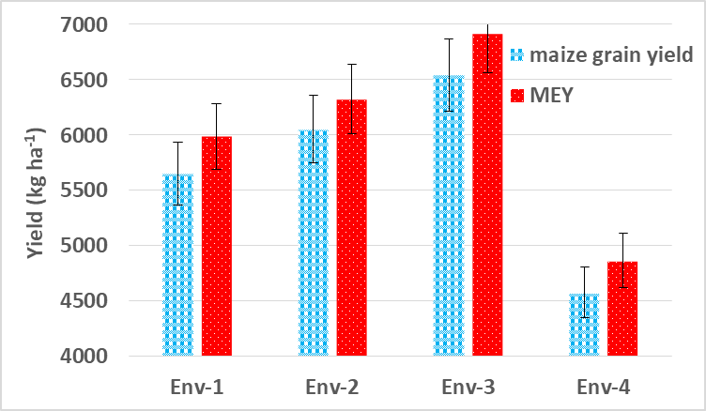

Figure 2: Environmental effects on maize grain and equivalent yield. Data were mean of 48 values. Env-1 (South Achefer 2017, tef precursor), Env-2 (Mecha 2017, Niger seed precursor), Env-3 (South Achefer 2018, potato precursor), Env-4 (Mecha 2018, finger millet precursor)

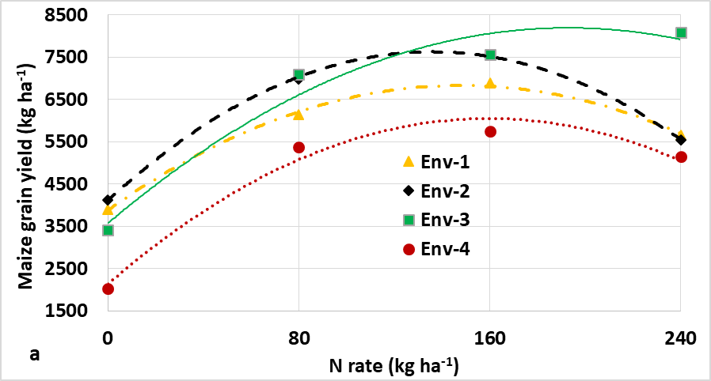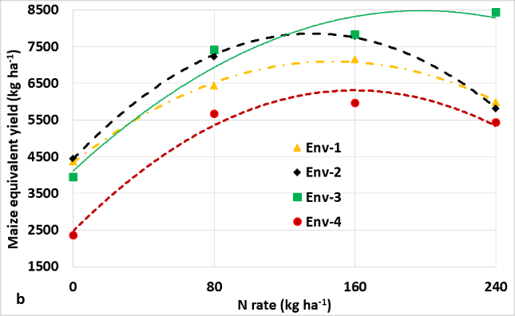

Figure 3: Maize grain yield (a) and equivalent yield (b) response to applied nitrogen. Data were mean of 48 values. Env-1 (South Achefer 2017-tef precursor), Env-2(Mecha 2017-Niger seed precursor), Env-3 (South Achefer 2018-potato precursor), Env-4 (South Achefer 2018-finger millet precursor)

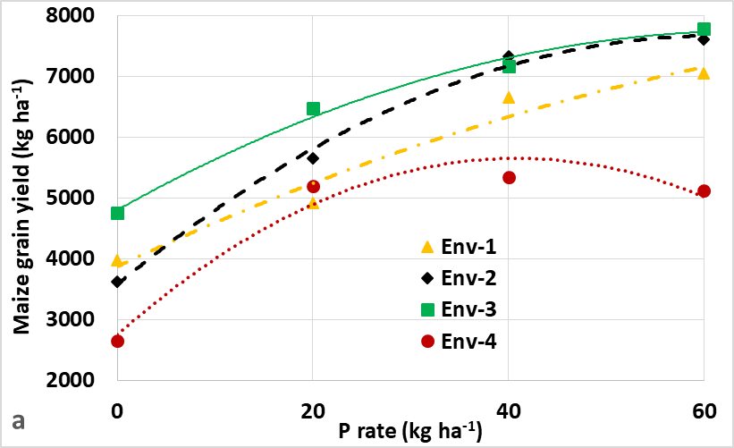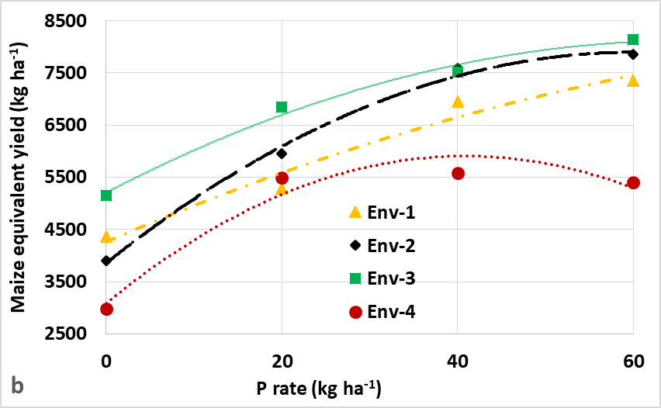

Figure 4: Maize grain yield (a) and equivalent yield (b) response to applied phosphorus. Data were mean of 48 values. Env-1 (South Achefer 2017-tef precursor), Env-2(Mecha 2017-Niger seed precursor), Env-3 (South Achefer 2018-potato precursor), Env-4 (South Achefer 2018-finger millet precursor)

The response of maize yield to nitrogen and phosphorus averaged over the environments also showed quadratic responses (Figure 5). Yields increased as the nutrient rate increased and then declined. Maize equivalent yield response to the applied nitrogen and phosphorus computed from equations 3 and 4 which were derivatives generated from response equations 1 and 2, respectively.

MEY=-0.14383N2+45.05625N+3836.27123, R2=0.99 - - - - - - - - - - - -Eq-1

MEY=-0.94498P2+107.99713P+4104.33595, R2=1 - - - - - - - - - - - - - -Eq-2

45.05625-0.28766N=0 - - - - - - - - - - - - - - - - - - - - - - - - - - - - - - - - - - - -Eq-3

107.9971-1.88996P=0 - - - - - - - - - - - - - - - - - - - - - - - - - - - - - - - - - - -- -Eq-4

Averaged over P, maize equivalent yield increased from 3836 to 7365 kg ha-1 (92%) as N rate increased from 0 to 157 kg N ha-1 (Figure 5a). Similarly, averaged over N, maize equivalent yield increased from 4104 to 7190 kg ha-1 (75%) as P rate increased from 0 to 67 kg P ha-1 (Figure 5b). Kaizzi et al. (2012) reported maize grain yield was consistently increased with N application by 120% compared with no N application. Maize yield response to nitrogen application was higher in the presence phosphors compared to without phosphorus (Figure 5a). Similarly, yield response to phosphorus application was higher in the presence nitrogen compared to without nitrogen (Figure 5b). The result suggests the compliment effect N and P nutrients to each other in increasing maize yield. Fosu-Mensah and Mensah (2016) reported application of inorganic P fertilizer increased the efficient utilization of inorganic N fertilizer and increased grain yield of maize. Pasley et al. (2019) reported nitrogen fertilizer increased plant uptake of P, S, Cu, and Zn by up to 280%, 320%, 420%, and 210%, respectively and pointed out that a balanced application of multiple essential nutrients is needed to sustainably increase yields. On the other hand, Zhihui et al. (2016) reported imbalanced application of nitrogen and phosphorus fertilizers can result in reduced crop yield and low nutrient use efficiency.

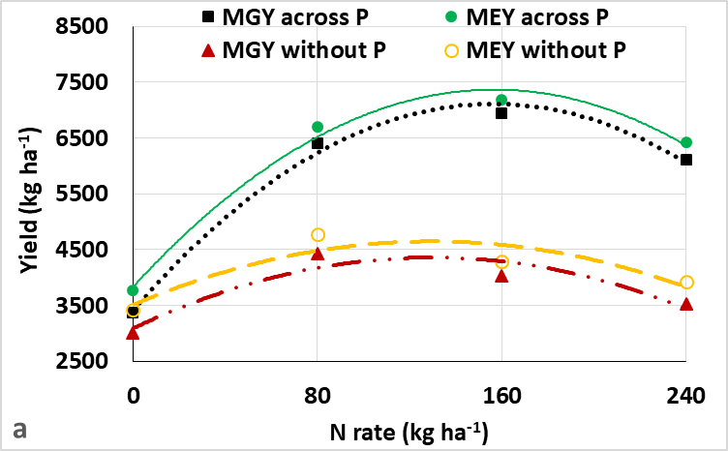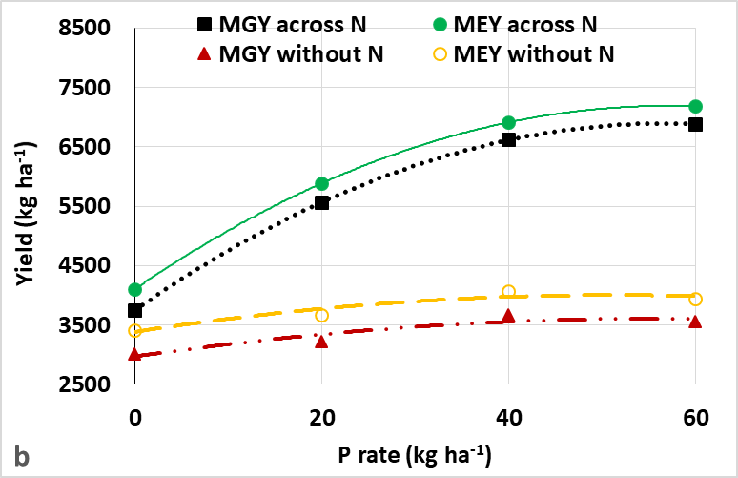

Figure 5: Maize grain and equivalent yield response to applied nitrogen (a) and phosphorus (b) combined over environments. Data were mean of 48 values. MGY across P (maize grain yield response to N application averaged over P), MGY without P (maize grain yield response to N application in the absence of P), MEY across P (maize equivalent yield response to N application averaged over P), MEY without P (maize equivalent yield response to N application in the absence of P), MGY across N (maize grain yield response to P application averaged over N), MGY without N (maize grain yield response to P application in the absence of N), MEY across N (maize equivalent yield response to P application averaged over N), MEY without N (maize equivalent yield response to P application in the absence of N).

The significant difference of N*P interaction on maize gain and maize equivalent yield indicated that the two most important nutrients had synergetic effect to each other in increasing maize yield. Response function of maize equivalent yield to N*P interaction averaged over the environments was indicated in equation-5 (Eq-5).

- - - - - - - - - - - - - - - - - - - - - - - - - - - - - - -Eq-5

The agronomic optimum rates (amount of N and P required to obtain the highest yield) for MEY was computed from the response function (Eq-5) using 120 possible combinations of N*P interactions. Accordingly, 159/63 kg N/ P ha-1 was found the optimum rate. Yield ranged from 3411 at 0/0 N/P to 9135 kg ha-1 at 159/63 kg N/P ha-1 (Figure 6) with yield increased by 5724 kg ha-1 (167.8%) relative to the unfertilized. Maize yield was higher when nitrogen and phosphorus applied in

combination (Figure 6) compared to the main effect of nitrogen and phosphorus alone (Figure 5). This is in line with Zhihui et al. (2016) who reported combined application of N and P increased maize grain yield by 82%, N uptake by 100% and concluded that combined application of N and P enhanced maize grain yield and nutrient uptake via stimulating root growth, leading to reduced accumulation of potentially leachable NO−3 -N in the soil.

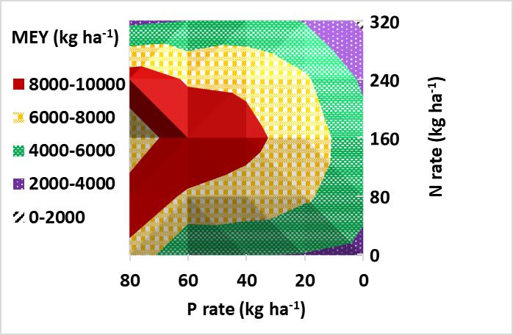

Figure 6: Response surface of N and P interaction effect on maize equivalent yield (total intercrop yield), combined over environments at South Achefer and Mecha in 2017 and 2018, North-Western Ethiopia. Data were mean of 12 values (four environments and three replications).

**Nutrient use efficiency**

Components of N use efficiencies (partial factor productivity and agronomic efficiency of applied N) and P use efficiencies (partial factor productivity and agronomic efficiency of applied P) declined as N and P rates increased (Figure 7). As N rate increased from 80 to 240 kg ha-1 PFPN and AEN declined from 70 to 22 and from 37 to 11, respectively (Figure 7a). Similarly, as P rate increased from 20 to 60 kg ha-1 PFPP and AEP declined from 241 to 100 and from 111 to 57, respectively (Figure 7b). Jiang et al. (2019) reported P rate at 90-120 kg ha-1 gave the highest improvement in P agronomic efficiency compared with the highest rate (135–180 kg ha-1). Low nitrogen use efficiency for high nitrogen rate was due to more loss of N in plots receiving higher rate compared to the lower rate. Nitrogen applied at low rates is efficiently utilized by the crop for biomass accumulation while maximum application of N beyond the optimum rate results in reduced N use efficiency. Plants cannot absorb nutrients applied in excess due to their absorption mechanisms becoming oversaturated (Balemi et al., 2019).

Yokamo et al (2022) reported that the average AEN and PFPN values across five cereal crops (wheat, maize, barley, tef, and sorghum) in Ethiopia were 18.2 and 71.81 kg kg−1, respectively. He also reported declined AEN and PFPN with the increase of the N fertilizer. At N rates of <30, 30 - 60, 60 - 100, and >100 kg ha−1, the AEN values were 23.42 kg kg−1, 19.21 kg kg−1, 16.43 kg kg−1, and 14.35 kg kg−1, while PFPN were 139.5 kg kg−1, 74.14 kg kg−1, 51.93 kg kg−1 and 32.24 kg kg−1, respectively. Among these cereals the highest AEN and PFPN were realized in maize 23.8 and 104.13 kg kg−1, respectively (Yokamo et al., 2022)

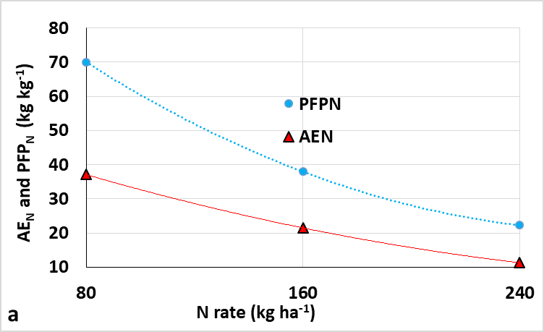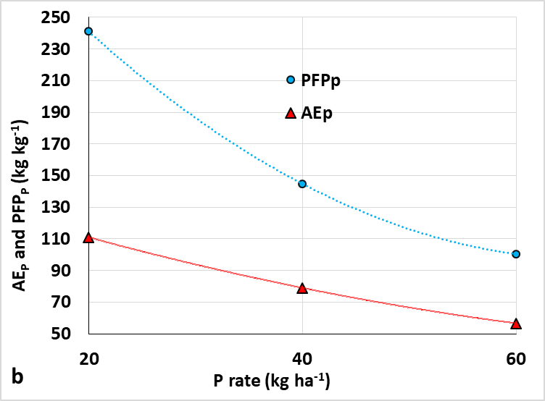

Figure 7: Nutrient use efficiency of maize in maize-lupine intercrop system (a) nitrogen use efficiency (b) phosphorus use efficiency. Data were mean of 36 values. PFPN is partial factor productivity of applied N, AEN is agronomic efficiency of applied N; PFPP is partial factor productivity of applied P, AEP is agronomic efficiency of applied P

**Economic return**

Economic fertilizer rates combined over environments for maize/lupine intercrop system computed as gross benefit (yield *grain price) minus the variable cost (N rate*N cost + P rate* P cost). The economic optimum rates (amount of N and P required to obtain the highest net returns) not greatly affected by cost price ratio. The economic optimum rates at different cost price scenarios ranged from 145 to 150 kg N ha-1 and from 58 to 61 kg P ha-1. The economic rates are 150/61, 150/60, 148/59, 146/59 and 145/58 kg N/P ha-1 at the current cost and assuming cost increased by 25, 50, 75 and 100%, respectively while maize grain price remain constant (Figure 8a). On the above economic rates, the respective highest net returns of 79893, 77781, 75684, 73614 and 71567 ETB ha-1 can be achieved from the intercrop system. Net return decreased by 10% as cost price ratio of N/maize grain increased from 3.4 to 6.7 and P/maize grain increased from 6.1 to 12.2 (Figure 8b).

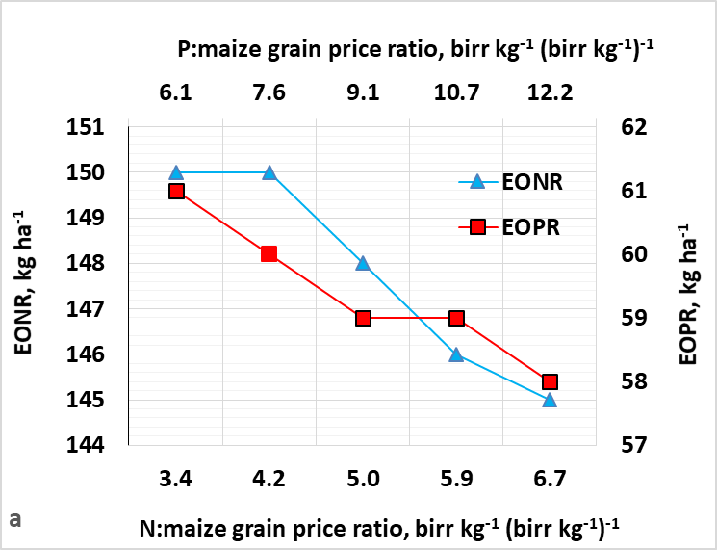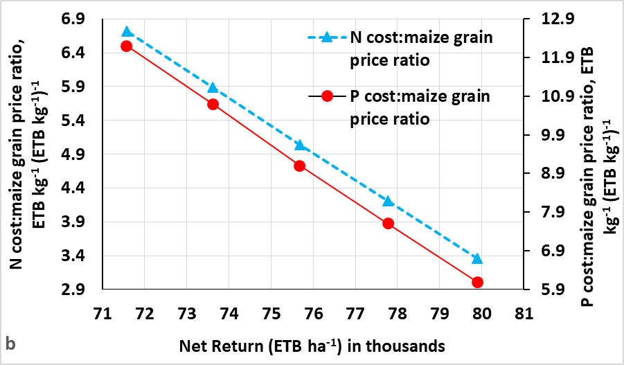

Figure 8: The effect of CPR on EONR (economic optimum N rate) and EOPR (economic optimum P rate (a) and net returns (b) on maize-lupine intercrop system at South Achefer and Mecha in North-Western Ethiopia. CPR

1. **CONCLUSION AND RECOMMENDATION**

Maize responded significantly to applied N, P and N*P interaction in maize-lupine intercrop of paired row planting arrangement system. Compared to the control (no fertilizer), maize equivalent yield was increased by 168% (5724 kg ha-1) when 159 kg N ha-1 and 63 kg P ha-1 (agronomic optimum rate) were applied and by 167% (5701 kg ha-1) when 150 kg N ha-1 and 61 kg P ha-1 (economic optimal) were applied. Nitrogen use efficiencies (partial factor productivity and agronomic efficiency of applied N) and P use efficiencies (partial factor productivity and agronomic efficiency of applied P) declined as N and P rates increased. Under the worst scenarios of cost price fluctuation, the optimal economic fertilizer rates are still within very narrow ranges and are tolerable to change. The yield difference within economical optimum rates is very minimal. Therefore, application of 145 to 150 kg N and 58 to 61 kg P ha-1 is recommended for maize production in South Achefer and Mecha areas, Northwest Ethiopia and similar agro-ecologies. The study revealed the need for further study of N and P rate determination of maize-sweet lupine intercrop system based on precursor crops.

**ACKNOWLEDGMENT**

This research was financially supported by Agricultural Growth Program (AGP II) of Ethiopia. Adet Agricultural Research Center within the Amhara Agricultural Research Institute facilitated the research work.

**REFERENCES**

Abera, T., Feyisa, D., & Friesen, D. K. (2009). Effects of crop rotation and NP fertilizer rate on grain yield and related characteristics of maize and soil fertility at Bako, Western Oromia, Ethiopia. East African Journal of Sciences, 3(1), 70-79. https://doi.org/10.20372/eajs.v3i1

Assefa, A., Tana, T., Dechassa, N., Dessalgn, Y., Tesfaye, K., & Wortmann, C. S. (2016). Maize-common bean/lupine intercrop productivity and profitability in maize-based cropping system of Northwestern Ethiopia. Ethiopian Journal of Science and Technology, 9(2), 69-85. <https://www.ajol.info/index.php/ejst/article/view/144295>

Balemi, T., Rurinda, J., Kebede, M., Mutegi, J., Hailu, G., Tufa, T., Abera, T., & Sida, T. S. (2019). Yield response and nutrient use efficiencies under different fertilizer applications in maize (Zea mays L.) in contrasting agro ecosystems. International Journal of Plant & Soil Science, 29(3), 1-19. <https://journalijpss.com/index.php/IJPSS/issue/view/171>

Bhantana, P. (2019). Studying of cropping system management towards improved soil fertility in the mid hills of eastern Nepal. Adv Plants Agric Res, 9(3), 372-375. <https://medcraveonline.com/APAR/>

Cassman, K. G., Dobermann, A., & Walters, D. T. (2002). Agroecosystems, nitrogen-use efficiency, and nitrogen management. AMBIO: A Journal of the Human Environment, 31(2), 132-140. https://pubmed.ncbi.nlm.nih.gov/12078002/

Central Statistical Agency (CSA). (2021). Report on area and production of major crops (private peasant

holdings, meher season). Agricultural Sample Survey 2020/21. Volume I, Statistical bulletin, 590, Addis Ababa, Ethiopia.

Dillon, J. L., & Anderson, J. G. (2012). The analysis of response in crop and livestock production. Third edition, Pergamon Press pp. 11-23.

Eskandari, H. (2012). Intercropping of maize (Zea mays) with cowpea (Vigna sinensis) and mungbean (Vigna radiata): effect of complementarity of intercrop components on resource consumption, dry matter production and legumes forage quality. Journal of Basic and Applied Scientific Research, 2(1), 355-360. <https://journals.indexcopernicus>.com/ search/details?id=32494

Fosu-Mensah, B. Y., & Mensah, M. (2016). The effect of phosphorus and nitrogen fertilizers on grain yield, nutrient uptake and use efficiency of two maize (Zea mays L.) varieties under rain fed condition on Haplic Lixisol in the forest-savannah transition zone of Ghana. Environmental Systems Research, 5 (22), 1-17. https://environmentalsystemsresearch. springeropen.com/articles? searchType= journal Search&sort=PubDate&page=6.

Gao, Y., Wu, P., Zhao, X., & Wang, Z. (2014). Growth, yield, and nitrogen use in the wheat/maize intercropping system in an arid region of northwestern China. Field Crops Research, 167, 19-30. https://doi.org/10.1016/j.fcr.2014.07.003.

Getnet, B. E., & Dugasa, T. (2019). Response of maize yield and yield related components to different levels of nitrogen and phosphorus fertilizers. Acta Scientific Agriculture, 3(1), 03-08. https://actascientific.com/ASAG/pdf/ASAG-03-0284.pdf

Ghosh, P. K., Mohanty, M., Bandyopadhyay, K. K., Painuli, D. K., & Misra, A. K. (2006). Growth, competition, yield advantage and economics in soybean/pigeonpea intercropping system in semi-arid tropics of India: I. Effect of subsoiling. Field Crops Research, 96(1), 80-89. https://doi.org/10.1016/j.fcr.2005.05.009

Gomez, K. A., & Gomez, A. A. (1984). Statistical procedures for agricultural research. John wiley & sons. New York.

Haileslassie, A., Priess, J., Veldkamp, E., Teketay, D., & Lesschen, J. P. (2005). Assessment of soil nutrient depletion and its spatial variability on smallholders’ mixed farming systems in Ethiopia using partial versus full nutrient balances. Agriculture, ecosystems & environment, 108(1), 1-16. https://www.sciencedirect.com/journal/agriculture-ecosystems-and-environment/vol/108/issue/1

Imran, M., Ali, A., Waseem, M., Tahir, M., Mohsin, A. U., Shehzad, M., & Ghaffari, A. (2011). Bio-economic assessment of sunflower-mungbean intercropping system at different planting geometry. International Research Journal of Agricultural Science and Soil Science. 1, 126-136. https://worldveg.tind.io/record/47781/

Islam, S., Ma, W., Ma, J., Buirchell, B. J., Appels, R., & Yan, G. (2011). Diversity of seed protein among the Australian narrow-leafed lupin (Lupinus angustifolius L.) cultivars. Crop and Pasture Science, 62(9), 765-775.

Jiang, W., Liu, X., Wang, X., Yang, L., & Yin, Y. (2019). Improving phosphorus use efficiency and optimizing phosphorus application rates for maize in the northeast plain of China for sustainable agriculture. Sustainability, 11(17), 4799. <https://doi.org/>10.3390/su11174799.

Kaizzi, K. C., Byalebeka, J., Semalulu, O., Alou, I., Zimwanguyizza, W., Nansamba, A., Patrick, M., Peter, E., Theodore, H., & Wortmann, C. S. (2012). Maize response to fertilizer and nitrogen use efficiency in Uganda. Agronomy journal, 104(1), 73-82. <https://doi.org/> 10.2134/agronj 2011.0181

Khan, S., Khan, M. A., Akmal, M., Ahmad, M., Zafar, M., & Jabeen, A. (2014). Efficiency of wheat brassica mixtures with different seed rates in rainfed areas of potohar-pakistan. Pak. J. Bot, 46(2), 759-766. https://www.researchgate.net/publication/261188448

Latati, M., Bargaz, A., Belarbi, B., Lazali, M., Benlahrech, S., Tellah, S., Ghiles, K., Jean, J. D., & Ounane, S. M. (2016). The intercropping common bean with maize improves the rhizobial efficiency, resource use and grain yield under low phosphorus availability. European journal of agronomy, 72, 80-90. https://doi.org/10.1016/j.eja.2015.09.015.

Maitra, S., Hossain, A., Brestic, M., Skalicky, M., Ondrisik, P., Gitari, H., Koushik, B., Tanmoy, S., Preetha, B., Jnana, B. P., Jagadish, J., Urjashi, B., Sarath, K. D., Sagar, L., & Sairam, M. (2021). Intercropping—A low input agricultural strategy for food and environmental security. Agronomy, 11(2), 343. <https://doi.org/10.3390/agronomy11020343>

Martínez-Villaluenga, C., Sironi, E., Vidal-Valverde, C., & Duranti, M. (2006). Effects of oligosaccharide removing procedure on the protein profiles of lupin seeds. European Food Research and Technology, 223(5), 691-696. [https://link.springer.com/article/10.1007/ s00217-006-0254-8](https://link.springer.com/article/10.1007/%20s00217-006-0254-8)

Mitiku, A., Chala, A., & Beyene, Y. (2014). Effect of intercropping on aphid vectors and yield of pepper (Capsicum annum L.) in southern part of Ethiopia. Int J Technol Enhanc Emerg Eng Res, 2(6), 24-34. [http://www.ijteee.org/research-paper-publishing. php?month= june2014](http://www.ijteee.org/research-paper-publishing.%20php?month=%20june2014)

Mousavi, S. R., & Eskandari, H. (2011). A general overview on intercropping and its advantages in sustainable agriculture. Journal of Applied Environmental and Biological Sciences, 1(11), 482-486. [https://www.textroad.com/pdf/JAEBS/J.%20Appl.%20Environ.%20Biol .%20Sci](https://www.textroad.com/pdf/JAEBS/J.%20Appl.%20Environ.%20Biol%20.%20Sci).,%201(11) 482-486,%202011.pdf

Nasri, R., Kashani, A., Barary, M., Paknejad, F., & Vazan, S. (2014). Nitrogen uptake and utilization efficiency and the productivity of wheat in double cropping system under different rates of nitrogen. International Journal of Bioscience. 4(4), 184-193. http://www.innspub.net.

Pasley, H. R., Cairns, J. E., Camberato, J. J., & Vyn, T. J. (2019). Nitrogen fertilizer rate increases plant uptake and soil availability of essential nutrients in continuous maize production in Kenya and Zimbabwe. Nutrient cycling in agroecosystems, 115(3), 373-389. <https://link.springer.com/article/> 10.1007/ s10705-019-10016-1.

SAS Institute Inc. (2004). SAS/STAT ® 9.1 User’s Guide. Cary, NC, USA

Seran, T. H., & Brintha, I. (2010). Review on maize based intercropping. Journal of agronomy, 9(3), 135-145. DOI: 10.3923/ja.2010.135.145.

Swer, H., & Dkhar, M. S. (2014). Influence of crop rotation and intercropping on microbial populations in cultivated fields under different organic amendments. Microbial diversity and biotechnology in food security, 571-580. DOI: 10.1007/978-81-322-1801-2_51

Tadesse, T., Assefa, A., Liben, M., & Tadesse, Z. (2013). Effects of nitrogen split-application on productivity, nitrogen use efficiency and economic benefits of maize production in Ethiopia. International Journal of Agricultural Policy and Research, 1(4), 109-115. <https://journalissues>. org/ijapr/june-2013-vol-14/

Tadesse, T., Haque, I., & Aduayi, E. A. (1991). Soil, plant, water, fertilizer, animal manure and compost analysis. Working Document No. 13. Addis Ababa, Ethiopia: International Livestock Research Center for Africa. https://hdl.handle.net/10568/4448.

Uddin II, R. O., & Adewale, S. O. (2014). Effects of intercropping sesame, Sesamum indicum and false sesame, Ceratotheca sesamoides on infestation by the sesame leafroller, Antigastra catalaunalis, the green semilooper, Chrysodeixis acuta and the parasitiod, Apanteles syleptae. Ethiopian Journal of Environmental Studies and Management, 7(1), 104-107. DOI:10.4314/ejesm.v7i1.13

Verma, S. P., & Modgal, S. C. (1983). Production potential and economics of fertilizer application as resource constraint in maize-wheat crop sequence. Himachal Journal of Agricultural Research. 9, 89-92.

Yeheyis, L., Kijora, C., Tegegne, F., & Peters, K. J. (2012). Sweet blue lupin (Lupinus angustifolius L.) seed as a substitute for concentrate mix supplement in the diets of yearling Washera rams fed on natural pasture hay as basal diet in Ethiopia. Tropical Animal Health and Production, 44, 1255-1261.

<https://link.springer.com/>article/ 10.1007/ s11250-011-0066-0

Yokamo, S., Jiao, X., Jasper, K., Gurmu, F., Jahan, M. S., & Jiang, R. (2022). Grain yield and nitrogen use efficiency vary with cereal crop type and nitrogen fertilizer rate in Ethiopia: A meta-analysis. Agricultural Sciences, 13(4), 612-631. DOI: 10.4236/as.2022.134041.

Zhihui, W., Jianbo, S., Blackwell, M., Haigang, L., Bingqiang, Z., & Huimin, Y. (2016). Combined applications of nitrogen and phosphorus fertilizers with manure increase maize yield and nutrient uptake via stimulating root growth in a long-term experiment. Pedosphere, 26(1), 62-73. <https://doi.org/10.1016/S1002-0160(15)60023-6>.