|  |  |
| --- | --- |
| ***BNJAR*** | **Blue Nile Journal of Agricultural Research (BNJAR)**  Vol. 5, Issue 2, December, 2022, pp. 89-97  Journal homepage: https://www.arari.gov.et/index_bnjar.php |

|  |  |  |  |
| --- | --- | --- | --- |
| **Verification and identification of the propagation techniques of native bee forage, 'Mentesie' (*Becium grandiflorum*) in Wag-himra zone Amhara region, Ethiopia** | | |  |
| *Agazhe Tsegaye1*, Alemu Tsegaye1, Ayalew Girmay1, Addisu Bihonegn2 and Meresa Lemma1*  *1*Sekota Dry Land Agricultural Research Center, Po. Box 62, Sekota, Ethiopia*  *2Andassa Livestock Research Center, P.o.box:27, Bahir Dar, Ethiopia*  *Corresponding author email:* [*agazhetsegaye@gmail.com*](mailto:agazhetsegaye@gmail.com) | | | |
| Copyright: ©2024 The author(s). This article is published by BNJAR and is licensed under the CC BY 4.0 license (http://creativecommons.org/licenses/by/4.0/). | | | |
|  |  | **ABSTRACT** | |
|  |  |  | |
| **Received:** August 14, 2022  **Revised:** November 26, 2022  **Accepted:** December 15, 2022  **Available online:** December 28, 2022 |  | *Becium grandiflorum is one of the major honey plants and sources of pollen and nectar for honeybees in the eastern part of the Amhara region, especially in the Wag-himra zone. Nowadays the plant has been found to depletion and extinction from its natural ecology due to human interference, as they are using it for different cultural household tools like as a source of fire wood. This study was conducted at the Jinqaba apiary site of Sekota Dryland Agricultural Research center between 2017 and 2019. The study was designed to evaluate the different propagation techniques of Becium grandiflorum and maximize the best method. The propagation techniques were direct sowing, seedling, cutting using a pot, plant splitting, ground, and air layering. Each of the treatments was replicated three times in a randomized complete block design. The planting materials were planted with a distance 1.5m*1.5m*2m between plants, rows, and blocks respectively. All the young plants or seedlings derived from the different propagation techniques were planted in pits of 20cm in diameter and 20cm in depth. The propagation techniques were evaluated for plant height (H), Canopy cover (CC), number of branches, total number of flowers per plant (FN) and Survival rate (SR). The study revealed that B.grandiflorum could be propagated in six successful techniques (direct sowing, seedling, cutting using a pot, plant splitting, ground, and air layering) tested in this experiment. The results found that B.grandiflorum plant height ranges from 77.6cm (cuttings) to 118.3cm (seedlings) and plants propagated through cutting had the highest number of branches (21), while air layering has produced the smallest number of branches (10.3) per plant. There was a significant difference (p>0.01 and p<0.001) among the evaluated propagation techniques in canopy cover, height, number of flowers, and branches per plant. Moreover propagation of B.grandiflorum using seedlings with pot was the best technique in producing the maximum (4427.8) number of flowers per plant, while sowing is the least (1415.9) technique in number of flowers per plant. Therefore, due to relatively the highest result in flower number and respective correlated parameters, propagation of the plant using seedling is the best technique among the techniques tested for mass multiplication of the plant in the study area. Hence demonstration and promotion of seedlings of B.grandiflorum could be also done for wider introduction of the technology to the beekeepers.* | |
| **Keywords:** *Bee flora, flower number, honeybees, propagation technique, natural ecology, becium grandiflorum* |  |

1. **INTRODUCTION**

*Becium grandiflorum* is one of the endemic plants in the highlands of Ethiopia and Eritrea (Fichtl and Admassu Adi 1994). It is a medium-sized, aromatic woody shrub that belongs to the Lamiaceae family. The species grows on eroded soils, particularly in rocky slopes and sandy soil, in mountain bushland and pastures. The species spans over altitude ranging between 1600 m and 3100 m.a.s.l (Kelbessa and Demissew 2006). Locally known as “Mentesie” (Amharic) or “Tebeb” (Tigrigna). In the Tigray region, *B.grandiflorum* is the only highly abundant and most frequently available bee flora species in the dry season (in closed forest areas (Equar Gebru 2015). The plant was also ranked as the best honeybee forage by beekeepers (Equar Gebru 2015) and (Equar Gebru  *et al* 2016). Forage inventory study in the Amhara region, the wag-khimra zone also showed as one of the top 10 abundant major bee forage species (Abebe Jenberie and Alemu Tsegaye 2016). In the area, the species is also the most important source of honeybee forage (in terms of preference by honeybees and abundance (Tewodros *et al* 2017).

Honeybees visit the flowers of the plant to collect pollen and/or nectar. The color of the honey is creamy white and granulates rapidly. Because of its attractive color and also light taste, honey from this plant is preferred by many consumers. The species has also added value as fuel wood, broom for cleaning the threshing ground, roofing of traditional houses, food flavoring, traditional medicine against malaria, and for soil and water conservation (Guinad and Dechassa 2001). Honeybees are exposed to a series of bee flora shortages which resulted colony absconding (Asmiro Abeje *et al* 2017). The possible reasons behind bee flora type’s population declining are population pressure, farmland expansion, and the use of plants for cultural household tools. Beyond this, increased demand for fuel wood has led to intensified extraction of mature plants from their natural habitats. More importantly, the natural regeneration of the species from seeds has become very difficult due to widespread human interference and climatic variability.

In this regard similar study was done by Mekelle Agricultural Research Center so far and confirmed *B.grandiflorum*could be propagated through cuttings, seed sowing, transplanting seedlings, plant splitting, and air layering and ground layering. Among the techniques there was significant difference in the average values of the various morphological and phonological attributes (Haftom Gebremedhn and Kebebew Wakijira 2013). After all had a recommendation of cuttings and seedlings of *B.grandiflorum* were the best techniques to multiply the plant in different growing areas. It is remained that different morphological attributes of a plant can be different in variability of agro-ecologies, landscapes, and soil types. Hence the growth attribute of *B.grandiflorum* is assumed to be different in Mekelle and Waghimra locations. As a result, Verification and identification of different propagation techniques of *B. grandiflorum* is an urgently needed task for this promising plant under Wag-himra zone context. This allows mass multiplication of the species with appropriate and recommended propagation technique in the waghimra conditions. Therefore the objective of this study was to verify and identify different propagation techniques of *B.grandiflorum* in waghimra zone, Amhara region, Ethiopia.

1. **MATERIALS AND METHODS**

**2.1. Description of the study area**

Agro-ecologically, the study area (Wag-himra zone) is categorized as lowland (63.3%), midland (31.43%), and highland (5.54%) with a total area of 878,195.3 hectares. Regarding the topography of the study area, it is located at an elevation between 500 and 3500 m.a.s.l. The annual rainfall distribution (erratic in its nature) varies between 150 to 700 mm. Its temperature ranges from 15°C - 40°C. There are about 67,224 honeybee colonies comprising 7.3% of the region, and honey productivity/hive/season is 9.8 Kg which is larger than regional average (Kerealem Ejigu *et al* 2009). In the Wag-himra zone, there is huge potential for beekeeping, which is an integral part of animal husbandry though it has not been well exploited yet. Moreover, the forest and bush cover is concentrated in utmost specific areas communally owned or possessed by churches. On the other hand, the topography dominated by several deep gorges, ups and downs, and a series of rugged massifs (uneven mountains) creates good opportunities for beekeeping practice (Tewodros *et al* 2017).

**2.2. Seeds and mother plant collection**

*B.grandiflorum* mother plants, with the same provenance, were selected from “Jinqaba” watershed and used as a source of planting material prior to the actual experiment. Seeds were collected from selected mature fruits and were packed in perforated polyethylene bags and allowed to dry for one month at room temperature. Seeds were taken as for the use of direct sowing and seedlings in a pot. The planting materials were also collected when the rainy season started and transplanted within the same day.

* 1. **Planting materials preparation**

Propagation techniques used in this experiment were; 1) direct sowing, 2) seedlings in a pot, 3) cuttings in a pot, 4) plant splitting, 5) air layering, and 6) ground layering. During the use of seeds in direct sowing technique, seeds were planted in rows and to keep proper spacing and avoid nutrient competition, thinning was done to densely populated plants on the 30th days from sowing. In seedling technique, plastic sleeves (diameter, 8 cm; length, 15cm) were prepared, sown and organized at ‘Wolh’ nursery site. Arranged and sown plastic sleeves were mulched with dried grass to decrease water loss through evaporation. Watering and other agronomic practices were done regularly for 45 days period, which was the end of the nursery age of the seedlings or the age at which the seedlings planted on the experimental plot (Figure 1).

In ground layering technique, each stem was attached to respective parent plants by bending selected branches to raise new plants from layering. The medium portion of selected and bended branches was buried under the soil and the rest left exposed. Stem cutting, just below the rooted zone was conducted on the 25th day then seedlings were transplanted to the experimental plots directly after cutting the branches from their mother plants (Figure 2). Sixty plant cuttings at the height of 40cm were collected early in the morning from naturally matured young and healthy mother plants and transferred to experimental pots. To avoid direct entrance of water during planting and growing, cuttings were prepared in such a way that top ends have a slant surface (at an angle of 45°) vertically and contain a minimum of two nodes. Then after, cuttings were transferred to the plastic sleeves (with 8 cm diameter and 15cm length) and well managed for days in the nursery before moving to the main experimental field (Figure 3). Then transplantation of these seedlings to experimental plots was done on their 55th day with a survival rate of 75%.

Mother plants that had more young branches were selected from established mother plants to split easily from the mother plant without injuring their roots and planted on experimental plots. For air layering (treatment 5), stem was enclosed with a

moist rooting medium soil at the point of its node and plastic wrapping and proper sealing was made to keep the layer from drying out and enable moisture retaining at its node area for 25 days. Then planting of this cutting was done in the experimental plot (Figure 4).

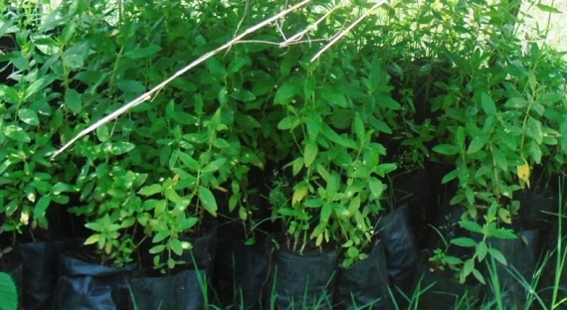 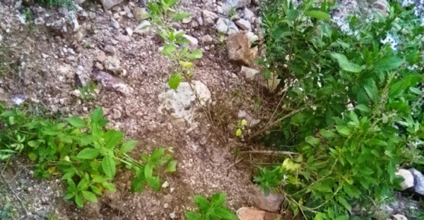

Figure 1: Seedlings Figure 2: Ground Layering

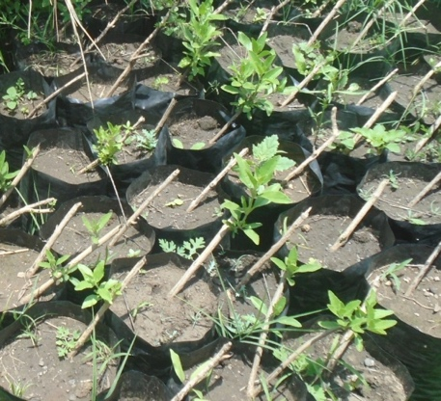 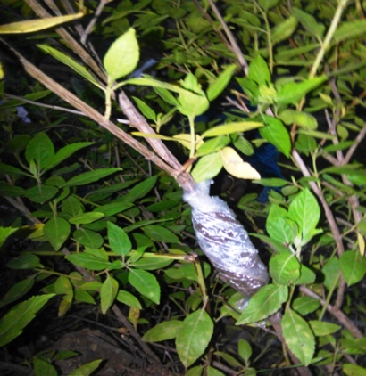

Figure 3: Cutting with Pot Figure 4: Air Layering

* 1. **Experimental design**

Each of the treatments was replicated three times in a randomized complete block design. The planting materials were planted with a distance 1.5m*1.5m*2m between plants, rows, and blocks respectively. All the young plants or seedlings derived from the different propagation techniques were planted in pits of 20cm in diameter and 20cm in depth.

* 1. **Data collection**

Three plants per plot and a total of nine plants per propagation technique were sampled randomly and considered for data collection. Data collection was conducted based on the following parameters.

Plant height (H): it was measured from bottom just above the root to the tip of the largest branch using a measuring tape.

Number of branches per plant (NB): it was determined by counting the number of branches per plant.

Canopy cover (CC): it was calculated using a formula C.C (cm). = (D1 +D2)/2 where D1 is the diameter of the plant towards the largest canopy cover, and D2 represents the diameter

of the plant towards the smallest canopy cover. Then, canopy cover of the plant was expressed in average diameter (cm).

Total number of flowers per plant (FN): it is the

total number of flowers counted per plant. Total number of flowers per plant was calculated using a formula FN = H.F *N.F.H where, H.F represents total number of flowers per plant, H.F stands for number of head flowers per plant, while N.F.H represents number of flowers per head. N.F.H is calculated form 10 randomly sampled head flowers per plant.

Survival rate: it is calculated using a formula SR = PS*100/PP where SR stands for survival rate, PS refers to the number of plants survived and PP explains number of plants initially planted.

* 1. **Data analysis**

The collected data were statistically tabulated in excel, organized, and analyzed using one-way ANOVA. The least significant difference /*LSD*/ was calculated to identify significant differences among the techniques and to compare the means of variables using SAS version 20 statistical software. Correlation analysis was also made to specific/selected variables.

1. **RESULTS AND DISCUSIONS**

The study revealed that *B. grandiflorum* could be propagated in six successful techniques (direct sowing, seedling, cutting using a pot, plant splitting, ground, and air layering*)* tested in this experiment. Similar propagation techniques have been reported for *B.grandiflorum* in Tigray (Haftom Gebremedhn and Kebebew Wakijira 2013). Comparatively, the result demonstrated that splitting technique had the probability of damaging the mother plant than the other methods. It is because plant root splitting destroys the separation of the new split from the mother plant during propagation attempts. More over the different propagation techniques of this plant species helps to multiply it with multiple options either in using seeds or the vegetation part of the plant.

* 1. **Plant Height, Number of Branches, Canopy Cover, and Number of Flower**

Differences were recorded among treatments in plant height at p*<0.001* (Table 1). The results found that *B.grandiflorum* plant height ranges from 77.6cm (cuttings) to 118.3cm (seedlings). Similarly, Haftom Gebremedhn and Kebebewa Wakijira (2013) also stated that plant height ranged from 104cm (cuttings) to 116cm (splitting). The difference in plant height could be the variation in agro-ecology, soil characteristics and provenance type of the plant.

There was a significant difference among techniques in the number of branches per plant (*p<0.01*, Table 1). Plants propagated through cutting had the highest number of branches (21), while air layering has produced the smallest number of branches (10.3) per plant. In contrast, Haftom Gebremedhn and Kebebew Wakijira (2013) stated that ground layering has provided the highest number of branches per plant (12) whereas seedlings produced the smallest number of branches (7) per plant. The difference might could be resulted from environmental variability, soil type and moisture availability of the area where ground layering is applied.

The study showed a significance difference in plant canopy cover among the techniques (*p<0.01*). The highest (121.2cm) canopy cover was obtained from the use of seedlings for propagation, while air layering technique provided the smallest (77.7cm) canopy cover. It was significantly positively correlated with mean number of flowers per plant (r=+0.76, *p<0.001*).

Difference was also found in the numbers of flowers per plant among the techniques (*p<0.001*). Plants propagated through seedlings had the highest number of flowers per plant (4427.8) whereas plants propagated through air layering provided the smallest number of flowers per plant (1415.9). Contrarily, Haftom Gebremedhn and Kebebew Wakijira (2013) stated that plants propagated from cuttings have produced the highest number of flowers per plants (12,910); while those propagated through sowing gave the smallest number of flowers (5637) per plant. The flowering pattern and flowering performance of a plant are considered to be the sum of all the genetic, physiological and morphological traits of a species variety

(Rajesh 2010). Hence the variation on the number of flowers per plant among the techniques might be due to differences on the number of branches per plant.

**Table 1:** Mean plant height, number of branches, canopy cover, root collar diameter, flower number and survival rate of different propagation techniques

|  |  |  |  |  |  |  |  |  |  |
| --- | --- | --- | --- | --- | --- | --- | --- | --- | --- |
| Parameters | Techniques | | | | | | | | |
|  | DS | SP | S | CP | AL | | GL | LSD | CV (%) |
| Plant height (cm) | 97.8b | 118.3a | 89.7c | 77.6d | | 91.2c | 86.1c | 6.3*\*\*\** | 3.7 |
| No of branches (cm) | 18ab | 20a | 13.2bc | 21a | | 10.3c | 13.4bc | 5*\*\** | 17 |
| Canopy cover (cm) | 94bc | 121.2a | 94bc | 110ab | | 77.7c | 86c | 17.2*\*\** | 9.8 |
| RCD (cm) | 1.7b | 1.8b | 2.4a | 1.8b | | 1.1c | 1.5b | 0.38*\*\*\** | 12.4 |
| Number of Flowers | 3066c | 4427.8a | 3066c | 3952.5b | | 1416e | 1805.5d | 314*\*\*\** | 5.8 |
| Survival rate (%) | 92.6a | 89ab | 89ab | 85.2ab | | 70.4b | 74.1ab | 20.5ns | 13.6 |

*Note: *** and ** = significant levels at p<0.001, and p<0.01 respectively, mean values followed by the same letters are not significantly different. DS= direct sowing, SP= seedling, S= splitting, AL= air layering and GL= ground layering and CRD = root collar diameter.*

**3.1. Correlation analysis**

In the present study, it was proved that plant height had no significant/positive correlation with number of branches per plant (r = +0.16, P > 0.05), canopy cover (r =+0.38, P > 0.05), and number of flowers per plant (r=+0.36, P > 0.05) (Table 2). Even Haftom Gebremedhn and Kebebew Wakijira (2013) stated that flower number of *B.grandiflorium* plant had a negative correlation with the height of the plant. This might be due to the growth habit of the plant that branches orient horizontally than growing upwards and more flower biomass was found from plants having a greater number of branches. However in the present finding height of *B.grandiflorum* had weak correlation with canopy cover, plant branch and number of flowers of a plant.Number of branches per plant was found to be significantly positively correlated with canopy cover (r=+0.82, *p<0.001*) and flower numbers (r=+0.78, *p<0.001*). This study was in line with the results of Haftom Gebremedhn and Kebebew Wakijira (2013) who demonstrated similar results for that the positive correlations of number of branches per plant with canopy cover and number of flowers per plant. In addition, Haftom Gebremedhn and Yaynishet Tesfay (2012) have reported the presence of positive correlation between number of flowers per plant and number of branches per plant with an experiment conducted on Hypoestes forskaoli.

**Table 2:** Correlation coefficient (r) between variables

|  |  |  |  |  |  |  |
| --- | --- | --- | --- | --- | --- | --- |
| FN |  |  |  |  |  |  |
| RCD | 0.58* |  |  |  |  |  |
| CC | 0.76*** | 0.21 |  |  |  |  |
| NB | 0.78*** | 0.22 | 0.82*** |  |  |  |
| H | 0.36 | -0.03 | 0.38 | 0.16 | 0.98*** |  |
|  | FN | RCD | CC | NB | CD | H |

*Note: ***, ** and * = significant at P<0.001, p<0.1 and p<0.5 respectively. FN=mean number of flowers per plant, RCD= root collar diameter (cm), CC=canopy cover (cm), NB=number of branches per plant, and H=height of a plant.*

1. **CONCLUSIONS AND RECOMMENDATIONS**

This study verified that *Becium grandiflorum* plant can be propagated through direct sowing, seedling, cuttings, splitting, ground, and air layering methods. These different propagation techniques give the opportunity of multiplication of the plant in any of beekeeping villages, protected areas and on the border of farmlands in the Waghimra zone. The present study revealed that *B. grandiflorum* plant propagated through seedlings had the highest canopy coverage and mean number of flowers per plant, while plants propagated through cutting with a pot had the highest number of branches followed by a seedling method. The highest plant height was found in plants propagated through seedlings, whereas the smallest was from cutting method. Besides, plant height has negatively correlated with number of branches per plant, canopy cover, and mean number of flowers per plant.

Therefore, due to relatively the highest result in flower number and respective correlated parameters, propagation of the plant using seedling is the best technique among the techniques tested for mass multiplication of the plant in the study area. Hence demonstration and promotion of *seedlings of B.grandiflorum could be also done for wider introduction of the technology to the beekeepers.* In addition to the present study further experiment could be designed in the area of agronomic, pruning and other methods that can boost the growth and flower biomass of this plant species.

**ACKNOWLEDGEMENT**

We would like to express our sincere gratitude to Sekota dry land agricultural research center, Amhara Agricultural Research Institute (ARARI) for providing research materials and covering the whole research cost

**REFERENCES**

Abebe J and Alemu T (2016). Amhara regional agricultural research institute Livestock Research Directorate. *Identification and Characterization of Honeybee Flora in Wag-Lasta Area, Amhara Region*, 339.

Asmiro A, Kindye A, Mulugeta A and Lijalem A (2017). Adoption and intensity of use of modern beehives in Wag Himra and north Wollo zones, Amhara region, Ethiopia. *Ethiopian Journal of Economics*, *26*(2), 1–30.

Ensermu K and Sebsebe D (2006). *The Red List of Endemic Trees & Shrubs of Ethiopia and Eritrea*. 28. https://doi.org/10.13140/2.1.3139.6168

Equar G (2015). *Assessment of Honey Bee Flora in Eastern Zone of Tigray, North*. *5*(1), 53–57.

Equar G, Berhanu A, Hayal L, Solomon A and Tsehaye A (2016). Honey bee flora diversity and their impact on honey production in the Tigray region of Ethiopia. *Livestock Research for Rural Development*, Vol. 28.

Fichtl R and Admasu A (1994). Honeybee flora of Ethiopia. The national herbarium, Addis Ababa university, Deutscher Entwicklungsdienst (DED). Margraf verlag, Germany.

Guinad Y and Dechassa L (2001). Wild-food

Plants in Ethiopia. Reflections on the role

of  'wild-foods' and  ‘famine-foods’ at a time of drought. United Nations Development Programme, Addis Abeba, Ethiopia.

Haftom G and Yaynishe T (2012). Identification and evaluation propagation techniques of Hypoestes forskaolii (Grbia) as bee fodder for smallholder farmers. *Livestock Research for Rural Development*, *24*(9), 18.

Haftom G and Kebebew W (2013).

Identification and evaluation of propagation techniques of native bee forage, "tebeb" (becium grandflorum). *Livestock Research for Rural Development*, *25*(1), 1–7.

Kerealem E, Gebey T and Preston T (2009). Constraints and prospects for apiculture research and development in Amhara region, Ethiopia. Livestock Research for Rural Development. Volume 21, Article #172. Retrieved September 26, 2019, from http://www.lrrd.org/lrrd21/10/ejig21172.htm

Rajesh K J (2010). Correlation study of flowering performance and pattern with

the yield in Linumusitatissimum L. African Journal of Plant Science Vol. 5 (3), pp. 146-151.

Towdros A, Seifu E and Amssalu B (2017).

*Honeybee production practices in Sekota district, northern Ethiopia. This article is licensed under a Creative Commons license, Attribution 4 . 0 International ( CC BY 4 . 0 ) Beekeeping is a sustainable form of agriculture, which is beneficial to the e*. *2* (May 2016), 263–275.