**~~Cultivating resilience:~~ Screening Ethiopian hot pepper accessions for resistance to Fusarium wilt (*Fusarium oxysporum)* under greenhouse conditions**

Tadesse Tilahuna, b, Solomon Abatec,Yilkal Beziea, d, Bekele Gebreamanulee, Mengistie Tayea, f

aInstitute of Biotechnology, Bahir Dar University, POBox 79, Bahir Dar, Ethiopia, bCollege of Natural and Computational Sciences, Debre Tabor University, POBox 272, Debre Tabor, Ethiopia, cEthiopian Institute of Agricultural Research, POBox 203, Addis Ababa, Ethiopia, dCollege of Natural and Computational Sciences, Debre Markos University, POBox 269, Debre Markos, Ethiopia, eCollege of Natural and Computational Sciences, Injibara University, POBox 40, Injibara, Ethiopia, fCollege of Agriculture and Environmental Sciences, Bahir Dar University, POBox 5501, Bahir Dar, Ethiopia

**Abstract:**

Fusarium wilt caused by *Fusarium oxysporum* f. sp. *capsici* (FOC) is a significant disease with economic implications. This disease results in substantial yield losses, potentially up to 80%, at various growth stages of crops. Using resistant varieties/accessions is the best option to manage FOC. This study aimed to screen fifty-two Ethiopian hot pepper accessions against fusarium wilt under greenhouse conditions using a completely randomized design (CRD) with three replications. The findings revealed that accession reactions to FOC varied significantly (P≤0.05). Out of the evaluated fifty-two hot pepper accessions, none of the accessions expressed an immune response against the fusarium wilt disease. Based on disease incidence (DI) two accessions (225733 and 25828) showed resistant reactions with a disease incidence of 8.3% and 9.4% respectively. Accessions 19974, 20869, and 9806 were found moderately resistant with 10.1-20.99% of DI. 24 (46.2%) of the accessions showed susceptible reaction Based on the disease severity index (DSI) six accessions (225733, 25828, 9806, 20869, 19974, and 20856), exhibited resistant reactions with <10% of DSI. 22 (42.3%) of the accession showed moderately susceptible reaction. The lowest AUDPC value was recorded from accessions 225733 (7.1%) and it is considered resistant. At each assessment, each accession showed variable responses to disease; some had resistant reactions, and others were susceptible. As the plant ages, disease severity increases, and it becomes wilted or dead. The variability in response to disease was due to the genetic heterogeneity of accessions. The availability of resistant hot pepper accessions was low compared to other reaction categories. Hence, to enhance the future breeding program, further screening research should conducted under greenhouse and field conditions.

**Keywords**: accession, *Fusarium oxysporum* f.sp. *capsici*, resistant, screening, susceptible

# **INTRODUCTION**

Pepper (*Capsicum annuum* L.) is one of the major important vegetable and spice crops that is cultivated all over the world, it significantly contributes to nutrition, medicine, and economic values (Demissie *et al.*, 2020; Hussain and Abid, 2011). Regarding its nutritional values, it is a source of essential vitamins (A, B, C, and E) (Kumar *et al.*, 2024) and minerals (potassium, magnesium, iron, calcium, and phosphorus) (Abdul Salam, 2015). Because of the presence of bioactive substances that have anti-inflammatory and antioxidant properties, such as fatty acids, volatile oils, capsaicinoids, and carotenoids, it is an important component of a healthy diet (Antonious, 2018; Ganguly *et al.*, 2017). Pepper also serves as a source of income for smallholder farmers in many developing countries, including Ethiopia (Aliyi *et al.*, 2019; Gobie, 2019; Wosene *et al.*, 2018).

The average world dry chilies and peppers production was estimated at 4.9 million tons from 1.6 million ha of land with productivity of 3 t/ha in 2022 (FAO, 2022). India is the largest world producer of pepper, with 1.8 million tons produced from 678 thousand hectares of land, which is much more than the second largest producer, China, which produces 318 thousand tons (FAO, 2022). In Ethiopia, pepper is cultivated in several parts of the country in different agro-ecological conditions such as tropical and sub-tropical regions. The production and productivity of pepper was 249,289 tons with a productivity of 1.6t/ha from 157,657 hectares of land in 2021/2022 main cropping season (CSA, 2022). Nevertheless, pepper production for green and dry pod yields has decreased over the years. This decrease may be attributed to several challenges such as the use of unimproved varieties, lack of good cultivation practices, high temperatures, pests, and prevalence of microbial disease, all of which negatively impacted the quality and yield of pepper production.

Among these factors, plant microbial diseases have a profound impact on both food security and food safety. To achieve the needs of an estimated 9.3 billion people by 2050, global food production must increase by 50%. However, plant pathogens and pests currently cause yield losses of up to 40% in essential crops, posing a major challenge to achieving this production goal (Wang *et al.*, 2024). Fusarium wilt, caused by *Fusarium oxusporum* f.sp. *capsici* (FOC*)*, is among the most economically impactful soil-borne diseases affecting Pepper (*Capsicum annuum* L.) in tropical and subtropical regions. This pathogen enters to plants through root wounds and multiplies quickly within the vascular system, ultimately blocking the xylem vessels. This blockage disrupts water transport, leading to symptoms such as leaf yellowing, wilting, vascular discoloration, and finally plant death (Bashir *et al.*, 2018; Sanogo and Zhang, 2016).

The most prevalent wilt disease in Ethiopian pepper crops, caused by *FOC* is widespread across all pepper-growing regions, with its occurrence varying by district and region. In the Middle Rift Valley of Oromia region, the incidence was estimated to be 46.5% (Endriyas *et al.*, 2020b); in the Jabi Tehinan district of the West Gojjam zone of the Amhara region, it was estimated to be 40% (Abebe and Abera, 2019); in West Gojjam zone Burie zuria district the incidence recorded was 56.6% (Tilahun *et al.*, 2024a); in Jabi Tehina district of West Gojjam zone Amhara region 72.4% (Alehegn *et al.*, 2022); in Bako Tibbe and Nonno Districts of West Shewa Zone 86.4% (Assefa *et al.*, 2015) in Southern Ethiopia, Hawassa Zuria district 73% (Shiferaw and Alemayehu, 2014); and in the Assosa and Kamashi zones, it is up to 50% (Kebede and Gidesa, 2017). These data indicates that *Fusarium oxysporum* is the primary cause of pepper wilt across these regions, with high incidence and severity. Fusarium wilt has been reported to be the cause of up to 80% of yield losses in the Dugda area (Shimeles *et al.*, 2007), and 68–71% of yield losses were obtained from untreated Marako-fana variety in Ethiopia (Teshome *et al.*, 2012). Hence, in recent years, the importance of Fusarium wilt has increased, attracting considerable attention from hot pepper producers and other stakeholders (Getnet, 2019).

To date, several approaches have been attempted in various countries at different times to manage Fusarium wilt in pepper, including the use of resistant cultivars, chemical fungicides, biological controls, and cultural practices (Zakaria, 2023). In addition to being costly, chemical treatments can harm the environment and pose risks to human health. Furthermore, no fungicides are currently available that can effectively control Fusarium wilt, and many are too expensive for farmers to adopt. (Ragab *et al.*, 2012). Biological control and cultural practices are often labor-intensive and costly, making them less feasible for widespread use in managing Fusarium wilt (Melkato, 2017). Furthermore, none of these strategies has been able to manage the disease completely alone due to the broad host range, genetic diversity of the pathogens, prolonged survival in the soil, and survival on vegetation as a latent infection (Mamphogoro *et al.*, 2020). Hence, there is a need to develop ecologically friendly wilt disease management strategies that are less reliant on agricultural pesticides and less destructive to soil, water, and biodiversity (Gabrekiristos and Demiyo, 2020).

Therefore, identification and use of resistant cultivars with other management options is an imperative, easily accessible, and environmentally friendly approach to managing Fusarium wilt (Keles *et al.*, 2015; Manu *et al.*, 2014). Unfortunately, commercially available varieties in Ethiopia are highly susceptible to Fusarium wilt (Aklilu *et al.*, 2018). However, it is plausible that resistant hot pepper germplasm may exist in landraces cultivated by small-scale farmers for many years. Therefore, it is essential to collect, characterize and evaluate locally available pepper germplasms and identify Fusarium wilt-resistant materials to serve as sources of resistance for incorporating these resistant traits into commercially viable hot pepper varieties. (Manu *et al.*, 2014). While some research has been conducted on the subject, no comprehensive systematic research has been done on the hot pepper accessions used in our study. Thus, this study aimed to screen Ethiopian hot pepper accessions for resistance to Fusarium wilt and identify potential parental lines that could be used in future hot pepper improvement programs.

**MATERIALS AND METHODS**

**Planting Materials and Planting**

The study was carried out to evaluate the resistance level of hot pepper accession against fusarium wilt under greenhouse conditions. For this study, fifty-one pepper accessions from the Ethiopian Biodiversity Institute (EBI) and one released variety as a susceptible check from Melkassa Agricultural Research Center (MARC) were used. Accessions are 80046, 19966, 229878, 20842, 237528, 23735, 24218, 208709, 244667, 9085, 229701, 20858, 225735, 244657, 80037, 20850, 225733, 20869, 229334, 240426, 235788, 19050, 23736, 223649, 9083, 25828, 19984, 20856, 229698, 223660, 19974, 28336, 236436, 80047, 26065, 80042, 223648, 9806, 28341, 237981, 23510, 80018, 80039, 9082, 80045, 223634, 9098, 212912, 80059, 25827, 244659, and variety Mareko fana.

The planting mix was prepared using moist, sterilized soil, compost, and sand in a 3:2:1 ratio (Oljira and Berta, 2020) and used to fill a 30 x 52 cm seedling trays as the potting medium.. The seeds of all accessions were surface sterilized with 0.5% aqueous sodium hypochlorite for 5 minutes and rinsed thoroughly with sterile distilled water. Air dried seeds were planted in seedling trays at the greenhouse of Department of Biology, Debre Markos University and the seeds were watered twice daily until germination, after which the germinated seedlings were watered once a day.

**Inoculum Preparation**

For assessing resistance, the FOC isolate 4WBG1, identified as the most virulent during the pathogenicity test conducted in our previous work were used (Tilahun *et al.*, 2024b). The pure culture of this isolate was grown and transferred to a 9-cm PDA plate with three replications and incubated for two weeks at 25°C (Ferniah *et al.*, 2018). The two-week-old pure cultures in PDA were flooded with 10 ml of sterile distilled water. A sterile microscope slide was used to scrape off the conidia and bring them into suspension. The scraped suspension was filtered into a 100-ml beaker using double sterile layers of cheesecloth to remove mycelium from the liquid and obtain pure conidial suspensions (stock suspension). A cell counter (hemocytometer) was used to calculate the spores’ concentration, and the inoculum was adjusted using sterile distilled water as required and adjusted to the expected spore concentrations (1x106 spores/ml).

**Inoculation Techniques**

Forty-day-old pepper seedlings were uprooted from the seedling tray, the roots washed in running tap water, and a 3 mm long root tips were cut with a sterile scissor and immersed into 40 mL of *Fusarium* spore suspensions (1x106 spores/mL) for 30 minutes (Guney and Guldur, 2018). Control plant roots were cut and immersed in 40 mL of sterilized distilled water for 30 minutes. A standard cut-root dip inoculation technique was implemented (Herman and Perl-Treves, 2007; Karimi *et al.*, 2010). The inoculated seedlings were transplanted into new sterilized 6 cm diameter and 9 cm deep pots filled with 220 g of steam-sterilized planting mix (3:2:1 ratio mixture of sterilized soil, compost, and sand) (Dubey and Singh, 2008; Oljira and Berta, 2020) The pots were arranged in a completely randomized design (CRD) in a greenhouse and replicated three times; eight plants were set per replication, a total of 24 plants per treatment. Eight plants per accession were used as a control. Transplanted pepper seedlings were watered twice a day with tap water until fully regenerated. From each accession those produce a typical wilting symptoms were observed (Tembhurne *et al.*, 2017). Pictorial experimental procedures were presented in figure 1.

**Evaluation of accessions for Fusarium oxysporum resistance**

Starting from two weeks of inoculation, the plants were monitored. Data were recorded every two weeks for disease symptoms such as leaf yellowing and chlorosis, shedding from the bottom, stunting plant height, and total plant wilt and death. The wilt incidence was assessed by counting the number of unhealthy plants within the inoculated seedlings based on the aforementioned specific symptoms of wilt formed after inoculation. Re-isolation of the pathogen from diseased plants after inoculation was performed according to Koch’s postulate, which is important to assure the existence of the pathogen (Endriyas *et al.*, 2020a).

Disease incidence (DI) percentage was calculated as the ratio of infected plants to total plant per plot, expressed as a percentage (Kumar *et al.*, 2024)

* DI (%) = [ $\frac{Number of infected plants}{Total number of plants per plot}$] ˟ 100

The disease severity rating scale was applied based on a 5-point scaling system as follows (Demissie *et al.*, 2020):

* 0: no visible infection
* 1: slight leaf yellowing
* 2: yellowing of old lower leaf and initial plant wilting
* 3: shedding of lower leaves and stunted plant growth
* 4: Complete leave shedding and the stem collapsed/few plants death
* 5: Total plant death

The disease severity index (DSI) was calculated using the formula given by (Galanihe *et al.*, 2004).

* DSI (%) = Σ [(S x N) /(T × H)] × 100

Where S =Severity rating score for each plant, N=number of plants having the same rating score; T=Total number of observed plants, and H=Highest rating scale value.

The percentage of disease incidence and severity was recorded and categorized using a slightly modified version of the grading system given by Aklilu *et al.* (2018).

Table 1. Disease reaction category of disease incidence and severity

|  |  |  |  |
| --- | --- | --- | --- |
| S.No. | Disease reaction | Disease incidence (%) | Disease Severity (%) |
| 1. | Highly Resistant/immune | 0 | 0 |
| 2. | Resistant | 1-10 | <10 |
| 3. | Moderately resistant | 10.1-20.99 | 10-20.99 |
| 4. | Moderately susceptible | 21-30.99 | 21-40.99 |
| 5. | Susceptible | 31-50 | 41-60 |
| 6. | Highly susceptible | >50 | >60 |

Based on their response to the disease, accessions were categorized into immune, resistant, moderately resistant, moderately susceptible, susceptible and highly susceptible accessions.

The area under the disease progress curve (AUDPC) was also calculated.

$$AUDPC=\sum_{i=1}^{n}{\left(\frac{y\text{i}+y\text{i+1}}{2})(t\text{i+1}-t\text{i}\right)}$$

Where n = total number of observations, yi = initial disease severity at the ith observation (in percentage), yi + 1 = disease severity at the second observation, ti = time (weeks) after inoculation at the ith observation, and t +1 = second weeks of observation. The unity for disease severity in the sample data is given as a percentage (%). A time interval of two weeks was used for calculating the Area under the Disease Progress curve (AUDPC). The values of DSI and AUDPC were then used to classify the resistance levels of different pepper accessions.

**Data analysis**

The data on disease incidence (DI) and disease severity index (DSI) were analyzed using various statistical techniques: descriptive statistics were computed to summarize the data, including mean, percentage, and frequency distributions of disease incidence, severity, and AUDPC; analysis of variance (ANOVA) was used to determine the significance of differences among accessions; a Least Significant Difference (LSD) test was used to separate means into distinct groups. P-values were used to determine statistical significance To quantify disease progression over time, the area under the disease progress curve (AUDPC) was calculated, and the results were presented using line and bar graphs. All analyses were performed in R software, and the outputs were presented as tables and graphical plots for clear interpretation.

**RESULTS AND DISCUSSION**

**Screening of Hot Pepper Accessions against *Fusarium oxysporum* f.sp. *capsici* (FOC)**

The comprehensive screening result for resistance to Fusarium wilt (*F.oxysporum* f.sp. *capsici*) in Capsicum accessions are presented in Table 2. The steps in screening of resistant accessions were also presented in figure 1. Inoculated pepper accessions were evaluated based on the observational disease symptoms from two to eight weeks after inoculation. A total of 51 accessions and 1 genotype were screened under greenhouse conditions, and none of the accessions were found to be immune (0% reaction) in terms of either disease incidence or severity. Two resistant, three moderately resistant, twenty-four susceptible, and fifteen highly susceptible accessions were identified based on the incidence. In contrast, six resistant, eighteen moderately resistant, twenty-two moderately susceptible, and six susceptible accession were found based on severity. The findings revealed that the accessions' reactions to FOC varied significantly (P≤0.05), suggesting that the materials under test test came from a variety of genetic origins.

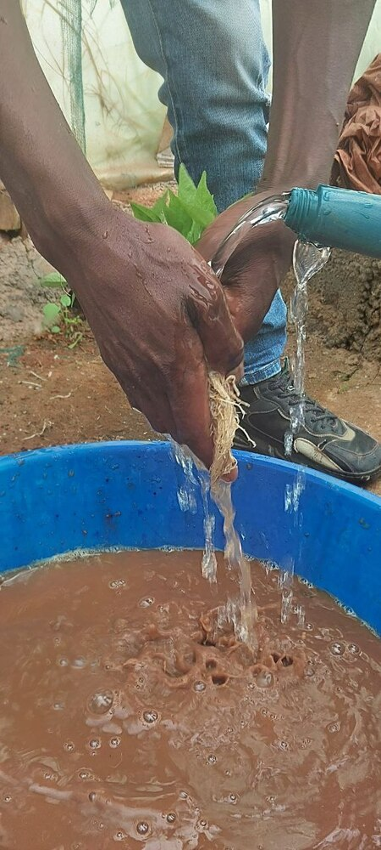

A

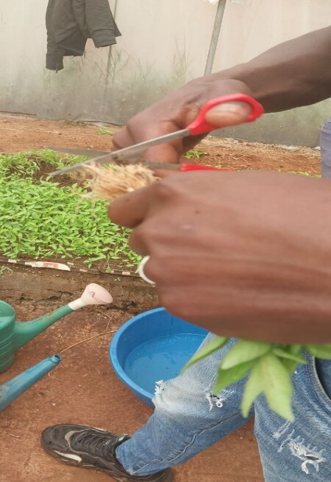

B

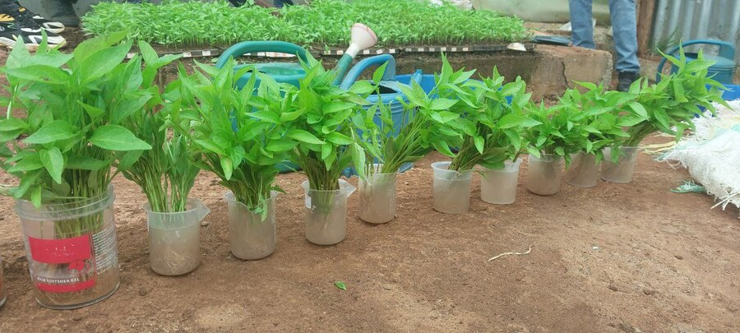

C

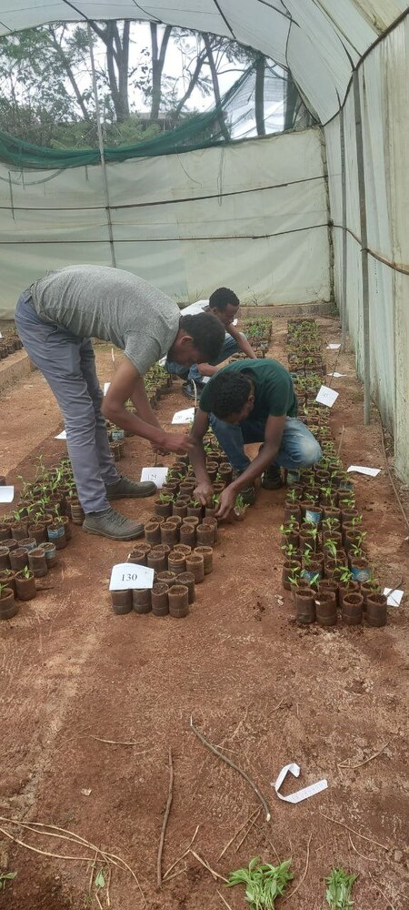

D

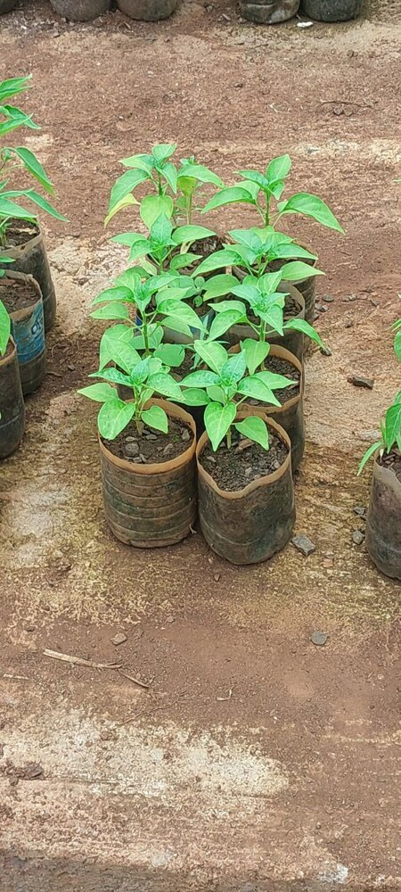

E

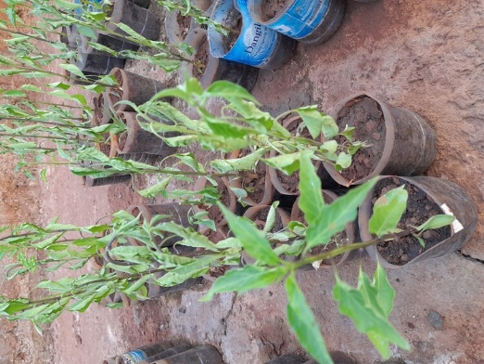

F

Figure 1. Steps in Screening resistant hot pepper accessions. (A) 40 days seedlings uprooted and washed before inoculation; (B) To facilitate infection a tips of root were cut with a sterilized scissor; (C) Prepared seedlings were immersed in 40 ml of suspension using the root dip technique; (D) The seedlings were transplanted into prepared pots; (E) Fully regenerated seedlings were obtained after transplanted; (F) leaves were wilted and curved upward.

**Wilt incidence percent (DI %):** The overall disease incidence percentage ranged from 8.3 to 70.8 %, with the lowest value recorded from pepper accession 225733, and the highest from 23510. From the total accessions, 15 (28.8%) of accessions (80046, 19966, 24258, 229701, 225735, 244657, 236436, 23510, 80018, 80045, 9098, 212912, 80059, 25827, and Mareko Fana) showed higher disease incidence (>50%) and categorized as highly susceptible accessions. Whereas 2 (3.8%) of the accessions (225733 and 25828) showed the lowest disease incidence (8.3 and 9.4%) and were considered as the resistant hot pepper accessions. The remaining accessions were categorized as follows: Moderately resistant: 3 accessions (5.8%) (19974, 20869, and 9806) showed disease incidences (DI) of 10.1-20.99%; moderately susceptible: 8 accessions (15.4%) (229334, 223649, 20856, 28336, 80047, 223648, 237981, and 80039) had DI value of 21-30.99%; and susceptible: 24 accessions (46.2%) (229878, 20842, 237528, 23735, 208709, 244667, 9085, 20858, 80037, 20850, 240426, 235788, 19050, 23736, 9083, 19984, 229698, 223660, 26065, 80042, 28341, 9082, 223634, and 244659) with DI ranging from 31-50% (Table 3). The majority of accessions (46.2%) were classified as susceptible. The highest incidences were observed in accession 23510 and *Mareko Fana* variety, with rates of 70.8% and 69.5%, respectively. No accession was completely free of disease symptoms.

**Disease severity index (DSI %):** The overall disease severity index ranged from 3.3 to 54.2 %, with the lowest value recorded from pepper accession 225733 and the highest from *Mareko Fana* variety. No immune and highly susceptible accessions were recorded. Among the accessions, six (11.5%): 225733, 25828, 9806, 20869, 19974, and 20856, showed a resistant reaction with disease () of <10%. A total of 18 (34.6%) accessions: 229878, 23735, 9085, 80037, 20850, 229334, 240426, 223649, 9083, 19984, 223660, 28336, 80047, 26065, 80042, 223648, 237981, and 9082, exhibited moderately resistant reactions with DI values of 10-20.99%. Moreover, 22 (42.3%) accessions: 80046, 19966, 20842, 237528, 208709, 244667, 20858, 225735, 244657, 235788, 19050, 23736, 229698, 28341, 80039, 80045, 223634, 9098, 212912, 80059, 25827, and 244659, were classified as moderately susceptible with DI values ranging from 21-40.99%. Finally, 6 (11.5%) accessions: 24218, 229701, 236436, 23510, 80018, and Mareko Fana, showed susceptible reactions with DI of 41-60% (Table 3). The highest DSI values were observed in variety *Mareko Fana* and accession 23510, with rates of 54.2% and 45.2%, respectively. Therefore, accessions 225733, 25828, 19974, 20869, 9806, and 20856 were classified as resistant, exhibiting variability in disease reactions, while the Mareko Fana, accession # 23510, and four other unmentioned accessions were classified as susceptible.

**Area Under the disease progress curve (AUDPC %):**

A standard quantitative measure in plant pathology for assessing disease severity over time is the Area Under the Disease Progress Curve or AUDPC. Scholars can evaluate various treatments or management practices with their summary value, which incorporates the length of the disease and its severity. Stronger disease resistance is indicated by lower AUDPC values, whereas higher AUDPC values reflect increased disease progression or severity over time. Accordingly, accessions such as 225733, 25828, and 19974 showed lower AUDPC values of 7.1, 10.9, and 13.9%, respectively, and exhibited resistant reactions. Accessions like 23510, 24218, 80018, 236436, and Mareko Fana varieties showed higher AUDPC values of 95, 92.3, 91.5, 90.9, and 100%, respectively and exhibited susceptible reactions to FOC. In all disease assessment methods disease incidence, severity, and AUDPC values two accessions (225733 and 25828) were found resistant to FOC. Hence, these promising accessions will serve as a source of resistance to the future breeding programs.

Table 2. Evaluation of 52 hot pepper accessions against FOC during 2024 under greenhouse conditions.

|  |  |  |  |  |  |
| --- | --- | --- | --- | --- | --- |
| Accession number | DI (%) | Reaction | DSI (%) | AUDPC (%) | Reaction |
| 80046 | 52.1 | HS | 21.5 | 45.1 | MS |
| 19966 | 51.0 | HS | 24.6 | 52.5 | MS |
| 229878 | 43.8 | S | 20.0 | 39.8 | MR |
| 20842 | 49.0 | S | 24.6 | 50.7 | MS |
| 237528 | 44.8 | S | 22.9 | 49.9 | MS |
| 23735 | 31.2 | S | 15.2 | 52.2 | MR |
| 24218 | 69.8 | HS | 42.1 | 92.3 | S |
| 208709 | 46.9 | S | 21.9 | 46.3 | MS |
| 244667 | 37.5 | S | 21.9 | 45.1 | MS |
| 9085 | 40.6 | S | 19.8 | 42.8 | MR |
| 229701 | 64.6 | HS | 42.5 | 89.7 | S |
| 20858 | 42.7 | S | 21.3 | 43.4 | MS |
| 225735 | 52.1 | HS | 22.9 | 47.8 | MS |
| 244657 | 51.0 | HS | 26.5 | 54.6 | MS |
| 80037 | 41.7 | S | 20.8 | 44.3 | MR |
| 20850 | 33.3 | S | 17.7 | 36.9 | MR |
| 225733 | 8.3 | R | 3.3 | 7.1 | R |
| 20869 | 20.2 | MR | 9.6 | 20.9 | R |
| 229334 | 25.0 | MS | 15.2 | 32.7 | MR |
| 240426 | 35.4 | S | 19.2 | 40.4 | MR |
| 235788 | 39.6 | S | 21.0 | 45.4 | MS |
| 19050 | 42.7 | S | 24.6 | 47.2 | MS |
| 23736 | 36.5 | S | 22.3 | 46.9 | MS |
| 223649 | 25.0 | MS | 16.7 | 34.8 | MR |
| 9083 | 40.6 | S | 20.4 | 43.7 | MR |
| 25828 | 9.4 | R | 4.8 | 10.9 | R |
| 19984 | 41.1 | S | 16.0 | 33.6 | MR |
| 20856 | 22.9 | MS | 9.8 | 20.7 | R |
| 229698 | 45.8 | S | 21.0 | 42.5 | MS |
| 223660 | 35.4 | S | 19.4 | 40.7 | MR |
| 19974 | 14.6 | MR | 6.9 | 13.9 | R |
| 28336 | 27.1 | MS | 14.0 | 30.1 | MR |
| 236436 | 65.6 | HS | 42.9 | 90.9 | S |
| 80047 | 27.1 | MS | 12.9 | 27.1 | MR |
| 26065 | 42.7 | S | 20.2 | 44.0 | MR |
| 80042 | 34.4 | S | 16.3 | 33.9 | MR |
| 223648 | 25.0 | MS | 13.3 | 28.0 | MR |
| 9806 | 19.7 | MR | 9.6 | 20.7 | R |
| 28341 | 43.8 | S | 21.5 | 45.4 | MS |
| 237981 | 30.2 | MS | 17.7 | 37.8 | MR |
| 23510 | 70.8 | HS | 45.2 | 95.0 | S |
| 80018 | 62.5 | HS | 41.9 | 91.5 | S |
| 80039 | 27.1 | MS | 22.1 | 26.3 | MS |
| 9082 | 33.3 | S | 19.6 | 40.1 | MR |
| 80045 | 65.6 | HS | 38.3 | 82.9 | MS |
| 223634 | 38.5 | S | 21.9 | 47.5 | MS |
| 9098 | 59.8 | HS | 35.6 | 73.3 | MS |
| 212912 | 67.7 | HS | 39.6 | 59.0 | MS |
| 80059 | 52.1 | HS | 27.5 | 58.1 | MS |
| 25827 | 57.3 | HS | 31.3 | 79.4 | MS |
| 244659 | 46.9 | S | 27.1 | 56.9 | MS |
| Mareko Fana (Check) | 69..5 | HS | 54.2 | 100.0 | S |

DI=Disease incidence, DSI= Disease severity index, AUDPC= Area Under Disease Progress Curve, R= Resistant, MR= Moderately resistant, MS= Moderately susceptible, S=Susceptible, CV%= Coefficient of variation, LSD (0.05) = least significant difference at p < 0.05.

The percentage of disease incidence (DI) and disease severity index (DSI) have a direct proportional relationship. However, the number of accessions in each category varied. This is due to the different scale of categorization in DI and DSI results (). The percentage of disease incidence frequently greater than the percentage of disease severity index, hence, one accession may categorized into different disease reaction category in DI and DSI. Furthermore, some accessions may exhibit a higher disease incidence without significantly affecting the plant, while others significantly affecting the plant with low disease incidence, leading to differences in their categorization between DI and DSI. As a result, while the number of accessions remains the same for both DI and DSI, their categorizations were varied (Figure 2).

Figure 2. Comparison of the number of accessions in each disease reaction category based on both disease incidence and severity.

Table 3. Categorizing hot pepper accessions based on their reactions to *Fusarium oxysporum* f.sp. *capsici*

|  |  |  |  |  |
| --- | --- | --- | --- | --- |
| Disease reaction | Incidence | | Severity | |
| Number of accessions | Name of accessions | Number of accessions | Name of accessions |
| Resistant (R) | 2 | 225733, 25828 | 6 | 225733, 25828, 9806, 20869, 19974, 20856 |
| Moderately resistant (MR) | 3 | 19974, 20869, 9806 | 18 | 229878, 23735, 9085, 80037, 20850, 229334, 240426, 223649, 9083,19984, 223660, 28336, 80047, 26065, 80042, 223648, 237981, 9082 |
| Moderately susceptible (MS) | 8 | 229334, 223649, 20856, 28336, 80047,  223648, 237981, 80039 | 22 | 80046, 19966, 20842, 237528, 208709, 244667, 20858, 225735, 244657, 235788, 19050, 23736, 229698, 28341, 80039, 80045, 223634, 9098, 212912, 80059, 25827, 244659 |
| Susceptible (S) | 24 | 229878, 20842, 237528, 23735, 208709, 244667, 9085, 20858, 80037, 20850, 240426, 235788, 19050, 23736, 9083, 19984, 229698, 223660, 26065, 80042, 28341, 9082, 223634, 244659 | 6 | 24218, 229701, 236436, 23510, 80018, Mareko Fana |
| Highly susceptible (HS) | 15 | 80046, 19966, 24258, 229701, 225735, 244657, 236436, 23510, 80018, 80045, 9098, 212912, 80059, 25827, Mareko Fana | 0 |  |

Assessing severity by time across accessions is crucial for determining how resistance or susceptibility varies among accessions at a specific point of time (Figure 3). Each point in the time line indicates the mean disease severity percentage for individual accessions. At time 2 (initial stage), severity varied among accessions, with accessions 23735,225733,25828,19974,28336 and 9082 showed 0% severity while accessions 80045, 23510, and variety Markeo fana exhibited 28.3, 24.2, and 32.5% of severity, respectively. In this time most accessions showed resistant reaction to disease. At time 8 (last stage), accessions 226436 and variety Mareko fana showed highest severity (78.4 and 81.7 respectively) and susceptible, while accessions 225733 and 25828 showed lowest severity (6.7 and 7.5% respectively) and resistant. Likewise at mid-stage disease development (at time 4 and 6) there is a variability is its severity scores. The severity of accessions increased from time 2 to 8. Similar studies on other crop confirmed that, 14 chickpea lines to be resistant to wilt at seedling stage but no line found to be resistant at reproductive stage (Rakesh *et al.*, 2023).

If you can, indicate which accessions are very important for the breeding purpose by annotating them on the graph as I did, and give caption for.

Figure 3. Disease Severity variability across accessions at different time points following inoculations

# Figure 4 illustrated the disease severity by accessions over time, which is important to comprehend the disease's progression within each accession and spot trends such as a delayed onset or worsening severity. Each color in the figure represents the 52 accessions and the line represents the progression of each accession over time. Most accessions exhibited a continuous increment of disease severity from time 2 to time 8 (Figure 4), it indicated a progressive worsening of disease over time. The rate of progression among accessions were variable, accessions such as 227533, 25828, 9806, 23735, and 80042 exhibited slow rate of increment, whereas accessions 236436, 23510, 229701, 24218, 212912 and Mareko Fana genotype were showed fastest rate of increment. In general, the disease progression was considerably slower in the resistant accessions, whereas susceptible accessions capitulated quickly to the pathogen. According to Lee *et al.* (2017) the presence of variability in disease severity among accessions can be attributed to their genetic makeup, which influence their susceptibility to the diseases. In addition, the dynamic nature of the pathogen, including its ability to multiply and spread, likely contributed to the increased infection of plant tissue, resulting in higher disease severity scores (Ravichandra, 2013). The continuous increase in disease severity implies that control measures may be necessary to manage the disease before it reaches critical levels. Hence, understanding the disease progression timeline is crucial for effective disease management, as early detection and intervention can significantly reduce disease severity.

# C:\Users\Tadesse\Downloads\Telegram Desktop\lastmeanplot.png

Figure 4. The progression of the disease severity in individual accessions at two-week time intervals after inoculation

The disease progression curve of Fusarium oxysporum f. sp. capsici (FOC) on hot pepper accessions, monitored at different plant ages, is shown in Figure 5. The association between time (in weeks) and the percentage of disease severity throughout various plant ages is described in this graph. The graph shows how the disease severity increases, especially as the plants age. There is a slow growth phase at first with few symptoms at initial stages, but as the plants get older, the disease severity quickly rises, following a normal exponential growth pattern. This implies that the pathogen starts to establish itself when a plant is first infected, although the disease severity is often mild (Reference). However, the disease worsens over time as the pathogen multiplies and spreads throughout the plant, producing visible symptoms. Sharper slopes indicate a more aggressive advancement of the disease, and the curve's shape can reveal information about the rate of disease development (reference). The trapezoidal structure of the graph indicates that following an initial phase of fast escalation, the disease severity tends to stabilize. This data emphasizes the significance of tracking disease progression at various plant ages to carry out swift interventions, which is essential for creating efficient management plans.

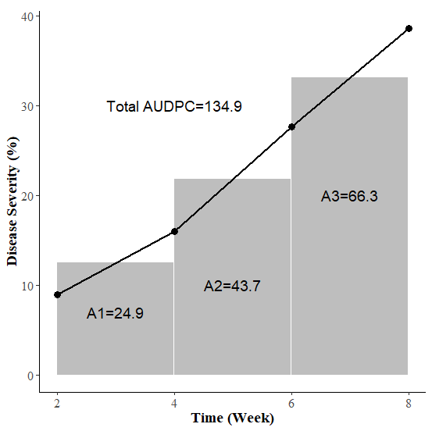

Figure 5. Disease progress curve of FOC on hot pepper accessions at given plant ages

# A resistance breeding program requires the identification of reliable and diverse field sources of resistance to Fusarium wilt. Using resistant varieties is beneficial not only for reducing disease-related losses but also for minimizing the toxicity associated with fungicide use (Manu *et al.*, 2014; Parey *et al.*, 2013). In the present study, Fifty two hot pepper accessions were screened for resistance against *F.oxysporum,* no highly resistant or immune accessions were identified; however, variability was observed among the accessions. This finding aligns with the results of Aklilu *et al.* (2018), who reported that no accession or genotype was completely free of disease symptoms, yet significant variability existed both within and between genotypes. Out of the fifty two hot pepper accessions screened based on disease incidence (DI), only two accessions, acc 227533 and acc 25828, were found to be resistant, with a disease incidence of less than 10%. These accessions are potentially valuable resources for future resistance breeding efforts. In addition, moderately resistant accessions, including acc 19974, acc 20869, and acc 9806, were exhibited a DI ranging from 11% to 20%. In contrast, 15 local accessions were rated as highly susceptible, showing a wilting rate exceeding 50%. Similarly, based on the disease severity index (DSI) 6 accessions showed resistant DSI < 10%, However, 18 accessions were moderately resistant (10-20.99% DSI), whereas, twenty two accessions were moderately susceptible (21 to 40.99% wilt), the remaining 6 accessions were susceptible (41-60% DSI), and no highly susceptible accessions were recorded, DSI >60%. Accessions that exhibited slower increase in disease severity and lower values of DSI possess higher level of resistance, demanding further investigation in to their genetic traits.

The present study in agreement with the report of Joshi *et al.* (2012) who reported that a significant variation in disease incidence was observed, ranging from 0% to 78.75%. Among the thirty screened varieties, only two (CO-4 and DLC-352) were found completely resistant (100% live plants) to chili wilt. This result is consistent with the finding of Aklilu *et al.* (2018) who indicated that there was great variation observed among accession/genotypes, from the total of 54 hot pepper genotypes screened, only two genotypes (PBC 731 and Acc-39) were found resistant and three accessions (Acc-46, 52, and 53) were moderately resistant, whereas 25 local accessions were rated highly susceptible. Similarly, Demissie *et al.* (2020) reported that, based on severity index rating, from the total 12 hot pepper varieties, only two (Melka Dera and Mareko Fana large pod) (16.7%) of the Ethiopian pepper cultivars were resistant to Fusarium isolate, while 8 (66.7%) showed moderate susceptibility.

Moreover, the cultivars Melka Zala and Mareko Fana were found to be highly susceptible to the Fusarium isolate. Furthermore, the study is in agreement with Gabrekiristos *et al.* (2020) who reported that, from 21 accessions/varieties tested, only one variety (Oda Haro) and one accession (ACC80061) showed moderately resistant reactions. The results are further supported by different studies, which show varying degrees of resistance depending on the inoculation method and the location (Aabida *et al.*, 2024; Alehegn *et al.*, 2024; Bajon *et al.*, 2024; Ferniah *et al.*, 2018; Saeed *et al.*, 2022; Singh *et al.*, 2017).

# The variations of resistance among accessions were due their genetic heterogeneity. This genetic diversity within the population can lead to differential response to disease. *Fusarium oxysporum* resistance is frequently controlled by a number of genes (polygenic resistance), and each plant may express these genes differently (Simons, 1972; Yadav *et al.*, 2023). Therefore, depending on their genetic composition, some plants within the same accession may have more potent defense mechanisms while others may exhibit higher susceptibility (Swarupa *et al.*, 2014). Hence, the genetic background of resistant and moderately resistant accessions may be responsible for their resistance potential, as their increased metabolic and gene activity may not be appropriate for the Fusarium wilt pathogen. This may be because of the antifungal substances, including phenolics, generated by resistant accessions were more effective than those produced by susceptible accessions (Shah and Smith, 2020).

# **CONCLUSION AND FUTURE PROSPECTS**

Two common accessions (225733 and 25828) were found resistant both in disease incidence and disease severity. These accessions are promising candidates as a valuable source of disease resistance for future hot pepper breeding programs. They could be used in hybridization programs to develop cultivars possessing desirable traits besides resistance to the Fusarium wilt pathogen and mitigating the economic impact of this disease. More research into the inheritance mechanisms of these resistant genotypes' disease-resistance traits is necessary before including them as donors in breeding efforts. However, expecting stable resistance against Fusarium diseases may be unrealistic due to the pathogen's high variability and dynamic nature. The majority of the accessions/varieties were classified as susceptible or moderately susceptible to disease reactions. To ensure thorough disease management, we forwarded the following recommendations; conducting a broader screening of accessions and genotypes under greenhouse and field conditions. In further breeding initiatives, the screened resistant accession should be utilized as a parental line to develop improved cultivars with increased resistance to Fusarium oxysporum. Conduct research on the genetic basis of resistance using molecular technologies like QTL mapping, genome-wide association studies (GWAS), or transcriptomics.

**Acknowledgments**

The authors would like to acknowledge Injibara University and Debre Markos University for allowing us to conduct our experiment in their laboratory and greenhouse with their dormitory, respectively. The authors additionally thank Debre Tabor University and the Ministry of Education Ethiopia (MoE) for giving study leave to the first author.

**Authors’ contributions**

TT: conceived, designed, performed the experiments, analyzed, and interpreted the data; drafted the manuscript; MT: supervised the overall experiment, commented on the drafted manuscript, and approved the version to be published; SA: took part in the design of the experiment, commented on the drafted manuscript, and revised the manuscript; YB: take part in performing the experiment and data collection; BG: take part in data analysis and interpretation of data. All authors read and approved the final manuscript.

**Consent for publication**

All authors agreed for the manuscript to be published.

**Disclosure statement**

The authors declare that they have no competing interests.

Tadesse Tilahun ORCID ID: <https://orcid.org/0000-0001-9468-9053>

# **References**

Aabida, Deepak, K., Ashok, K. S., MD, T., Satender, K. S., & Manmohan, S. (2024). Field Screening of Chilli (Capsicum annuum L.) Germplasm for Fusarium Wilt Resistance. *PLANT CELL BIOTECHNOLOGY AND MOLECULAR BIOLOGY, 25*(9-10), 67-73.

Abdul Salam, S. (2015). Biochemical Studies on Peppers as Specific Foodstuffs. *Egypt: CU thesis*.

Abebe, A., & Abera, M. (2019). Pepper Disease Assessment and Identification in Major Growing Districts of West Gojam Zone in Northwestern Ethiopia. *International Journal of Sustainable Agricultural Research, 6*(1), 8-20. DOI: <https://doi.org/10.18488/journal.70.2019.61.8.20>

Aklilu, S., Ayana, G., Abebie, B., & Abdissa, T. (2018). Screening for Resistance Sources in Local and Exotic Hot Pepper Genotypes to *Fusarium* Wilt (*Fusarium oxysporium*) and Associated Quality Traits in Ethiopia. *Adv Crop Sci Tech, 6*, 367. DOI: <https://doi.org/10.4172/2329-8863.1000367>.

Alehegn, M., Fininsa, C., Terefe, H., Dejene, M., & Mohammed, W. (2022). Agro-ecological factors influencing geographic distribution and epidemic development of hot pepper wilt complex disease in Northwestern Ethiopia. *International Journal of Pest Management*, 1-15. DOI: <https://doi.org/10.1080/09670874.2022.2132546>.

Alehegn, M., Fininsa, C., Terefe, H., Dejene, M., & Mohammed, W. (2024). Evaluation of Hot Pepper (Capsicum annuum L.) Varieties for their Resistance Reactions to Wilt Complex Disease and Yield Performances in Jabi Tehena District, Northwestern Ethiopia. *Canadian Journal of Plant Pathology, 46*(8), 119. DOI: <http://dx.doi.org/10.1080/07060661.2024.2388773>.

Aliyi, I., Gezahegn, M., & Seyoum, C. (2019). Contribution of Hot Pepper Production to Household Food Security: The Case of Gursum District, Oromia Regional State, Ethiopia.

Antonious, G. F. (2018). Capsaicinoids and vitamins in hot pepper and their role in disease therapy. In *Capsaicin and its human therapeutic development*: IntechOpen.

Assefa, M., Dawit, W., Lencho, A., & Hunduma, T. (2015). Assessment of wilt intensity and identification of causal fungal and bacterial pathogens on hot pepper (*Capsicum annuum* L.) in Bako Tibbe and Nonno districts of West Shewa zone, Ethiopia. *International Journal of Phytopathology, 4*(1), 21-28.

Bajon, C. I., Zakari, B. G., & Ishaku, G. A. (2024). Screening pepper (Capsicum annuum L.) cultivars for resistance against Fusarium wilt disease in Yola, Adamawa State, Nigeria. *BIMA JOURNAL OF SCIENCE AND TECHNOLOGY (2536-6041), 8*(3B), 235-245.

Bashir, M. R., Atiq, M., Sajid, M., Mohsan, M., Abbas, W., Alam, M. W., & Bashair, M. (2018). Antifungal exploitation of fungicides against Fusarium oxysporum f. sp. capsici causing Fusarium wilt of chilli pepper in Pakistan. *Environmental Science and Pollution Research, 25*, 6797-6801.

CSA (2022). The federal democratic republic of Ethiopia Ethiopian statistics service agricultural sample survey 2021/22 (2014 E.C.), report on area and production of major crops, Addis Ababa, Ethiopia.*, 1*.

Demissie, S., Megersa, G., Meressa, B. H., & Muleta, D. (2020). Resistance levels of Ethiopian hot pepper (Capsicum spp.) varieties to a pathogenic Fusarium spp. and in vitro antagonistic effect of Trichoderma spp. *Archives of Phytopathology and Plant Protection, 54*, 1-18. DOI: <https://doi.org/10.1080/03235408.2020.1853494>.

Dubey, S., & Singh, S. R. (2008). Virulence analysis and oligonucleotide fingerprinting to detect diversity among Indian isolates of Fusarium oxysporum f. sp. ciceris causing chickpea wilt. *Mycopathologia, 165*(6), 389-406.

Endriyas, G., Daniel, T., & Getachew, A. (2020a). Cultural, Morphological and Pathogenic Variability among Isolates of *Fusarium oxysporum* f. sp. *capsici* Causing Wilt of Hot Pepper in Central Rift Valley, Ethiopia. *Journal of Plant Pathology & Microbiology, 11*(6), 1-12. DOI: <https://doi.org/10.35248/2157-7471.20.11.499>.

Endriyas, G., Daniel, T., & Getachew, A. (2020b). Distribution and Relative Importance of Hot Pepper Fusarium Wilt (Fusarium oxysporium f.sp. capsici) and Associated Agronomic Factors in the Central Rift Valley of Ethiopia. *Advances in Crop Science and Technology, 8*(1).

FAO (2022). Food and Agriculture Organization of the United Nations. Statistics Division. <http://www.fao.org/faostat/en/#data/QC>. Google Scholar.

Ferniah, R. S., Kasiamdari, R. S., Priyatmojo, A., & Daryono, B. S. (2018). Resistance response of chilli (Capsicum annuum L.) F1 to Fusarium oxysporum involves expression of the CaChi2 gene. *Tropical life sciences research, 29*(2), 29.

Gabrekiristos, E., & Demiyo, T. (2020). Hot Pepper *Fusarium* Wilt (*Fusarium oxysporum* f. sp. *capsici*): Epidemics, Characteristic Features and Management Options. *Journal of Agricultural Science, 12*(10), 347-360. DOI: <https://doi.org/10.5539/jas.v12n10p347>

Gabrekiristos, E., Teshome, D., & Ayana, G. (2020). Prospects of host resistance and biocontrol agent for the management of hot pepper Fusarium wilt (Fusarium oxysporum f. sp. capsici) in the Central Rift valley of Ethiopia. *Academic reseach Journal, 8*(3), 156-162. DOI: <https://doi.org/10.14662/ARJASR2020.130>.

Galanihe, L., Bandara, H., Priyantha, M., Yapa, D., & Ranasinghe, J. (2004). Insect pest and disease incidences of exotic hybrid chilli varieties grown in the low country dry zone of Sri Lanka.

Ganguly, S., Praveen, K., Para, P. A., & Sharma, V. (2017). Medicinal properties of chilli pepper in human diet. *ARC J. Public Health Community Med., 2*(1), 6-7.

Getnet, M. (2019). Characterization of Fusarium species from hot pepper (Capsicum anuum L.) and In vitro antagonistic effect of Trichoderma species. *Thesis*, 1-79.

Gobie, W. (2019). A seminar review on red pepper (*Capsicum*) production and marketing in Ethiopia. *Cogent Food & Agriculture, 5*(1), 1-14. DOI: <https://doi.org/10.1080/23311932.2019.1647593>.

Guney, İ. G., & Guldur, M. E. (2018). Inoculation techniques for assessing pathogenicity of Rhizoctonia solani, Macrophomina phaseolina, Fusarium oxysporum and Fusarium solani on pepper seedlings. *Türkiye Tarımsal Araștırmalar Dergisi, 5*(1), 1-8.

Herman, R., & Perl-Treves, R. (2007). Characterization and inheritance of a new source of resistance to Fusarium oxysporum f. sp. melonis race 1.2 in Cucumis melo. *Plant Disease, 91*(9), 1180-1186.

Hussain, F., & Abid, M. (2011). Pest and diseases of chilli crop in Pakistan: A review. *Int. J. Biol. Biotech, 8*(2), 325-332.

Joshi, M., Srivastava, R., Sharma, A. K., & Prakash, A. (2012). Screening of resistant varieties and antagonistic *Fusarium oxysporum* for biocontrol of Fusarium wilt of chilli. *Journal of Plant Pathology & Microbiology, 3*(5), 1-6. DOI: <https://doi.org/10.4172/2157-7471.1000134>.

Karimi, R., Owuoche, R., & Silim, S. (2010). Inheritance of fusarium wilt resistance in pigeonpea [Cajanus cajan (L.) Millspaugh. *Indian Journal of Genetics and Plant Breeding, 70*(3), 271-276.

Kebede, M., & Gidesa, A. (2017). Survey and Identification of Diseases on Major Crops of Assosa and Kamashi Zones, Ethiopia. . *Galore Int J Appli Sci, 1*, 27-31.

Keles, D., Pınar, H., Ata, A., Taşkın, H., Yıldız, S., & Büyükalaca, S. (2015). Effect of pepper types on obtaining spontaneous doubled haploid plants via anther culture. *HortScience, 50*(11), 1671-1676.

Kumar, D., Singh, A. K., Thabrez, M., Sharma, S. K., & Singh, M. (2024). Field Screening of Chilli (Capsicum annuum L.) Germplasm for Fusarium Wilt Resistance. *PLANT CELL BIOTECHNOLOGY AND MOLECULAR BIOLOGY, 25*(9-10), 65-73.

Lee, J. C., Biasci, D., Roberts, R., Gearry, R. B., Mansfield, J. C., Ahmad, T., . . . Jostins, L. (2017). Genome-wide association study identifies distinct genetic contributions to prognosis and susceptibility in Crohn's disease. *Nature genetics, 49*(2), 262-268.

Mamphogoro, T., Babalola, O., & Aiyegoro, O. (2020). Sustainable management strategies for bacterial wilt of sweet peppers (Capsicum annuum) and other Solanaceous crops. *Journal of Applied Microbiology, 129*(3), 496-508.

Manu, D., Tembhurne, B., Kisan, B., Aswathnarayana, D., & Diwan, J. (2014). Inheritance of fusarium wilt and qualitative and quantitative characters in chilli (Capsicum annuum L.). *Journal of Agriculture and Environmental Sciences, 3*(2), 433-444.

Melkato, S. H. (2017). *Virulence of Colletotrichum capsici (syd. Buter and Bisby) in Pepper (Capsicum spp) Varieties in major Growing Areas of Ethiopia: Implications To Integrated Disease Management (IDM) Using Chemicals And Biological Control Agents.* Addis Ababa University Addis Ababa, Ethiopia,

Oljira, T., & Berta, S. (2020). Isolation and Characterization of Wilt-Causing Pathogens of Local Growing Pepper (*Capsicum annuum* L.) in Gurage Zone, Ethiopia. *International Journal of Agronomy, 2020*, 1-8. DOI: <https://doi.org/10.1155/2020/6638683>.

Parey, M. A., Razdan, V., & Sofi, T. (2013). Comparative study of different fungi associated with fruit rot of chilli and screening of chilli germplasm against Colletotrichum capsici. *International Journal of Agriculture and Crop Sciences, 5*(7), 723.

Ragab, M. M., Ashour, A., Abdel-Kader, M., El-Mohamady, R., & Abdel-Aziz, A. (2012). In vitro evaluation of some fungicides alternatives against Fusarium oxysporum the causal of wilt disease of pepper (Capsicum annum L.). *International Journal of Agriculture and Forestry, 2*(2), 70-77. DOI: <https://doi.org/10.5923/j.ijaf.20120202.11>

Rakesh, Y., Tripathi, M., Tiwari, S., Asati, R., Chauhan, S., Paliwal, S., . . . Tripathi, N. (2023). Screening chickpea genotypes against Fusarium wilt disease under controlled conditions. *International Journal of Plant & Soil Science, 35*(19), 698-710.

Ravichandra, N. (2013). *Fundamentals of plant pathology*: PHI Learning Pvt. Ltd.

Saeed, S., Sahi, S. T., Atiq, M., Shahid, M., & Arshad, M. (2022). Exploration of Resistance and Susceptibility in Chilli Varieties/Advanced Lines against Fusarium Wilt Caused by Fusarium oxysporum f. sp. capsici (FOC). *International Journal of Phytopathology, 11*(1), 59-64.

Sanogo, S., & Zhang, J. (2016). Resistance sources, resistance screening techniques and disease management for Fusarium wilt in cotton. *Euphytica, 207*, 255-271.

Shah, A., & Smith, D. L. (2020). Flavonoids in agriculture: Chemistry and roles in, biotic and abiotic stress responses, and microbial associations. *Agronomy, 10*(8), 1209.

Shiferaw, M., & Alemayehu, C. (2014). Assessment of Hot Pepper (*Capsicum species*) Diseases in Southern Ethiopia. . *International Journal of Science and Research, 3*(3), 91-95. DOI: <https://paper> id 02013906.

Shimeles, A., Berhanu, B., & Bekele, K. (2007). Survey report on current pepper production constraints in

major pepper growing areas of Ethiopia. . *EIAR, Addis Abeba, Ethiopia*.

Simons, M. (1972). Polygenic resistance to plant disease and its use in breeding resistant cultivars. *Journal of Environmental quality, 1*(3), 232-240.

Singh, J., Kumar, M., Kumar, A., & Mehta, N. (2017). Screening of chili cultivars against fusarium wilt of chilli (Capsicum annuum L.). *Int. J. Agric. Sci. Res, 7*(1), 235-240.

Swarupa, V., Ravishankar, K., & Rekha, A. (2014). Plant defense response against Fusarium oxysporum and strategies to develop tolerant genotypes in banana. *Planta, 239*, 735-751.

Tembhurne, B., Belabadevi, B., Kisan, B., Tilak, I., Ashwathanarayana, D., Suvarna, N., & Naik, M. (2017). Molecular Characterization and Screening for Fusarium (Fusarium solani) Resistance in Chilli (Capsicum annuum L.) Genotypes. *Int. J. Curr. Microbiol. App. Sci, 6*(9), 1585-1597.

Teshome, B. S., Chemeda, F., & Dereje, G. (2012). Integrated Approach and Plant Extract Management Options

against Pepper Wilt (Fusarium oxysporum Var. Vasinfectum) at Bako, Western Ethiopia.

Tilahun, T., Abate, S., Andualem, S., Kebede, D., Gebreamanule, B., & Taye, M. (2024b). Hot pepper wilt intensity, management practices, and pathogenic variability of Fusarium oxysporum f. sp. capsici (FOC) isolates in northwest Ethiopia. *Archives of Phytopathology and Plant Protection*, 1-30.

Tilahun, T., Abate, S., Tilahun, T., & Taye, M. (2024a). Morphological variability of *Fusarium oxysporum* f. sp. *capsici* (FOC) isolates infecting pepper *(Capsicum annum* L.) landraces in West Gojjam Zone, Ethiopia. *Cogent Food & Agriculture, 10*(1), 1-15. DOI: <https://doi.org/10.1080/23311932.2024.2322782>.

Wang, N., Sundin, G. W., Fuente, L. D. L., Cubero, J., Tatineni, S., Brewer, M. T., . . . Wang, C. (2024). Key challenges in plant pathology in the next decade. *Phytopathology®, 114*(5), 837-842.

Wosene, G., Ketema, M., & Ademe, A. (2018). Factors affecting market outlet choices of pepper producers in Wonberma district, Northwest Ethiopia: multivariate probit approach. *Cogent Food & Agriculture, 4*(1), 1558497.

Yadav, R. K., Tripathi, M. K., Tiwari, S., Tripathi, N., Asati, R., Patel, V., . . . Payasi, D. K. (2023). Breeding and genomic approaches towards development of fusarium wilt resistance in chickpea. *Life, 13*(4), 988.

Zakaria, L. (2023). Fusarium Species Associated with Diseases of Major Tropical Fruit Crops. *Horticulturae, 9*(3), 322. DOI: <https://doi.org/10.3390/horticulturae9030322>.