**Agronomic performance and stability of Kabuli type chickpea genotypes in Northwestern Ethiopia**

Anteneh Adebabay* 1 ., Abebe Haiu 1 ., Muluken Ayana 1 ., Fentaneshi Sendekie 1 ., Aragaw Amare 1 .,

Yohannes Kefale1., Fentahun Biset 1 ., Melaku Azanw 1 ., Mulatie kindie 1 ., Birihanu Fentahun 1

1. Amhara Agricultural Research Institution Gondar Agricultural Research Center P.O.Box 1337

Gondar, Ethiopia

Correspondent Author [antenehadebabay999@gmail.com](mailto:antenehadebabay999@gmail.com)

**ABSTRACT**

*Chickpea (Cicer arietinum) is a widely adaptable pulse crop in Ethiopia. It is one of the sources of protein and cash for the farmers while also enhancing soil fertility. Breeders focused on recommending high-yielding, market-oriented, and stable crop varieties across environments. Numerous varieties have been officially released and registered; however, farmers commonly cultivate a few. Most released varieties are low-yielders and unstable across environments due to various biotic and abiotic influences, which is a major challenge in a breeding program. The research was initiated to develop a widely adaptable chickpea variety, which is a stable and high-yielding Kabuli chickpea variety. The research activity was conducted in eleven environments for three years, 2020, 2021, and 2022. The trial comprised thirteen genotypes, including two standard checks, and was carried out using a randomized complete block design (RCBD) with three replications. The measured traits were days to flowering, days to maturity, Plant height, Pods per plant, seeds per pod hundred seed weight, and grain yield. GGEbiplot analysis and a multi-trait stability index (MTSI) were employed to identify high-yielding and stable genotypes. The combined ANOVA showed a significant difference between the tested genotypes for all traits except seed per pod (SPP). Furthermore, genotype by environment interaction was significant for all traits except plant height (PH) and seed per pod (SPP). The highest grain yield (1897.7 kg ha-1) was recorded on genotype DZ-2012-CK-0291 (G12) followed by DZ-2012-CK-0306(13) recorded 1797.2 kgha-1. In contrast, the lowest yield was recorded for the variety Acosdubie, which was 1023.3 kg ha-1. Moreover, the stability analysis, mean vs stability, indicated that genotypes DZ-2012-CK-0291 (G12) and ICCI449XEjerip6-14(G1) were characterized as high yielders and stable. Whereas, Acosdubie (G4), Flip-09-76c (G6), and Arerti (G10) were stable, but low yielders. In contrast, DZ-2012-CK--0025(G7), Flip-09-187c (G8), and DZ-2012-CK-0306 (G13) were high-yielders but unstable across environments. The ranking genotypes plot indicates that Flip-09-187c (G8) and DZ-2012-CK-0291 (G12) were the ideal genotypes. The MTSI indicates that DZ-2012-CK-0291(G12), and Flip-93-146-c (G11) were stable across environments in terms of multi-trait analysis. The result concludes that based on agronomical performance and multivariate stability, DZ-2012-CK-0291 (G12) was a high-performed and stable genotype for the high-potential chickpea growing areas of the Amhara region. Hence, DZ-2012-CK-0291 (G12) was verified and officially approved for cultivation in the region and was named TANA.*

**Keywords** Chickpea, Kabuli type, GGEbiplot, MTSI, stability, Agronomic performance, prison’s correlation

**INTRODUCTION**

Chickpea (*Cicer arietinum*) is an annual legume and belongs to the Fabaceae family in botanical classification (Zhang *et al*. 2024). It is a highly valuable crop, with multiple uses and wide adaptability. Ethiopia is recognized as a secondary origin of diversity for this crop (Vishnyakova *et al*. 2017). It is prominent among legumes for its high protein content and nutritional value, contributing to their widespread popularity worldwide in both cooking versatility and health benefits. Additionally, it can be grown during the fall and rainy seasons (Yegrem *et al*. 2022). Chickpeas have a positive impact on increasing soil organic matter and productivity, particularly for cereal crops (Aslam *et al*. 2003). In Ethiopia, chickpea is the most important pulse crop next to fababean and field pea in terms of production and area coverage (FAOSTAT, 2022). For example, in the 2022 cropping season, the total chickpea area harvested was 208015 hectares, with a total production of 322,987.1 tons (CSA, 2022). The Amhara region covers over 49% of the country's chickpea production, with 70% of this being desi-type varieties (CSA, 2022).

Identification of high-yield and market-preferred varieties with adaptation to a wide range of environments is the major goal in crop breeding programs (Araus *et al*. 2008). In Ethiopia, the initial chickpea breeding efforts introduced several varieties intended to benefit farmers, but these varieties were not well suited to the current climatic conditions, which are affected by both biotic and abiotic factors(Mengistu et al., 2024). Furthermore, the inconsistent performance of genotypes across different environments poses a significant challenge in breeding programs, particularly in crops like chickpeas, which are susceptible to varying environmental conditions. Stability analysis is fundamental for plant breeders as it enables the identification of superior genotypes that consistently surpass diverse environments, demonstrating wider adaptability ( Becker and Leon 1988; Annicchiarico 2002; Döring *et al*. 2011). This analysis also mitigates the risks linked to crop failure due to unforeseen environmental shifts, allowing breeders to confidently recommend varieties to farmers (Annicchiarico 2002). Overall, stability analysis plays a pivotal role in aiding plant breeders to select ideal varieties that perform reliably across various conditions, thereby promoting sustainable and dependable agricultural practices.

In the previous studies, several stability analysis techniques have been employed, including best linear unbiased predictions (BLUP), additive main effects and multiplicative interaction (AMMI) in multi-environment trials, multi-trait stability index (MTSI), and GGE (Genotype Main Effect plus Genotype-by-Environment Interaction) biplot. Those techniques are best for evaluating plant genotypes in diverse environmental conditions and developing elastic genotypes across environments. AMMI is broadly utilized for analyzing genotype-by-environment interactions (GxE) and the stability of crop genotypes by using a single trait (Bacha et al. 2015, and Al-Naggar *et a*l. 2018). Furthermore, the GGE biplot serves as a better visual aid in analyzing the stability of crop performance across various environments, illustrating interactions between genotypes (G) and genotype × environment (GE) in multi-environment trials (Mohammadi *et al.* 2023). In addition to this, MTSI is used to identify stable genotypes across diverse environments by combining all measured agronomical traits of the genotypes (Benakanahalli *et al*. 2021; Hussain *et al.* 2021), and this method allows researchers to assess how well genotypes maintain desirable characteristics across various conditions, rather than focusing on single traits in isolation (Hussain *et al*. 2021). By examining multiple traits simultaneously, such as plant height, pod per plant, seed per pod, primary branch, hundred seed weight, and grain yield, breeders can gain a more comprehensive understanding of genotype stability and make informed decisions regarding breeding strategies or variety recommendations. In general, the graphical method helps researchers understand how different crop varieties perform across various environmental conditions, facilitating the identification of genotypes that exhibit stability and adaptability across diverse growing environments and classifying mega-environments (Mohammadi *et al*. 2023). This approach helps ensure that chickpea genotypes selected for cultivation are robust and reliable across diverse agricultural locations, contributing to sustainable and resilient crop production.

Numerous varieties have been released in Ethiopia through the national research system’s efforts. Regional research centers are also working to adapt these varieties to local conditions using different approaches. As a result, only a few varieties have been successfully adopted in certain areas, while farmers, due to their poor performance, have not adopted most of the nationally released varieties. Furthermore, Kabuli-type chickpeas have not been released for the high-potential areas of the Amhara region, despite being suitable for all chickpea-growing regions. This study aimed to identify stable, high-yielder, bolded seed, and disease-resistant Kabuli chickpea genotypes in a high-potential area of the Amhara region, utilizing both GGE biplot analysis and a multi-trait stability index.

**MATERIALS AND METHODS**

*Description of the study area*

The trial was conducted over three consecutive years (2020-2022) across four locations (Table 1) in the Dabat, Gondar Zuria, Dembia, and Takusa districts of Gondar (Figure 1). The climatic conditions are described in detail and provided in (Figure 2)

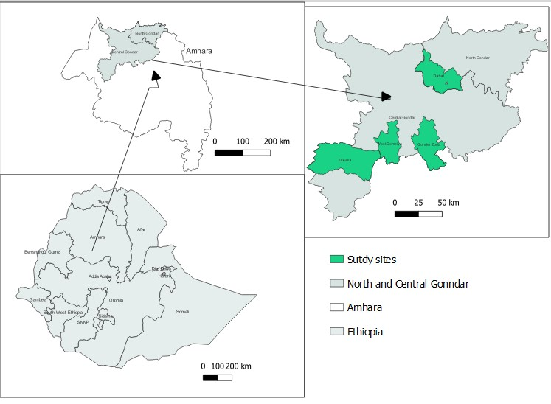

**Figure 1:** The map of the study area

|  |  |  |
| --- | --- | --- |
| **Environment** | **Location** | **Year** |
| E1 | Takusa Station | 2021 |
| E2 | Takusa Station | 2022 |
| E3 | Takusa, On-farm | 2022 |
| E4 | Dembia | 2022 |
| E5 | Dembia | 2021 |
| E6 | Gondar Zuria | 2022 |
| E7 | Gondar Zuria | 2021 |
| E8 | Dabat | 2022 |
| E9 | Dabat | 2021 |
| E10 | Takusa Station | 2020 |
| E11 | Takusa On farm | 2020 |

**Table 1:** The tested location of eleven environment

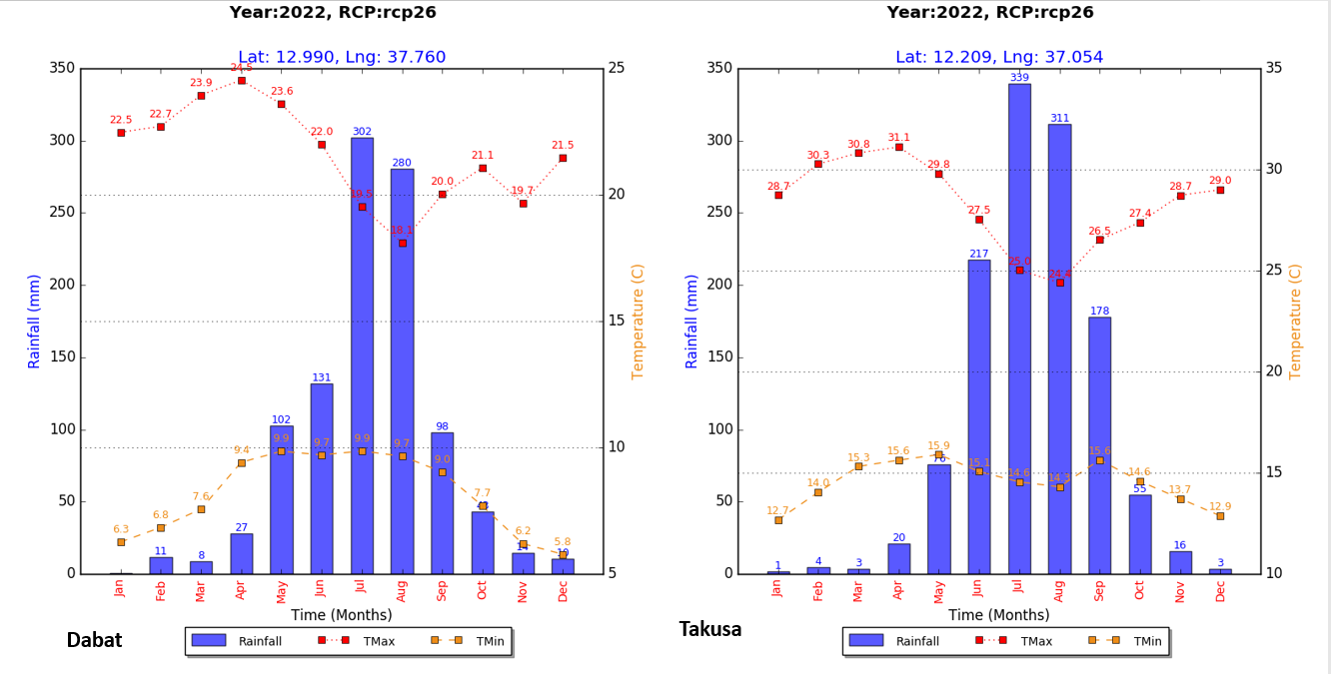

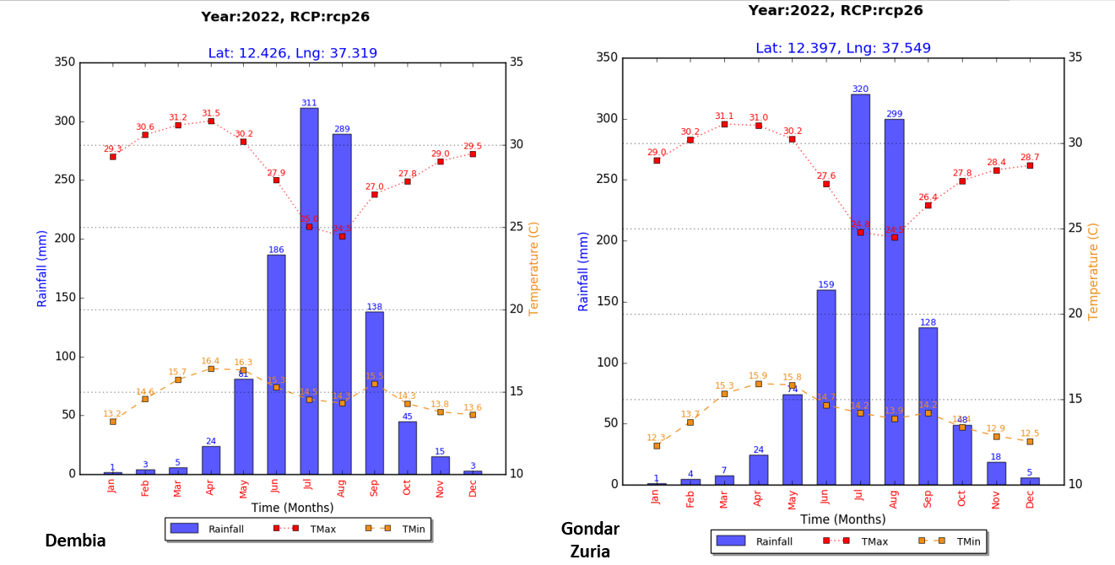

*Source: - MarkSim@ DISSAT weather file generator*

**Figure 2:** The climatic conditions of the testing districts over one year, including rainfall, minimum and maximum temperatures, as well as latitude and longitude.

*Experimental genotypes and trial management*

The experiment was performed by using thirteen genotypes, including two standard checks (Arerti and Acosdubie) (Table 2). It was carried out using a randomized complete block design (RCBD) with three replications. Each plot measured 1.5m × 5m (7.5m²) and consisted of five rows, and all data were collected from the central three rows. Planting distances were set at 1.5m between replications, 50cm between plots, 30cm between rows, and 10cm between plants. Phonological traits such as days to flowering and days to maturity, as well as metric traits including plant height, pods per plant, seeds per pod, primary branches, hundred seed weight, and grain yield, were recorded. Disease scores for fusarium wilt and dry root rot were documented during the experiment using a 1 to 9 scale according to (Irulappan et al. 2021). The data were analyzed using R software. Mean separation among genotypes of agronomic performance was done using LSD at a 5% significance level. The stability analysis was conducted using metan package and correlation was analyzed by using “corrplot” package.

**Table 2**: The description of the tested genotypes with pedigree

|  |  |  |  |
| --- | --- | --- | --- |
| **Name of Genotypes** |  | **Code** | **Origin** |
| ICCI449XEjerip6-14 |  | G1 | DZARC |
| DZ-2012-CK-0298 |  | G2 | DZARC |
| DZ-2012-CK-0288 |  | G3 | DZARC |
| Acosdubie |  | G4 | DZARC |
| Flip-93-93c |  | G5 | DZARC |
| Flip-09-76c |  | G6 | DZARC |
| DZ-2012-CK--0025 |  | G7 | DZARC |
| Flip-09-187c |  | G8 | DZARC |
| Flip-86-5c |  | G9 | DZARC |
| Arerti |  | G10 | DZARC |
| Flip-93-146-c |  | G11 | DZARC |
| DZ-2012-CK-0291 |  | G12 | DZARC |
| DZ-2012-CK-0306 |  | G13 | DZARC |

Bottom of Form

**RESULTS AND DISCUSSION**

*Combined Yield and yield-related traits of the genotypes*

The combined ANOVA (Table 3) showed that there is a significant difference between the genotypes (p<0.05) on the measured traits except seed per pod (SPP). The ANOVA of genotype by environment interaction demonstrated that all measured traits were significantly different (p<0.05) excluding plant height (PH) and seed per pod (SPP). Among the tested genotypes the highest grain yield was observed on genotypes DZ-2012-CK-0291 and DZ-2012-CK-0306 (1897.7kg ha-1 and 1797.2 7kg ha-1,respectively); While the lowest yield was observed on the variety Acosdubie (1023.3 kg ha-1). In addition to this, the standard check variety Arerti recorded 1540.3 kg ha-1. The result indicates that the superior genotype DZ-2012-CK-0291 has a 25% and 46% yield advantage over the standard check varieties Arerti and Acosdubie, respectively. In addition, genotype DZ-2012-CK-0306 was the second-best genotype and had 17.1 and 37.6 yield advantages over Arerti and Acosdubie, respectively. A recent study, similar to the findings of (Mengistu et al. 2020, and Belete et al., 2017), revealed that the grain yield of the newly released chickpea varieties beats that of the oldest variety. The results suggested that genetic improvements were increased each year.

The size of the seeds is another primary factor used to determine the ideal genotypes in chickpea. The current study demonstrated a significant difference among genotypes, environments, and their interaction for hundred-seed weight. Specifically, Acosdubie and DZ-2012-CK-0025 exhibited the largest seed size, weighing 50.6 g and 45.4 g, respectively, while the smallest seed size, 27.8 g, was found in the Arerti variety. In the current study, which is consistent with (Mengistu et al. 2020), the largest seed size was found in the Acosdubie variety, while the smallest seed size was observed in the Arerti variety. The number of pods per plant significantly varied among genotypes, across environments, and their interaction as indicated by ANOVA. Genotype DZ-2012-CK-0291(G12) recorded the highest number of pods per plant at 38.9, followed by genotype DZ-2012-CK-0306 (13) at 38.5, which is consistent with previous research reports (Eker et al. 2022; Gautam et al. 2021; Kumar et al. 2020; Singh, Kumar, and Mishra 2021). This result verified that the genotype exhibiting the highest yield also resulted in a greater number of pods per plant. However, the number of seeds per pod does not exhibit significant variation among genotypes, nor does the interaction between genotypes by environment. Additionally, significant differences in days to flowering and maturity were observed among genotypes, across environments, and their interaction. The variety Arerti took the latest days to flower and maturity, whereas genotype DZ-2012-CK-0025(G7) showed the earliest days to flowering and maturity. According to previous studies, among the kabuli types of chickpea released varieties, Arerti is the late maturing variety (Goa 2014; Mengistu et al. 2020; Shumi et al., 2020).

***Table 3:*** *The combined result of yield and yield-related parameters in eleven environments.*

|  |  |  |  |  |  |  |  |  |
| --- | --- | --- | --- | --- | --- | --- | --- | --- |
| Genotypes | DF | DM | PH | PPP | SPP | PB | HSW(g) | GYD(kg/ha) |
| ICCI449XEjerip6-14 | 45 | 102 | 40.9 | 36.4 | 1.11 | 3.33 | 32.7 | 1663.4 |
| DZ-2012-CK-0298 | 48 | 103 | 39.8 | 32.3 | 1.08 | 3.14 | 32.1 | 1568.7 |
| DZ-2012-CK-0288 | 51 | 107 | 43.0 | 30.3 | 1.08 | 2.95 | 37.3 | 1379.7 |
| Acosdubie | 47 | 102 | 45.6 | 26.1 | 1.07 | 2.46 | 50.6 | 1023.3 |
| Flip-93-93c | 48 | 107 | 43.2 | 36.0 | 1.10 | 3.09 | 31.3 | 1590.5 |
| Flip-09-76c | 54 | 109 | 44.0 | 33.8 | 1.14 | 4.06 | 29.6 | 1396.6 |
| DZ-2012-CK--0025 | 43 | 102 | 38.9 | 25.6 | 1.12 | 2.77 | 45.4 | 1640.4 |
| Flip-09-187c | 48 | 104 | 41.6 | 35.7 | 1.11 | 2.81 | 31.3 | 1741.1 |
| Flip-86-5c | 49 | 104 | 41.2 | 33.1 | 1.13 | 3.20 | 29.1 | 1323.1 |
| Arerti | 57 | 112 | 39.6 | 34.8 | 1.08 | 4.40 | 27.8 | 1458.9 |
| Flip-93-146-c | 49 | 105 | 41.7 | 35.2 | 1.13 | 2.97 | 30.7 | 1540.3 |
| DZ-2012-CK-0291 | 47 | 103 | 42.2 | 38.9 | 1.15 | 3.02 | 32.2 | 1897.7 |
| DZ-2012-CK-0306 | 48 | 105 | 42.5 | 38.5 | 1.10 | 3.13 | 32.2 | 1797.2 |
| Mean | 49 | 105 | 41.8 | 33.5 | 1.1 | 3.1 | 33.9 | 1538 |
| CV | 6.9 | 4.67 | 10.1 | 27.6 | 15.5 | 24 | 13 | 27 |
| LSD | 1.6 | 2 | 2 | 4.5 | 0.8 | 0.37 | 2.1 | 203 |
| GEN | ** | ** | ** | ** | ns | ** | ** | ** |
| ENV | ** | ** | ** | ** | ** | ** | ** | ** |
| GEN*ENV | ** | ** | ns | ** | ns | ** | ** | ** |

*NB:-DF-Days to flowering, DM- days to maturity, PH-plant height, PPP-pod per pod, SPP-seed per pod, PB-primary branch, HSW-hundred seed weight, GYD-grain yield*

*The response of the genotypes for economically important diseases*

In Ethiopia, Fusarium wilt (*Fusarium oxysporum f. sp. ciceris (Foc)*), and dry root rot (*Rhizoctonia bataticola*) are widespread in chickpea fields, as reported by (Bekele et al. 2021). The current study highlights that in 2021, the genotypes showed a range of responses, from highly resistant (HR) to resistance (RR) for Fusarium wilt, and from highly resistant (HR) to moderately resistant (MR) for dry root rot. During the 2022 cropping season, the genotypes exhibited diverse reactions, with responses ranging from resistant (RR) to moderately susceptible (MS) for Fusarium wilt and from moderately resistant (MR) to susceptible (SS) for dry root rot (Table 4). These results are consistent with previous research by (Mirchandani et al. 2023, and Rai et al.2022), which emphasize the significant threat posed by these diseases to chickpea production.

**Table 4**: The response of genotypes for fusarium wilt (*Fusarium oxysporum f. sp. ciceris (Foc)*),and dry root rot (*Rhizoctonia bataticola*) in 2021 and 2022.

|  |  |  |  |  |  |
| --- | --- | --- | --- | --- | --- |
| Genotype | Code | Year | | | |
| 2021 | | 2022 | |
| Wilt (%) | DRR (%) | Wilt (%) | DRR (%) |
| DZ-2012-CK-0298 | G2 | 6.0(RR) | 8.7(RR) | 13.3(MR) | 12.7(MR) |
| DZ-2012-CK-0288 | G3 | 3.6(HR) | 3.3(HR) | 9.5(RR) | 6.0(RR) |
| 24(MONINO) | G4 | 2.0(HR) | 6.0(RR) | 10.3(MR) | 2.0(HR) |
| Flip-93-93c | G5 | 2.3(HR) | 13.0(MR) | 6.0(RR) | 47.7(SS) |
| Flip-09-76c | G6 | 4.3(HR) | 13.0(MR) | 9.3(RR) | 20.0(MR) |
| DZ-2012-CK--0025 | G7 | 4.7(HR) | 1.7(HR) | 8.7(RR) | 13.0(MR) |
| Flip-09-187c | G8 | 5.0(HR) | 10.0(RR) | 10.7(MR) | 18.9(MR) |
| Flip-86-5c | G9 | 2.0(HR) | 9.3(RR) | 11.3(MR) | 36.7(SS) |
| Arerti | G10 | 1.7(HR) | 18.0(MR) | 18.7(MR) | 43.0(SS) |
| Flip-93-146-c | G11 | 2.3(HR) | 7.3(RR) | 5.7(RR) | 55.3(SS) |
| DZ-2012-CK-0291 | G12 | 4.3(HR) | 6.7(RR) | 8.0(RR) | 20(MR) |
| DZ-2012-CK-0306 | G13 | 1.3(HR) | 14.3(RR) | 13.0(MR) | 32.3(SS) |

*NB: - wilt- fusarium wilt, DRR-dry root rot, HR - highly resistant, RR-resistance, MR-moderately resistant, MS-moderately susceptible, SS- susceptible*

*Correlation of grain yield and the yield-related traits*

The prison’s correlation coefficient indicates the positive and negative significant correlation between the traits. Among the recorded traits, plant height, pods per plant, and seed per pod positively respond to grain yield (Figure 3). Similar results were reported by (Janghel *et al.* 2020, and Singh et al. 2021) in which the number of pods per plant and plant height positively correlated with grain yield. The current findings suggest that the breeder is aiming to enhance overall productivity by prioritizing breeding strategies that increase the number of pods per plant.

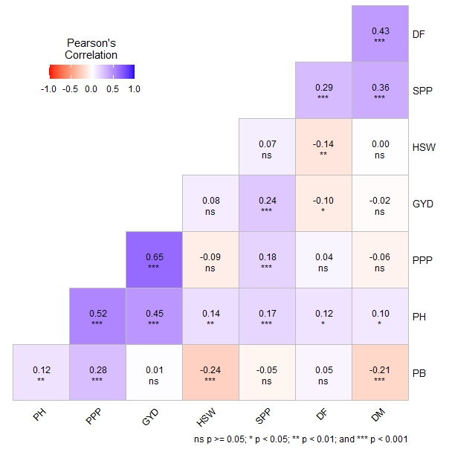

**Figure 3:** The prison’s correlation coefficient of eight traits for thirteen genotypes in eleven environments

**Stability Analysis**

*Mean Vs stability, and which –won –where a view of GGE biplot*

The evaluation of stability across multiple environments using the “mean vs. stability” analysis of the genotype plus genotype by environment (GGE) bi-plot is an appropriate approach (Yan and Kang 2002; Yan WeiKai and Kang 2003). A genotype that lies closer to the origin of the AEC plot has a low average yield and low stability, which is less desirable. In contrast, a genotype that is far from the origin but along the x-axis shows a higher average yield is more stable across environments, and is considered highly productive and stable (Mohammadi & Amri, 2013). The uppermost grain yield was recorded on DZ-2012-CK-0291 (G12), DZ-2012-CK-0306 (G13), Flip-09-187c (G8), and ICCI449XEjerip6-14(G1) as well as DZ-2012-CK-0298 (G2), while Flip-93-93c (G5) and Flip-93-146-c (G11) exhibited similar to the grand mean (Figure 4a). In contrast, Acosdubie (G4) and Flip-86-5c (G9) recorded the lowest mean grain yield. The stability indicated by a vertical line signifies high variability across environments indicated by the blue dotes is longer than the others (figure 4a). In this experiment, DZ-2012-CK-0291 (G12), ICCI449XEjerip6-14 (G1), variety Arerti (G10), Flip-09-76c (G6), and Acosdubie (G4) were the most stable varieties across the environment. On the other hand, DZ-2012-CK-0306 (G13), Flip-09-187c (G8), DZ-2012-CK-0298 (G2), and Flip-93-93c (G5) showed greater variability across the environments. Following the present result, various investigators also found stable chickpea genotypes(Azam et al., 2020; Danakumara et al., 2023). Illustrates polygon patterns titled "Which Genotype Won Where/What," emphasizing how different genotypes best in specific environments, with a particular emphasis on yield performance (Yan and Kang 2002; Yan WeiKai and Kang 2003). In the current study, genotypes DZ-2012-CK-0291 (G12) demonstrated excellent performance at E3, E8, E9, E10, and E6. Moreover DZ-2012-CK-0306 (G13) and Flip-09-187c (G8) exhibited superior performance at E1, E2, E7 and E11 (Figure 4b).

Bottom of Form

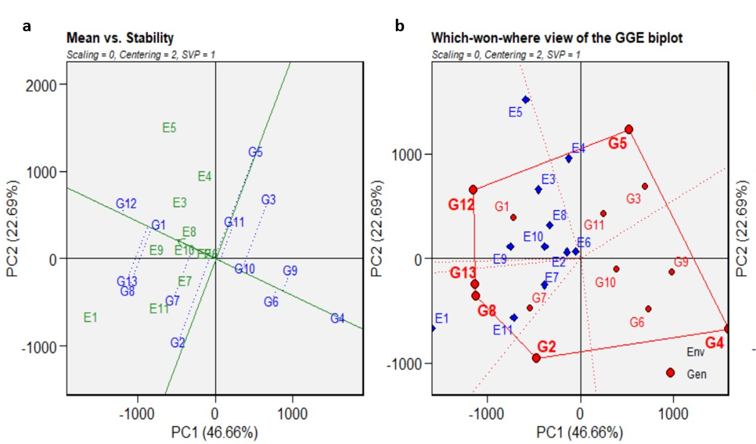

**Figure 4**: (a) The GGE biplot’s depiction of the “mean vs. stability” pattern. (b) The which–won–where a view of 13 genotypes and at 11 environments. The biplot was created based on centering = 2, SVP = 1, and scaling = 0.

*Ranking environment and ranking genotypes*

The genotype ranking biplot, as shown in Figure 5a, is used as a valuable tool for identifying superior-performing genotypes in comparison (Li *et al.* 2023). The biplot shows that the first PCA captured 46.66% of the variability, and the second PCA explained 22.69%, together representing a significant share. Notably, genotypes such as DZ-2012-CK-0291(G12) and ICCI449XEjerip6-14 (G1) stand out as top candidates due to their proximity to the concentric circle of the plot. The top-performing genotype, located near the concentric circle, exhibits high yield and stability across various environments (Laxami, Kumar, and Razdan 2017).

Similar to the ideal genotype the ideal environment is located in the first or near to the first concentric circle in the environment focused biplot and desirable environments are close to the ideal environments. Environment E9 and E3 were closer to the ideal environment (concentric) than the other tested environments (Figure 5b), therefor it should regarded as the most suitable for selecting widely adapted genotypes. E6, E4, E5, E11, and E1 were far from the concentric circle and considered as undesirable environments. The ideal environment is representative and has the highest discriminating power (Yan & Tinker, 2006).

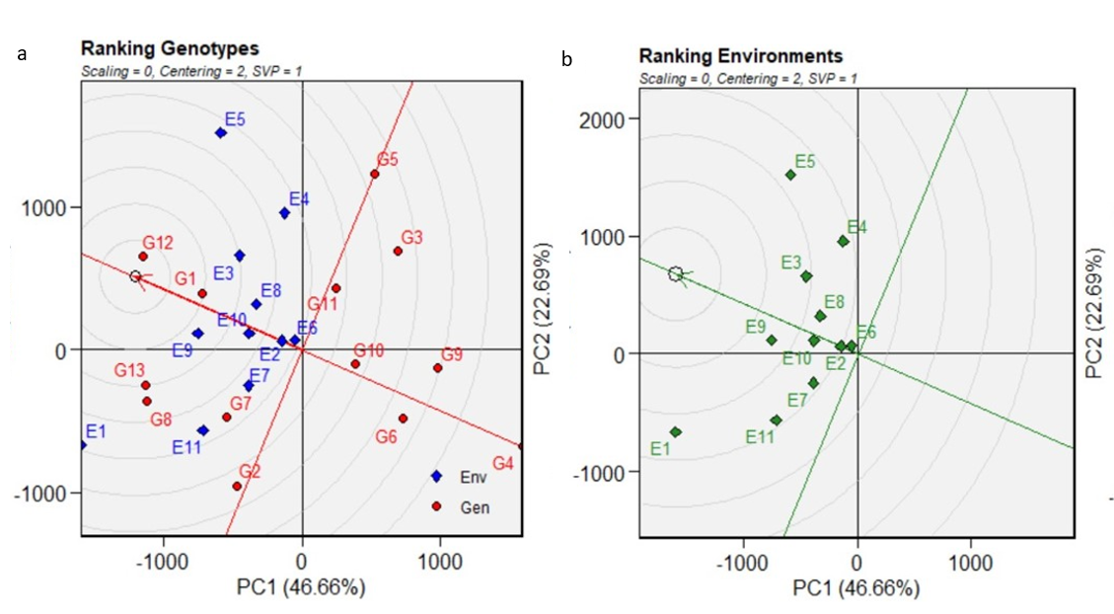

**Figure 5:** (a) The ranking genotypes view of 13 genotypes and at 11 environments. The biplot was created based on centering = 2, SVP = 1, and scaling = 0. (b) Ranking environment view of 13 genotypes and at 11 environments. The biplot was created based on centering = 2, SVP = 1, and scaling = 0.

*The multi traits stability index (MTSI)*

For biological experiments, multivariate data are applicable using data from multiple traits to reach better conclusions (Olivoto and Nardino, 2020). The genotypes were categorized into two groups, selected and non-selected, based on the data from the eight measured traits (Figure 6). As a result, genotypes DZ-2012-CK-0291 (G12) and Flip-93-146-c (G11) were the selected genotypes, which are the most stable genotypes across environments. The current results suggested that the top-performing genotypes could be utilized as parent lines in future hybridization efforts to create chickpea genotypes with improved agronomic performance. Furthermore, the Weighted Average of Absolute Scores of the Best Individual (WAASBI), is a stability index used in plant breeding, particularly within the context of the Multi-Trait Stability Index (MTSI). Based on this, the selected genotypes showed less weighted average of absolute scores (WAASBI) value where genotype DZ-2012-CK-0291 (G12) recorded 0.841 and genotype Flip-93-146-c (G11) showed 1.22, and those genotypes were above the cut-off point of the circle (Figure 6), and the lowest WAASBI value (Table 5). (Jorben *et al*. 2022) reported a lower WASSB value, which is consistent with the current study.

**Table 5**: The value of the weighted average of absolute scores (WAASBI) for thirteen genotypes based on eight traits across eleven environments.

|  |  |  |  |  |
| --- | --- | --- | --- | --- |
| **Genotypes** | **code** | **WASSB** | **Rank** |  |
| DZ-2012-CK-0291 | G12 | 0.841 | 1 |  |
| Flip-93-146-c | G11 | 1.22 | 2 |  |
| Acosdubie | G4 | 1.4 | 3 |  |
| DZ-2012-CK-0298 | G2 | 1.46 | 4 |  |
| Flip-86-5c | G9 | 1.54 | 5 |  |
| DZ-2012-CK-0306 | G13 | 1.54 | 6 |  |
| Flip-09-187c | G8 | 1.67 | 7 |  |
| ICCI449XEjerip6-14 | G1 | 1.93 | 8 |  |
| DZ-2012-CK-0288 | G3 | 2.26 | 9 |  |
| DZ-2012-CK--0025 | G7 | 2.36 | 10 |  |
| Flip-09-76c | G6 | 2.43 | 11 |  |
| Arerti | G10 | 3.87 | 12 |  |
| Flip-93-93c | G5 | 4.06 | 13 |  |

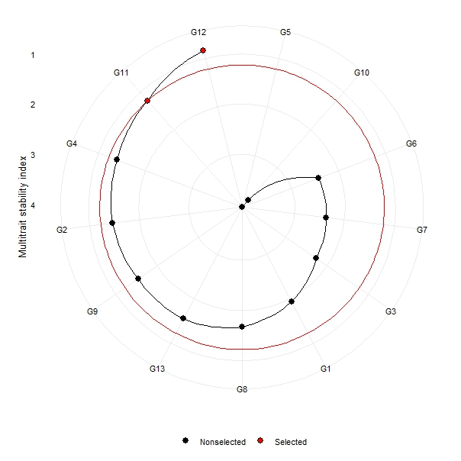

**Figure 6**:Genotypes selected by multi-trait stability index applied on the traits of days to flowering (DF), days to maturity (DM), plant height (PH), pod per plant (PPP), seed per pod (SPP), hundred seed weight (HSW), primary branch (PB), and grain yield (GY).

**CONCLUSION AND RECOMMENDATION**

The combined analysis of variance indicated significant differences among the tested genotypes and the genotype-by-environment interaction for most measured parameters, including grain yield and hundred seed weight. The GGE-biplot analysis for grain yield stability also demonstrated substantial variation among the genotypes in terms of their yield stability across the testing environments. Additionally, the tested genotypes showed considerable variation in their responses to various chickpea diseases and their environmental adaptability over the years. The MTSI analysis across all measured traits and testing environments further confirmed the wide variation among the genotypes. DZ-2012-CK-0291 (G-12) based on their mean grain yield, DZ-2012-CK-0025 (G-7) large seed size, and DZ-2012-CK-0306 (G-13) better reaction for disease and specific adaptability, were selected, and recommended for variety verification trial. The National Variety Release Committee (NVRC) evaluated these genotypes alongside the standard check for grain yield, yield-related traits, disease resistance, and farmer preference. Of these, DZ-2012-CK-0291 (G-12) officially approved for full release under the local name TANA, intended for major chickpea-producing areas in the Amhara region, which are Takusa, Dembia, Gondar-Zuria, Dabat, and similar regions in Ethiopia. The passport data for TANA is described (Table 6).

**Table:-6**. The passport data of released Kabuli types of chickpea

|  |  |  |  |
| --- | --- | --- | --- |
| 1. | Kabuli type |  |  |
| 1.1. | New variety |  |  |
| 1.2. | Variety name | (TANA) **ጣና** DZ-2012-CK-0291 |  |
|  |  | Adaptation | Midland and highland chickpea growing areas Gondar (Takusa, Dembia, Gondar Zuria, and Dabat) and similar agro-ecology |
|  |  | Altitude | 1800-2700 m.a.s.l |
|  |  | Rain Fall | 800-1200mm |
|  |  | Soil type | Vertisol |
|  |  | Seed rate(kg/ha) | Range over 100-140 depending on HSW |
|  |  | Planting date | End of August 3rd week of September |
|  |  | Fertilizer rate |  |
|  |  | P2O5 | 46kg/ha |
|  |  | N | 18kg/ha |
|  |  | Day to flowering | 40-75 days |
|  |  | Day to maturity | 83-128 days |
|  |  | Plant height(cm) | 41-52 cm |
|  |  | Growth habit | Semi-erected and with high primary and secondary branches |
|  |  | Hundred seed weight | 28-37(g) |
|  |  | Seed coat color | White creamy |
|  |  | Flower color | White |
|  |  | Grain size | Large seed size |
|  |  | Crop pest reaction* |  |
|  |  | Yield (qt/ha -1) |  |
|  |  | Research field | 16-33 |
|  |  | Farmer field | 14- 22 |
| 2. | Year of release | 2024 |  |
| 3. | Breeder/maintainer | ARARI/GARC |  |
| 4. | *Better tolerance to collar root rot, dry root rot, and fusarium wilt | | |

**ACKNOWLEDGMENT**

I would like to express my sincere gratitude to all those who contributed to the achievement of this research activity. My deepest appreciation goes to my colleagues, for their invaluable guidance and support throughout the research process. I also thank Amhara Agricultural Research Institute Gondar Agricultural Center for providing the necessary resources and facilities that made this study possible.

**REFERENCES**

Al-Naggar, A. M. M., R. M. Abd El-Salam, M. R. Asran, and Walaa Yaseen. 2018. “Yield Adaptability and Stability of Grain Sorghum Genotypes across Different Environments in Egypt Using AMMI and GGE-Biplot Models.” *Annual Research & Review in Biology,* 23(3):1–16.

Annicchiarico, Paolo. 2002. “Genotype x Environment Interactions: Challenges and Opportunities for Plant Breeding and Cultivar Recommendations.

Araus, José Luis, Gustavo A. Slafer, Conxita Royo, and M. Dolores Serret. 2008. “Breeding for Yield Potential and Stress Adaptation in Cereals.” *Critical Reviews in Plant Sciences,* 27(6):377–412.

Aslam, M., I. A. Mahmood, M. B. Peoples, G. D. Schwenke, and D. F. Herridge. 2003. “Contribution of Chickpea Nitrogen Fixation to Increased Wheat Production and Soil Organic Fertility in Rain-Fed Cropping.” *Biology and Fertility of Soils,* 38(1):59–64.

Azam, M. G., Iqbal, M. S., Hossain, M. A., & Hossain, M. F. (2020). Stability investigation and genotype\times environment association in chickpea genotypes utilizing AMMI and GGE biplot model. *Genetics and Molecular Research*, *19*(3), 1–15.

Bacha, Temesgen, Sintayehu Alemerew, and Zerihun Tadesse. 2015. “Genotype x Environment Interaction and Yield Stability of Bread Wheat (Triticum Aestivum L.) Genotype in Ethiopia Using the AMMI Analysis.” *Journal of Biology, Agriculture and Healthcare*, 5(11):129–139.

Becker, H. C., and J. I. Leon. 1988. “Stability Analysis in Plant Breeding.” *Plant Breeding,* 101(1):1–23.

Bekele, D., Tesfaye, K., Fikre, A., & Cook, D. R. 2021. The extent and association of chickpea Fusarium wilt and root rot disease pressure with major biophysical factors in Ethiopia. *Journal of Plant Pathology*, *103*(2), 409–419.

Belete, T., Mekbib, F., & Eshete, M. (2017). Assessment of genetic improvement in grain yield potential and related traits of kabuli type chickpea (Cicer arietinum L.) varieties in Ethiopia (1974-2009). *Advances in Crop Science and Technology*, *5*(3), 1–10

Benakanahalli, Niranjana Kumara, Shankarappa Sridhara, Nandini Ramesh, Tiago Olivoto, Gangaprasad Sreekantappa, Nissren Tamam, Ashraf MM Abdelbacki, Hosam O. Elansary, and Shaimaa AM Abdelmohsen. 2021. “A Framework for Identification of Stable Genotypes Basedon MTSI and MGDII Indexes: An Example in Guar (Cymopsis Tetragonoloba L.).” *Agronomy,* 11(6):1–20.

Central Statistical Agency (CSA) (2022). Agricultural Sample Survey 2021/22. Central Statistical Agency, Federal Democratic Republic of Ethiopia, Addis Ababa. Volume V.

Danakumara, T., Kumar, T., Kumar, N., Patil, B. S., Bharadwaj, C., Patel, U., Joshi, N., Bindra, S., Tripathi, S., & Varshney, R. K. (2023). A Multi-Model Based Stability Analysis Employing Multi-Environmental Trials (METs) Data for Discerning Heat Tolerance in Chickpea (Cicer arietinum L.) Landraces. *Plants*, *12*(21), 2-16.

Döring, Thomas F., Samuel Knapp, Geza Kovacs, Kevin Murphy, and Martin S. Wolfe. 2011. “Evolutionary Plant Breeding in Cereals—into a New Era.” *Sustainability*, 3(10):1944–1971.

Eker, Tuba, Hatice Sari, Duygu Sari, Huseyin Canci, Mehmet Arslan, Bilal Aydinoglu, Hilal Ozay, and Cengiz Toker. 2022. “Advantage of Multiple Pods and Compound Leaf in Kabuli Chickpea under Heat Stress Conditions.” *Agronomy*, 12(3):1–17.

FAOSTAT, 2022 Food and Agricultural Organization Statistical Database Crops and Livestock Products. https://www.fao.org/faostat/en/#data/QCL

Gautam, Ashish, R. K. Panwar, S. K. Verma, Anju Arora, Amit Kumar Gaur, and Charupriya Chauhan. 2021. “Assessment of Genetic Variability Parameters for Yield and Its Components in Chickpea (Cicer Arietinum L.).” in *Biological Forum–An International Journal*, 13(1): 651–655.

Goa, Yasin. 2014. “Evaluation of Chick Pea (Cicer Arietinum L.) Varieties for Yield Performance and Adaptability to Southern Ethiopia.” *Evaluation,* 4(17):34 –38.

Hussain, Tamoor, Zahid Akram, Ghulam Shabbir, Abdul Manaf, and Mukhtar Ahmed. 2021. “Identification of Drought Tolerant Chickpea Genotypes through Multi Trait Stability Index.” *Saudi Journal of Biological Sciences,* 28(12):6818–6828.

Irulappan, V., Mali, K. V., Patil, B. S., Manjunatha, H., Muhammad, S., & Senthil‐Kumar, M. (2021). A sick plot–based protocol for dry root rot disease assessment in field‐grown chickpea plants. *Applications in Plant Sciences*, *9*(8), e11445.

Janghel, D. K., Krishan Kumar, S. S. Verma, and A. K. Chhabra. 2020. “Genetic Relationships and Principal Component Analysis in Elite Chickpea (Cicer Arietinum L.) Genotypes for Seed Yield and Its Component Traits.” *Legume Research-An International Journal,* 43(6):770–778.

Jorben, J., Apoorva Rao, C. Bharadwaj, S. D. Nitesh, Neha Tiwari, Tapan Kumar, D. R. Saxena, M. Yasin, P. L. Sontakke, and Jagdish E. Jahagirdar. 2022. “Multi-Trait Multi-Environment Analysis for Stability in MABC Lines of Chickpea (Cicer Arietinum).” *Indian J. Agric. Sci* , 92(8):1005–1009.

Kumar, Amit, Mukesh Kumar, Pooran Chand, S. K. Singh, Puspendra Kumar, and L. K. Gangwar. 2020. “Studies on Genetic Variability and Inter Relationship among Yield and Related Traits of Parents and F1 Population in Chickpea (Cicer Arietinum L.).” *Journal of Pharmacognosy and Photochemistry,*  9(3):1434–1438.

Laxami, Jay, Bupesh Kumar, and A. K. Razdan. 2017. “GGE Biplot Analysis of Genotype x Environment Interaction in Basmati Rice (Oryza Sativa L.).” *Int. J. Curr. Microbiol. App. Sci,* 6(12):3345–3350.

Li, Yipu, Haizhu Bao, Zhenghan Xu, Shuping Hu, Jiying Sun, Zhigang Wang, Xiaofang Yu, and Julin Gao. 2023. “AMMI an GGE Biplot Analysis of Grain Yield for Drought-Tolerant Maize Hybrid Selection in Inner Mongolia.” *Scientific Reports*,13(1):1–9.

Mengistu, Genet, Bulti Tesso, and Asnake Fikre. 2020. “Quantifying Genetic Advance of Kabuli Chickpea Varieties for Yield and Yield Related Traits in Ethiopia.” *Journal of Biology, Agriculture and Healthcare,* 10(15):19–29.

Mengistu, D. K., Terefe, H., Teshome, T., Garamu, T., Lakew, B. F., & Fadda, C. (2024). Chickpea production restored through upscaling crowdsourcing winner varieties and planting date adjustments in the Ada’a district, East Shoa zone, Ethiopia.10(2024) *Heliyon* 2-11

Mirchandani, R., Irulappan, V., Chilakala, A. R., & Senthil-Kumar, M. 2023. Dry root rot disease: Current status and future implications for chickpea production. *Proceedings of the National Academy of Sciences, India Section B: Biological Sciences*, *93*(4), 791–800.

Mohammadi, Reza, Jaffar Jafarzadeh, Mohammad Mehdi Poursiahbidi, Hossein Hatamzadeh, and Ahmed Amri. 2023. “Genotype-by-Environment Interaction and Stability Analysis for Grain Yield in Durum Wheat Using GGE Biplot and Genotypic and Environmental Covariates.” *Agricultural Research*, 12(4):364–374.

Mohammadi, R., & Amri, A. (2013). Genotype × environment interaction and genetic improvement for yield and yield stability of rainfed durum wheat in Iran. *Euphytica*, *192*(2), 227–249

Olivoto, Tiago, and Maicon Nardino. 2020. “MGIDI: A Novel Multi-Trait Index for Genotype Selection in Plant Breeding.” *bioRxiv,* 7(1):1–22.

Rai, A., Irulappan, V., & Senthil-Kumar, M. 2022. Dry Root Rot of Chickpea: A Disease Favored by Drought. *Plant Disease*, *106*(2), 346–356.

Shumi, Deresa, Demissie Alemayehu, and Tekalign Afeta. 2020. “Adaptation Study of Improved Chickpea (Cicer Arietinum L.) Varieties at Mid and Highland of Guji Zone, Southern Ethiopia.” *Journal of Agricultural Science and Research,* 6(1):42–46.

Singh, Brindaban, Vinod Kumar, and S. P. Mishra. 2021. “Genetic Variability, Path Analysis and Relationship among Quantitative Traits in Chickpea (Cicer Arietinum L.) Genotypes.” *The Pharma Innovation Journal,* 10(5):1564–1568.

Vishnyakova, M. A., M. O. Burlyaeva, S. V. Bulyntsev, I. V. Seferova, E. S. Plekhanova, and S. V. Nuzhdin. 2017. “Chickpea Landraces from Centers of the Crop Origin: Diversity and Differences.” *Selskokhozy aistvennaya Biol,* 52(5):976–985.

Yan, W., & Tinker, N. A. (2006). Biplot analysis of multi-environment trial data: Principles and applications. *Canadian Journal of Plant Science*, *86*(3), 623–645.

Yan, Weikai, and Manjit S. Kang. 2002. *GGE Biplot Analysis: A Graphical Tool for Breeders, Geneticists, and Agronomists*. CRC press.

Yan WeiKai, Yan WeiKai, and M. S. Kang. 2003. “GGE Biplot Analysis: A Graphical Tool for Breeders, Geneticists, and Agronomists.”

Yegrem, Lamesgen, Derbie Mengestu, Oli Legesse, Workenh Abebe, and Negussie Girma. 2022. “Nutritional Compositions and Functional Properties of New Ethiopian Chickpea Varieties: Effects of Variety, Grown Environment and Season.” *International Journal of Food Properties,* 25(1):1485–1497.

Zhang, Junjie, Jingqi Wang, Cancan Zhu, Raghvendra Pratap Singh, and Wenfeng Chen. 2024. “Chickpea: Its Origin, Distribution, Nutrition, Benefits, Breeding, and Symbiotic Relationship with Mesorhizobium Species.” *Plants,* 13(3):1–13.